Q1

A

1. Create a folder named “R Practical” in your home directory/C: drive
2. Set the working directory to this folder
3. Create Ordinal categorical vector with the values ‘evening’,’morning’,’afternoon,’midday’,’midnight’,’evening’.
4. Convert it to factor with ordered level.
5. Display the above created factor.

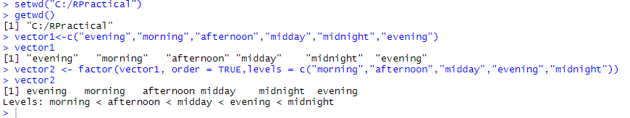

Q2

A

Perform ETL process in Pentaho with excel as input and excel as output after applying any 3 transformations on Sales data in Pentaho.

Transformation 1) Split the Name Field

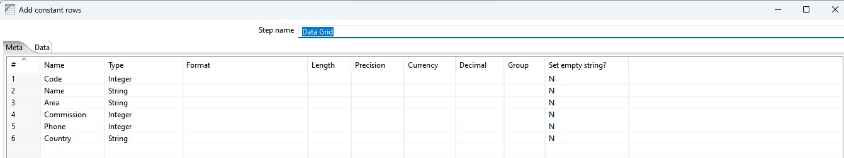

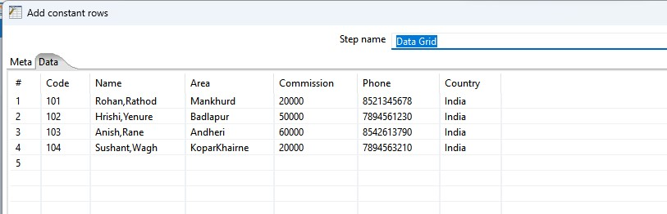

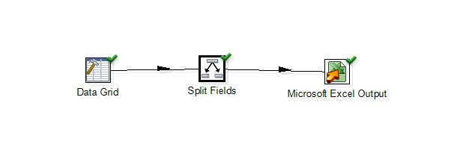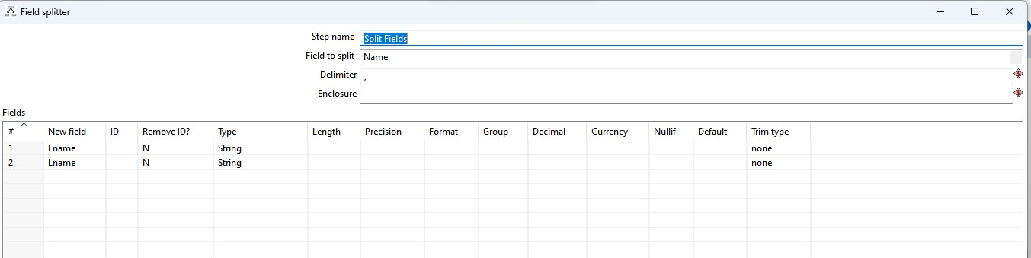

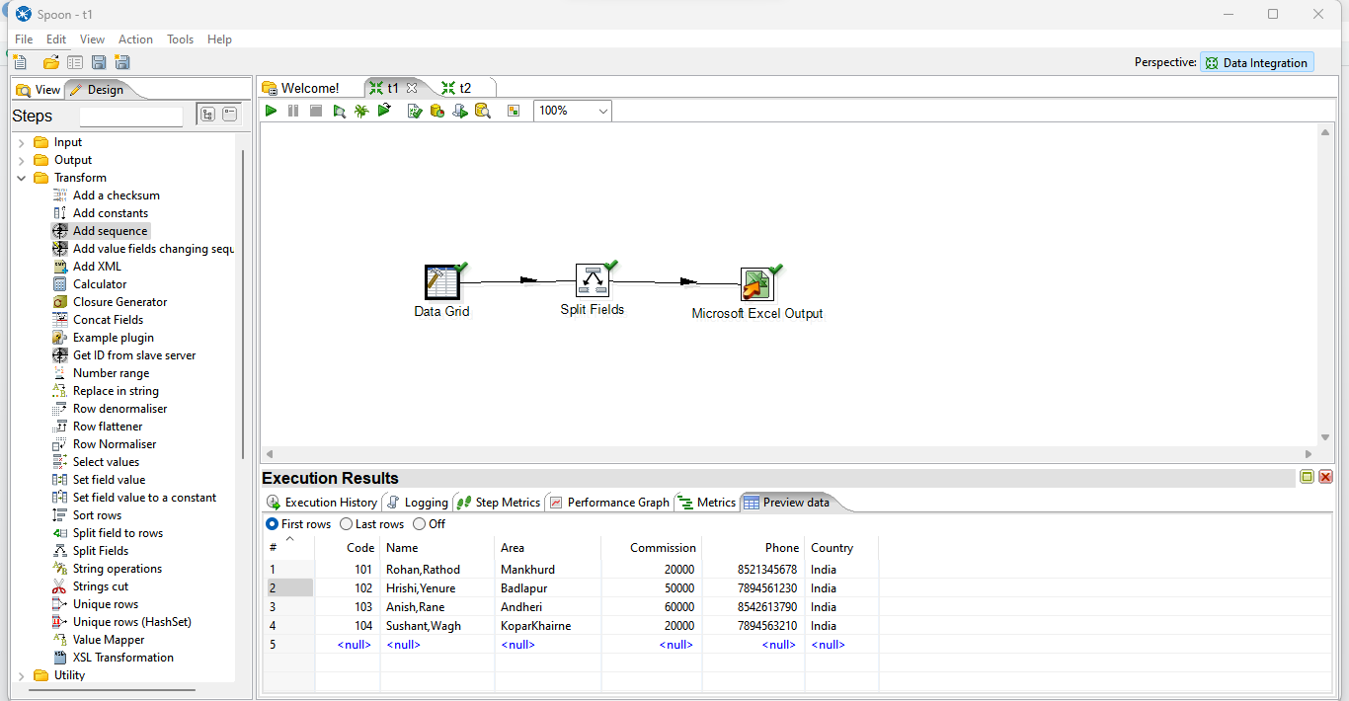

Loaded the data into Excel

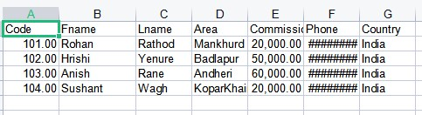

Transformation 2) Add a Sequence:

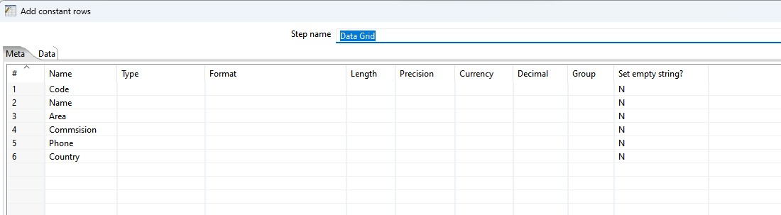

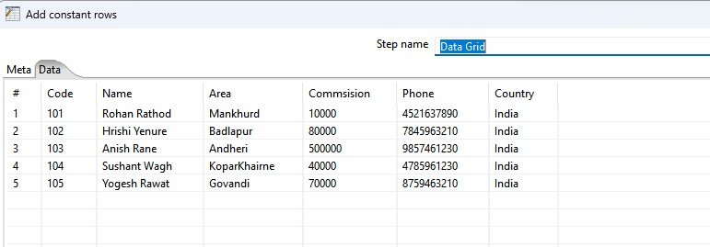

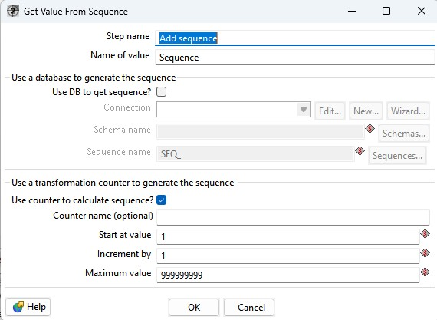

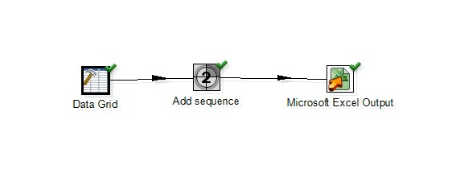

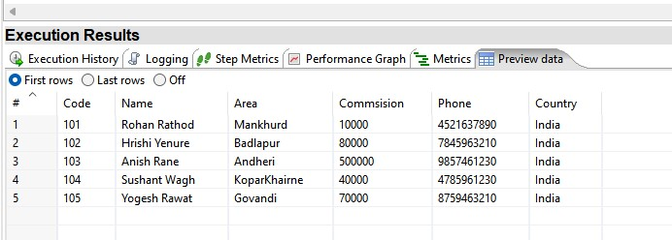

Loaded the data into Excel

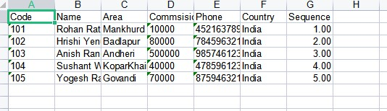

B

Create table sales(sid,ssname,salesregion) with 3 partition using list partition based on region

1. Describe the structure of the table and display the parition of table.
2. Insert minimum 6 records and display the content from each partition.
3. Update any one records from each partition and display the content from each partition.

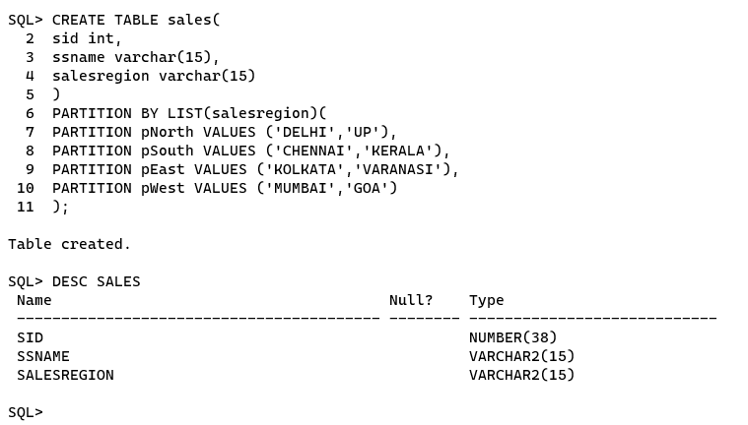

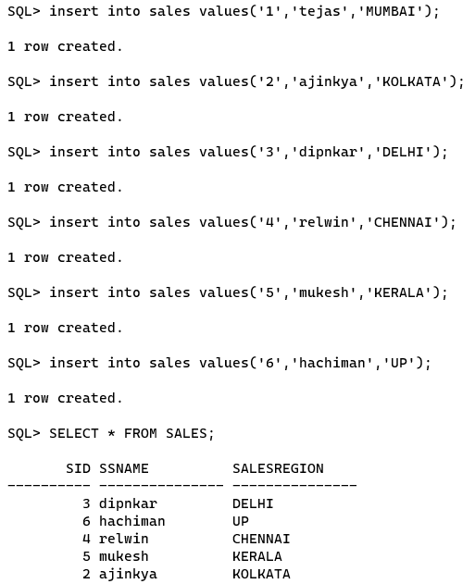

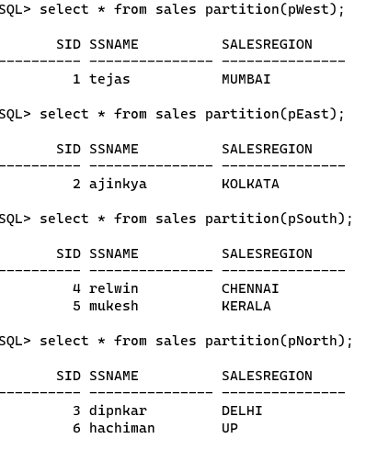

Q3

A

Create abstract datatype of Book_type containing Bookno, Title, Author, pub_date,

Price. Create a table Books of Book_type.

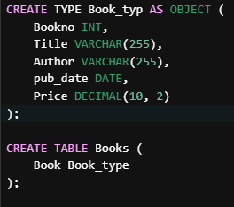

B

Show the usage of LEAD and Lag Analytical Functions on following table in Oracle

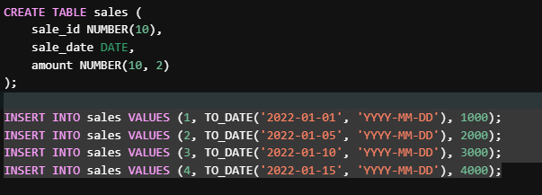

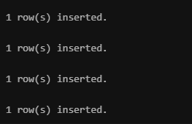

B

Show the usage of LEAD and Lag Analytical Functions on following table in Oracle

