Q.1 A)

- create a folder named “RPractical” in your directory/C:drive

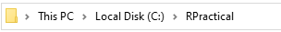

- Set the working directory to this folder

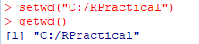

3.)Create ordinal vector with the values ‘evening’,’morning’,’afternoon’,’midday’,’midnight’,’evening’.
4.)Convert it to factor with ordered level.
5.)Display the above created factor.

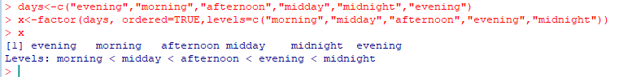

Q.2.A) Perform ETL process in Pentaho with excel as input and excel as output after applying any 3 transformation on sales data in pentaho

1)Sorting rows:-

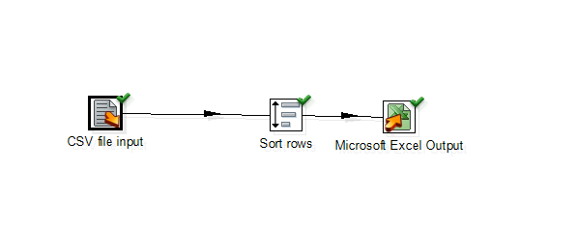
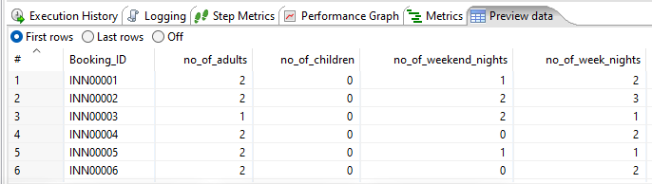

2)Calculator:-

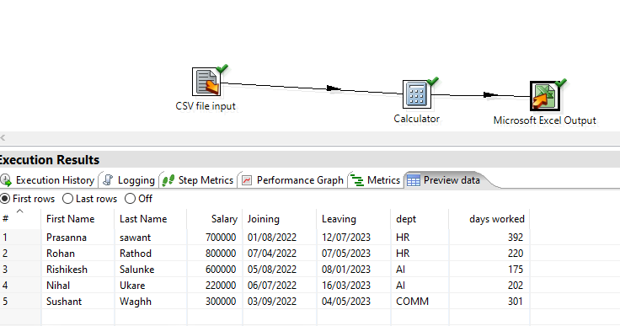

- ) Add Sequence

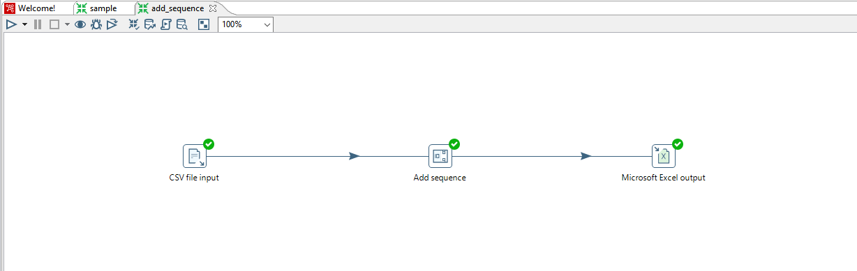
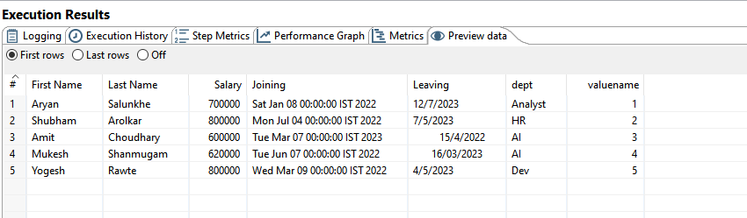
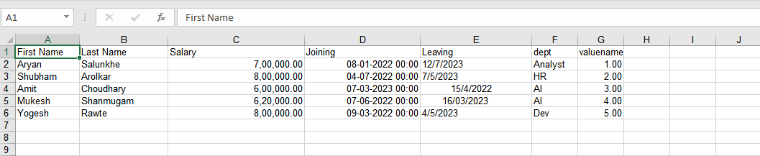

Q.2.B)
Create table sales(sid,ssname,salesregion) with 3 partition using list partition based on region
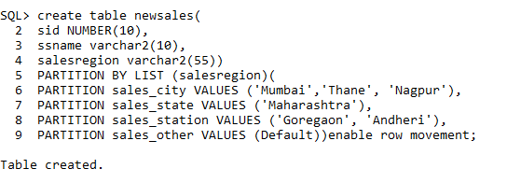

- Describe the structure of the table and display the partition of the table.

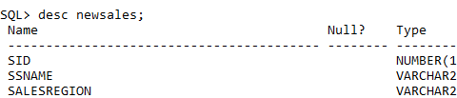

- Insert minimum 6 records and display the content from each partition

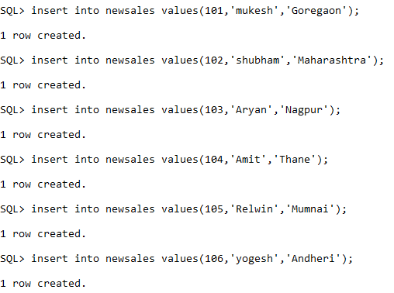\
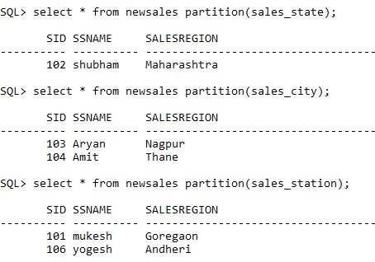

- Update any one record from each partition and display the content

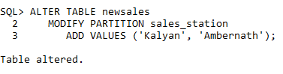

Q 3 A) Create abstract datatype of Book_Type containing Book no. ,Title, Author, Pub_date, Price.
Create a table Books of Book_type

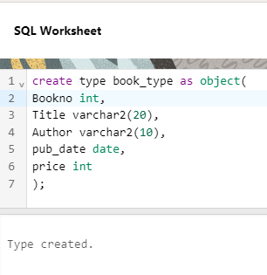
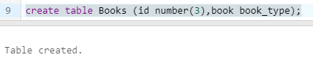

- Show the usage of Lead and Lag Analytical function on following table in oracle

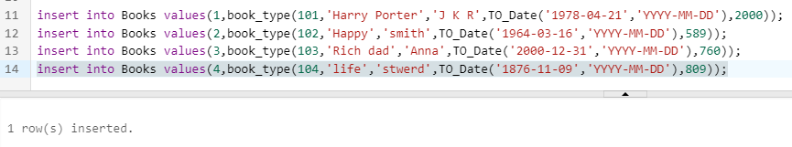

Lead :-

Lag:-

