1. Design a loan calculator using JSP which accepts periods of time(in years) and principal loan amount.Display the payment Amount for each loan and then list the loan balance and interest paid for each payment over the term of loan
2. 1 to 4 years at 2.35%
3. 4 to 10 year at 6.5%

c.10 to 15 years at 8.75%

CODE:

index.html

<!DOCTYPE html>

<html>

<head>

<meta charset=*"UTF-8"*>

<title>Loan Calculator</title>

</head>

<body>

<h1>Loan Calculator</h1>

<form action=*"calculate.jsp"* method=*"post"*>

<label for=*"principal"*>Principal loan amount:</label>

<input type=*"text"* name=*"principal"* id=*"principal"* required><br>

<label for=*"years"*>Loan period (in years):</label>

<input type=*"number"* name=*"years"* id=*"years"* min=*"1"* max=*"15"* required><br>

<input type=*"submit"* value=*"Calculate"*>

</form>

</body>

</html>

calculate.jsp

<%@ page contentType=*"text/html; charset=UTF-8"* language=*"java"* %>

<!DOCTYPE html>

<html>

<head>

<meta charset=*"UTF-8"*>

<title>Loan Calculator Results</title>

</head>

<body>

<h1>Loan Calculator Results</h1>

<%

// Get parameters from user input

**double** principal = Double.parseDouble(request.getParameter("principal"));

**int** years = Integer.parseInt(request.getParameter("years"));

// Calculate monthly interest rate for each period of time

**double** rate = 0;

**if** (years >= 1 && years <= 4) {

rate = 0.0235 / 12;

} **else** **if** (years > 4 && years <= 10) {

rate = 0.065 / 12;

} **else** **if** (years > 10 && years <= 15) {

rate = 0.0875 / 12;

} **else** {

// Invalid input, display error message

out.println("Invalid input. Please enter a valid number of years.");

**return**;

}

// Calculate monthly payment amount

**int** months = years * 12;

**double** payment = (principal * rate) / (1 - Math.pow(1 + rate, -months));

// Display payment amount for each year

out.println("<h2>Payment amount for each year:</h2>");

out.println("<ul>");

**for** (**int** i = 1; i <= years; i++) {

out.println("<li>Year " + i + ": rs" + payment * 12 + "</li>");

}

out.println("</ul>");

// Display loan balance and interest paid for each payment over the term of the loan

out.println("<h2>Loan balance and interest paid for each payment:</h2>");

out.println("<table>");

out.println("<tr><th>Payment</th><th>Interest</th><th>Principal</th><th>Balance</th></tr>");

**double** balance = principal;

**double** totalInterest = 0;

**for** (**int** i = 1; i <= months; i++) {

**double** interest = balance * rate;

**double** principalPaid = payment - interest;

balance -= principalPaid;

totalInterest += interest;

out.println("<tr><td>" + i + "</td><td>rs" + interest + "</td><td>rs" + principalPaid + "</td><td>rs" + balance + "</td></tr>");

}

out.println("</table>");

// Display total interest paid over the term of the loan

out.println("<p>Total interest paid: rs" + totalInterest + "</p>");

%>

</body>

</html>

OUTPUT:

A.

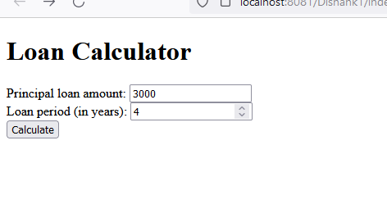

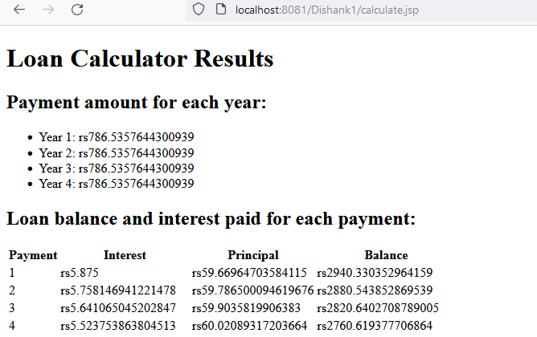

B.

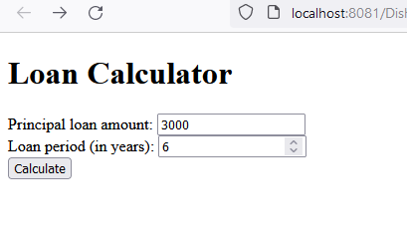

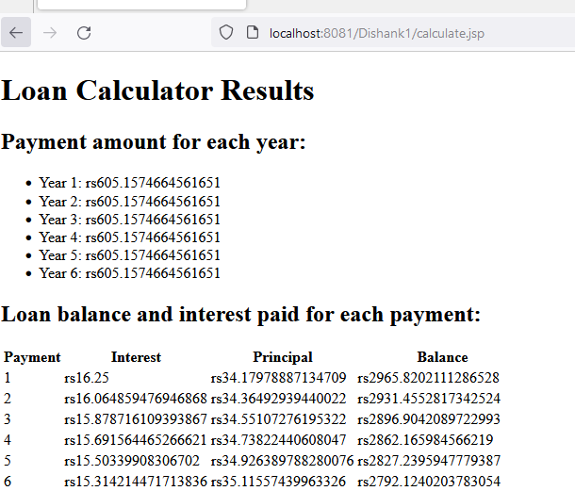

C,