A Project Report on

PROPERTY MANAGEMENT SYSTEM
By
Mani Mallik 19BD1A0447 ECE-A
Chinmayee 19BD1A0439 ECE-A
Akshaya Sai 19BD1A04A3 ECE-B
Suraj 19BD1A04B1 ECE-B

Under the esteemed guidance of
UMESH GOGTE
SHANKER M MACCHA
NARSIMHULU



KESHAV MEMORIAL INSTITUE OF TECHNOLOGY
Approved by AICTE, Affiliated to JNTUH
3-5-1206, Narayanguda, Hyderabad -500029
2021 – 2022

KESHAV MEMORIAL INSTITUTE OF TECHNOLOGY
Approved by AICTE, Affiliated to JNTUH
3-5-1206, Narayanguda, Hyderabad -500029



CERTIFICATE

This is to certify that the project entitled “KMIT SECOND HAND BOOK STORE” being submitted by Mr. Mani Mallik (19BD1A0447), Miss. Chinamyee (19BD1A0439),Mr. Suraj (19BD1A04B1), Miss. Akshaya Sai(19BD1A04A3) students of Keshav Memorial Institute of Technology, JNTUH in partial fulfilment of the requirements of the award of the Degree of Bachelor of Technology in Computer Science and Engineering as a specialization is a record of bonafide work carried out by them under my guidance and supervision in the academic year 2021 – 2022.

GUIDE
UMESHGOGTE
SHANKER M MACCHA
NARSIMHULU

Submitted for the Project Viva Voce examination held on …………….

EXTERNAL EXAMINER

DECLARATION

We hereby declare that the project report entitled “property management system” is done in the partial fulfillment for the award of the Degree of Bachelor of Technology in Computer Science and Engineering affiliated to Jawaharlal Nehru Technological University, Hyderabad. This project has not been submitted anywhere else.

ACKNOWLEDGMENT

We take this opportunity to thank all the people who have rendered their full support to our project work. We render our thanks to Dr. Maheshwar Dutta, B.E., M Tech., Ph.D., Principal who encouraged us to do the Project. We are grateful to Mr. Umesh Gogte, Director for facilitating all the amenities required for carrying out this project. We are also thankful to our guide Mr. Shanker, Mr. Narasimhulu for their valuable guidance and encouragement given to us throughout the project work. We would like to thank the entire ECE Department faculty, who helped us directly and indirectly in the completion of the project. We sincerely thank our friends and family for their constant motivation during the project work.
.
Mani Mallik 19BD1A0447 ECE-A
Chinmayee 19BD1A0439 ECE-A
Akshaya Sai 19BD1A04A3 ECE-B
Suraj 19BD1A04B1 ECE-B
-B

CONTENTS
DESCRIPTION
ABSTRACT
1.INTRODUCTION
1.1 Problem Statement
1.2 TECHNICAL Concepts associated with modules
2.FEASIBILITY STUDY
2.1Technical Feasibility
2.2 Operational Feasibility
2.3 Economical Feasibility
3.PROJECT REQUIREMENT SPECIFICATONS
3.1 System Implementation or System Design
3.1.1 Flow charts
3.1.2 Use Case Diagram
3.2HardwareRequirements
3.3 Software Requirements
3.4Implementationof DS (code snippets)
4.TEXT FILE DETAILS
5.C CODE
6.SYSTEM EVALUATION AND MAINTENANCE
7.FUTURE SCOPE
8.CONCLUSION

INTRODUCTION:
Property Management System is software that takes care of everything that a real estate company wants to do. Property Management System is developed for both buyers and sellers. It is very strong and easy to use that makes quick booking and selling. Property management system is a C data structure based project and you can access it from anywhere.
This ensures the service to the client 24X7. Clients can view and book their favourite property online just after entering few details. Admin/seller can sell the property just by providing the property details.
our project is mainly divided into two modules:
- Admin Module
- User Module
Functions of Admin module:
- Add Property
- Update Property
- Delete Property
- Access Booked User Details
- Access Booked Property Details
Functions of User module:
- Sign-up
- Sign-in
- Search Property using Unique ID
- Search property using multiple filters
- Buy Property
How it works?
A user/admin must first register himself/herself in order to use the application. For registration the user must provide his username, full name and mobile number. Once registered user can login and explore various events. The application can used by both user as well as admin. Based on the user credentials he will be directed to the respective functions

.

TECHNICAL CONCEPTS USED:
BINARY SEARCH TREE
● BINARY SEARCH TREE[BST] is a non linear data structure. It is an abstract Data Type(i.e. it gives an overview of the operations being performed without showing the working to the user).
● BST is the easiest method to search for elements that are already sorted .
● A BST contains 3 elements: A left Child pointer, Data element and a Right Child pointer.
● Data Elements lesser in value than the roots node are placed on the left side and greater than value root node on the right side .
● The very first node is called the head node .
● The binary search is used in the sign in /signup module .
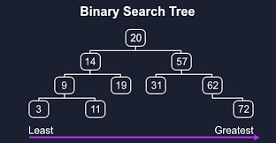

HASH TABLES
● Hash table is a linear data structure .hashing is a technique that is used to identify a specific object from a group of similar objects .
● It stores data in an associative manner , in an array format .
● Each Data element has its own unique index value.it distributes entries in (key/value)pairs.
● The inserting and searching of elements are very fast irrespective of the size of the data .
● Hashing converts a range of key values into a range of indexes.

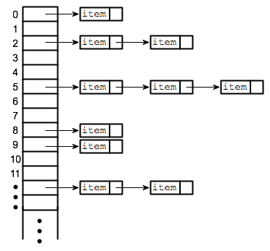

LINKED LISTS
● The data in linked lists are arranged in sequential manner, not necessarily in contiguous memory locations
● It contains two elements: ’data elements’ and a self-referential pointer called ‘link’.
● Traversal in a linked list is Uni -directional .
● Link pointers links all the individual nodes
● Linked lists are often used because of their efficiency in insertion and deletion
● They can be used to implement stacks ,queues, and other abstract data types

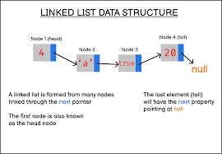

QUEUES:
● Queues are also linear data structures.
● They are also of abstract Data Type i.e it is defined by certain operations whose working is hidden from the user. Example: enqueue(),dequeue().
● A queue follows First In First Out[FIFO]Technique. ● A Queue has two ends :’front’ and Rear’
● The Deletion of data elements takes place from the front and the function is called Dequeue().
● The insertion of Data Elements takes place from the Rear end and the function is called Enqueue().

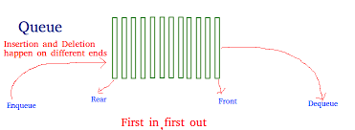

STACKS:
● Stacks are linear Data Structures .
● It is an abstract Data Type i.e. it is defined by certain operations whose working is hidden from the user. Example: Push() and Pop() ,isEmpty(), isFull() functions
● A stack uses last in first out[LIFO] technique to remove data from the heap.
● It uses the ‘Pop’ function to remove data from the stack .Pop functions are not applicable when the stack is empty.
● It uses the ‘push’ function to add data into the stack .Pop function is not applicable when the stack is full.

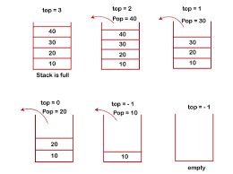

Implementation of technologies in the project.
- SIGNIN/SIGNUP: STRUCTURES, FILES
- ADDITION OF A NEW PROPERTY: HASHTABLES, LINKEDLIST, FILES, QUEUES
- UPDATION OF PROPERTY DETAILS: LINKEDLIST, FILES
- DELETION OF PROPERTY DETAILS: LINKEDLIST, FILES
- DISPLAYING RECORD OF AN USER: BINARY SEARCH TREE
- DISPLAYING PROPERTIES: HASHTABLE
- SEARCHING PROPERTY USING UNIQUE ID: LINKED LIST, FILES
- SEARCHING PROPERTY USING DIFFERENT FILTERS: LINKEDLIST, FILES
- DISPLAYING BOOKED USER DETAILS: FILES

PROBLEM STATEMENT:
- Property Management System (PMS) is software application that facilitates management of properties, personal properties etc.​
- PMS is introduced to replace the old-fashioned, paper-based methods that tended to be inefficient.​

Existing System:

- Before PMS was introduced, buying a property was a time taking process in which the documents were handled manually by both owner and customer. Here there were also agents/brokers who used to handle the dealings between customer and owner and was also getting paid commission fee.
Proposed System:

- C data structures facilitating admin to add, update and delete property details and access both booked user and property details. It helps user/buyer to search desired property from multiple properties using different filters such as Budget range, BHK, SFT, Address, Unique ID.
FEASIBILITY STUDY:
Feasibility study is a cross life cycle activity and should be continuously performed throughout a system project.

PROPERTY MANAGEMENT SYSTEM IS FEASIBLE DUE TO THE FOLLOWING REASONS:
- Property management is feasible because it will meet the user requirements
- This application can be implemented using the current technology.
- This application is compactable with other existing hardware and software.
TECHNICAL FEASIBILITY:
Technical feasibility study is an excellent tool for long term planning.Property management system is technical feasible due to following reasons:-
- It will be developed with c programming language as it is relevant,stable and also established.
OPERATIONAL FEASIBILITY:
- Operational feasibility is a measure of how well a proposed system solves the problems.
PROPERTY MANAGEMENT IS OPERATIONALLY FEASIBLE DUE TO FOLLOWING REASONS:
- Because the application will operate after it is developed and will be operative once it is installed.
- User can adopt it easily because it will increase the security of employer’s data.
ECONOMIC FEASIBILITY:
- It details the costs that will be incurred by the organization adopting the new system; considers development costs and running costs.

PROJECT REQUIREMENT SPECIFICATIONS:
Software Requirements
Platform: DEV C++
Database: FILES
Operation System: WINDOWS
Hardware Requirements:
Processor: Intel Core Duo 2.0 GHz or more
RAM: 2 GB or More
Hard disk: 80GB or more
Monitor: 15” CRT, or LCD monitor
Internet: Speed of 100Mbps or higher
Keyboard: Normal or Multimedia
Mouse: Compatible mouse

SYSTEM IMPLEMENTATION:
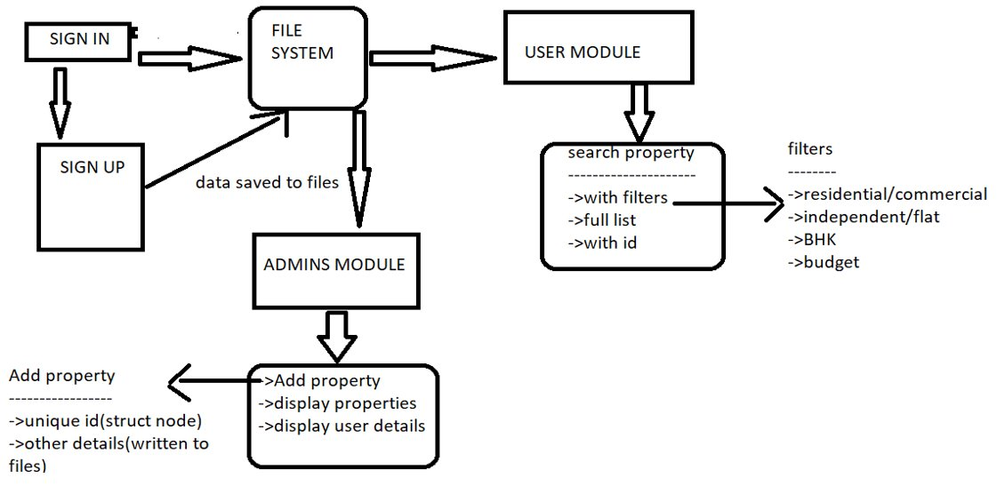

USE CASE DIAGRAM
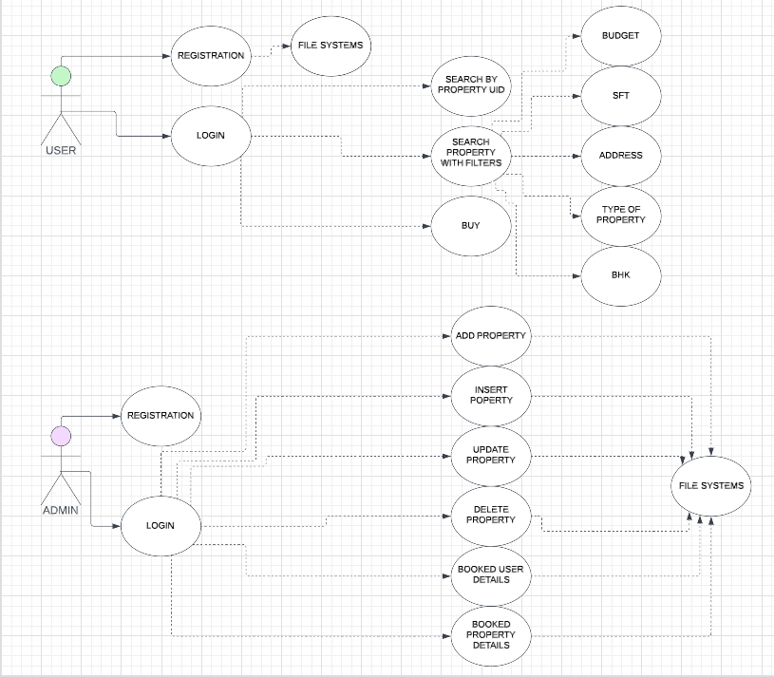

SOFTWARE DETAILS:
Platform : DEV C++
Database : TEXT FILES
Operation System : Windows 7, Windows 8 or 10 or 11
Hardware Requirements
Processor : I3/Intel Processor
RAM : 4GB (MIN)
Hard disk : 160GB
Monitor : 15” CRT, or LCD monitor
Internet : Minimum speed
Keyboard : Normal or

Multimedia Mouse : Compatible

TEXT FILES:
- bhk1.txt: To store details of BHK1 properties
- bhk2.txt: To store details of BHK2 properties
- bhk3.txt: To store details of BHK3 properties
- residential.txt: To store details of all residential properties
- comPlot.txt: To store details of commercial plot properties
- comShop.txt: To tore details of commercial shop properties
- commercial.txt: To store details of all commercial properties
- properties.txt: To store details of both residential and commercial properties
- usertrial.txt: To store user details like mobile no, password, username
bhk1.txt:
1 2500000 Moosarambagh 1500 Deepak 9515634784
2 560000 Ashok Nagar 1670 Rama 9456321078
3 12500000 Narayanguda 1900 Priyanka 8520741963
4 7800000 Himayathnagar 2050 Karthik 9654123078
bhk2.txt:
5 2500000 Banjara Hills 1200 Ram Krishna 841023697
6 560000 Ameerpet 2010 Arun 7410258963
7 12500000 Lakdikapul 1700 Venkat 9632587410
bhk3.txt:
8 2500000 Vidya Nagar 1500 Rajesh 8741025369
residential.txt:
1 2500000 Moosarambagh 1500 Deepak 9515634784
2 560000 Ashok Nagar 1670 Rama 9456321078
3 12500000 Narayanguda 1900 Priyanka 8520741963
4 7800000 Himayathnagar 2050 Karthik 9654123078
5 2500000 Banjara Hills 1200 Ram Krishna 841023697
6 560000 Ameerpet 2010 Arun 7410258963
7 12500000 Lakdikapul 1700 Venkat 9632587410
8 2500000 Vidya Nagar 1500 Rajesh 8741025369
comShop.txt:
18 118671 Kachiguda 1186 Sidhu 7841590236
20 3400000 Masab Tank 1567 Prakash 9510236874
complot.txt:
11 150000 Vanasthalipuram 780 Vennala 842697130
12 67000 Jubliee Hills 3456 Chinnu 9515634784
commercial.txt:
18 118671 Kachiguda 1186 Sidhu 7841590236
20 3400000 Masab Tank 1567 Prakash 9510236874
11 150000 Vanasthalipuram 780 Vennala 842697130
12 67000 Jubliee Hills 3456 Chinnu 9515634784
usertrial.txt:
pooja 9848140022 pooja hello
pavani 9177181315 pavanik hi
preetham 9700439168 sai sai12

Admin Module:
- addproperty()
- The addproperty() function is used to add property details into standalone application.
- To create a seamless environment for the users to search the property hashing and queues are used.

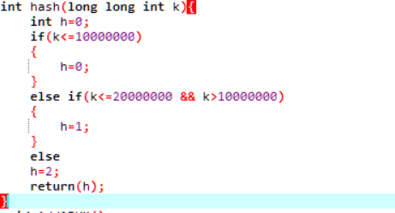
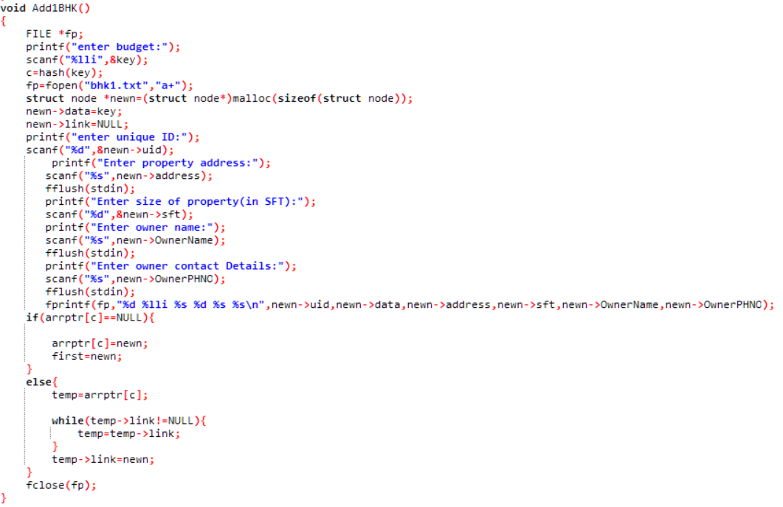

- updateproperty():
- This function is used to modify and kind of details related to property like updating budget, bhk etc.
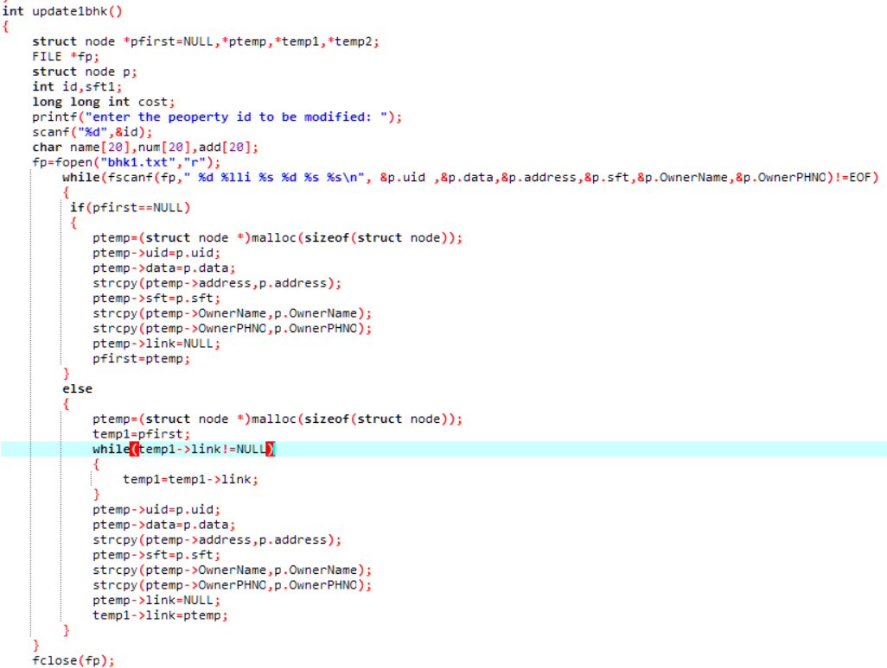
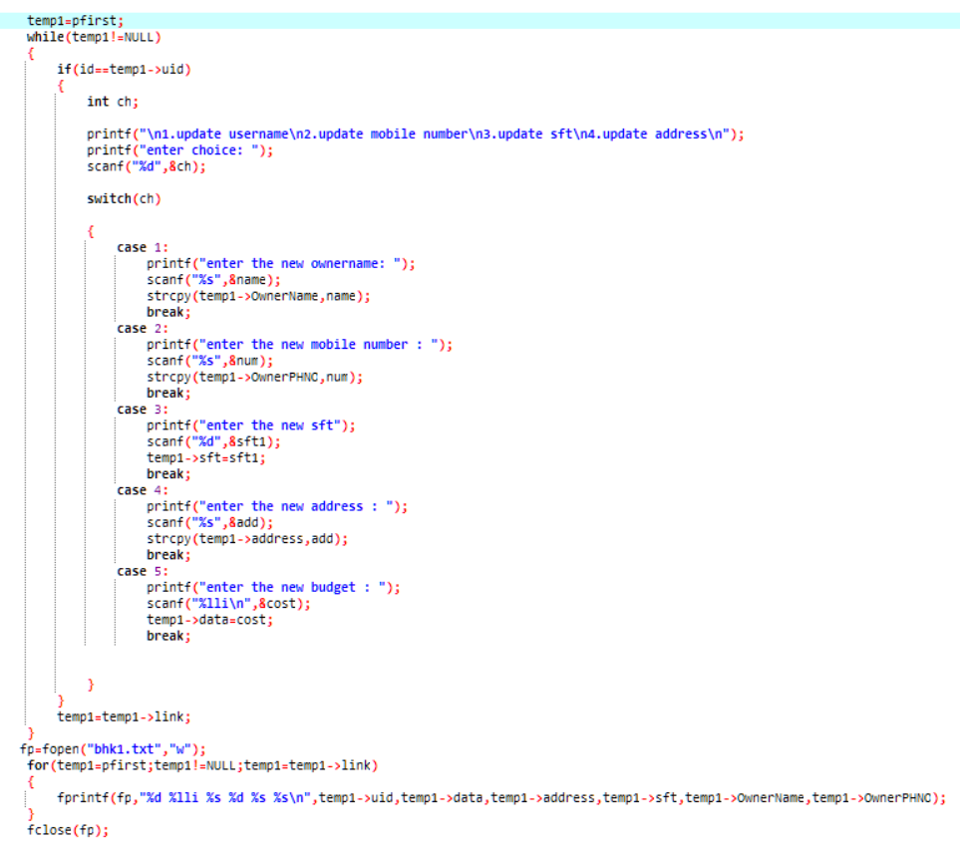

- deleteproperty():
- This function is used to delete property from the application
- the main technology used are file handling and linkedlist.

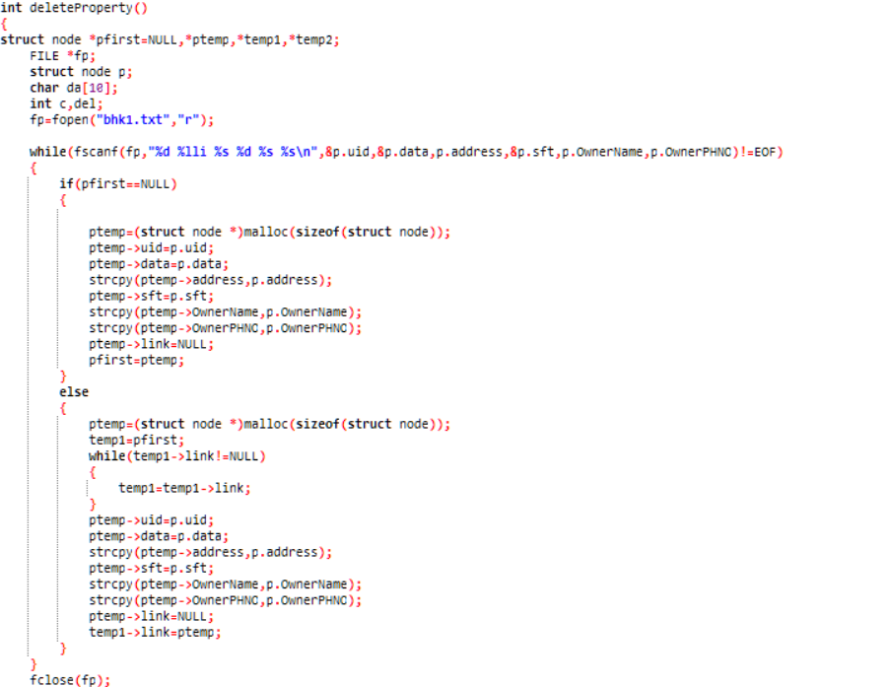
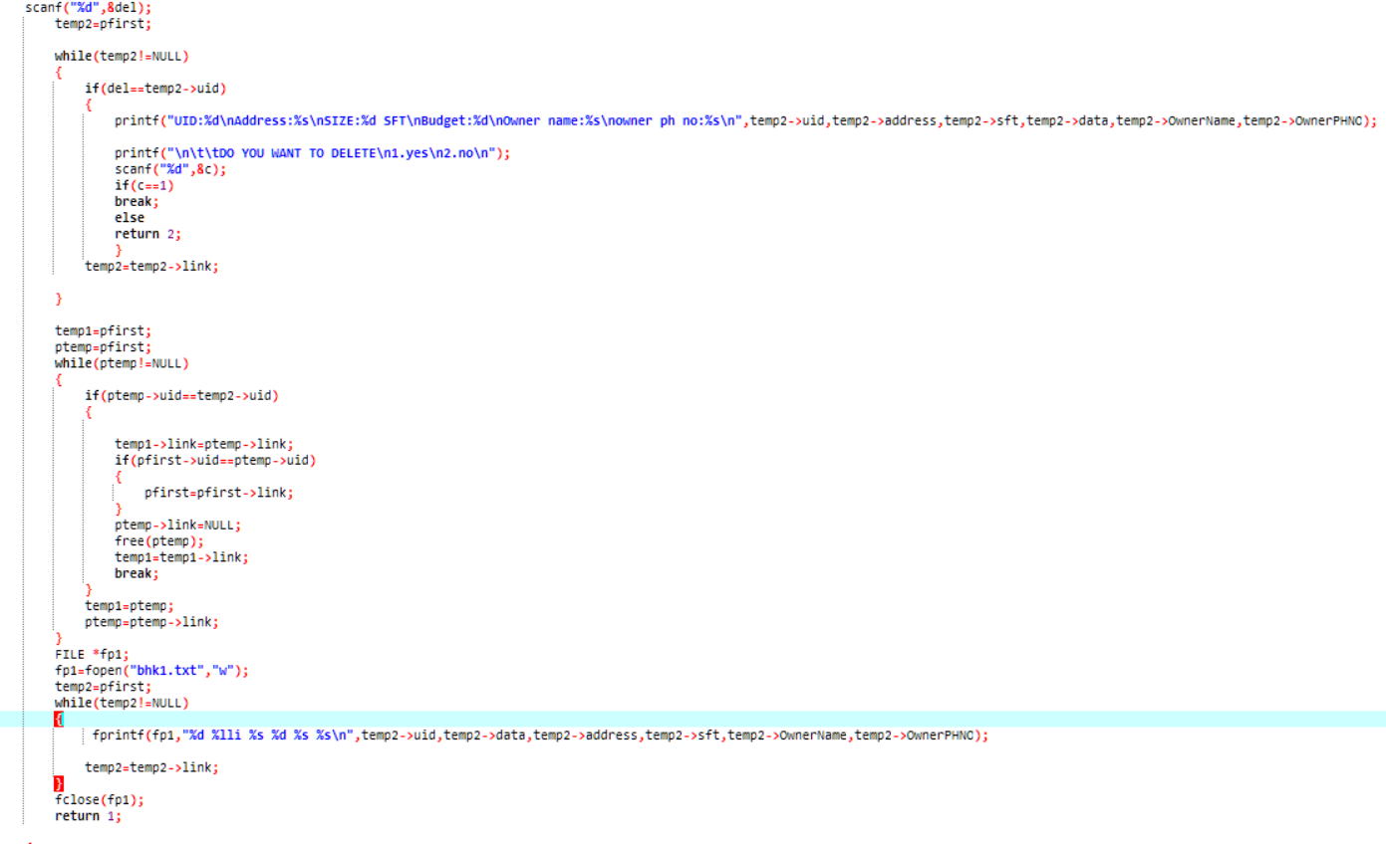

- displayproperty():
- The display function facilitates the admin to always have an overview of all the properties listed in the application
- Main technology used is hash table.
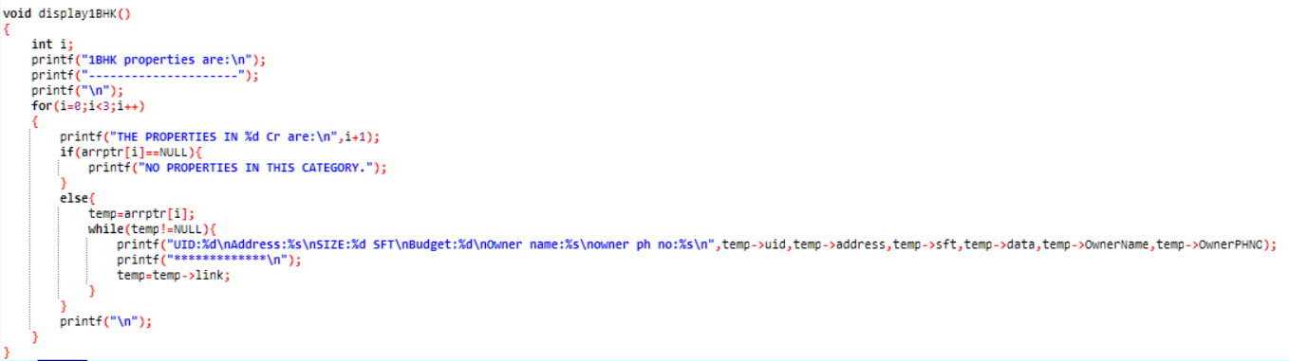
User Module:
- In user module, the registered user can have the access to view all the property details and also can search from variety of options.
- Functions used in user module are:
  - Signin & Signup
  - Search property
  - Book property

signup():
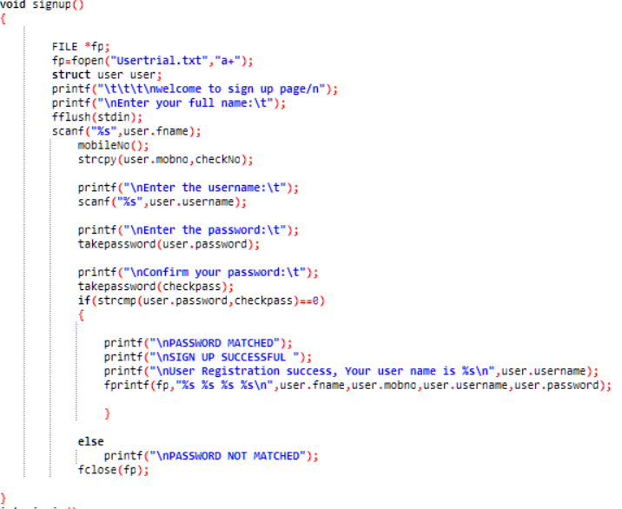

signin():
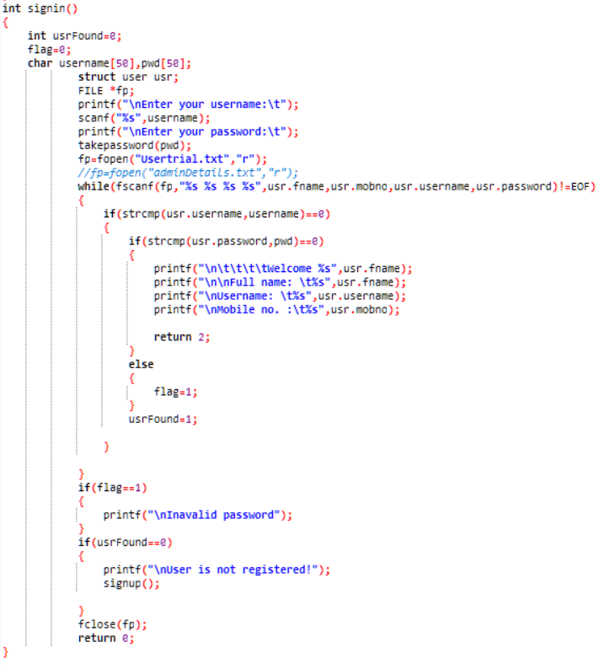

searchproperty():
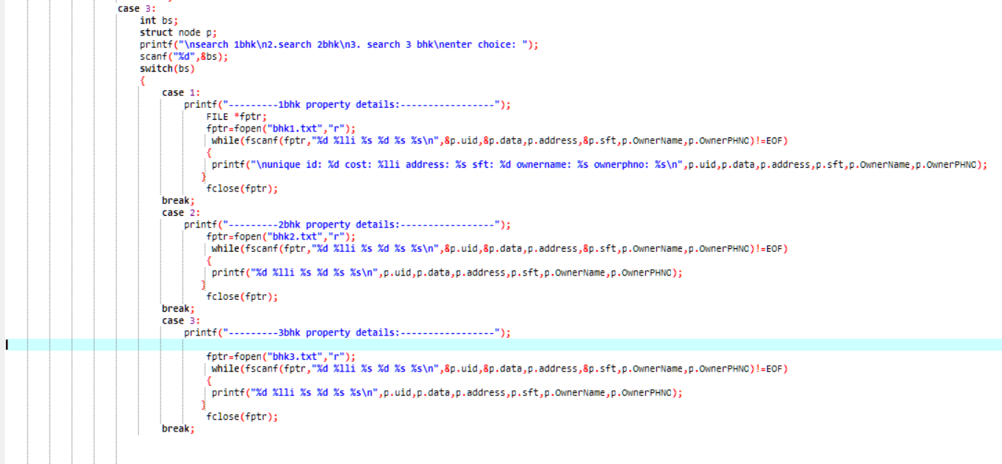
bookproperty():
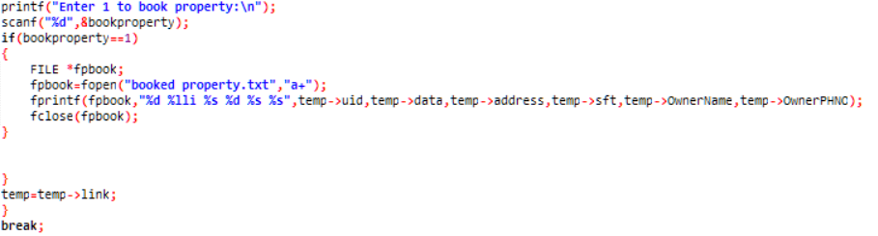

6.SYSTEM EVALUATION AND MAINTENANCE
Black Box Testing:Black box testing is a method of software testing that examines the functionality of an application without peering into its internal structures or workings.
Black box mainly focuses on input and output of software applications and it is entirely based on software requirements and specifications. It is also known as behavioural Testing.
The test procedure of black box testing is a kind of process in which the tester has specific knowledge about the software's work, and it develops test cases to check the accuracy of the software's functionality. The test team reports the result to the development team and then tests the next function. After completing testing of all functions if there are severe problems, then it is given back to the development team for correction.
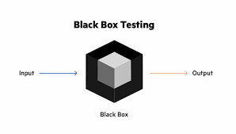
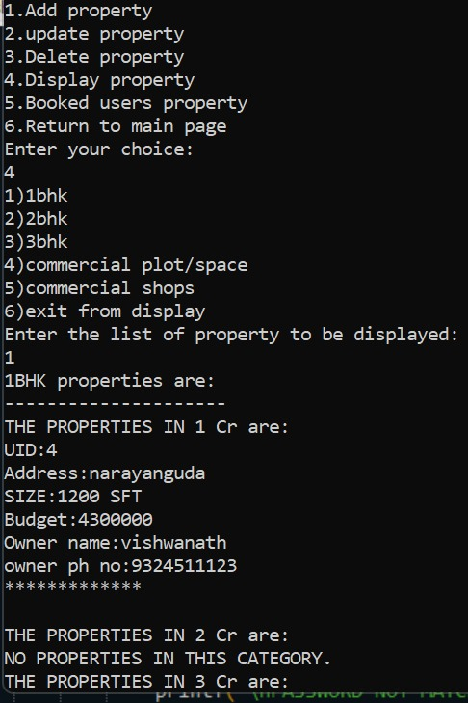

Future Scope:
As per the user requirement our whole project is designed. We can add an additional constraint to our project. We will also try to make payment option available in our project. This can be used for other commercial purpose, one of them is business relationship with comprehensive online services like transport, banking etc.
COMPARISION OF PROPERTIES:
We provide an option to compare different properties which will be useful for user to select property according to his desire and buy the best property.
comparison can be done between different properties using all the parameters. we can provide comparison in such a way user can select from two same type of properties and go for comparision

Conclusion of Property Management System:
Finally, in the Online property management system, we have developed a secure, user-friendly Property Management System. This system is capable of taking care of each work that needs to be done in the real estate business. The client can log in using a user id and password. This means the unauthorized user cannot enter into the system making it secure. Searching for property help to find their desire property fast.This system would definitely go to reduce labor and make business more profitable and promising to clients.

