UNIT - V
1. Basic searching in an array of elements (linear and binary search techniques).
Searching:
1. Another common operation in computer science is searching, which is the process used to find
the location of a target among a list of objects.
2. In the case of an array, searching means that given a value, we want to find the location
(index) of the first element in the array that contains that value.

Types of Search Algorithms:
Linear Search, Binary Search, Tree Search, Genetic Algorithm.

Linear Search (OR) Sequential Search:
- It is used to find whether a given number is present in an array and if it is present then at what location it occurs.
- It is also known as sequential search.
- It is straightforward and works as follows: We keep on comparing each element with the element to search until it is found or the list ends. Linear search in C language is using function.
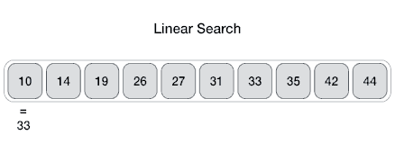

Write a C program that uses non recursive function to search for a Key value in a given list of integers. Use linear search method.

SOURCE CODE:

#include<stdio.h>
#include<conio.h>
int lsearch(int a[],int,int);
int main()
{
int i,j,a[100],key,n;
printf("Number of elements in the array\n");
scanf("%d",&n);
printf("\n Enter %d elements\n",n);
for(i=0;i<n;i++)
scanf("%d",&a[i]);
printf("Element to be searched\n");
scanf("%d",&key);
lsearch(a,n,key);
getch();
}
int lsearch(int a[],int n,int key)
{
int flag=0,i;
for(i=0;i<n;i++)
if(key= =a[i])
{
flag=1;
break;
}
if(flag= = 0)
printf("key value not found");
else
printf("key value found at %d index",i);
}

Binary Search:

- Binary search is a fast search algorithm with run-time complexity of Ο(log n).
- This search algorithm works on the principle of divide and conquers.
- For this algorithm to work properly, the data collection should be in the sorted form.
- Binary search looks for a particular item by comparing the middle most item of the collection.
- If a match occurs, then the index of item is returned.
- If the middle item is greater than the item, then the item is searched in the sub-array to the left of the middle item.
- Otherwise, the item is searched for in the sub-array to the right of the middle item.
- This process continues on the sub-array as well until the size of the sub array reduces to zero.

How Binary Search Works?
The following is our sorted array and let us assume that we need to search the location of value 31 using binary search.

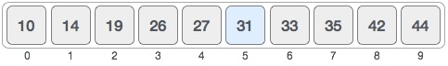
First, we shall determine half of the array by using this formula −
mid = low + (high - low) / 2

Here it is, 0 + (9 - 0 ) / 2 = 4 (integer value of 4.5). So, 4 is the mid of the array.
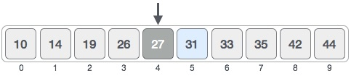
Now we compare the value stored at location 4, with the value being searched, i.e. 31. We find that the value at location 4 is 27, which is not a match. As the value is greater than 27 and we have a sorted array, so we also know that the target value must be in the upper portion of the array.
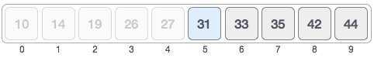
We change our low to mid + 1 and find the new mid value again.
low = mid + 1
mid = low + (high - low) / 2
Our new mid is 7 now. We compare the value stored at location 7 with our target value 31.
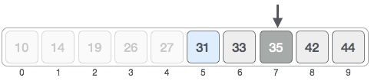
The value stored at location 7 is not a match, rather it is more than what we are looking for. So, the value must be in the lower part from this location.
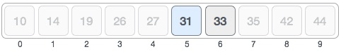
Hence, we calculate the mid again. This time it is 5.

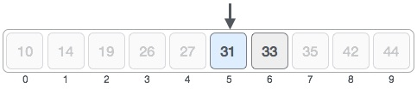
We compare the value stored at location 5 with our target value. We find that it is a match.

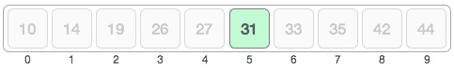
We conclude that the target value 31 is stored at location 5.

Write a C program that uses non recursive function to search for a Key value in a given sorted list of integers. Use binary search method.

SOURCE CODE:

#include<stdio.h>
#include<conio.h>
int bsearch(int a[],int,int);
int main()
{
int i,a[100],key,n;
printf("Enter Number of elements in the array:");
scanf("%d",&n);
printf("\n Enter %d elements in sorted order\n",n);
for(i=0;i<n;i++)
scanf("%d",&a[i]);
printf("Element to be searched\n");
scanf("%d",&key);
bsearch(a,n,key);
getch();
}

int bsearch(int a[],int n,int key)
{
int flag=0,low=0,mid,high=n-1;
while(low<=high)
{
mid=(low+high)/2;
if(key==a[mid])
{
flag=1;
break;
}
else if(key<a[mid])
high=mid-1;
else if(key>a[mid])
low=mid+1;
}
if(flag==0)
printf("key value not found");
else
printf("key value found at %d index",mid);
}

Difference between linear search and binary search:

BASIS FOR COMPARISON | LINEAR SEARCH | BINARY SEARCH
Time Complexity | O(N) | O(log 2 N)
Best case time | First Element O(1) | Center Element O(1)
Prerequisite for an array | No required | Array must be in sorted order
Worst case for N number of elements | N comparisons are required | Can conclude after only log2N comparisons
Can be implemented on | Array and Linked list | Cannot be directly implemented on linked list
Insert operation | Easily inserted at the end of list | Require processing to insert at its proper place to maintain a sorted list.
Algorithm type | Iterative in nature | Divide and conquer in nature
Usefulness | Easy to use and no need for any ordered elements. | Anyhow tricky algorithm and elements should be organized in order.
Lines of Code | Less | More

Basic algorithms to sort array of elements (Bubble, Insertion and Selection sort algorithms):

Sorting:
- One of the most common applications in computer science is sorting—the process through which data is arranged according to their values.
- We are surrounded by data. If the data are not ordered, we would spend hours trying to find a single piece of information.
- Sorting can be done on names, numbers and records.
- For example, it is relatively easy to look up the phone number of a friend from a telephone dictionary because the names in the phone book have been sorted into alphabetical order.

Sorting can be performed using several methods, they are:
Insertion sort, Quick Sort, Radix Sort, Heap Sort, Selection sort, Bubble sort, Merge sort.

Bubble Sort Algorithm:

- Bubble sort algorithm starts by comparing the first two elements of an array and swapping if necessary, i.e., if you want to sort the elements of array in ascending order and if the first element is greater than second then, you need to swap the elements but, if the first element is smaller than second, you mustn't swap the element.
- Then, again second and third elements are compared and swapped if it is necessary and this process go on until last and second last element is compared and swapped.
- This completes the first step of bubble sort.
- If there are n elements to be sorted then, the process mentioned above should be repeated n-1 times to get required result.
- But, for better performance, in second step, last and second last elements are not compared because, the proper element is automatically placed at last after first step.
- Similarly, in third step, last and second last and second last and third last elements are not compared and so on.
Example: A figure is worth a thousand words so, acknowledge this figure for
better understanding of bubble sort.
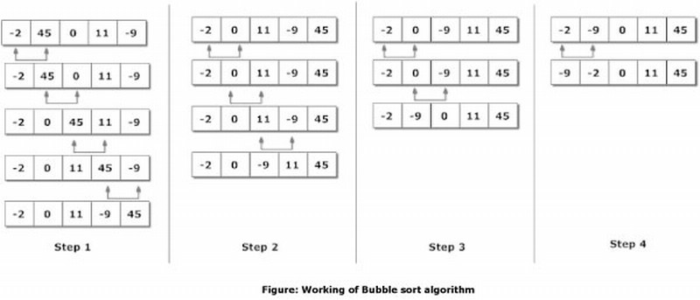
Here, there are 5 elements to the sorted. So, there are 4 steps.
Write a C program that implements the Bubble sort method to sort a given list of integers in ascending order.

SOURCE CODE:
#include <stdio.h>
int main()
{
int array[100], n, c, d, swap;
printf("Enter number of elements\n");
scanf("%d", &n);
printf("Enter %d integers\n", n);

for (c = 0; c < n; c++)
{
scanf("%d", &array[c]);
}

for (c = 0 ; c < ( n - 1 ); c++)
{
for (d = 0 ; d < n - c - 1; d++)
{
if (array[d] > array[d+1]) /* For decreasing order use < */
{
swap = array[d];
array[d] = array[d+1];
array[d+1] = swap;
}
}
}

printf("Sorted list in ascending order:\n");
for ( c = 0 ; c < n ; c++ )
{
printf("%d\n", array[c]);
}
return 0;
}

Insertion sort algorithm :
Insertion sort algorithm picks elements one by one and places it to the right position where it belongs in the sorted list of elements.
It is much less efficient on large lists than more advanced algorithms such as Quick sort, heap sort, or Merge sort i.e., This algorithm is not suitable for large data sets as its average and worst case complexity are of Ο(n2), where n is the number of items.

However, insertion sort provides several advantages:
- Simple implementation
- Efficient for (quite) small data sets
- Adaptive (i.e., efficient) for data sets that are already substantially sorted: the
time complexity is O(n + d), where d is the number of inversions
- More efficient in practice than most other simple quadratic (i.e., O(n2))
algorithms such as selection sort or bubble sort; the best case (nearly sorted input)
is O(n)
- Stable; i.e., does not change the relative order of elements with equal keys
- In-place; i.e., only requires a constant amount O(1) of additional memory space
- Online; i.e., can sort a list as it receives it.

How Insertion Sort Works?
We take an unsorted array for our example.
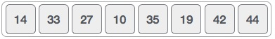
Insertion sort compares the first two elements.
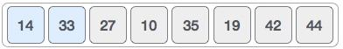
It finds that both 14 and 33 are already in ascending order. For now, 14 is in sorted sub-list.
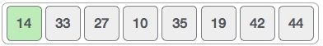
Insertion sort moves ahead and compares 33 with 27.
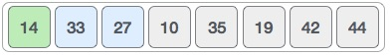
And finds that 33 is not in the correct position.
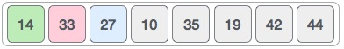
It swaps 33 with 27. It also checks with all the elements of sorted sub-list. Here we see that the sorted sub-list has only one element 14, and 27 is greater than 14. Hence, the sorted sub-list remains sorted after swapping.
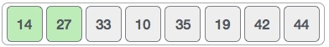
By now we have 14 and 27 in the sorted sub-list. Next, it compares 33 with 10.
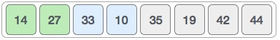
These values are not in a sorted order.
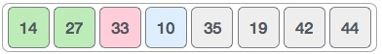
So we swap them.
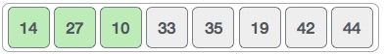
However, swapping makes 27 and 10 unsorted.
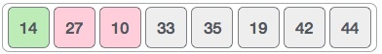
Hence, we swap them too.
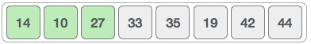
Again we find 14 and 10 in an unsorted order.
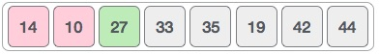
We swap them again. By the end of third iteration, we have a sorted sub-list of 4 items.
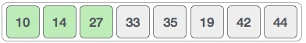
This process goes on until all the unsorted values are covered in a sorted sub-list.

Example program on Insertion Sort:
#include<stdio.h>
void sort(int arr[],int n); //Function Prototype

void main()
{
int arr[20],i,n,j,k;

printf("\nEnter the number of elements in the array : ");
scanf("%d",&n);

printf("\nEnter the elements of the array");
for(i=0 ; i < n ; i++)
{
printf("\n arr[%d] = ",i);
scanf("%d",&arr[i]);
}

sort(arr,n);

printf("\nThe sorted array is: \n");
for(i=0;i<n;i++)
printf("%d\t",arr[i]);
}

void sort(int arr[],int n)
{
int k,j,temp;
for(k=1 ; k < n ; k++)
{
temp=arr[k];
j=k-1;
while((temp < arr[j]) && (j>=0))
{
arr[j+1]=arr[j];
j--;
}
arr[j+1]=temp;
}
}

RESULT:
INPUT:
Enter the number of elements in the array : 8
Enter the elements of the array
arr[0] = 6
arr[1] = 45
arr[2] = 109
arr[3] = 87
arr[4] = 34
arr[5] = 11
arr[6] = 631
arr[7] = 81

OUTPUT:
The sorted array is:
6 11 34 45 81 87 109 631

Selection sort algorithm :
A Selection Sort is a Sorting algorithm which finds the smallest element in the array and swaps with the first element then with the second element and continues until the entire array is sorted.
This algorithm is not suitable for large data sets as its average and worst case complexities are of Ο(n2), where n is the number of items.

How Selection Sort Works?
Consider the following depicted array as an example.
For the first position in the sorted list, the whole list is scanned sequentially. The first position where 14 is stored presently, we search the whole list and find that 10 is the lowest value.
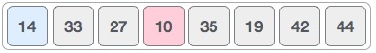
So we replace 14 with 10. After one iteration 10, which happens to be the minimum value in the list, appears in the first position of the sorted list.
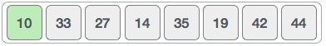
For the second position, where 33 is residing, we start scanning the rest of the list in a linear manner.
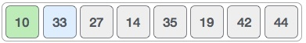
We find that 14 is the second lowest value in the list and it should appear at the second place. We swap these values.
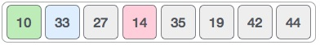
After two iterations, two least values are positioned at the beginning in a sorted manner.
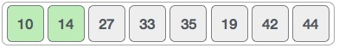
The same process is applied to the rest of the items in the array.
Following is a pictorial depiction of the entire sorting process −
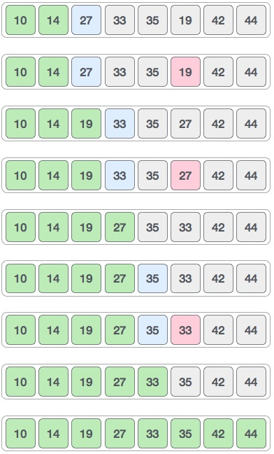
Example program on Selection Sort:
#include<stdio.h>
void main()
{
int a[100],n,i,j,min,temp;
printf("\n Enter the Number of Elements: ");
scanf("%d",&n);
printf("\n Enter %d Elements: ",n);
for(i=0;i<n;i++)
{
scanf("%d",&a[i]);
}
for(i=0;i<n-1;i++)
{
min=i;
for(j=i+1;j<n;j++)
{
if(a[min]>a[j])
min=j;
}

if(min!=i)
{
temp=a[i];
a[i]=a[min];
a[min]=temp;
}
}
printf("\n The Sorted array in ascending order: ");
for(i=0;i<n;i++)
{
printf("%d ",a[i]);
}
}

RESULT:

INPUT:
Enter the Number of Elements: 5
Enter 5 Elements: 4 1 9 3 6

OUTPUT:
The Sorted array in ascending order: 1 3 4 6 9

