

COLLEGE OF SCIENCE AND TECHNOLOGY

COMPUTING TECHNOLOGY DEPARTMENT

CTE207 Artificial Intelligence
Lecturer: Manoj Chhetri

Assignment Number: 1
Programming Assignment: Graph Traversal Algorithms

Date: 4 April 2026

NAME: SURAJ GHALLEY
INDEX: 02240179
Analysis:

For the data given below, elements were not found in all the traversal to compute worst case
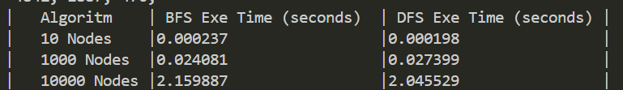

- How does execution time change as the number of nodes increases for each algorithm?
Ans:
As the number of nodes increases, execution time for both BFS and DFS rises significantly. This is expected because larger graphs contain more vertices and edges to traverse.

- Which algorithm was faster on large graphs, and why do you think that is?
Ans:
On large graphs, DFS is slightly faster than BFS. The main reason is structural overhead. BFS uses a queue and processes nodes level by level, which often leads to exploring many nodes before terminating especially when the goal does not exist (the worst case). DFS, using a stack, dives deep along a path and may terminate earlier in some cases. Additionally, BFS stores more number of nodes in its queue at once, increasing overhead.

- What is the theoretical time complexity of BFS and DFS, and does your data support it?
Ans:
The time complexity of both BFS and DFS is O(V + E), where V is the number of vertices and E is the number of edges. In our case, since each node has a bounded number of edges (2–5), E ≈ kV, making the complexity effectively O(V).
Asper my above data table execution time increases proportionally with node count, without exponential growth. Minor difference between BFS and DFS are due to constant factors such as data structure operations and the order in which nodes are explored.

