Cortex Analytics — Website Change Requests
Consolidated list of edits by page/section

1. Homepage Changes
1.1 Eyebrow text
Current: "A software company for complex business operations"
Change to: "A technology studio for businesses built to move fast"
1.2 H1
Current: "Building Intelligent Platforms for Healthcare, Diagnostics, Manufacturing & Commerce"
Change to: "Engineering the Systems Behind Ambitious Businesses"
1.3 Sub-headline
Current: "Cortex Analytics builds scalable software that replaces fragmented workflows with connected operations that are easier to manage, measure, and grow."
Change to: "We design and build the systems that sit at the center of a business — software engineered with the precision to scale and the range to adapt."
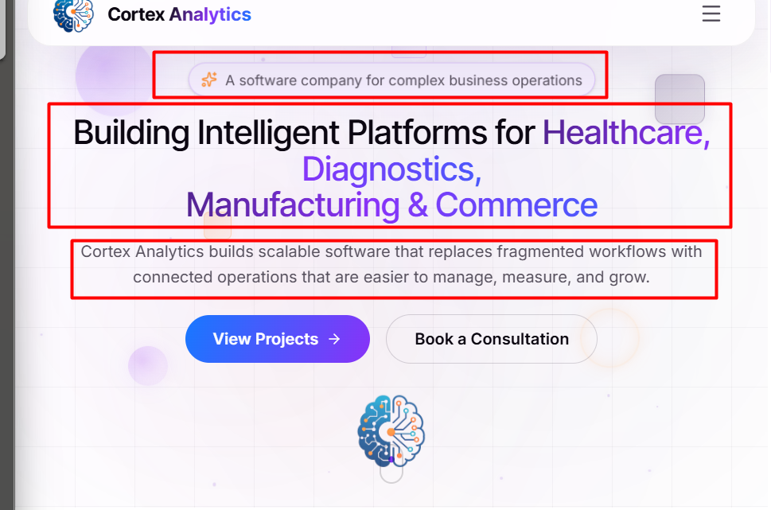
1.4 CTA buttons — remove both the buttons and the logo
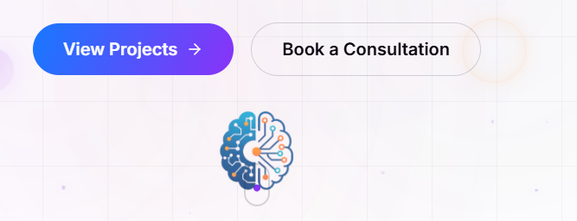
1.5 Client Story
Change heading from "Client story" to "Featured Client Stories".
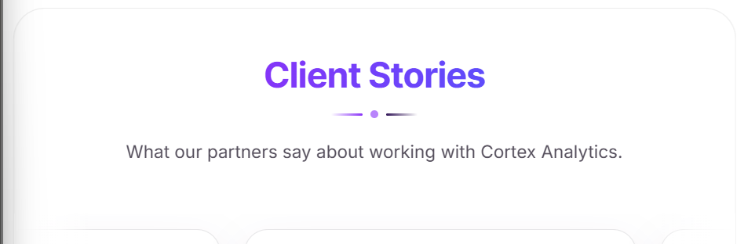
- Don't make them move — instead give side buttons to scroll, as there are only 4 stories.
- In place of the name "Operation Director," remove it and write "Siddharth Sharma."
- Also add Mr. and Ms. Infront of every name and full name is to be displayed.
- Write Mr. Atharv Srivastava instead of Atharv
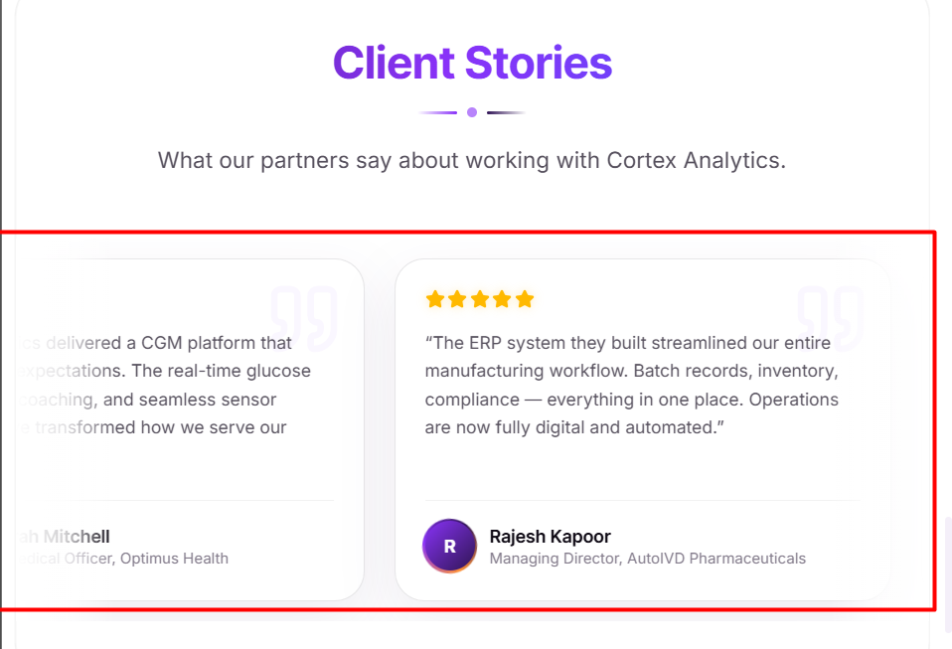

1.6 Remove the "get in touch" button in the top menu buttons

1.7 Remove this in the footer section

1.8 Remove this "what we build" section completely from the home page
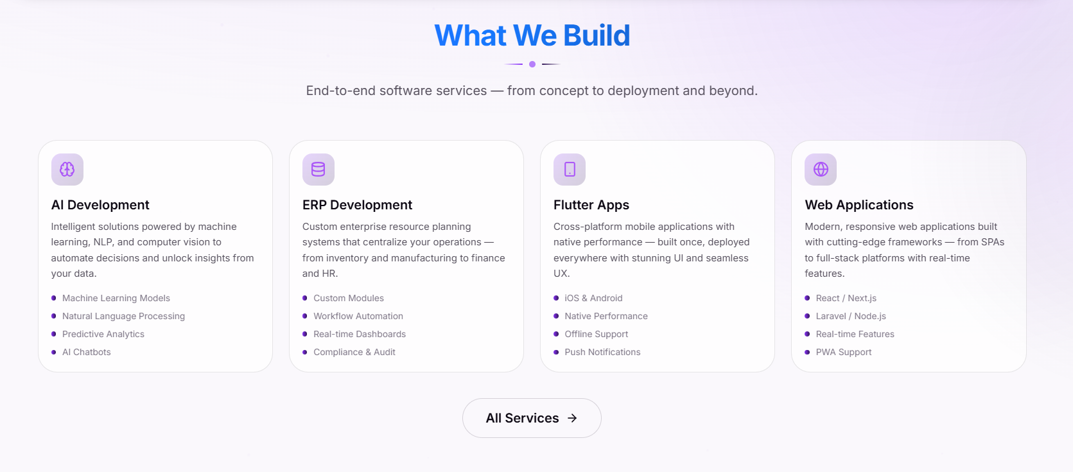

2. About
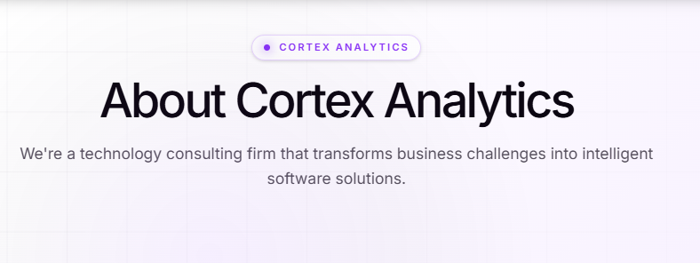
2.1 Heading
Current: "About Cortex Analytics"
Change to: "About Company"
2.2 Sub-heading
Current: "We're a technology consulting firm that transforms business challenges into intelligent software solutions."
Change to: "Engineering the Systems Behind Ambitious Businesses"
2.3 Body copy
Current: "Founded with the vision of bridging the gap between cutting-edge technology and real-world business needs, Cortex Analytics specializes in building AI-powered applications, enterprise resource planning systems, cross-platform mobile apps, and modern web platforms. Our tagline — Insight. Innovation. Impact. — reflects our commitment to delivering solutions that are not just technically excellent, but strategically impactful."
Change to: "We started with one belief: the right software can make anything run better. Cortex Analytics builds the systems businesses run on — AI applications, ERP platforms, mobile apps, and web experiences — engineered with precision and built to scale. Our tagline, Insight. Innovation. Impact., is the standard we hold every build to: technically excellent, strategically impactful."
2.4 Remove this from the heading placard and from all the tabs — services, projects, contacts

2.5 Replace content on our values with below content and make it in right to left auto scroll format .
- Precision
Every solution begins with disciplined engineering. We obsess over the details to build software that is accurate, reliable, and performs flawlessly under real-world demands.
- Innovation
We combine proven engineering principles with emerging technologies to create intelligent solutions that solve today's challenges while preparing businesses for tomorrow.
- Ownership
We take responsibility beyond delivery. Every project is approached with accountability, transparency, and a commitment to achieving meaningful business outcomes.
- Endurance
We build with the future in mind. Our systems are designed to scale, adapt, and deliver lasting value as businesses evolve and grow.

2.6 Add Founder Story section on the about tab before what we build widget and below is the content
Over the years, I noticed a pattern across businesses of every size. Teams weren't struggling because they lacked ambition—they were struggling because the systems they depended on weren't built to support it.
Processes were fragmented. Data was scattered. Decisions were slower than they needed to be. Technology had become something businesses worked around instead of something that worked for them.
That realization led to the creation of Cortex Analytics.
I wanted to build a company where engineering came first—where every solution was designed with precision, built to scale, and focused on solving real business problems rather than adding unnecessary complexity.
Today, that philosophy remains unchanged. Every ERP platform, AI solution, mobile application, and web platform we build is driven by one goal: helping businesses operate smarter, move faster, and grow with confidence.
Because great software isn't defined by the number of features it has. It's defined by the impact it creates.
- Founder Cortex Analytics
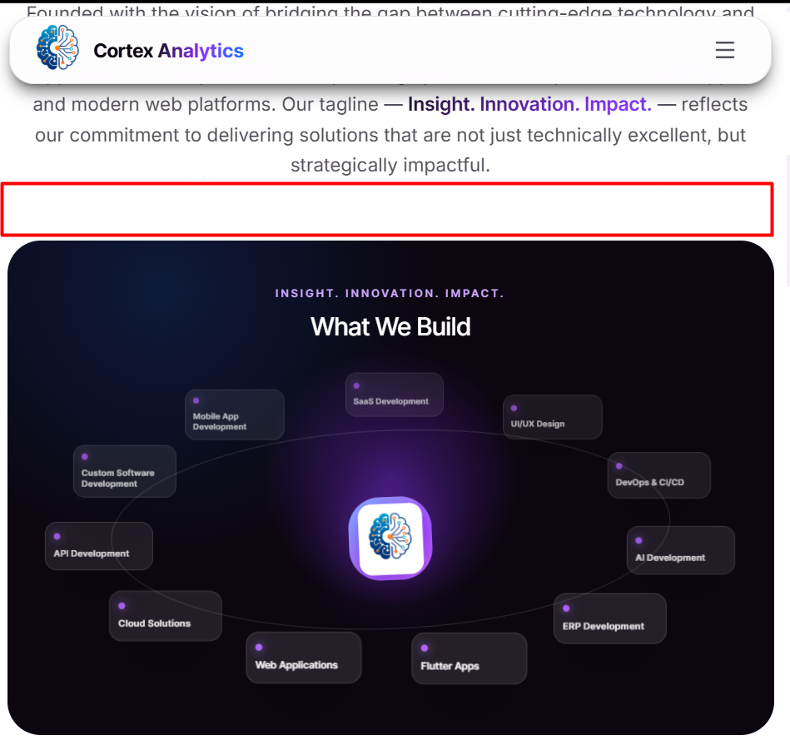
Added in the red-highlighted section
2.7 Reduce the size of Our Technology Stack by adding more items on each row on both side empty space
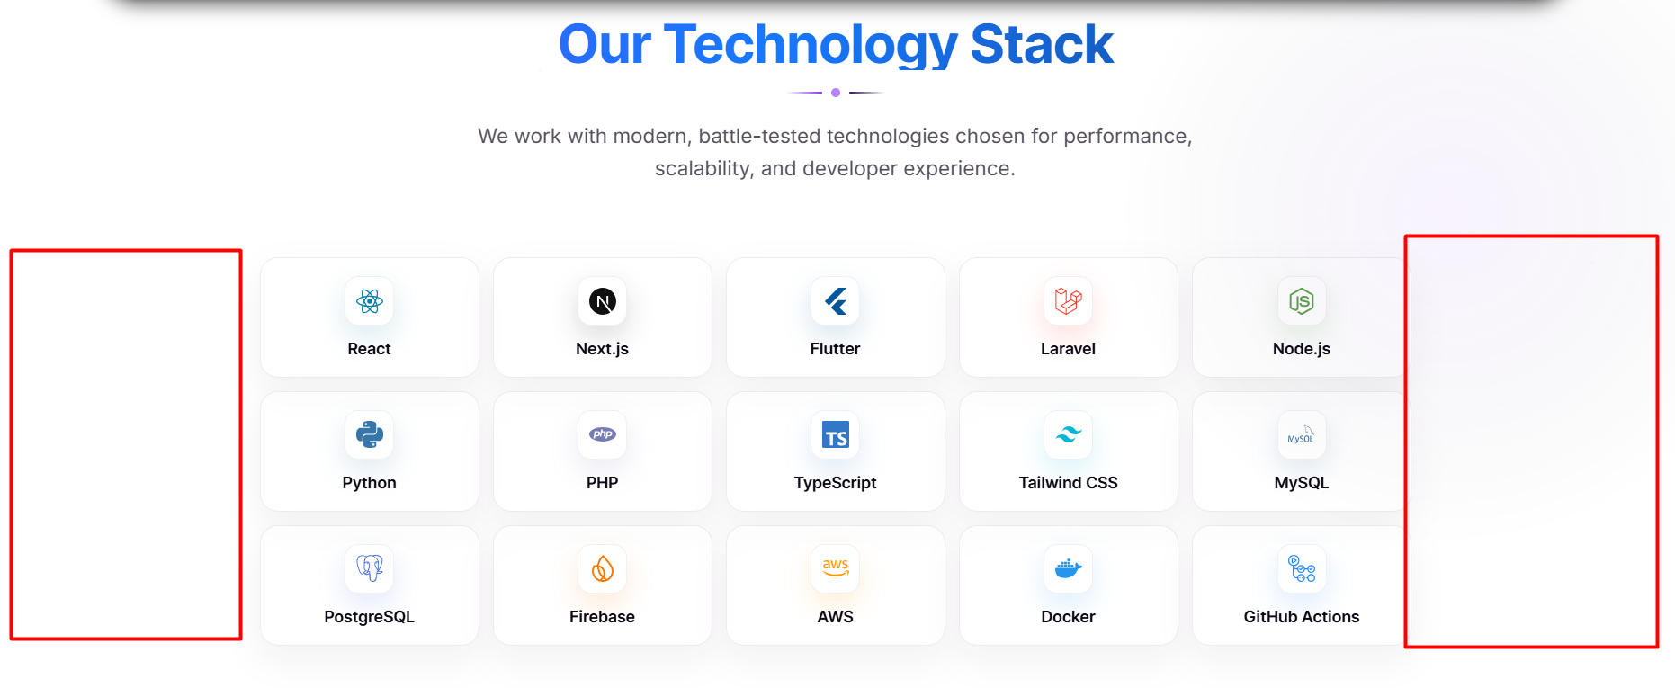

3. Services
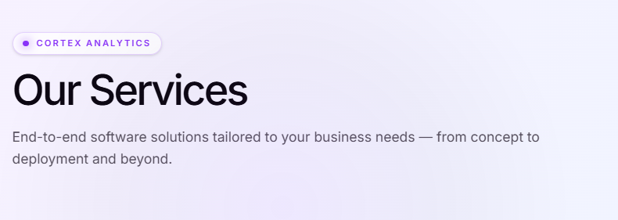
3.1 Body copy
Current: "End-to-end software solutions tailored to your business needs — from concept to deployment and beyond."
Change to: "When a challenge doesn't fit a category, we build the category. Integrations, automation, and emerging technology — engineered with the same discipline as everything else we ship."

4. Projects
4.1 Remove these 2
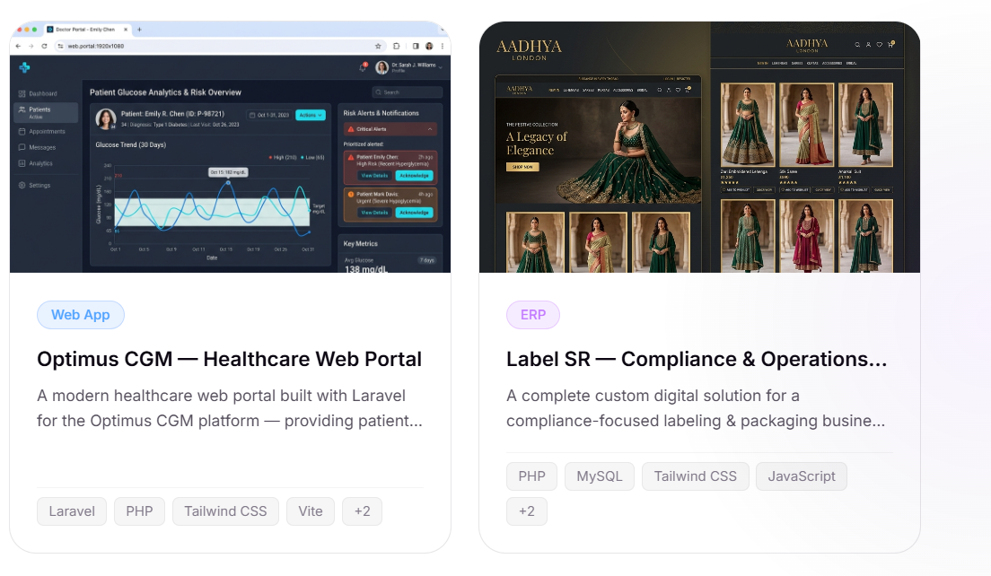
4.2 Current — image is blurry

Change to — below image


5. Review from menu button remove
Remove the review page altogether — only keep the featured client story on the home page.

6. General Fixes

6. Heading placard styling (all tabs)
All the heading placards on all the tabs should follow the colour, theme, and structure of the image below and reduce the width of the heading placards.
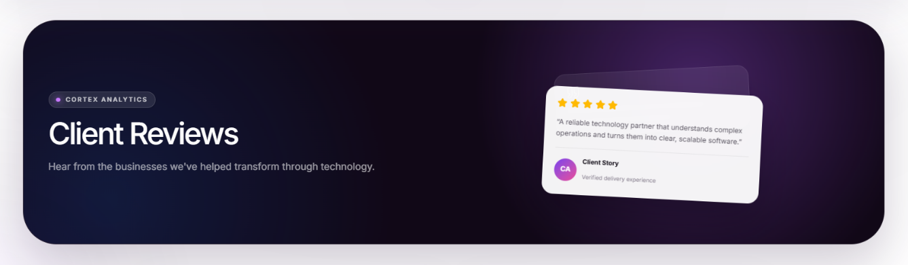

7. About section — cut-off text
In the About section, "gy" in "technology" is cut off below. Correct it.


8. Services tab — placard sizing
In the Services tab, the placards are not of the same dimensions. Please make them uniform.
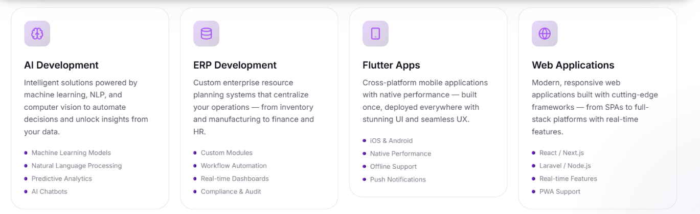

9. Contact — email update
In Contact, please write the email
Email: contactcortexanalytics@gmail.com
Phone: 8810927291
Location: Lucknow & Pune

10. Remove the red-highlighted section from the footer
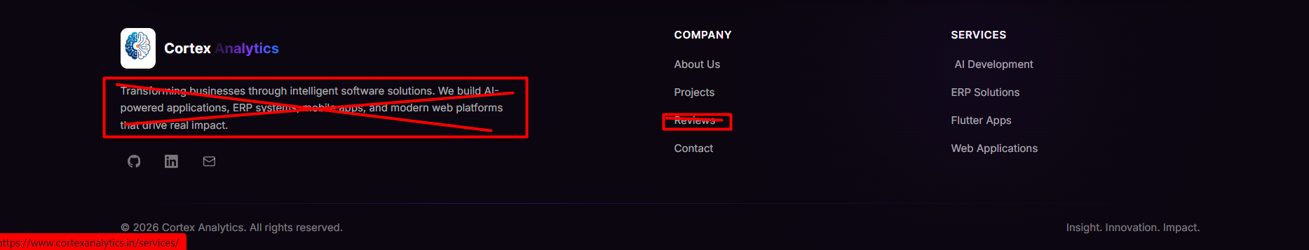

11. In the below highlighted section, add the icon below and clicking on that will open the following information.
- GitHub – Remove this icon
- LinkedIn – Add the attached link that will redirect to the LinkedIn page (https://www.linkedin.com/company/cortex-analytics-solutions/ )
- Email – contactcortexanalytics@gmail.com
- WhatsApp - 8810927291


12. Most Important Enhancement required in Projects
Add more projects here if possible, based on our company work; no need to disclose names, but to show multiple sectors or projects we have done.
Pravin & Suraj, please add your projects wherever possible to make this more attractive. Rest assured, as more institutions are added, we will keep this updated.


