1. **KPI**

select round(sum(sales),1) as Sales, sum(`Quantity`) as Qty, sum(Profit) as Profit ,

ROUND(AVG( DATEDIFF( DATE(`Ship Date`),DATE(`Order Date`)))) as 'Ship Day' from sdata

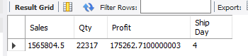

1. **Sales Growth: Measures the percentage increase in sales revenue over a set period compared to the previous period.**

WITH sc AS (

SELECT

YEAR(`Order Date`) as Years,

MONTHNAME(`Order Date`) as Months,

FLOOR(SUM(Sales*Quantity)) as Sales_Revenue,

LAG(FLOOR(SUM(Sales*Quantity)), 1) OVER () as prev_rev

FROM sdata

GROUP BY 1, 2

) SELECT sc.Months,sc.Sales_Revenue,sc.prev_rev, CONCAT(round((sc.prev_rev /sc.Sales_Revenue * 100),1),"%") as "%_changes"

FROM sc

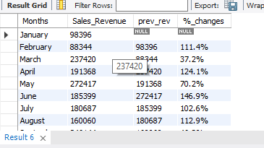

1. **Sales by region with respective percentage**

select `Region`, round(sum(`Sales`)) as Sales,

concat(round(sum(`Sales`)/(select sum(sales) from sdata)*100),'%') as '% of region'

from sdata

group by 1

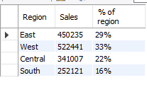

1. **Sales by Payment mode with respective percentage**

select `Payment Mode`, round(sum(`Sales`)) as Sales,

concat(round((sum(`Sales`)/(select sum(`Sales`) from sdata)*100),0),'%') as '% of Mode' from sdata

group by 1

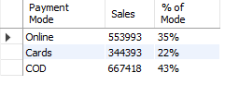

1. **Top 10 sales by states**

select `State`, round(sum(`Sales`)) as 'Sales' from sdata

group by 1

order by 2 desc limit 10

