Computer Networks: Assignment-1
Name: Suraj Shah
Admission Number: I24AI012

Q 1) Study network configuration commands and execute them on your system. For Example:

- IPCONFIG
Command:
ipconfig
Output:
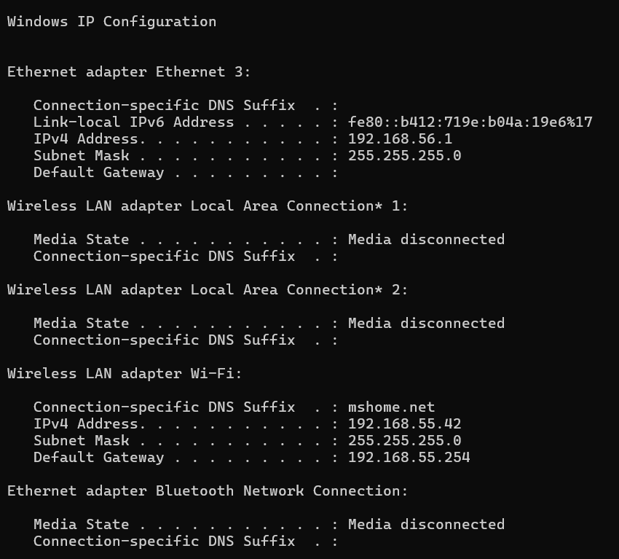

- NSLOOKUP
Command:
nslookup -type = google.com
Output:
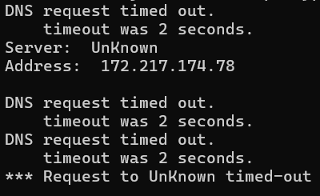

- HOSTNAME
Command:
hostname
Output:

- PING
Command:
ping google.com
Output:
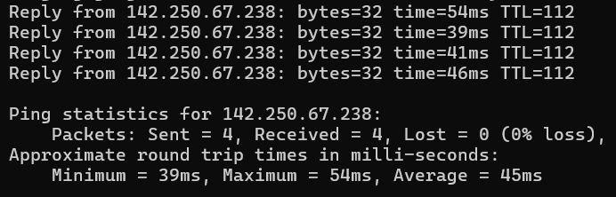

- TRACERT
Command:
tracert google.com
Output:
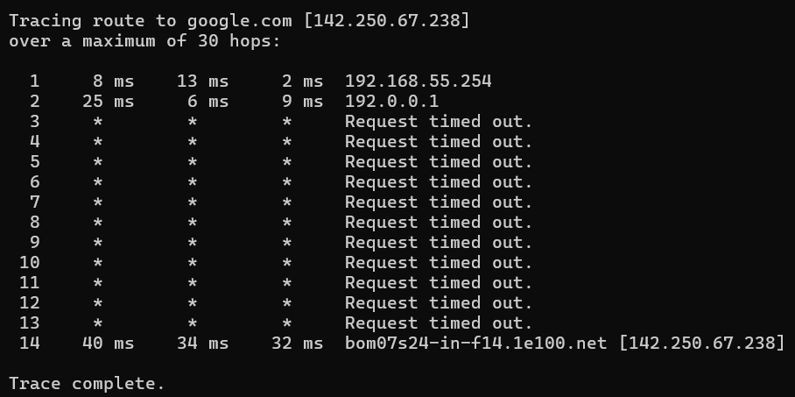

- NETSTAT
Command:
netstat
Output:
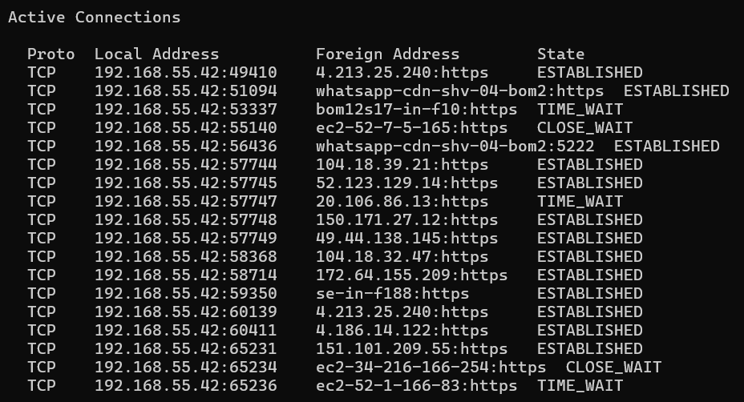

- ARP(Address Resolution Protocol)
Command:
arp -a
Output:


- SYSTEMINFO
Command:
systeminfo
Output:
