Computer Networks: Assignment-10
Name: Suraj Shah
Admission Number: I24AI012

Q 1) Configure the network below using two routers, one wireless and another 1841 router.
Diagram:
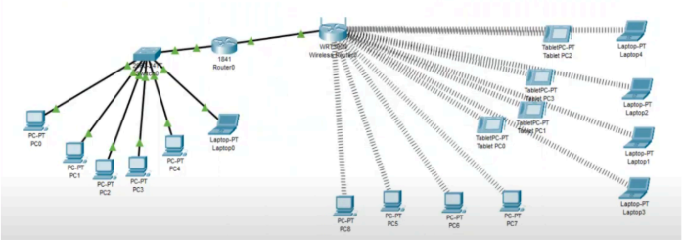

IP Config:
PC0: 192.168.1.2 / 255.255.255.0 / 192.168.1.1
PC1: 192.168.1.3 / 255.255.255.0 / 192.168.1.1
PC2: 192.168.1.4 / 255.255.255.0 / 192.168.1.1
PC3: 192.168.1.5 / 255.255.255.0 / 192.168.1.1
PC4: 192.168.1.6 / 255.255.255.0 / 192.168.1.1
Laptop0: 192.168.1.7 / 255.255.255.0 / 192.168.1.1
PC5: 192.168.4.3 / 255.255.255.0 / 192.168.4.1
PC6: 192.168.4.4 / 255.255.255.0 / 192.168.4.1
PC7: 192.168.4.5 / 255.255.255.0 / 192.168.4.1
PC8: 192.168.4.2 / 255.255.255.0 / 192.168.4.1
Tablet PC4: 192.168.4.10 / 255.255.255.0 / 192.168.4.1
Tablet PC5: 192.168.4.11 / 255.255.255.0 / 192.168.4.1
Tablet PC6: 192.168.4.13 / 255.255.255.0 / 192.168.4.1
Tablet PC7: 192.168.4.12 / 255.255.255.0 / 192.168.4.1
Laptop1: 192.168.4.7 / 255.255.255.0 / 192.168.4.1
Laptop2: 192.168.4.8 / 255.255.255.0 / 192.168.4.1
Laptop3: 192.168.4.6 / 255.255.255.0 / 192.168.4.1
Laptop4: 192.168.4.9 / 255.255.255.0 / 192.168.4.1
Router0:
FastEthernet0/0: 192.168.1.1 / 255.255.255.0
FastEthernet0/1: 192.168.4.1 / 255.255.255.0
WirelessRouter0:
Internet:
Default Gateway: 192.168.4.1
LAN: 192.168.4.2 / 255.255.255.0
Wireless:
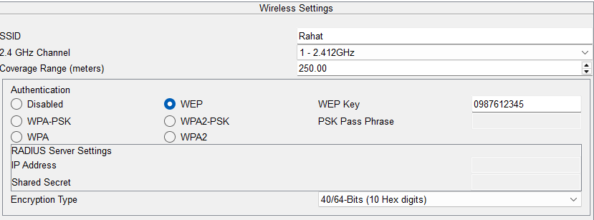

PC, Tablet, Laptop:
Wireless:
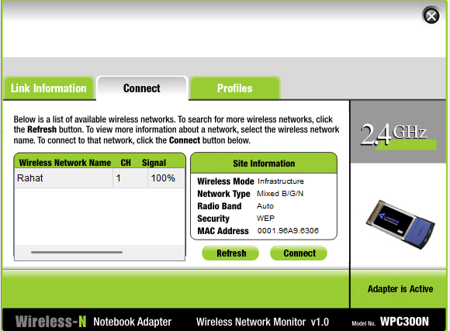

Output:
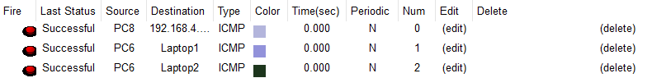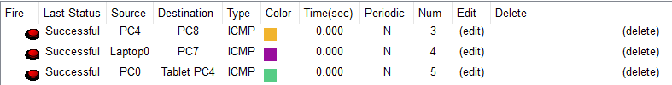

Q 2) Configure the FTP server as shown in the below network.
Diagram:
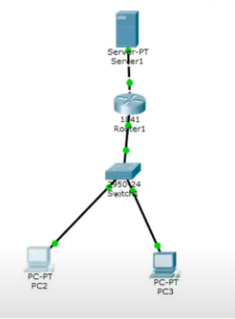

IP Config:
PC0: 192.168.0.2 / 255.255.255.0 / 192.168.0.1
PC1: 192.168.0.3 / 255.255.255.0 / 192.168.0.1
Router1:
FastEthernet0/0: 10.10.10.1 / 255.0.0.0
FastEthernet0/1: 192.168.0.1 / 255.255.255.0
Server1: 10.10.10.2 / 255.0.0.0 / 10.10.10.1

Services:
FTP:
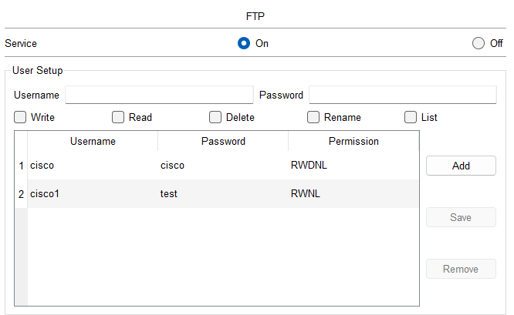

Output:
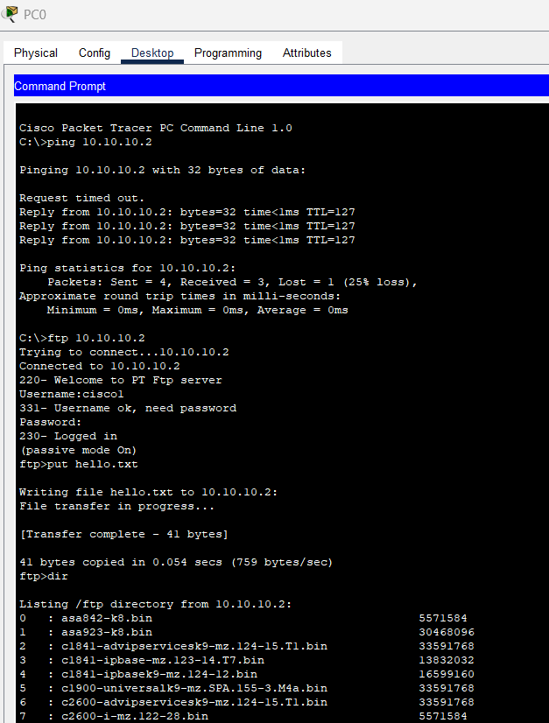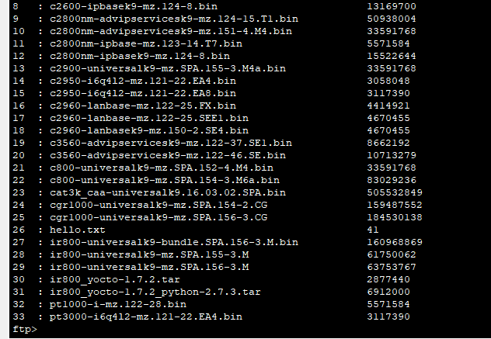
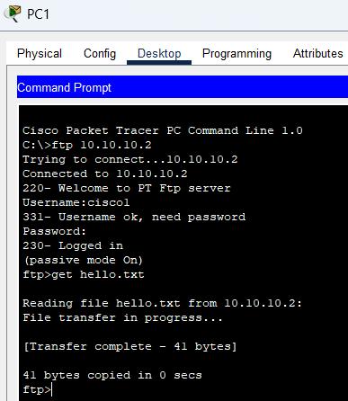

Q3) Configure the email server as shown in the network below.
Diagram:
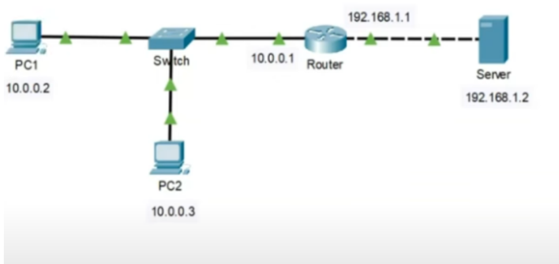
IP Config:
PC1: 10.0.0.2 / 255.0.0.0 / 10.0.0.1
PC2: 10.0.0.3 / 255.0.0.0 / 10.0.0.1
Router:
FastEthernet0/0: 10.0.0.1 / 255.0.0.0
FastEthernet0/1: 192.168.1.1 / 255.255.255.0
Server: 192.168.1.2 / 255.0.0.0 / 192.168.1.1

Services:
EMAIL:
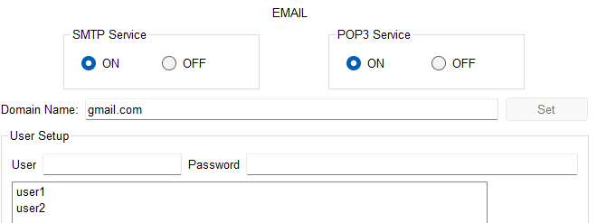

Mail Config:
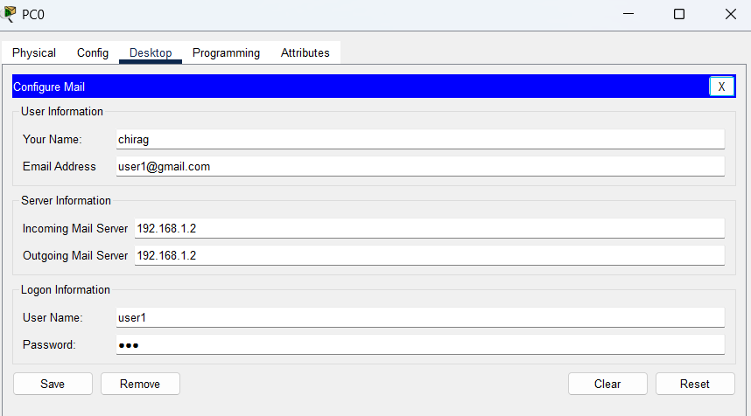
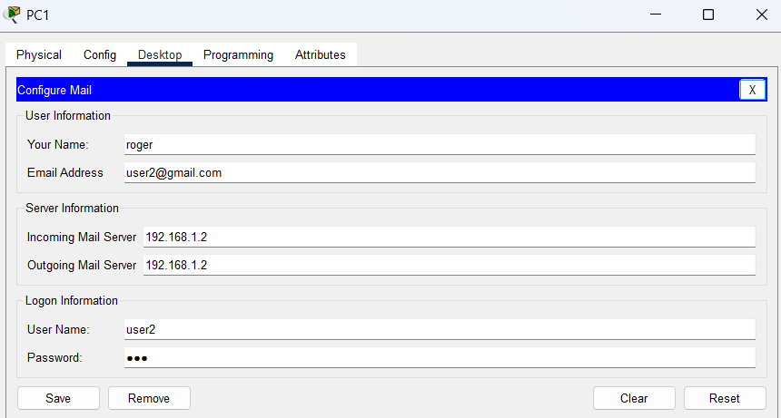
Output: