Computer Networks: Assignment-2
Name: Suraj Shah
Admission Number: I24AI012

Q 1) Construct a virtual LAN in the Cisco packet tracer as shown below, and check where the data packets are transferring from one system to another.
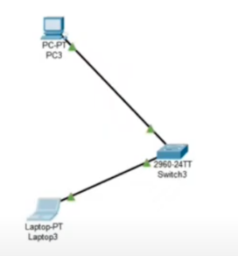
IP config:
PC3: 192.168.10.2 / 255.255.255.0
Laptop3: 192.168.10.3 / 255.255.255.0
Output:
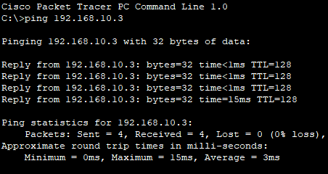

Q 2) Construct a virtual MAN in the Cisco packet tracer, as shown below, and check where the data packets transfer from one system to another.
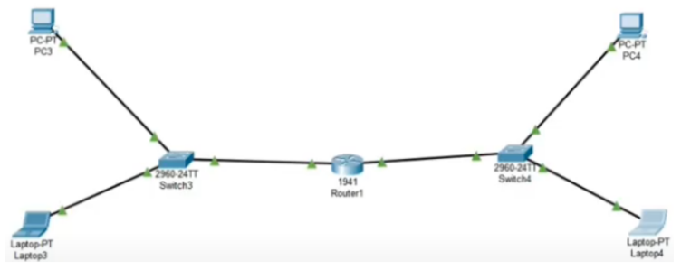
IP Config:
PC3: 192.168.1.2, GW 192.168.1.1
Laptop3: 192.168.1.3, GW 192.168.1.1
PC4: 192.168.2.2, GW 192.168.2.1
Laptop4: 192.168.2.3, GW 192.168.2.1
Commands:
For router:
enable
configure terminal

interface gigabitEthernet0/0
ip address 192.168.1.1 255.255.255.0
no shutdown
exit

interface gigabitEthernet0/1
ip address 192.168.2.1 255.255.255.0
no shutdown
exit

end
write memory

Output:
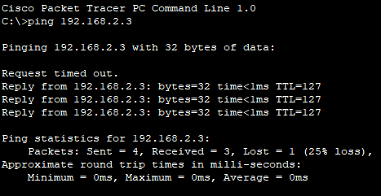

Q 3) Construct a virtual WAN in the Cisco packet tracer as shown below, and check where the data packets are transferring from one system to another.
Diagram:
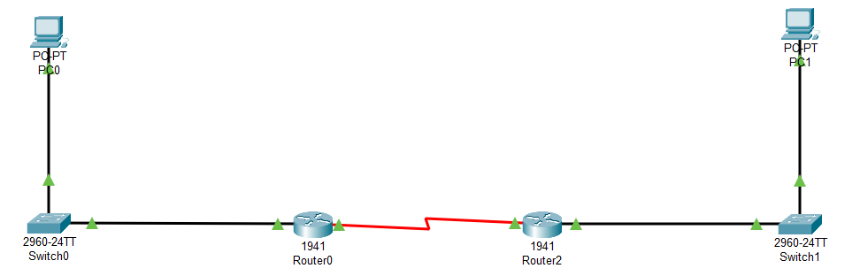
IP Config:
PC0: 192.168.10.2 / 255.255.255.0, GW 192.168.10.1
PC1: 192.168.20.2 / 255.255.255.0, GW 192.168.20.1
Commands:
For Router1:
enable
configure terminal

interface gigabitEthernet0/0
ip address 192.168.10.1 255.255.255.0
no shutdown
exit

interface serial0/0/0
ip address 10.0.0.1 255.255.255.252
clock rate 64000
no shutdown
exit

ip route 192.168.20.0 255.255.255.0 10.0.0.2
end
write memory

For Router2:
enable
configure terminal

interface gigabitEthernet0/0
ip address 192.168.20.1 255.255.255.0
no shutdown
exit

interface serial0/0/0
ip address 10.0.0.2 255.255.255.252
no shutdown
exit

ip route 192.168.10.0 255.255.255.0 10.0.0.1
end
write memory

Output:
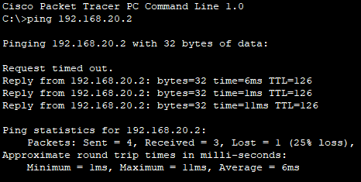

Q-4 IIn Cisco Packet Tracer, design a campus network with two buildings (Building-A and Building-B). Each building should have at least two IP subnets (e.g., Subnet 10–Students and Subnet 20–Faculty) implemented using switches. Connect both buildings via routers (using either subinterfaces or inter-router links), assign suitable IP subnets to each group, configure links between switches and routers, set up inter-subnet routing so that only Faculty subnets of both buildings can communicate with each other while Student subnets remain isolated, and verify this behavior using ping and simulation mode to observe packet flow
Diagram:
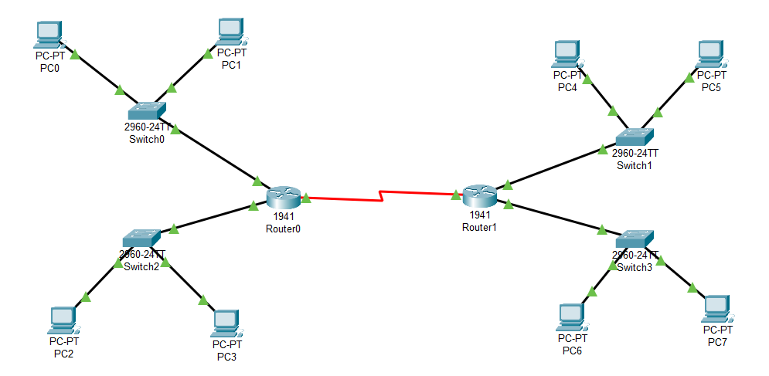
IP Config:
A-Student-PC0: 192.168.10.10 / 255.255.255.0, GW 192.168.10.1
A-Student-PC1: 192.168.10.11 / 255.255.255.0, GW 192.168.10.1
A-Faculty-PC2: 192.168.20.10 / 255.255.255.0, GW 192.168.20.1
A-Faculty-PC3: 192.168.20.11 / 255.255.255.0, GW 192.168.20.1
B-Student-PC4: 192.168.30.10 / 255.255.255.0, GW 192.168.30.1
B-Student-PC5: 192.168.30.11 / 255.255.255.0, GW 192.168.30.1
B-Faculty-PC6: 192.168.40.10 / 255.255.255.0, GW 192.168.40.1
B-Faculty-PC7: 192.168.40.11 / 255.255.255.0, GW 192.168.40.1
Commands:
For Router1:
interface GigabitEthernet0/0
ip address 192.168.10.1 255.255.255.0
no shutdown
interface GigabitEthernet0/1
ip address 192.168.20.1 255.255.255.0
no shutdown
interface Serial0/0/0
ip address 10.0.0.1 255.255.255.252
clock rate 64000 !
no shutdown

ip route 192.168.40.0 255.255.255.0 10.0.0.2

For Router2:
interface GigabitEthernet0/0
ip address 192.168.30.1 255.255.255.0
no shutdown
interface GigabitEthernet0/1
ip address 192.168.40.1 255.255.255.0
no shutdown
interface Serial0/0/0
ip address 10.0.0.2 255.255.255.252
no shutdown
ip route 192.168.20.0 255.255.255.0 10.0.0.1

Output:
