Computer Networks: Assignment-3
Name: Suraj Shah
Admission Number: I24AI012

Q 1) Construct a star topology in the Cisco packet tracer as shown below, and check where the data packets are transferring from one system to another using ping.

Diagram:
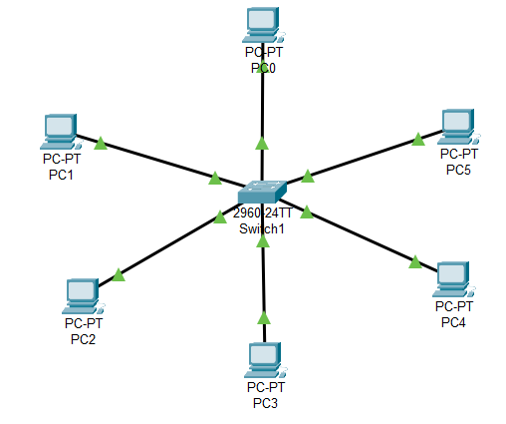

IP Config:
PC0: 192.168.1.1 / 255.255.255.0
PC1: 192.168.1.2 / 255.255.255.0
PC2: 192.168.1.3 / 255.255.255.0
PC3: 192.168.1.4 / 255.255.255.0
PC4: 192.168.1.5 / 255.255.255.0
PC5: 192.168.1.6 / 255.255.255.0
Output:
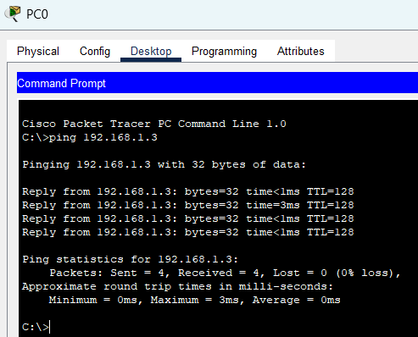

Q2) Construct a bus topology in the Cisco packet tracer as shown below, and check where the data packets are transferring from one system to another.
Diagram:
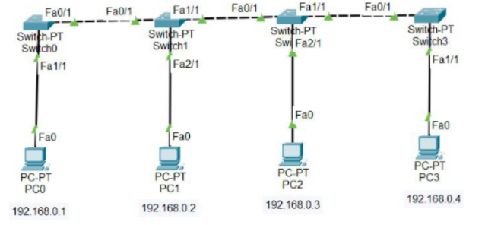

IP Config:
PC0: 192.168.0.1 / 255.255.255.0
PC1: 192.168.0.2 / 255.255.255.0
PC2: 192.168.0.3 / 255.255.255.0
PC3: 192.168.0.4 / 255.255.255.0

Output:
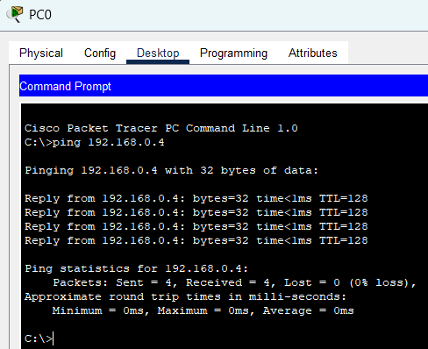
Q 3) Construct a ring topology in the Cisco packet tracer as shown below, and check where the data packets are transferring from one system to another.

Diagram:
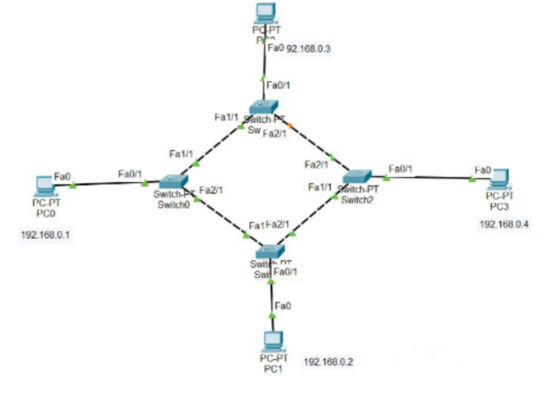

IP Config:
PC0: 192.168.0.1 / 255.255.255.0
PC1: 192.168.0.2 / 255.255.255.0
PC2: 192.168.0.3 / 255.255.255.0
PC3: 192.168.0.4 / 255.255.255.0

Output:
