Computer Networks: Assignment-4
Name: Suraj Shah
Admission Number: I24AI012

Q 1) Construct a tree topology in the Cisco packet tracer, as shown below, and check where the data packets transfer from one system to another.
Diagram:
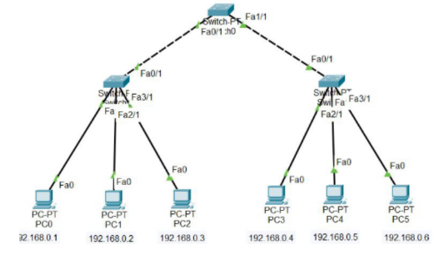
IP Config:
PC0: 192.168.0.1 / 255.255.255.0
PC1: 192.168.0.2 / 255.255.255.0
PC2: 192.168.0.3 / 255.255.255.0
PC3: 192.168.0.4 / 255.255.255.0
PC4: 192.168.0.5 / 255.255.255.0
PC5: 192.168.0.6 / 255.255.255.0

Output:
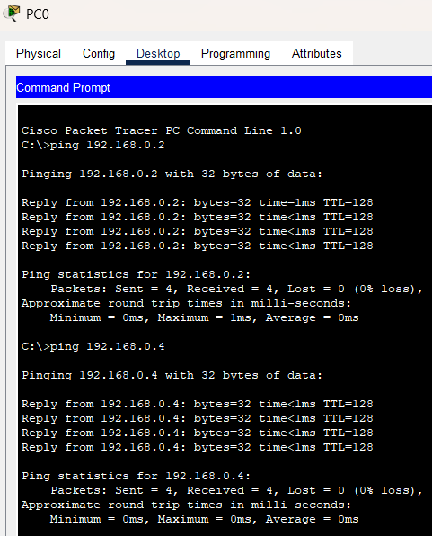

Q 2) Construct a mesh topology in the Cisco packet tracer as shown below, and check where the data packets are transferring from one system to another.
Diagram:
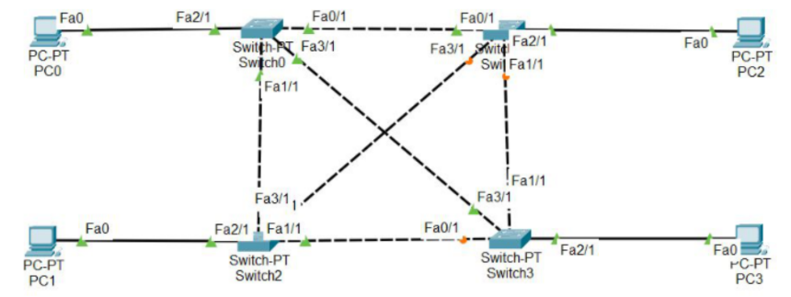
IP Config:
PC0: 192.168.1.1 / 255.255.255.0
PC1: 192.168.1.2 / 255.255.255.0
PC2: 192.168.1.3 / 255.255.255.0
PC3: 192.168.1.4 / 255.255.255.0

Output:
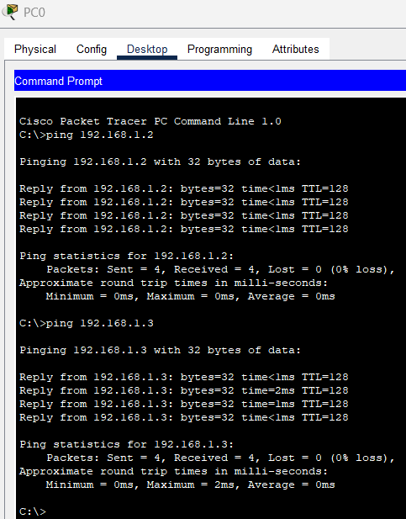

Q 3) Construct a hybrid topology in the Cisco packet tracer as shown below, and check where the data packets are transferring from one system to another.
Diagram:
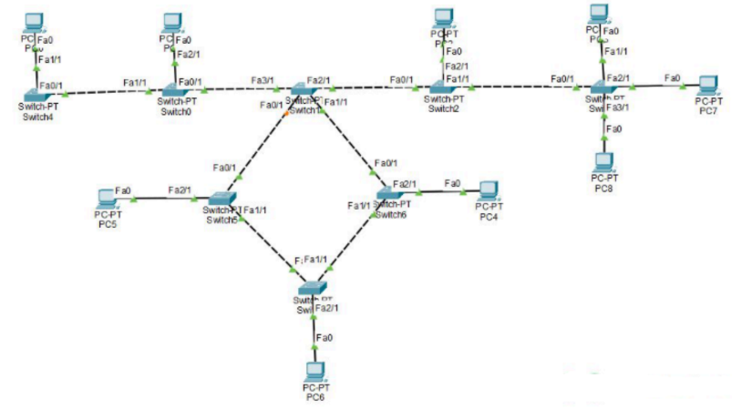
IP Config:
PC0: 192.168.2.1 / 255.255.255.0
PC1: 192.168.2.2 / 255.255.255.0
PC2: 192.168.2.3 / 255.255.255.0
PC3: 192.168.2.4 / 255.255.255.0
PC4: 192.168.2.5 / 255.255.255.0
PC5: 192.168.2.6 / 255.255.255.0
PC6: 192.168.2.7 / 255.255.255.0
PC7: 192.168.2.8 / 255.255.255.0
PC8: 192.168.2.9 / 255.255.255.0

Output:
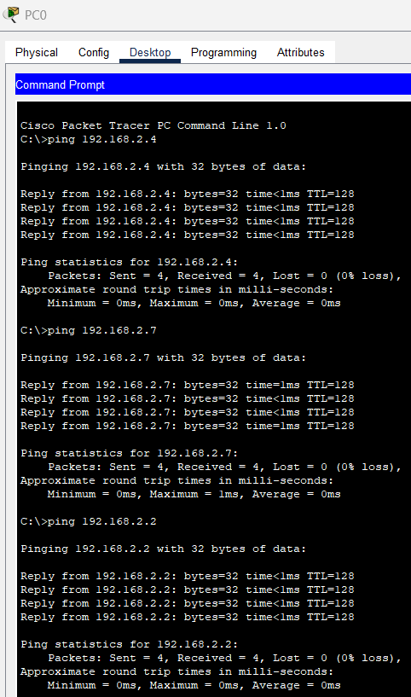

Q4) In Cisco Packet Tracer, construct a connecting six PCs using two interconnected switches or routers forming two rings. Assign proper IP addresses, ensure full connectivity using the ping command between all PCs, then intentionally disable one link in the ring and observe how data packets are rerouted in the network.
Diagram:
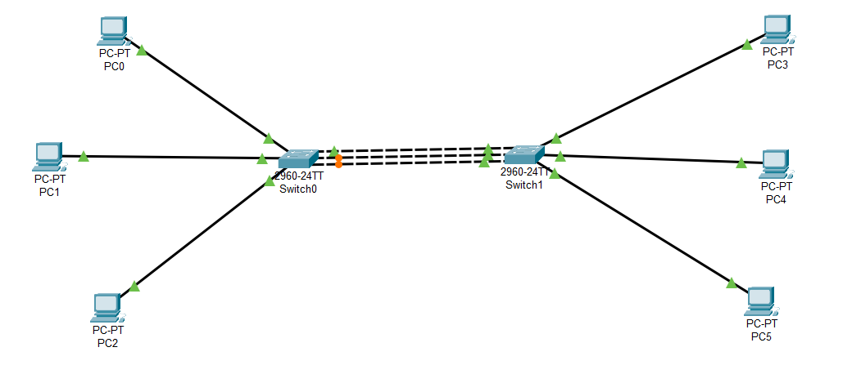
IP Config:
PC0: 192.168.1.1 / 255.255.255.0
PC1: 192.168.1.2 / 255.255.255.0
PC2: 192.168.1.3 / 255.255.255.0
PC3: 192.168.1.4 / 255.255.255.0
PC4: 192.168.1.5 / 255.255.255.0
PC5: 192.168.1.6 / 255.255.255.0

Output:
