Computer Networks: Assignment-5
Name: Suraj Shah
Admission Number: I24AI012

Q 1) Construct the below network in the Cisco packet tracer, as shown below, and check where the data packets transfer from one system to another using
Diagram:
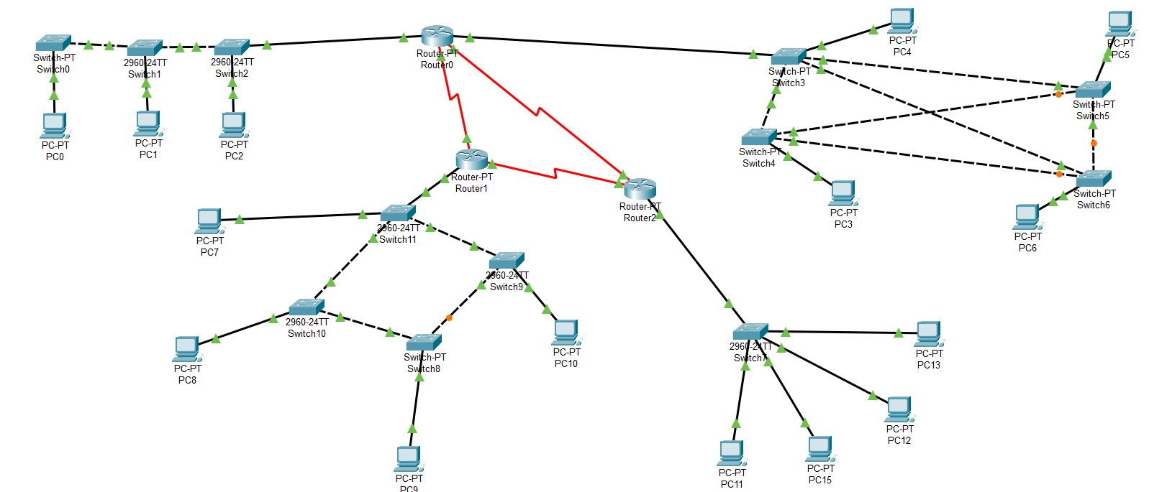
IP Config:
PC0: 192.168.1.4 / 255.255.255.0
PC1: 192.168.1.2 / 255.255.255.0
PC2: 192.168.1.3 / 255.255.255.0
PC3: 192.168.4.3 / 255.255.255.0
PC4: 192.168.4.5 / 255.255.255.0
PC5: 192.168.4.2 / 255.255.255.0
PC6: 192.168.4.4 / 255.255.255.0
PC7: 192.168.3.5 / 255.255.255.0
PC8: 192.168.3.2 / 255.255.255.0
PC9: 192.168.3.3 / 255.255.255.0
PC10: 192.168.3.4 / 255.255.255.0
PC11: 192.168.2.4 / 255.255.255.0
PC12: 192.168.2.2 / 255.255.255.0
PC13: 192.168.2.5 / 255.255.255.0
PC15: 192.168.2.3 / 255.255.255.0
Router0:
FastEthernet0/0: 192.168.1.1 / 255.255.255.0
FastEthernet1/0: 192.168.4.1 / 255.255.255.0
Serial2/0: 10.0.0.5 / 255.255.255.252
Serial3/0: 10.0.0.1 / 255.255.255.252
Router1:
FastEthernet0/0: 192.168.3.1 / 255.255.255.0
Serial2/0: 10.0.0.2 / 255.255.255.252
Serial3/0: 10.0.0.6 / 255.255.255.252
Router2:
FastEthernet0/0: 192.168.2.1 / 255.255.255.0
Serial2/0: 10.0.0.10 / 255.255.255.252
Serial3/0: 10.0.0.14 / 255.255.255.252

- Static routing (STATIC) and

Router Config:
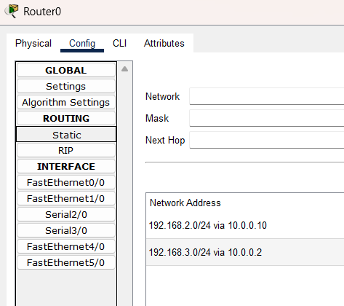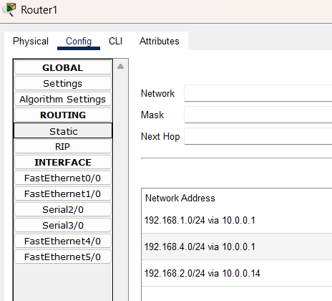
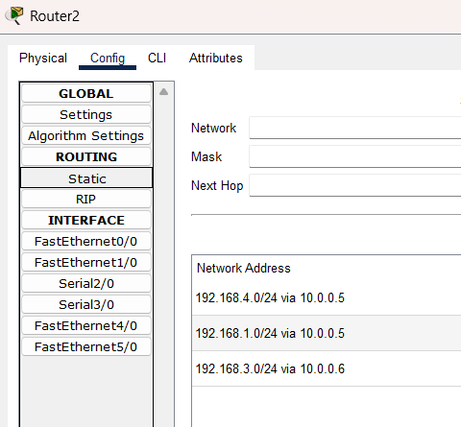

Output:
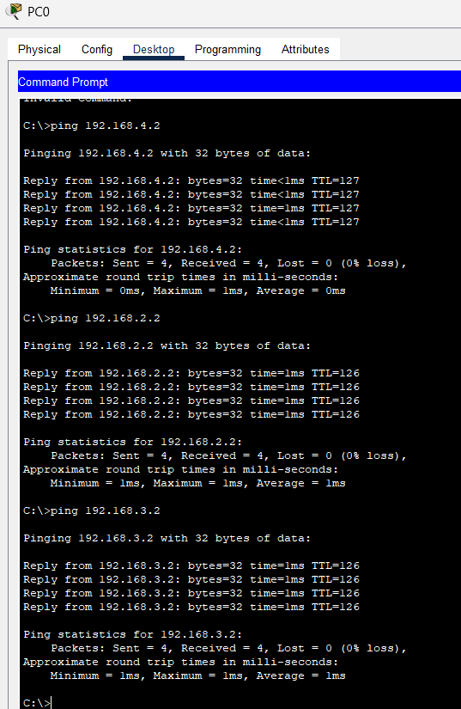

- Dynamic routing (RIP), further demonstrate the use of half and full duplex in the switch in the below network.

Router Config:
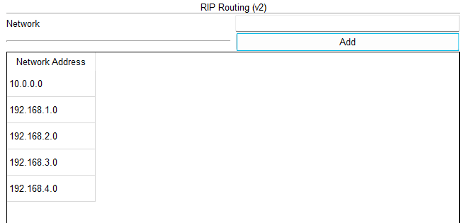

Output:


