Computer Networks: Assignment-6
Name: Suraj Shah
Admission Number: I24AI012

Q 1) Construct the below network in the Cisco packet tracer, as shown below, and connect them more securely using VLAN.
Diagram:
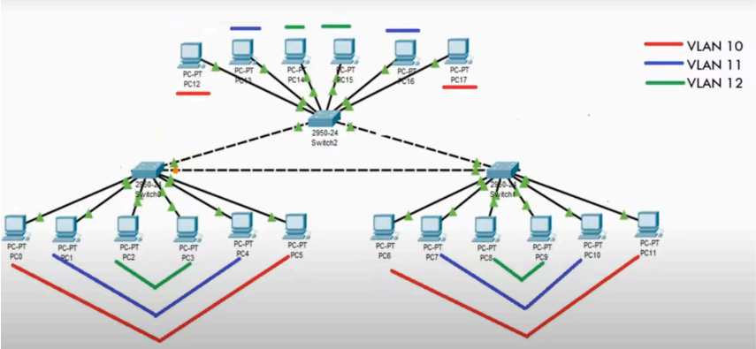
IP Config:
PC0: 192.168.10.1 / 255.255.255.0
PC1: 192.168.20.1 / 255.255.255.0
PC2: 192.168.30.1 / 255.255.255.0
PC3: 192.168.30.2 / 255.255.255.0
PC4: 192.168.20.2 / 255.255.255.0
PC5: 192.168.10.2 / 255.255.255.0
PC6: 192.168.10.3 / 255.255.255.0
PC7: 192.168.20.3 / 255.255.255.0
PC8: 192.168.30.3 / 255.255.255.0
PC9: 192.168.30.4 / 255.255.255.0
PC10: 192.168.20.4 / 255.255.255.0
PC11: 192.168.10.4 / 255.255.255.0
PC12: 192.168.10.5 / 255.255.255.0
PC13: 192.168.20.5 / 255.255.255.0
PC14: 192.168.30.5 / 255.255.255.0
PC15: 192.168.30.6 / 255.255.255.0
PC16: 192.168.20.6 / 255.255.255.0
PC17: 192.168.10.6 / 255.255.255.0
Switch Config:
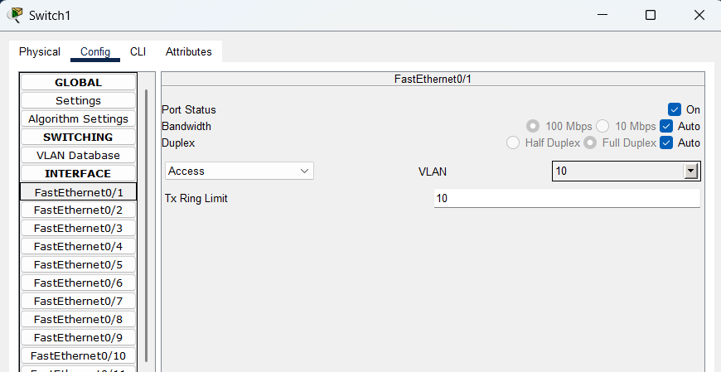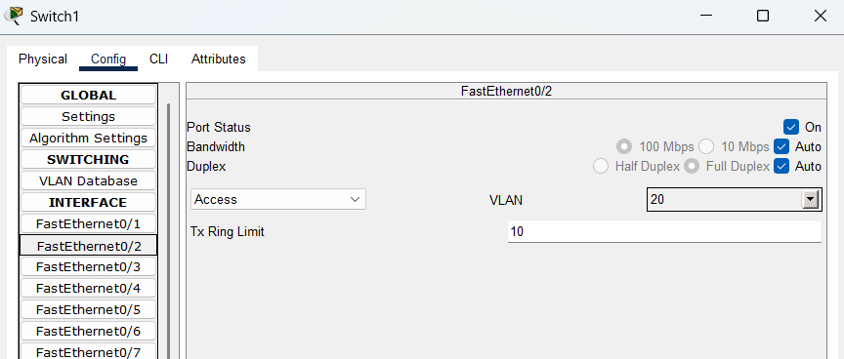
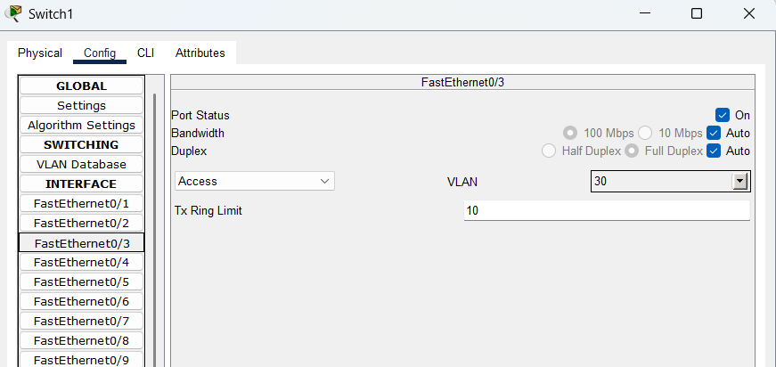

Output:
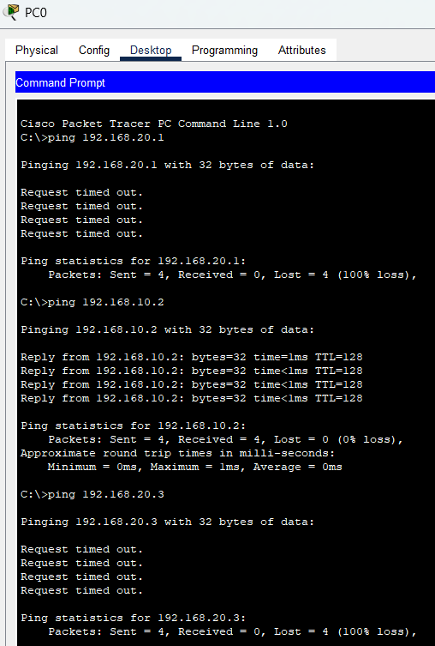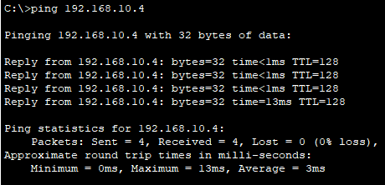

Q 2) Design s network in CISCO packer tracer to connect Accounts, Sales, Delivery, and Manufacturing departments:
a) Each department should contain at least 2 PCs.
b) An appropriate number of switches and routers should be used in the network, and proper IP addresses with subnet masks should be given.
c) Connect all the devices with the appropriate wires and check their connectivity.
d) Check the OSI layer information of the packet as shown below:
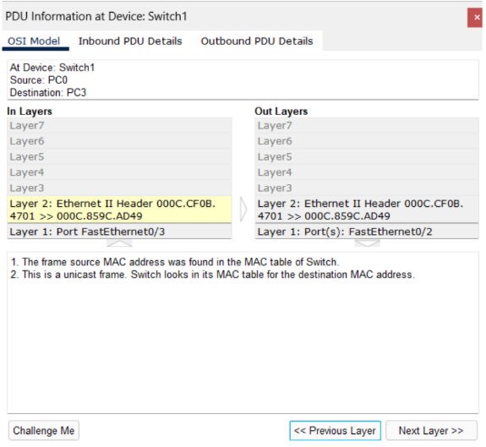

Diagram:
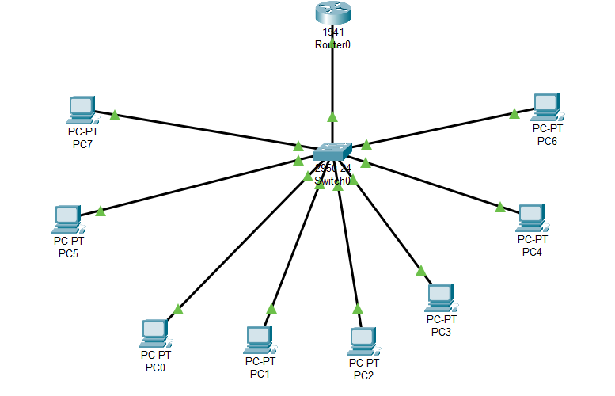
IP Config:
PC0: 192.168.10.10 / 255.255.255.0
PC1: 192.168.10.11 / 255.255.255.0
PC2: 192.168.20.10 / 255.255.255.0
PC3: 192.168.20.11 / 255.255.255.0
PC4: 192.168.30.10 / 255.255.255.0
PC5: 192.168.30.11 / 255.255.255.0
PC6: 192.168.40.10 / 255.255.255.0
PC7: 192.168.40.11 / 255.255.255.0

Switch Config:
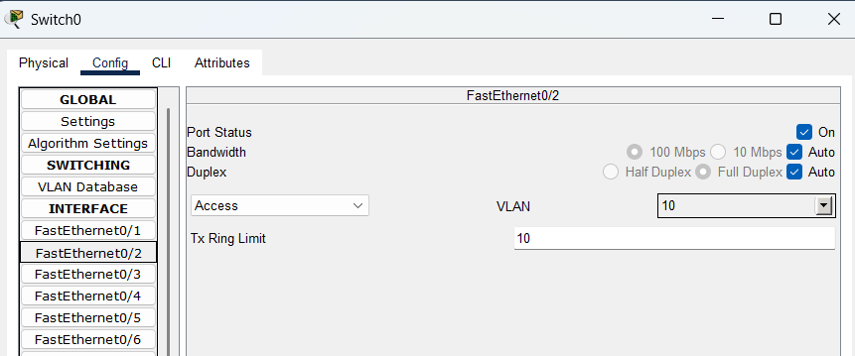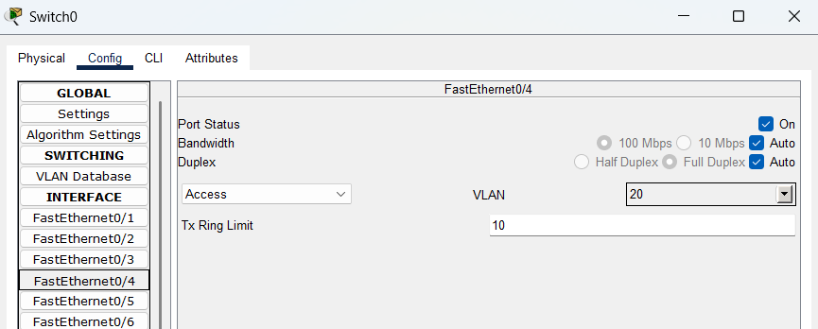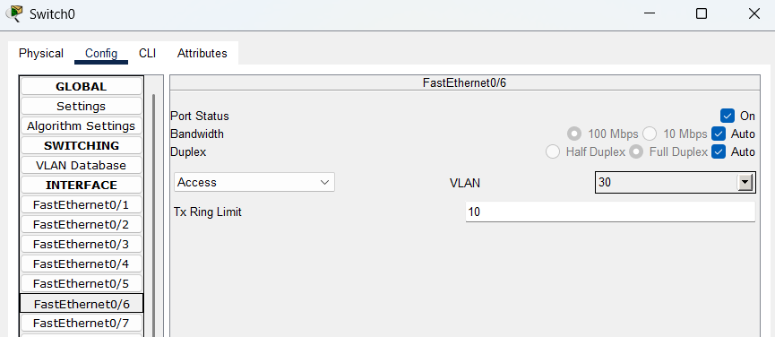

Output:
