Computer Networks: Assignment-7
Name: Suraj Shah
Admission Number: I24AI012

Q 1) Construct the below network in the Cisco packet tracer and connect the server and Pcs using DHCP protocol.
Diagram:
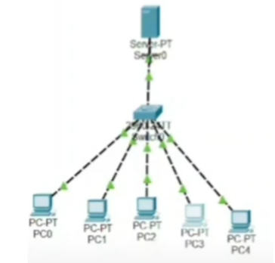
IP Config:
Server0: 192.168.1.1 / 255.255.255.0

DHCP Service:
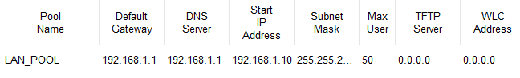

Received PC IPs:
PC0: 192.168.1.5 / 255.255.255.0
PC1: 192.168.1.2 / 255.255.255.0
PC2: 192.168.1.4 / 255.255.255.0
PC3: 192.168.1.6 / 255.255.255.0
PC4: 192.168.1.3 / 255.255.255.0

Output:
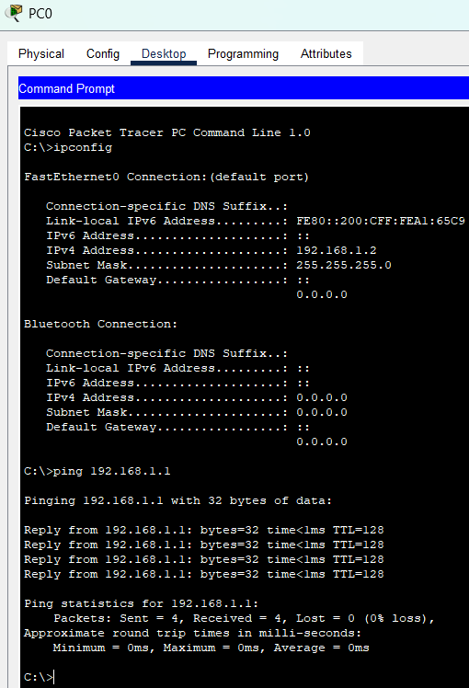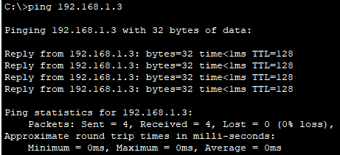

Q 2) Construct the below network in the Cisco packet tracer and Configuring a Cisco Router as a DHCP Server
Diagram:
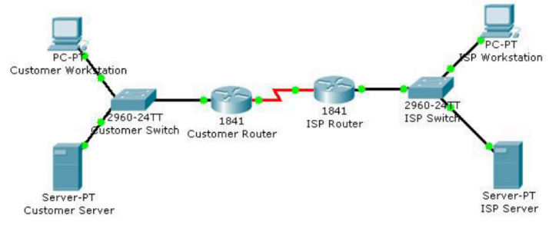

IP Config:
Customer Router:
FastEthernet0/0: 192.168.1.1 / 255.255.255.0
Serial0/1/0: 10.0.0.1/ 255.255.255.252
ISP Router:
FastEthernet0/0: 192.168.2.1 / 255.255.255.0
Serial0/1/0: 10.0.0.2/ 255.255.255.252
ISP Workstation: 192.168.2.2 / 255.255.255.0

Commands:
Customer Router:
ip dhcp excluded-address 192.168.1.1 192.168.1.10

ip dhcp pool CUSTOMER_LAN
network 192.168.1.0 255.255.255.0
default-router 192.168.1.1
dns-server 8.8.8.8
exit
Received PC IP:
Customer Workstation: 192.168.1.11 / 255.255.255.0

Output:
