Computer Networks: Assignment-8
Name: Suraj Shah
Admission Number: I24AI012

Q 1) Configure and implement a network using Packet Tracer and configure DNS.
a. Connect a PC with the server.
b. Sending Simple Text Messages in Realtime Mode
c. Establishing a Web Server Connection Using the PC’s Web Browser
Diagram:
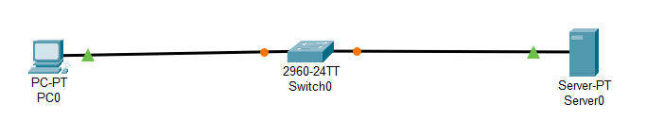
IP Config:
PC0: 192.168.1.2 / 255.255.255.0 / 192.168.1.3
Server0: 192.168.1.3 / 255.255.255.0

DNS Config:
Name: www.myweb.com
Address: 192.168.1.3

Output:
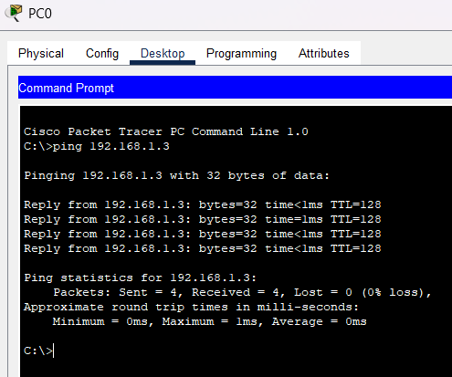
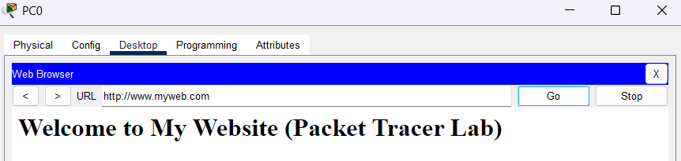

Q 2) i) Construct the below network in the Cisco packet tracer and configure DHCP, DNS, and HTTP protocols where DHCP, DNS, and Web server are on the different side of router
Diagram:
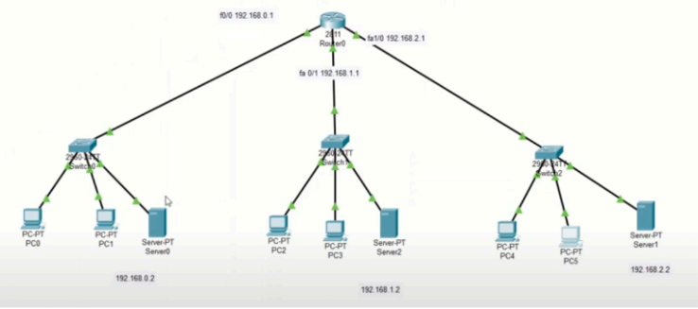

IP Config:
Router0:
FastEthernet0/0: 192.168.0.1 / 255.255.255.0
FastEthernet0/1: 192.168.1.1 / 255.255.255.0
FastEthernet1/0: 192.168.2.1 / 255.255.255.0
Server0: 192.168.0.2 / 192.168.0.1 / 192.168.0.2
Server1: 192.168.1.2 / 192.168.1.1 / 192.168.1.2
Server2: 192.168.2.2 / 192.168.2.1 / 192.168.2.2

Server0 DHCP Config:
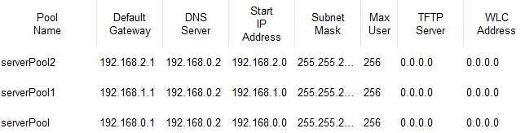

Server0 DNS Config:
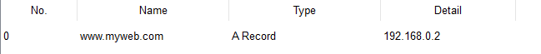

Router Config:
interface fa0/0
ip helper-address 192.168.0.2

interface fa0/1
ip helper-address 192.168.0.2

interface fa1/0
ip helper-address 192.168.0.2

Output:
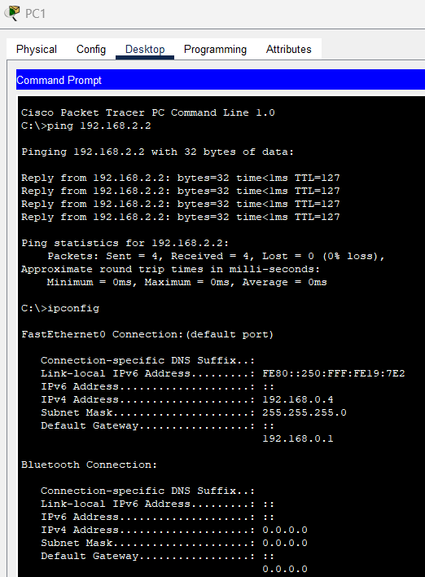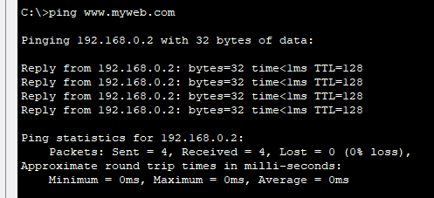
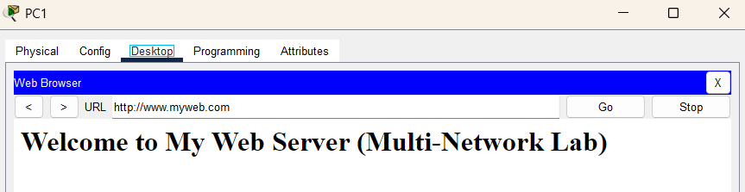
ii) Construct the below network in the Cisco packet tracer and configure DHCP,
DNS, and HTTP protocols where DHCP, DNS and Web server are on the same side
of router
Diagram:
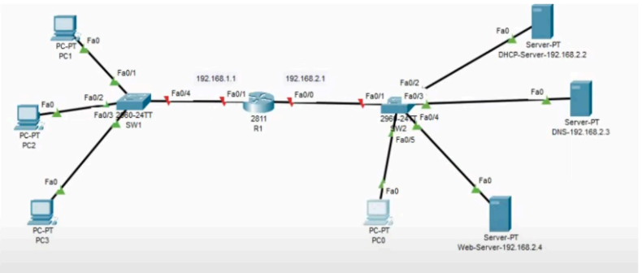

IP Config:
Router0:
FastEthernet0/0: 192.168.2.1 / 255.255.255.0
FastEthernet0/1: 192.168.1.1 / 255.255.255.0
Server0: 192.168.2.2 / 192.168.2.1 / 192.168.2.3
Server1: 192.168.2.3 / 192.168.2.1 / 192.168.2.3
Server2: 192.168.2.4 / 192.168.2.1 / 192.168.2.3

Server0 DHCP Config:
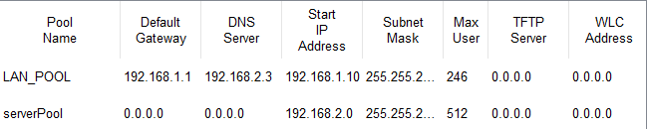

Server1 DNS Config:
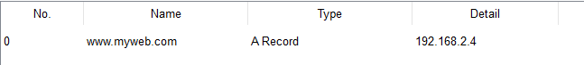
Router Config:
interface fa0/0
ip helper-address 192.168.2.2

interface fa0/1
ip helper-address 192.168.2.2

Output:
