Computer Networks: Assignment-9
Name: Suraj Shah
Admission Number: I24AI012

Q 1) Configure a wireless connection as shown in the below network.
Diagram:
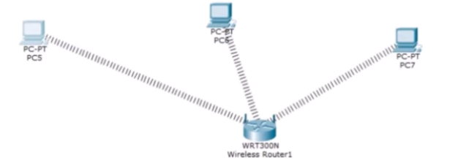

Router Config:
Wireless Settings:
Basic Wireless Settings:
Network Name: MyWiFi
Wireless Security:
Security Mode: WEP
Key1: 1234567890

IP Config:
PC0: 192.168.0.5 / 255.255.255.0 / 192.168.0.1
PC1: 192.168.0.6 / 255.255.255.0 / 192.168.0.1
PC2: 192.168.0.7 / 255.255.255.0 / 192.168.0.1

PC Wireless:
Connect:
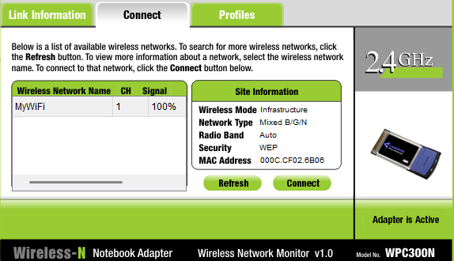

Output:
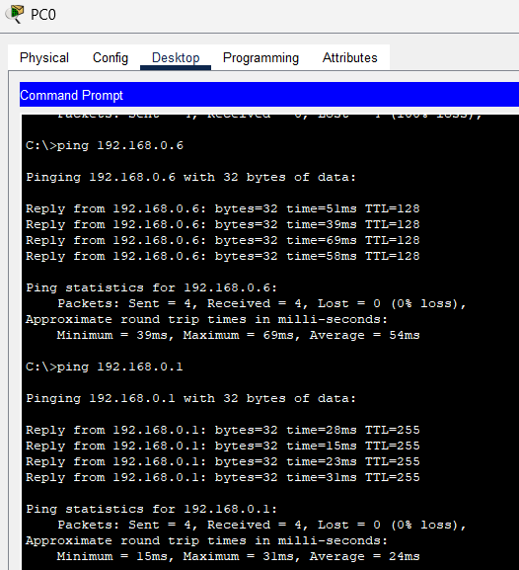
Q2) Configure the below network using a server and connect wirelessly all the device.
Diagram:
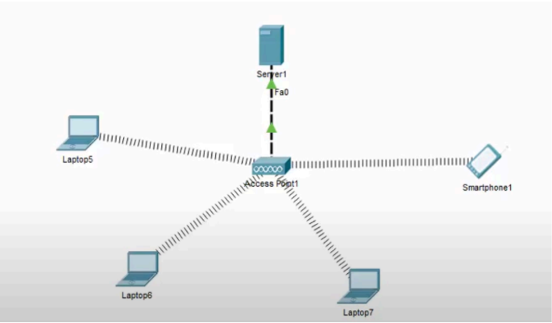

IP Config:
Server0: 172.16.0.1 / 255.255.255.0

Server0 DHCP Config:
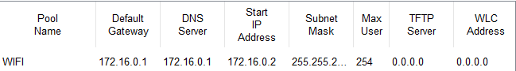

Received IPs:
Laptop0: 172.16.0.8 / 255.255.255.0
Laptop1: 172.16.0.7 / 255.255.255.0
Laptop2: 172.16.0.5 / 255.255.255.0
Smartphone0: 172.16.0.2 / 255.255.255.0

Output:
