Web Programming and Python: Assignment-9
Name: Suraj Shah
Admission Number: I24AI012

- Design a Webpage for online food delivery system using HTML and CSS.
HTML Code:
<!DOCTYPE html>
<html lang="en">
<head>
<meta charset="UTF-8">
<meta name="viewport" content="width=device-width, initial-scale=1.0">
<title>Online Food Delivery System</title>
<link rel="stylesheet" href="style.css">
</head>
<body>
<div class="main">
<nav>
<button style="color: white;">Get the App</button>
<div class="">
<button class="btn">Login</button>
<button class="btn btn-red-sm">Sign Up</button>
</div>
</nav>
<div class="box">
</div>
<div class="hero">
<span style="font-size: 150px;">zomato</span>
<span>Discover the best food & drinks in Chennai</span>

<div class="hero-buttons">
<input type="text" placeholder="Custom Colony, Besant Nagar">
<input type="text" placeholder="Search for a restaurant, cuisine or dish">
</div>
</div>
</div>

<section class="options">
<button class="option"><img src="order_food_online.jpg" alt="Order Food"><p>Order Food Online</p></button>
<button class="option"><img src="go_out_for_a_meal.jpg" alt="Dine Out"><p>Go out for a meal</p></button>
<button class="option"><img src="night_life_and_clubs.jpg" alt="Nightlife"><p>Night Life & Clubs</p></button>
<button class="option"><img src="zomato_pro.webp" alt="Zomato Pro"><p>Zomato Pro</p></button>
</section>
</body>
</html>

CSS Code:
@import url('https://fonts.googleapis.com/css2?family=Martel+Sans:wght@200;300;400;600;700;800;900&display=swap');
@import url('https://fonts.googleapis.com/css2?family=Martel+Sans:wght@200;300;400;600;700;800;900&family=Poppins:ital,wght@0,100;0,200;0,300;0,400;0,500;0,600;0,700;0,800;0,900;1,100;1,200;1,300;1,400;1,500;1,600;1,700;1,800;1,900&display=swap');

* {
padding: 0;
margin: 0;
font-family: sans-serif;
}

.main {
background-image: url(back.webp);
background-position: center center;
background-repeat: no-repeat;
background-size: max(1200px, 100vw);
height: 70vh;
position: relative;
}

.nav span {
background-color: white;
}

.main .box {
height: 70vh;
width: 100%;
opacity: 0.4;
background-color: black;
position: absolute;
top: 0;
}

nav {
max-width: 60vw;
margin: auto;
justify-content: space-between;
display: flex;
align-items: center;
height: 62px;
}

nav img {
width: 130px;
position: relative;
z-index: 10;
}

nav button {
position: relative;
z-index: 10;
background-color: transparent;
border: none;
cursor: pointer;
}

.hero {
font-family: "Martel Sans", serif;
;
height: calc(100% - 122px);
display: flex;
align-items: center;
justify-content: center;
flex-direction: column;
color: white;
position: relative;
gap: 23px;
padding: 30px;
}

.hero> :nth-child(1) {
font-family: "Poppins", serif;
font-weight: bolder;
font-size: 48px;
text-align: center;
}

.hero> :nth-child(2) {
font-weight: 400;
font-size: 24px;
text-align: center;
}

.hero> :nth-child(3) {
font-weight: 400;
font-size: 20px;
text-align: center;
}

.separation {
height: 7px;
background-color: rgb(49, 45, 45);
position: relative;
z-index: 20;
}

.btn {
padding: 3px 8px;
font-weight: 400;
background-color: rgba(248, 243, 243, 0.021);
color: coral;
border: 1px solid white;
border-radius: 4px;
cursor: pointer;
background-color: white;
}

.btn-red {
background-color: red;
padding: 3px 24px;
font-size: 20px;
border-radius: 4px;
color: white;
font-weight: 400;
}

.btn-red-sm {
background-color: white;
color: coral;
}

.main input {
color: white;
padding: 7px 101px 8px 14px;
font-size: 12px;
border-radius: 4px;
color: white;
background-color: rgba(23, 23, 23, 0.7);
border: 1px solid rgba(237, 231, 231, 0.5);
}

.hero-buttons {
display: flex;
justify-content: center;
align-items: center;
}

.hero-buttons input {
background-color: white;
color: black;
}

.options {
display: flex;
justify-content: center;
gap: 100px;
margin: 20px 0;
}

.option img {
padding-top: 10px;
width: 200px;
height: 150px;
}

.option {
text-align: center;
border: 2px solid rgb(157, 149, 149);
border-radius: 10px;
cursor: pointer;
}

.option p {
font-size: 12px;
padding-bottom: 10px;
}

Output:
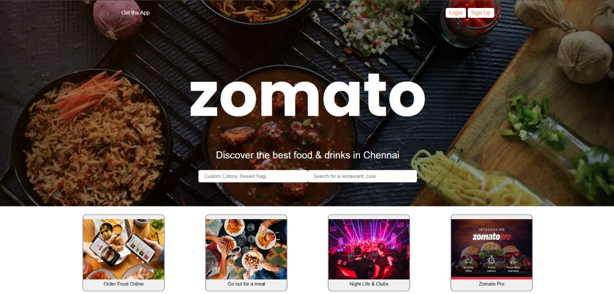

- Design a design college website using HTML and CSS.

Code:
<!DOCTYPE html>
<html lang="en">
<head>
<meta charset="UTF-8">
<meta name="viewport" content="width=device-width, initial-scale=1.0">
<title>College Website</title>
<link rel="stylesheet" href="styles.css">
<style>
body {
font-family: Arial, sans-serif;
margin: 0;
padding: 0;
}
header {
text-align: center;
padding: 1px 0;
display: flex;
align-items: center;
}
.head {
width: 650px;
}
.logo {
width: 100px;
margin-right: auto;
height: 75px;
padding-left: 50px;
}
.sardar {
height: 75px;
width: 100px;
margin-left: auto;
padding-right: 50px;
}
nav {
display: grid;
grid-template-columns: 1fr 1fr 1fr 1fr 1fr 1fr 1fr;
align-items: center;
justify-content: center;
background: #0073b1;
}
nav a {
color: white;
padding: 10px 20px;
text-decoration: none;
}
.container {
font-weight: bold;
display: flex;
padding: 50px;
}
.left-menu, .right-menu {
width: 20%;
padding: 10px;
}
.left-menu a, .right-menu a {
display: block;
padding: 10px;
margin: 5px 0;
background: #70c0ec;
color: black;
text-decoration: none;
text-align: center;
}
.left-menu a:hover, .right-menu a:hover {
color: red;
}
.main-content {
width: 60%;
text-align: center;
}
.banner img {
width: 100%;
border-radius: 5px;
}
.end a {
text-decoration: none;
color: rgb(100, 96, 96);
}
.end a:hover {
color: red;
}
.end img {
width: 70px;
height: auto;
margin-left: 10px;
float: left;
}
</style>
</head>
<body>
<header>
<img class= "logo" src="logo.png" alt="" style="width: 100px;">
<img class="head" src="svnit.png" alt="">
<img class="sardar" src="sardar_vallabhbhai_patel.png" alt="">
</header>
<nav>
<a href="#">ABOUT US</a>
<a href="#">ADMINISTRATION</a>
<a href="#">ACADEMIC</a>
<a href="#">DEPARTMENTS</a>
<a href="#">STUDENT LIFE</a>
<a href="#">RESEARCH & CONSULTANCY</a>
<a href="#">CAREER DEVELOPMENT CELL</a>
<a href="#">CENTRAL FACILITY</a>
<a href="#">CONTACT US</a>
</nav>
<div class="container">
<div class="left-menu">
<a href="#">Minutes of Meetings</a>
<a href="#">Memorandum of Understanding</a>
<a href="#">Ek Bharat Shreshta Bharat</a>
<a href="#">Achievements</a>
<a href="#">Central Library</a>
<a href="#">Alumni</a>
<a href="#">NIRF</a>
<a href="#">Career</a>
<a href="#">Vigilance Section</a>
<a href="#">RTI</a>
<a href="#">Employee Corner</a>
</div>
<div class="main-content">
<div class="banner">
<img src="3b.jpg" alt="SVNIT Banner">
</div>
</div>
<div class="right-menu">
<a href="#">Samarth-eGov</a>
<a href="#">Chapters | Clubs | Society</a>
<a href="#">Magazine | Newsletter</a>
<a href="#">Admission</a>
<a href="#">Scholarship</a>
<a href="#">Fees Structure</a>
<a href="#">Academic Calendar</a>
<a href="#">JoSAA | CCMT</a>
<a href="#">Hostel</a>
<a href="#">Fees Payment</a>
<a href="#">NCC | NSS | Yoga</a>
<a href="#">Cells</a>
</div>
</div>

<div class="end">
<img src="new alert.png" alt="">
<p><a href="#">Ph.D Admission - July 2025 (Indian Nationals):</a> <a href="#">Information Brochure</a> | <a href="#">Schedule</a> | <a href="#">Apply Online</a></p>
<p><a href="#">Study in India - July 2025 (Indian Nationals):</a> <a href="#">Information Brochure</a> | <a href="#">Schedule</a> | <a href="#">Apply Online</a></p>
</div>
</body>
</html>

Output:
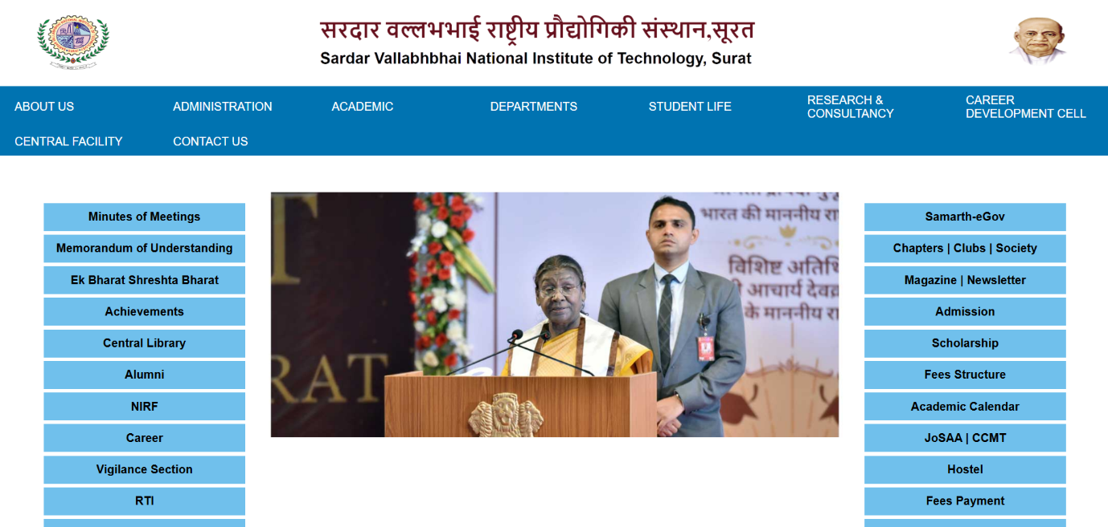

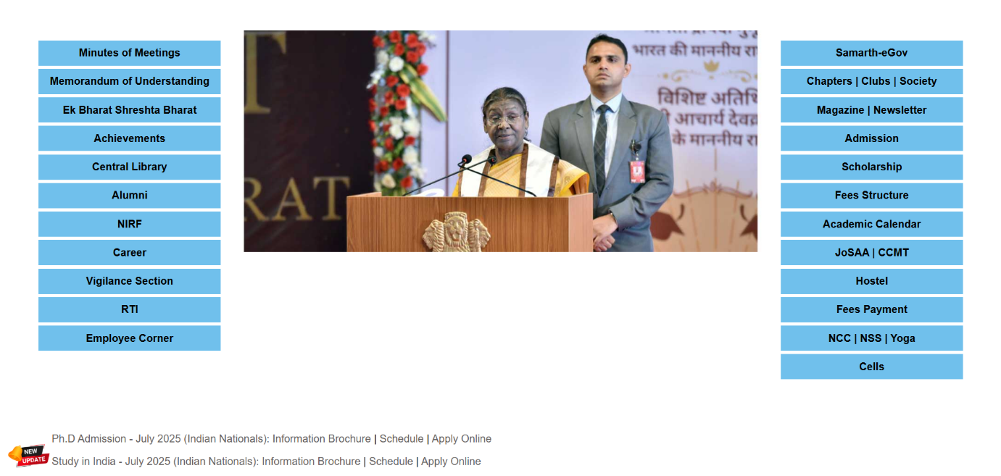

- Design Shopping Website Using HTML And CSS
Code:
<!DOCTYPE html>
<html lang="en">

<head>
<meta charset="UTF-8">
<meta name="viewport" content="width=device-width, initial-scale=1.0">
<title>Shopping Website</title>
<style>
body {
margin: 0;
font-family: Arial, sans-serif;
}

.navbar {
display: flex;
align-items: center;
background-color: #232f3e;
padding: 10px 20px;
color: white;
font-size: 14px;
font-weight: bold;
}

.logo {
width: 60px;
margin-right: 20px;
}

.navbar input[type="text"] {
flex-grow: 1;
padding: 10px;
border: none;
border-radius: 4px;
margin-right: 10px;
}

.navbar button {
background-color: #febd69;
border: none;
padding: 10px 15px;
border-radius: 4px;
cursor: pointer;
}

.navbar .menu {
margin-left: 20px;
display: flex;
gap: 15px;
}

.navbar .menu a {
text-decoration: none;
color: white;
transition: color 0.3s;
white-space: normal;
}

.navbar .menu a:hover {
color: #febd69;
}

.second_bar {
display: flex;
align-items: center;
justify-content: center;
background: #2a3644;
color: white;
padding: 10px 20px;
}

.second_bar button {
display: flex;
align-items: center;
justify-content: center;
background: #2a3644;
color: white;
padding: 10px;
text-decoration: none;
border: none;
}

.second_bar button:hover {
cursor: pointer;
border: 2px solid white;
border-radius: 2px;
}

.main {
background-image: url(amazon_back.jpg);
background-position: center center;
background-repeat: no-repeat;
background-size: cover;
height: 80vh;
display: flex;
justify-content: center;
align-items: center;
color: white;
text-align: center;
padding: 20px;
}

.box-container {
display: flex;
justify-content: center;
gap: 30px;
width: 100%;
max-width: 1200px;
margin-top: 300px;
margin-left: 30px;
margin-right: 30px;
}

.box {
background: white;
box-shadow: 0 4px 8px rgba(0, 0, 0, 0.1);
padding: 20px;
text-align: center;
width: 300px;
height: 350px;
}

.images {
display: grid;
grid-template-columns: 1fr 1fr;
gap: 10px;
}

.box img {
width: 150px;
}

.box h3 {
margin: 15px 0 10px;
text-align: left;
color: #232f3e;
}

.box p {
text-align: left;
color: #555;
font-size: 0.9rem;
}

.item a {
text-decoration: none;
}

.box button {
width: 350px;
/* height: 50px; */
margin: 10px;
padding: 5px 20px;
background-color: gold;
border: none;
border-radius: 50px;
cursor: pointer;
color: rgb(0, 0, 0);
font-size: 14px;
}

.box button:hover {
background-color: rgb(229, 198, 23);
}
</style>
</head>

<body>
<div class="navbar">
<img src="amazon_logo.webp" alt="" class="logo">
<div class="menu">
<a href="#" style="max-width: 90px; overflow-wrap: break-word; white-space: normal;">Deliver to Los Angeles</a>
</div>
<input type="text" placeholder="Search">
<button>Search</button>
<div class="menu">
<a href="#"><img src="usa.webp" alt="" width="20px"></a>
<a href="#" style="max-width: 120px; overflow-wrap: break-word; white-space: normal;">Hello, Sign In Account & Lists</a>
<a href="#" style="max-width: 60px; overflow-wrap: break-word; white-space: normal;">Returns & Orders</a>
<a href="#">Cart</a>
</div>
</div>

<div class="second_bar">
<button href="#">All</button>
<button href="#">Best Sellers</button>
<button href="#">Amazon Basics</button>
<button href="#">New Releases</button>
<button href="#">Today's Deals</button>
<button href="#">Customer Service</button>
<button href="#">Prime</button>
<button href="#">Books</button>
<button href="#">Registry</button>
<button href="#">Gift Cards</button>
<button href="#">Toys & Games</button>
<button href="#">Fashion</button>
<button href="#">Kindle Books</button>
<button href="#">Amazon Home</button>
</div>

<div class="main">
<div class="box-container">
<div class="box">
<h3>Pre-loved handbags</h3>
<div class="images">
<div class="item">
<a href="#">
<img src="gucci.jpg" alt="Product 1">
<p>Gucci</p>
</a>
</div>
<div class="item">
<a href="#">
<img src="chanel.jpg" alt="Product 1">
<p>Chanel</p>
</a>
</div>
<div class="item">
<a href="#">
<img src="louis_vuitton.jpg" alt="Product 1">
<p>Louis Vuitton</p>
</a>
</div>
<div class="item">
<a href="#">
<img src="dior.jpg" alt="Product 1">
<p>Dior</p>
</a>
</div>
</div>
</div>
<div class="box">
<h3>Spring break styles for all</h3>
<div class="images">
<div class="item">
<a href="#">
<img src="CLOTHES.jpg" alt="Product 1">
<p>Clothes</p>
</a>
</div>
<div class="item">
<a href="#">
<img src="accessories.jpg" alt="Product 1">
<p>Accessories</p>
</a>
</div>
<div class="item">
<a href="#">
<img src="sandals.jpg" alt="Product 1">
<p>Sandals</p>
</a>
</div>
<div class="item">
<a href="#">
<img src="swimwear.jpg" alt="Product 1">
<p>Swimwear</p>
</a>
</div>
</div>
</div>
<div class="box">
<h3>Deals on tech</h3>
<div class="images">
<div class="item">
<a href="#">
<img src="pc.jpg" alt="Product 1">
<p>PC</p>
</a>
</div>
<div class="item">
<a href="#">
<img src="wireless.jpg" alt="Product 1">
<p>Wireless</p>
</a>
</div>
<div class="item">
<a href="#">
<img src="software.jpg" alt="Product 1">
<p>Software</p>
</a>
</div>
<div class="item">
<a href="#">
<img src="home_entertainement.jpg" alt="Product 1">
<p>Home Entertainment</p>
</a>
</div>
</div>
</div>
<div class="box" style="width: 350px; height: 100px; display: flex; flex-direction: column; justify-content: center; align-items: center;">
<h3 style="text-align: center; white-space: nowrap; font-size: 1.2rem;">Sign in for the best experience</h3>
<button>Sign in securely</button>
</div>
</div>
</div>
</body>

</html>

Output:
