Web Programming and Python: Assignment-11
Name: Suraj Shah
Admission Number: I24AI012

1. Write a Pandas program to create
a) Date time object for Jan 15 2012.
b) Specific date and time of 9:20 pm.
c) Local date and time.
d) A date without time.
e) Current date.
t) Time from a date time.
g) Current local time.
Code:
import pandas as pd
from datetime import datetime

dt_a=pd.Timestamp('2012-01-15')
print("Date time object for Jan 15 2012:",dt_a)

dt_b=pd.Timestamp('2025-04-09 21:20')
print("Specific date and time of 9:20 pm:",dt_b)

dt_c=pd.Timestamp.now()
print("Local date and time:",dt_c)

dt_d=pd.to_datetime('2025-04-09').date()
print("A date without time:",dt_d)

dt_e=pd.Timestamp.today().date()
print("Current date:",dt_e)

dt_f=pd.Timestamp.now().time()
print("Time from a date time:",dt_f)

dt_g=datetime.now().time()
print("Current local time:",dt_g)

Output:
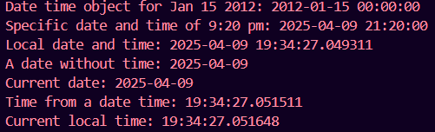

2. Write a Pandas program to convert all the string values to upper, lower cases in a given
pandas series. Also find the length of the string values.
s = pd.Series ([‘X’, ‘Y’, ‘T’, ‘Aaba’, ‘Baca’, ‘CABA’, None, ‘bird’, ‘horse’, ‘dog’])
Code:
import pandas as pd

s = pd.Series (['X', 'Y', 'T', 'Aaba', 'Baca', 'CABA', None, 'bird', 'horse', 'dog'])

upper_case=s.str.upper()
print("Upper case:\n",upper_case)

lower_case=s.str.lower()
print("Lower case:\n",lower_case)

string_length=s.str.len()
print("Length of each string:\n",string_length)

Output:
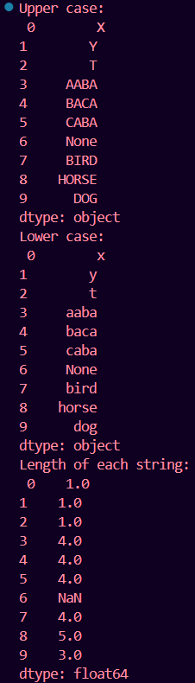
3. After accidentally leaving an ice chest of fish and shrimp in your car for a week while you
were on vacation, you’re now in the market for a new vehicle. Your insurance didn’t cover
the loss, so you want to make sure you get a good deal on your new car.
Given a Series of car asking_prices and another Series of car fair_prices, determine which
cars for sale are a good deal. In other words, identify cars whose asking price is less than
their fair price.
The result should be a list of integer indices corresponding to the good deals
in asking_prices.
Code:
import pandas as pd

asking_prices=pd.Series([13000, 15000, 18000, 12000, 16000])
fair_prices=pd.Series([14000, 15500, 17500, 12500, 15000])

good_deals=asking_prices<fair_prices

good_deals_indices=good_deals[good_deals].index.tolist()

print("Indice of good deals:", good_deals_indices)

Output:

4. Whenever your friends John and Judy visit you together, y’all have a party. Given a
DataFrame with 10 rows representing the next 10 days of your schedule and whether John
and Judy are scheduled to make an appearance, insert a new column
called days_til_party that indicates how many days until the next party.
days_til_party should be 0 on days when a party occurs, 1 on days when a party doesn’t
occur but will occur the next day, etc.
Code:
import pandas as pd
import numpy as np

df = pd.DataFrame({
'John': [True, False, True, False, True, False, False, True, True, False],
'Judy': [True, True, False, False, True, False, True, True, False, False]
})

party_days = (df['John'] & df['Judy']).values

days_til_party = np.full(len(df), fill_value=np.nan)

next_party = None
for i in reversed(range(len(df))):
if party_days[i]:
next_party = i
days_til_party[i] = 0
elif next_party is not None:
days_til_party[i] = next_party - i

df['days_til_party'] = days_til_party.astype(int)

print(df)

Output:
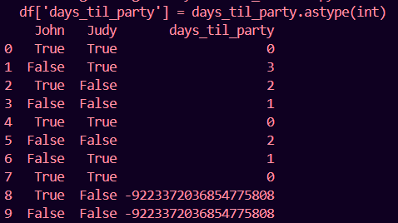
5. Given a dataset of concerts, count the number of concerts per (artist, venue), per year
month. Make the resulting table be a wide table - one row per year month with a column
for each unique (artist, venue) pair. Use the cross product of the artists and venues Series
to determine which (artist, venue) pairs to include in the result.
Code:
import pandas as pd

df = pd.DataFrame({
'artist': ['A', 'B', 'A', 'A', 'C', 'B', 'A'],
'venue': ['X', 'Y', 'X', 'Y', 'Z', 'X', 'Z'],
'date': pd.to_datetime([
'2024-01-10', '2024-01-15', '2024-01-20',
'2024-02-05', '2024-02-20', '2024-02-25', '2024-03-01'
])
})

df['year_month'] = df['date'].dt.to_period('M')

artists = df[['artist']].drop_duplicates()
venues = df[['venue']].drop_duplicates()

# Step 3: Cross join using pandas merge
cross = artists.merge(venues, how='cross')

grouped = (
df.groupby(['year_month', 'artist', 'venue'])
.size()
.rename('count')
.reset_index()
)

all_months = df[['year_month']].drop_duplicates()

full_index = all_months.merge(cross, how='cross')

full_data = (
full_index.merge(grouped, on=['year_month', 'artist', 'venue'], how='left')
.fillna(0)
)

pivot = full_data.pivot_table(
index='year_month',
columns=['artist', 'venue'],
values='count',
fill_value=0
)

pivot = pivot.reset_index()

print(pivot)

Output:
