Data Structures: Assignment-1
Name: Suraj Shah
Admission Number: I24AI012
Q1: An array is a bitonic array if all integers from index 0 to index i are sorted in
ascending order, and all subsequent integers from index i+1 to n-1 are sorted in
descending order. Given a bitonic array of n distinct integers, write a C/C++ program to
find the maximum integer in the array in O(log(n)) time.
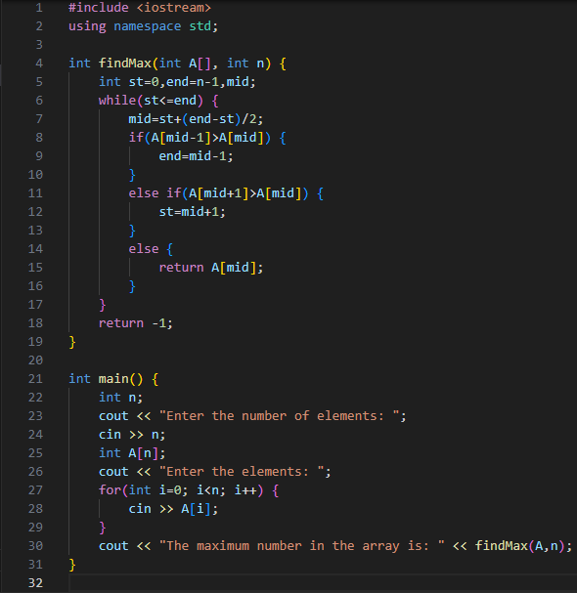
Output:
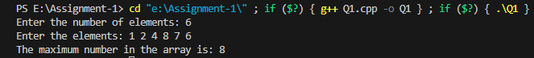
Q2: Let A[n] be an array of n distinct integers. If i < j and A[i] > A[j], then the pair (i, j)
is called an inversion of A. Write a C/C++ program that determines the number of
inversions in any permutation on n elements.
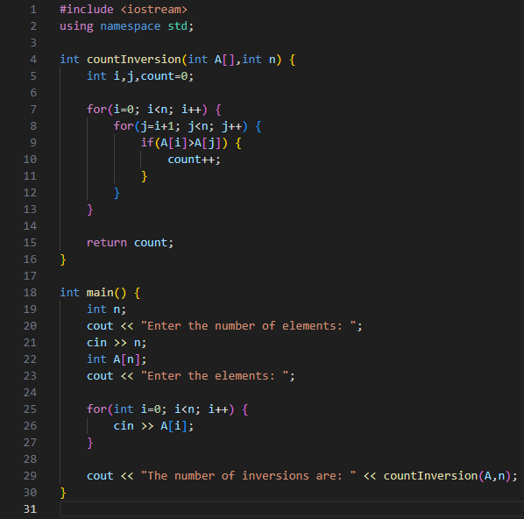
Output:
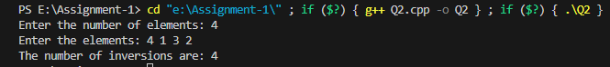

Q3: Write a C program to manage the details of students using an array of structures.
The program should:
1. Accept the number of students (n) from the user.
2. For each student, input the following details:
• Roll number (integer)
• Name (string)
• Marks (floating-point value)
3. Store the details of all students in an array of structures.
4. Display the details of all students in a formatted way.
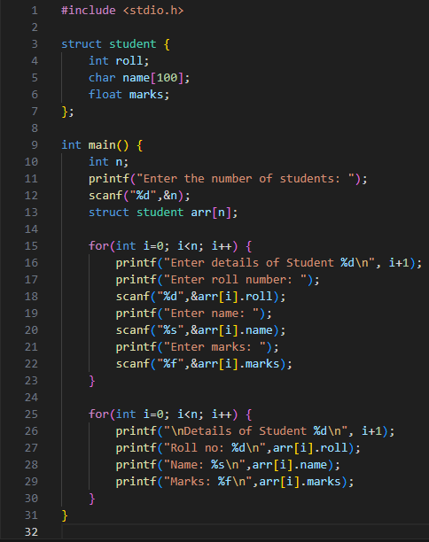
Output:
