Data Structures: Assignment-10
Name: Suraj Shah
Admission Number: I24AI012

1. You are given a text file, named “students.txt” that contains students’ records. Each Line
contains information of a single student in the form of <Student Name, Roll No,
Department>.
A. Read the records from the file into an array of structures.
B. Three Options will turn up: (1) Bubble Sort, (2) Binary Search, and (3) Quit. In the
following we describe what your C/C++ program will do on Selecting the options.
(1) Bubble Sort: Sorts the records based on Student Name. If more than One students has
the same name, then sort them on their roll no.
(2) Binary Search: Given a student name, the function will return all the Student records
<Student Name, Roll No, Department> having the Student name.
(3) Quit: Exit the program.
Code:
#include <stdio.h>
#include <string.h>
#include <stdlib.h>

#define MAX_STUDENTS 100
#define NAME_SIZE 50
#define DEPT_SIZE 30

typedef struct {
char name[NAME_SIZE];
int rollNo;
char department[DEPT_SIZE];
} Student;

int readFromFile(Student students[], const char* filename) {
FILE* file = fopen(filename, "r");
if (!file) {
printf("Error: Could not open file.\n");
return 0;
}

int count = 0;
while (fscanf(file, "%s %d %s", students[count].name, &students[count].rollNo, students[count].department) == 3) {
count++;
if (count >= MAX_STUDENTS) break;
}
fclose(file);
return count;
}

void bubbleSort(Student students[], int n) {
for (int i = 0; i < n - 1; i++) {
for (int j = 0; j < n - i - 1; j++) {
if (strcmp(students[j].name, students[j + 1].name) > 0 ||
(strcmp(students[j].name, students[j + 1].name) == 0 && students[j].rollNo > students[j + 1].rollNo)) {
Student temp = students[j];
students[j] = students[j + 1];
students[j + 1] = temp;
}
}
}
}

void binarySearch(Student students[], int n, const char* targetName) {
int found = 0;
for (int i = 0; i < n; i++) {
if (strcmp(students[i].name, targetName) == 0) {
printf("Found: %s %d %s\n", students[i].name, students[i].rollNo, students[i].department);
found = 1;
}
}
if (!found) {
printf("No records found for student name: %s\n", targetName);
}
}

int main() {
Student students[MAX_STUDENTS];
int studentCount = readFromFile(students, "students.txt");

if (studentCount == 0) {
return 1;
}

int choice;
do {
printf("Choose an option:\n1. Bubble Sort\n2. Binary Search\n3. Quit\n");
scanf("%d", &choice);

switch (choice) {
case 1:
bubbleSort(students, studentCount);
printf("Records after sorting:\n");
for (int i = 0; i < studentCount; i++) {
printf("%s %d %s\n", students[i].name, students[i].rollNo, students[i].department);
}
break;
case 2: {
char name[NAME_SIZE];
printf("Enter the name to search: ");
scanf("%s", name);
binarySearch(students, studentCount, name);
break;
}
case 3:
printf("Exiting program...\n");
break;
default:
printf("Invalid option. Try again.\n");
}
} while (choice != 3);

return 0;
}

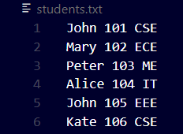
Output:
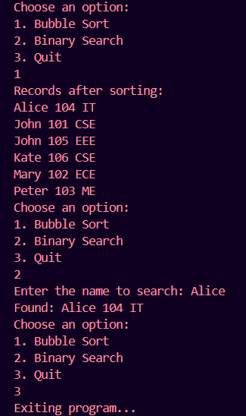

2. Let A[n] be an array of n distinct integers. If I < j and A[i] > A[j], then the pair (I, j) Is
called an inversion of A. Write a C/C++ program that determines the number of
Inversions in any permutation on n elements in O(n lg n) worst-case time. (Hint: Modify
merge sort)
Code:
#include <iostream>
using namespace std;

int count=0;
void merge(int arr[] ,int low, int mid, int high) {
int temp[high-low+1];
int i=low;
int j=mid+1;
int k=0;

while (i<=mid && j<=high) {
if (arr[i]<=arr[j]) {
temp[k++]=arr[i++];
}

else {
temp[k++]=arr[j++];
count+=mid-i+1;
}
}

while (j<=high) {
temp[k++]=arr[j++];
}

while (i<=mid) {
temp[k++]=arr[i++];
}

for (k=0, i=low; i<=high; k++, i++) {
arr[i]=temp[k];
}
}

void mergeSort(int arr[], int low, int high) {
if (low<high) {
int mid=low+(high-low)/2;
mergeSort(arr, low, mid);
mergeSort(arr, mid+1, high);
merge(arr, low, mid, high);
}
}

void printArray(int arr[], int n) {
for (int i=0; i<n; i++) {
cout << arr[i] << " ";
}
cout << endl;
}

int main() {
int n;
cout << "Enter the number of elements: ";
cin >> n;
int arr[n];
cout << "Enter the elements: ";
for (int i=0; i<n; i++) {
cin >> arr[i];
}

cout << "Array: ";
printArray(arr, n);

mergeSort(arr, 0, n-1);
cout << "Number of Inversions: " << count << endl;
}

Output:
