Data Structures: Assignment-12
Name: Suraj Shah
Admission Number: I24AI012

1. Write a C or C++ program to sort the input array [12, 45, 33, 87, 56, 9, 11, 7,
67] using the Bucket Sort algorithm with 7 buckets.
Code:
#include <iostream>
#include <vector>
#include <algorithm>

using namespace std;

void bucketSort(vector<int>& arr, int bucketCount) {
if (arr.empty()) {
return;
}

int min_value=*min_element(arr.begin(), arr.end());
int max_value=*max_element(arr.begin(), arr.end());

vector<vector<int>> buckets(bucketCount);

for (int num: arr) {
int index=(num-min_value)*bucketCount/(max_value-min_value+1);
buckets[index].push_back(num);
}

arr.clear();
for (auto bucket: buckets) {
sort(bucket.begin(), bucket.end());
arr.insert(arr.end(), bucket.begin(), bucket.end());
}
}

int main() {
vector<int> arr={12, 45, 33, 87, 56, 9, 11, 7, 67};
int bucketCount=7;

cout << "Original Array: ";
for (int num: arr) {
cout << num << " ";
}
cout << endl;

bucketSort(arr, bucketCount);

cout << "Sorted Array: ";
for (int num: arr) {
cout << num << " ";
}
cout << endl;
}

Output:
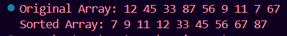

2. Write a C/C++ program that ask the user to enter 10 integer values. Use these
values to construct a binary tree with 10 nodes. After constructing the tree,
perform and display the inorder, preorder, and postorder traversals.
Code:
#include <iostream>
using namespace std;

struct Node{
int data;
Node *left;
Node *right;

Node(int val) : data(val), left(nullptr), right(nullptr) {}
};

Node *insert(Node *root, int val) {
if (root==nullptr) {
return new Node(val);
}
if (val<root->data) {
root->left=insert(root->left, val);
}
else {
root->right=insert(root->right, val);
}
return root;
}

void inorder(Node *root) {
if (root!=nullptr) {
inorder(root->left);
cout << root->data << " ";
inorder(root->right);
}
}

void preorder(Node *root) {
if (root!=nullptr) {
cout << root->data << " ";
preorder(root->left);
preorder(root->right);
}
}

void postorder(Node *root) {
if (root!=nullptr) {
postorder(root->left);
postorder(root->right);
cout << root->data << " ";
}
}

int main() {
Node *root=nullptr;
int value;

cout << "Enter 10 integer values:\n";
for (int i=0; i<10; i++) {
cout << "Value: " << i+1 << ": ";
cin >> value;
root=insert(root, value);
}

cout << "\nInorder traversal: ";
inorder(root);

cout << "\nPreorder traversal: ";
preorder(root);

cout << "\nPostorder traversal: ";
postorder(root);
}

Output:
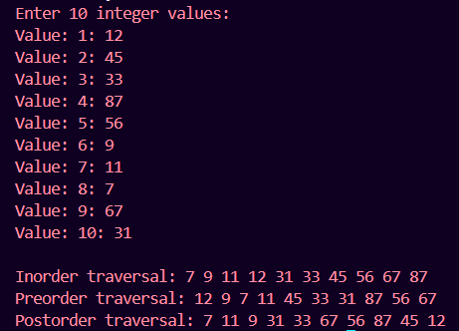

3. Given the inorder and preorder traversals of a binary tree, write a C/C++
program to construct the binary tree.
Inorder: 1, 8, 19, 13, 25, 9, 5, 10, 4, 3
Preorder: 25, 8, 1, 13, 19, 5, 9, 4, 10, 3
Code:
#include <iostream>
using namespace std;

struct Node{
int data;
Node *left;
Node *right;

Node(int val) : data(val), left(nullptr), right(nullptr) {}
};

Node *buildTree(int pre[], int lpre, int hpre, int in[], int lin, int hin) {
if (lpre<=hpre) {
Node *root=new Node(pre[lpre]);
int i=0;
for (i=lin; i<=hin; i++) {
if (pre[lpre]==in[i]) {
break;
}
}
int size=i-lin;
root->left=buildTree(pre, lpre+1, lpre+size, in, lin, lin+size-1);
root->right=buildTree(pre, lpre+size+1, hpre, in, lin+size+1, hin);
return root;
}
return nullptr;
}

void inorderTraversal(Node* root) {
if (root) {
inorderTraversal(root->left);
cout << root->data << " ";
inorderTraversal(root->right);
}
}

void preorderTraversal(Node* root) {
if (root) {
cout << root->data << " ";
preorderTraversal(root->left);
preorderTraversal(root->right);
}
}

int main() {
int inorder[]={1, 8, 19, 13, 25, 9, 5, 10, 4, 3};
int preorder[]={25, 8, 1, 13, 19, 5, 9, 4, 10, 3};
Node *root=nullptr;
int n=sizeof(inorder)/sizeof(inorder[0]);

root=buildTree(preorder, 0, n-1, inorder, 0, n-1);

cout << "Inorder (from built tree): ";
inorderTraversal(root);

cout << "\nPreorder (from built tree): ";
preorderTraversal(root);

cout << endl;
}

Output:

