Data Structures: Assignment-8
Name: Suraj Shah
Admission Number: I24AI012

Question 1: Implement a priority queue using a linked list. The queue has the
following basic operations:
● enqueue() – Insert an element in the queue.
● dequeue() – Remove the element from the queue.
● peek() – Return the element at the front node of the queue
● isFull() – Validates if the queue is full or not.
● isEmpty() – Checks if the queue is empty.Code:
#include <stdio.h>
#include <stdlib.h>

typedef struct Node {
int data;
int pri;
struct Node *next;
}Node;

void enqueue(Node **head, int pri, int data) {
Node *newNode=(Node*)malloc(sizeof(Node));
newNode->pri=pri;
newNode->data=data;
newNode->next=NULL;
if (*head==NULL) {
*head=newNode;
}

else if((*head)->pri<pri) {
newNode->next=*head;
*head=newNode;
return;
}

else {
Node *temp=*head;

while (temp->next!=NULL && temp->next->pri>pri) {
temp=temp->next;
}

newNode->next=temp->next;
temp->next=newNode;
return;
}
}

int isEmpty(Node *head) {
if (head==NULL) {
return 1;
}
return 0;
}

int dequeue(Node **head) {
if (isEmpty(*head)) {
printf("Queue is Empty\n");
return -1;
}
Node *temp=*head;
printf("%d deleted with priority %d", temp->data, temp->pri);
*head=(*head)->next;
free(temp);
}

int peek(Node **head) {
if (isEmpty(*head)) {
printf("Queue is Empty\n");
return -1;
}
printf("The front element of the queue is %d", (*head)->data);
}

int main() {
Node *head=NULL;
int choice, data, pri;
while (1) {
printf("\nPriority Queue Operations:\n");
printf("1. Enqueue\n");
printf("2. Dequeue\n");
printf("3. Peek\n");
printf("0. Exit\n");
printf("Enter your choice: ");
scanf("%d", &choice);
switch (choice) {
case 1:
printf("Enter data: ");
scanf("%d", &data);
printf("Enter priority: ");
scanf("%d", &pri);
enqueue(&head, pri, data);
break;
case 2:
dequeue(&head);
break;
case 3:
peek(&head);
break;
case 0:
return 0;

default:
printf("Invalid choice!\n");
}
}
}

Output:
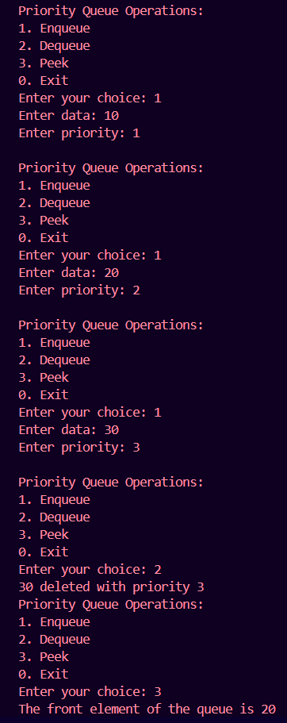
Question 2: Implement a Circular queue using a linked list. The queue has the
following basic operations:
● enqueue() – Insert an element in the queue.
● dequeue() – Remove the element from the queue.
● peek() – Return the element at the front node of the queue
● isFull() – Validates if the queue is full or not.
● isEmpty() – Checks if the queue is empty.
Code:
#include <stdio.h>
#include <stdlib.h>

typedef struct Node {
int data;
struct Node *next;
}Node;

void enqueue(Node **f, Node **r, int data) {
Node *newNode=(Node*)malloc(sizeof(Node));
newNode->data=data;
newNode->next=NULL;
if (*r==NULL) {
*r=newNode;
*f=newNode;
}
else {
(*r)->next=newNode;
*r=newNode;
newNode->next=*f;
}
}

int isEmpty(Node *f) {
if (f==NULL) {
return 1;
}
return 0;
}

int dequeue(Node **f, Node **r) {
Node *temp=*f;
if (isEmpty(*f)) {
printf("Queue is Empty\n");
return -1;
}

else {
(*r)->next=(*f)->next;
*f=(*f)->next;
printf("Element deleted: %d", temp->data);
free(temp);
}
}

int peek(Node **f, Node **r) {
if (isEmpty(*f)) {
printf("Queue is Empty\n");
return -1;
}
print("The front element of the queue is %d", (*f)->data);
}

int main() {
Node *front=NULL;
Node *rear=NULL;
int choice, data;
while (1) {
printf("\nQueue Operations:\n");
printf("1. Enqueue\n");
printf("2. Dequeue\n");
printf("3. Peek\n");
printf("0. Exit\n");
printf("Enter your choice: ");
scanf("%d", &choice);
switch (choice) {
case 1:
printf("Enter data: ");
scanf("%d", &data);
enqueue(&front, &rear, data);
break;
case 2:
dequeue(&front, &rear);
break;
case 3:
peek(&front, &rear);
break;
case 0:
return 0;

default:
printf("Invalid choice!\n");
}
}
}

Output:
