Database Management Systems: Assignment-1
Name: Suraj Shah
Admission Number: I24AI012

Q1: Create a table EMPLOYEE with following schema:
(Emp_no, E_name, E_address, E_ph_no, Dept_no, Dept_name,Job_id , Salary)

- Add a new column; HIREDATE to the existing relation.
Query:
ALTER TABLE employee
ADD HIREDATE date NOT NULL;
Output:
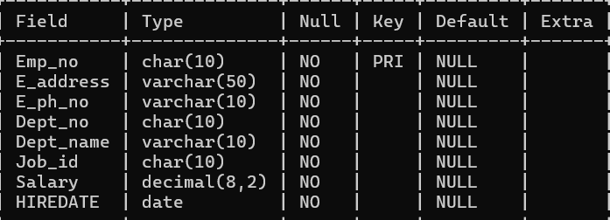

- Change the datatype of JOB_ID from char to varchar.
Query:
ALTER TABL employee
MODIFY job_id varchar(10) NOT NULL;
Output:
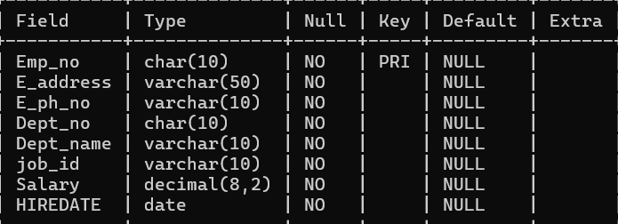

- Change the name of column/field Emp_no to E_no.
Query:
ALTER TABLE employee
CHANGE COLUMN Emp_no E_no char(10);
Output:
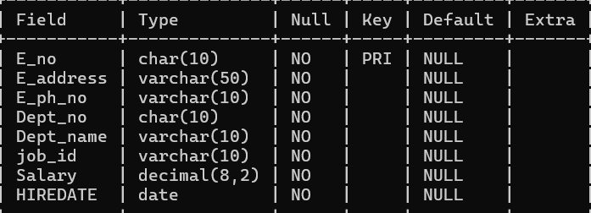

- Modify the column width of the job field of emp table
Query:
ALTER TABLE employee
MODIFY job_id varchar(20) NOT NULL;
Output:
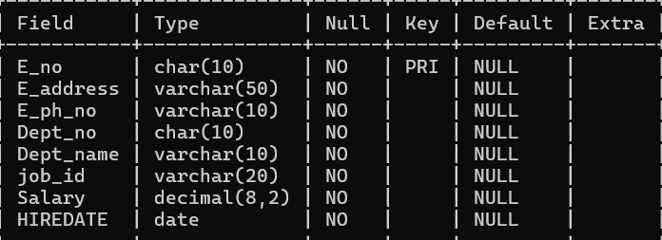

Q2: Create following tables as per given schema:
1. Create Table “employee”
create table (empid varchar(10) primary key, empname varchar2(20) not null,
gender varchar2(7) not null, age number(3) not null, dept varchar2(15) not null,
dob date not null, doj date not null);
2. Create table “salary”
create table salary (empid varchar(10) references employee(empid), salary
number(10) not null, dept varchar(15) not null, branch varchar2(20) not null);
3. Create table “branchtable”
create table branchtable (branch varchar2(20) not null, city varchar2(20) not null);
Perform the following operations:

- Add a new column named designation in the employee table.
Query:
ALTER TABLE employee
ADD designation varchar(20) NOT NULL;
Output:
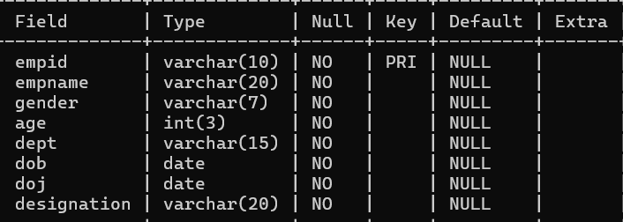

- To drop a column from table salary.
Query:
ALTER TABLE salary
DROP COLUMN branch;
Output:
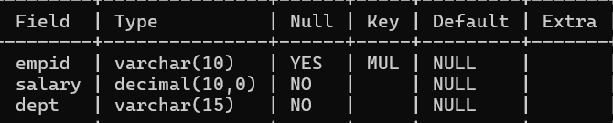
- Rename the table employee to emp.
Query:
ALTER TABLE employee
RENAME TO emp;
Output:
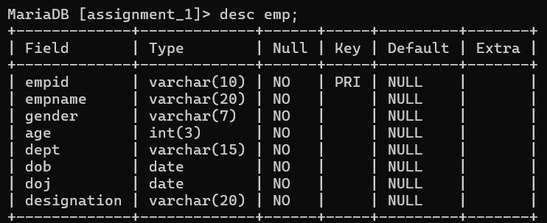

- Display the tables.
Query:
DESC emp;
Output: 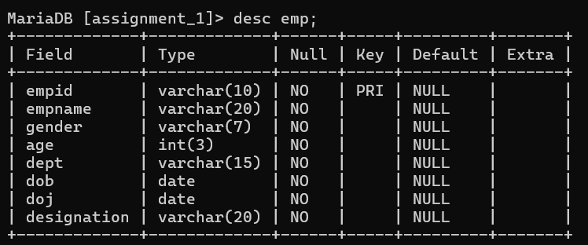

Query:
DESC salary;
Output:
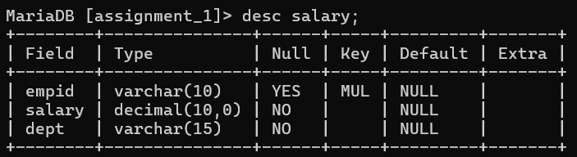

Query:
DESC branchtable;
Output:
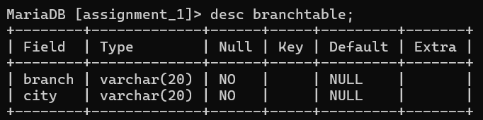

- Perform drop and truncate operations.
Query:
DROP TABLE branchtable;
Output:

Input:
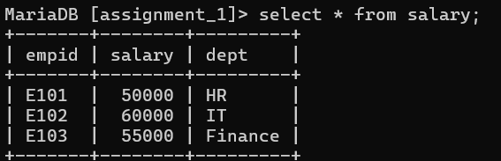
Query:
TRUNCATE TABLE salary;
Output:
