Database Management Systems: Assignment-10
Name: Suraj Shah
Admission Number: I24AI012

Create the below given table and insert the data accordingly.
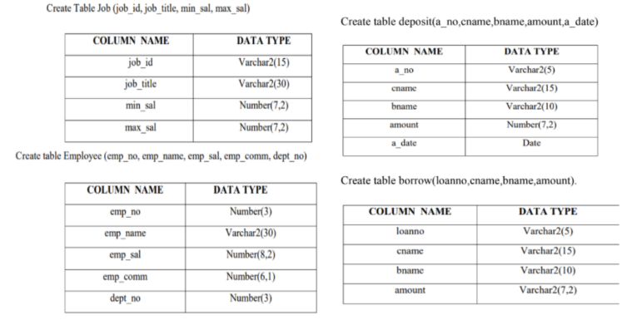
Insert five records in the tables given above and perform followings:
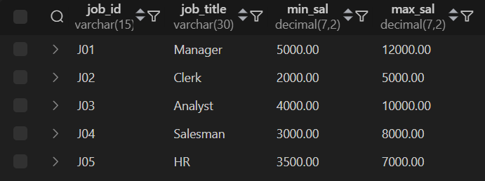
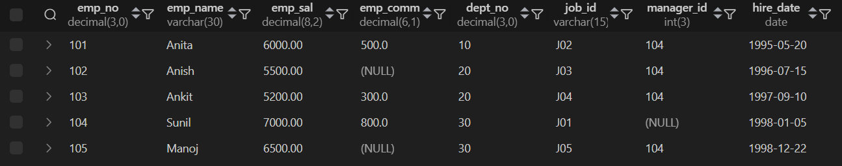
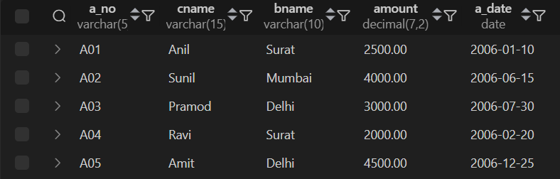
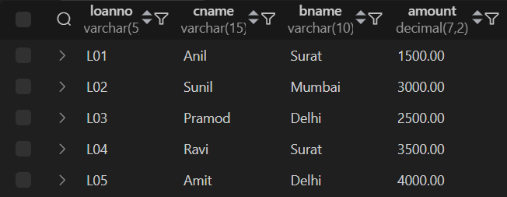

- Give details of account no. and deposited rupees of customers having account opened between dates 01-01-06 and 25-07-06.
Query:
SELECT a_no, amount FROM deposit WHERE a_date BETWEEN '2006-01-01' AND '2006-07-25';
Output:
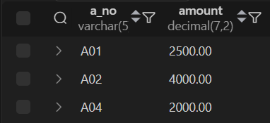

- Display name and salary of employee whose department no is 20. Give alias name to name of employee.
Query:
SELECT emp_name AS "Employee Name", emp_sal FROM Employee WHERE dept_no = 20;
Output:


- Display name, number and salary of those employees whose name is 5 characters long and first three characters are ‘Ani’.
Query:
SELECT emp_name, emp_no, emp_sal FROM Employee WHERE emp_name LIKE 'Ani__';
Output:


- Display the non-null values of employees and also employee name second character should be ‘n’ and string should be 5 character long.
Query:
SELECT * FROM Employee WHERE emp_name LIKE '_n___';
Output:
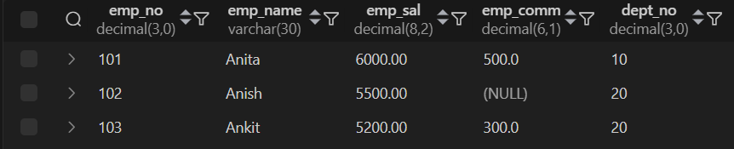

- What will be output if you are giving LIKE predicate as ‘%\_%’ ESCAPE ‘\’?
Answer:
-- LIKE '%\_%' ESCAPE '\'
-- Matches any string containing a literal underscore '_'

- For each employee, display the employee number, job, salary, and salary increased by 15% and expressed as a whole number. Label the column New Salary.
Query:
SELECT emp_no, emp_name, emp_sal, ROUND(emp_sal * 1.15) AS "New Salary" FROM Employee;
Output:
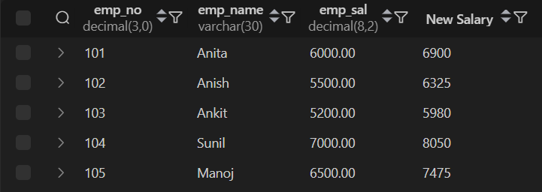

- Modify your query no 4.(2) to add a column that subtracts the old salary from the new salary. Label the column Increase.
Query:
SELECT emp_no, emp_name, emp_sal, ROUND(emp_sal * 1.15) AS "New Salary", ROUND(emp_sal * 0.15) AS "Increase" FROM Employee;
Output:
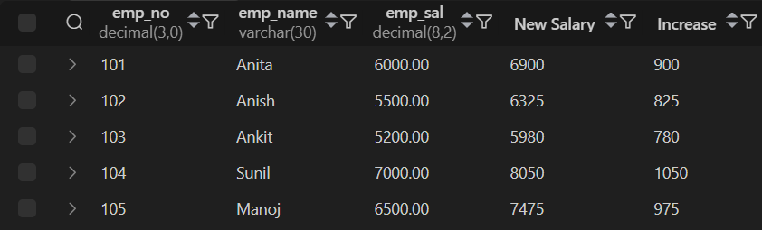

- Write a query that displays the employee’s names with the first letter capitalized and all other letters lowercase, and the length of the names, for all employees whose name starts with J, A, or M. Give each column an appropriate label. Sort the results by the employees’ last names.
Query:
SELECT CONCAT(UCASE(LEFT(emp_name, 1)), LCASE(SUBSTRING(emp_name, 2))) AS "Proper Name", LENGTH(emp_name) AS "Name Length" FROM Employee WHERE UPPER(SUBSTR(emp_name, 1, 1)) IN ('J', 'A', 'M') ORDER BY emp_name;
Output:
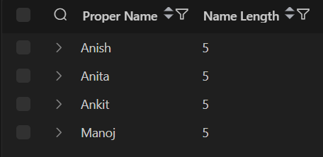

- Create a unique listing of all jobs that are in department 30. Include the location of the department in the output. (Use join)
Department
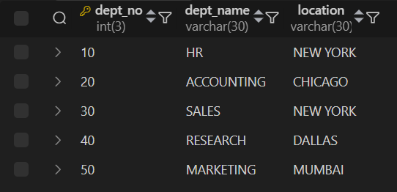
Query:
SELECT DISTINCT j.job_title, d.location FROM Employee e JOIN Job j ON e.job_id = j.job_id JOIN department d ON e.dept_no = d.dept_no WHERE e.dept_no = 30;
Output:


- Write a query to display the employee name, department number, and department name for all employees who work in NEW YORK. (Use join)
Query:
SELECT e.emp_name, e.dept_no, d.dept_name FROM Employee e JOIN department d ON e.dept_no = d.dept_no WHERE d.location = 'New York';
Output:
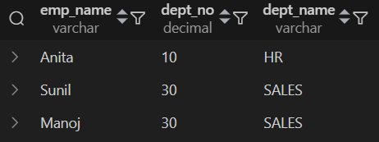

- Display the employee’s last name and employee number along with their manager’s last name and manager number. Label the columns Employee, Emp#, Manager, and Mgr#, respectively. (Use join)
Query:
SELECT e.emp_name AS Employee, e.emp_no AS "Emp#", m.emp_name AS Manager, m.emp_no AS "Mgr#" FROM Employee e JOIN Employee m ON e.manager_id = m.emp_no;
Output:
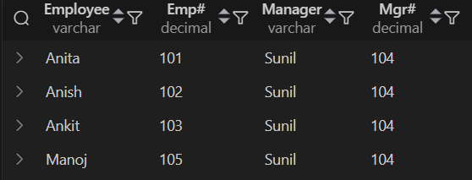

- Write a query that displays the difference between the highest and lowest salaries. Label the column DIFFERENCE.
Query:
SELECT MAX(emp_sal) - MIN(emp_sal) AS DIFFERENCE FROM Employee;
Output:


- Create a query that will display the total number of employees and, of that total, the number of employees hired in 1995, 1996, 1997, and 1998.
Query:
SELECT COUNT(*) AS Total_Employees, SUM(YEAR(hire_date) = 1995) AS Hired_1995, SUM(YEAR(hire_date) = 1996) AS Hired_1996, SUM(YEAR(hire_date) = 1997) AS Hired_1997, SUM(YEAR(hire_date) = 1998) AS Hired_1998 FROM Employee;
Output:

- Find the average salaries for each department without displaying the respective department numbers.
Query:
SELECT AVG(emp_sal) FROM Employee GROUP BY dept_no;
Output:
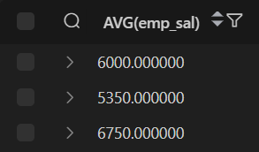

- Write a query to display the total salary being paid to each job title, within each department.
Query:
SELECT d.dept_no, j.job_title, SUM(e.emp_sal) AS Total_Salary FROM Employee e JOIN Job j ON e.job_id = j.job_id JOIN department d ON e.dept_no = d.dept_no GROUP BY d.dept_no, j.job_title ORDER BY d.dept_name, j.job_title;
Output:
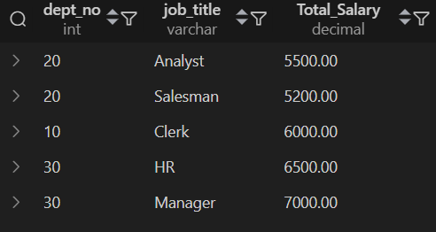

- Find the average salaries > 2000 for each department without displaying the respective department numbers.
Query:
SELECT AVG(emp_sal) FROM Employee WHERE emp_sal > 2000 GROUP BY dept_no;
Output:
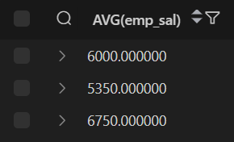

- Give name of customers who are depositors having same branch city of mr. sunil. (Use sub query)
Query:
SELECT cname FROM deposit WHERE bname = (SELECT bname FROM deposit WHERE cname = 'Sunil');
Output:


- Give deposit details and loan details of customer in same city where pramod is living. (Use sub query)
Query:
SELECT a_no AS id, cname, bname, amount, a_date AS transaction_date, 'Deposit' AS type FROM deposit WHERE bname = (SELECT bname FROM deposit WHERE cname = 'Pramod') UNION SELECT loanno AS id, cname, bname, amount, NULL AS transaction_date, 'Loan' AS type FROM borrow WHERE bname = (SELECT bname FROM deposit WHERE cname = 'Pramod');
Output:
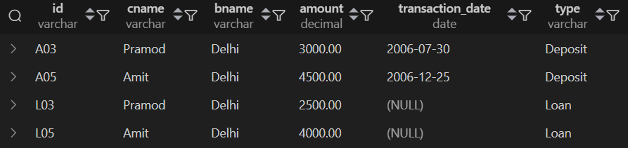

- Create a query to display the employee numbers and last names of all employees who earn more than the average salary. Sort the results in ascending order of salary. (Use sub query)
Query:
SELECT emp_no, emp_name FROM Employee WHERE emp_sal > (SELECT AVG(emp_sal) FROM Employee) ORDER BY emp_sal;
Output:


- Give names of depositors having same living city as mr. anil and having deposit amount greater than 2000. (Use sub query)
Query:
SELECT cname FROM deposit WHERE bname = (SELECT bname FROM deposit WHERE cname = 'Anil') AND amount > 2000;
Output:


- Display the last name and salary of every employee who reports to ford. (Use sub query)
Query:
SELECT emp_name, emp_sal FROM Employee WHERE manager_id = (SELECT emp_no FROM Employee WHERE emp_name = 'Ford');
Output:


- Display the department number, name, and job for every employee in the accounting department. (Use sub query)
Query:
SELECT e.dept_no, e.emp_name, (SELECT j.job_title FROM Job j WHERE j.job_id = e.job_id) AS job_title FROM Employee e WHERE dept_no = (SELECT dept_no FROM department WHERE dept_name = 'ACCOUNTING');
Output:


- List the name of branch having highest number of depositors. (Use sub query)
Query:
SELECT bname FROM deposit GROUP BY bname HAVING COUNT(cname) = (SELECT MAX(depositor_count) FROM (SELECT bname, COUNT(cname) AS depositor_count FROM deposit GROUP BY bname) AS sub);
Output:


