Database Management Systems: Assignment-11
Name: Suraj Shah
Admission Number: I24AI012

Q 1. PL/SQL Program for Prime Number.
Code:
DECLARE
num NUMBER:=&num;
i NUMBER;
flag BOOLEAN:=TRUE;
BEGIN
IF num<=1 THEN
flag:=FALSE;
ELSE
FOR i IN 2 .. FLOOR(SQRT(num)) LOOP
IF num MOD i = 0 THEN
flag:=FALSE;
EXIT;
END IF;
END LOOP;
END IF;

IF flag THEN
DBMS_OUTPUT.PUT_LINE(num || ' is a prime number.');
ELSE
DBMS_OUTPUT.PUT_LINE(num || ' is NOT a prime number.');
END IF;
END;
/
Output:
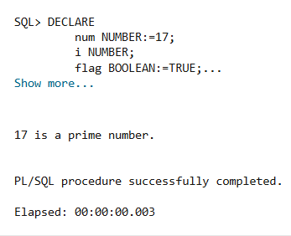

Q 2. PL/SQL Program for Reverse of a Number.
Code:
DECLARE
num NUMBER:=&num;
original NUMBER:=num;
rev NUMBER:=0;
digit NUMBER;
BEGIN
WHILE num>0 LOOP
digit:=MOD(num, 10);
rev:=rev*10+digit;
num:=TRUNC(num/10);
END LOOP;

DBMS_OUTPUT.PUT_LINE('Original Number: ' || original);
DBMS_OUTPUT.PUT_LINE('Reversed Number: ' || rev);
END;
/
Output:
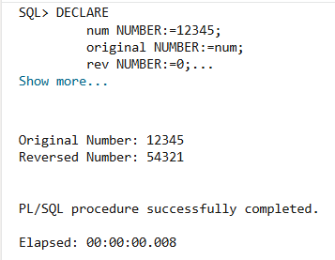

Q 3. PL/SQL Program for Fibonacci Series.
Code:
DECLARE
n NUMBER:=&n;
a NUMBER:=0;
b NUMBER:=1;
c NUMBER;
i NUMBER:=1;
BEGIN
DBMS_OUTPUT.PUT_LINE('Fibonacci Series:');

WHILE i<=n LOOP
DBMS_OUTPUT.PUT_LINE(a);

c:=a+b;
a:=b;
b:=c;

i:=i+1;
END LOOP;
END;
/
Output:
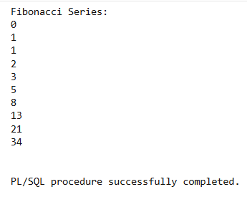

Q 4. PL/SQL Program to Check Number is Odd or Even.
Code:
DECLARE
num NUMBER:=&num;
BEGIN
IF MOD(num, 2)=0 THEN
DBMS_OUTPUT.PUT_LINE(num || ' is Even.');
ELSE
DBMS_OUTPUT.PUT_LINE(num || ' is Odd.');
END IF;
END;
/
Output:
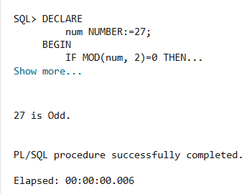

Q 5. PL/SQL Program to Reverse a String.
Code:
DECLARE
str VARCHAR2(100):='&str';
rev VARCHAR2(100):='';
i NUMBER;
BEGIN
FOR i IN REVERSE 1 .. LENGTH(str) LOOP
rev:=rev || SUBSTR(str, i, 1);
END LOOP;

DBMS_OUTPUT.PUT_LINE('Original String: ' || str);
DBMS_OUTPUT.PUT_LINE('Reversed String: ' || rev);
END;
/
Output:
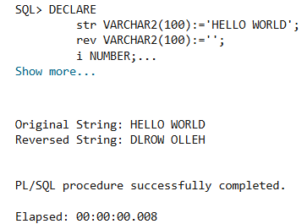

Q 6. Pl/SQL Program for Palindrome Number.
Code:
DECLARE
num NUMBER:=&num;
original NUMBER:=num;
rev NUMBER:=0;
digit NUMBER;
BEGIN
WHILE num>0 LOOP
digit:=MOD(num, 10);
rev:=rev*10+digit;
num:=TRUNC(num/10);
END LOOP;

IF rev=original THEN
DBMS_OUTPUT.PUT_LINE(original || ' is a Palindrome Number.');
ELSE
DBMS_OUTPUT.PUT_LINE(original || ' is NOT a Palindrome Number');
END IF;
END;
/
Output:
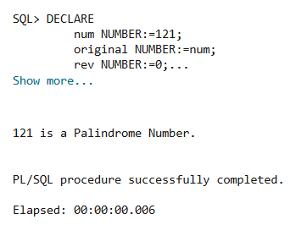

Q7. PL/SQL Program to Swap two Numbers.
Code:
DECLARE
a NUMBER:=&a;
b NUMBER:=&b;
temp NUMBER;
BEGIN
DBMS_OUTPUT.PUT_LINE('Before Swap: A=' || a || ', B=' || b);

temp:=a;
a:=b;
b:=a;

DBMS_OUTPUT.PUT_LINE('After Swap: A=' || a || ', B=' || b);
END;
/
Output:
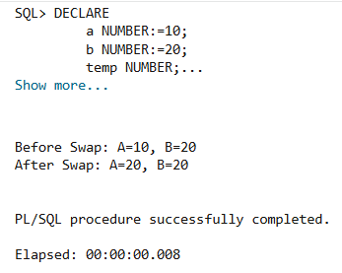

Q8. PL/SQL Program for Armstrong Number.
Code:
DECLARE
num NUMBER:=&num;
original NUMBER:=num;
digit NUMBER;
sum NUMBER:=0;
n NUMBER;
BEGIN
n:=LENGTH(num);

WHILE num>0 LOOP
digit:=MOD(num, 10);
sum:=sum+POWER(digit, n);
num:=TRUNC(num/10);
END LOOP;

IF sum=original THEN
DBMS_OUTPUT.PUT_LINE(original || ' is an Armstrong Number.');
ELSE
DBMS_OUTPUT.PUT_LINE(original || ' is NOT an Armstrong Number.');
END IF;
END;
/
Output:
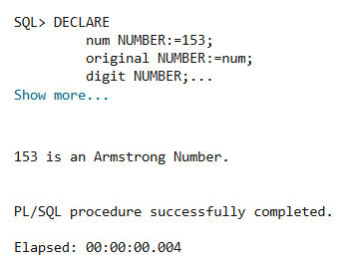

Q9. PL/SQL Program to Find Greatest of Three Numbers.
Code:
DECLARE
a NUMBER:=&a;
b NUMBER:=&b;
c NUMBER:=&c;
greatest NUMBER;
BEGIN
IF a>=b AND a>=c THEN
greatest:=a;
ELSIF b>=a AND b>=c THEN
greatest:=b;
ELSE
greatest:=c;
END IF;

DBMS_OUTPUT.PUT_LINE('Greatest Number= ' || greatest);
END;
/
Output:
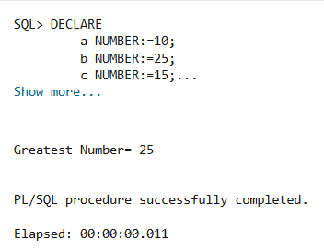

Q10. PL/SQL Program to Print Patterns.


Code:
BEGIN
FOR i IN 1..5 LOOP
DBMS_OUTPUT.PUT_LINE(RPAD('*', i, '*'));
END LOOP;
END;
/
Output:
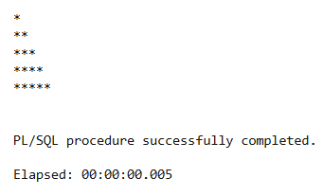


Code:
BEGIN
FOR i IN REVERSE 1..5 LOOP
DBMS_OUTPUT.PUT_LINE(LPAD(' ', 5-i) || RPAD('*', i, '*'));
END LOOP;
END;
/
Output:
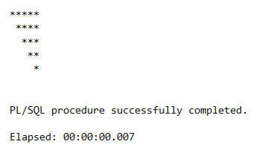


Code:
BEGIN
FOR i IN 1..5 LOOP
DBMS_OUTPUT.PUT_LINE(LPAD(' ', 5-i) || RPAD('*', 2*i-1, '*'));
END LOOP;
END;
/
Output:
