Database Management Systems: Assignment-12
Name: Suraj Shah
Admission Number: I24AI012

Q1 Perform the following tasks: (Use employee table from assignment 2)

- Write a program in PL/SQL to display a cursor based detail information of employees from employees table.
Code:
DECLARE
CURSOR emp_cur IS
SELECT emp_id, first_name, last_name, job_id, salary, dept_id
FROM employee;

v_emp_id employee.emp_id%TYPE;
v_fname employee.first_name%TYPE;
v_lname employee.last_name%TYPE;
v_job employee.job_id%TYPE;
v_salary employee.salary%TYPE;
v_dept employee.dept_id%TYPE;
BEGIN
OPEN emp_cur;

LOOP
FETCH emp_cur INTO v_emp_id, v_fname, v_lname, v_job, v_salary, v_dept;
EXIT WHEN emp_cur%NOTFOUND;

DBMS_OUTPUT.PUT_LINE(
'ID: ' || v_emp_id ||
', Name: ' || v_fname || ' ' || v_lname ||
', Job: ' || v_job ||
', Salary: ' || v_salary ||
', Dept: ' || v_dept
);
END LOOP;

CLOSE emp_cur;
END;
/
Output:
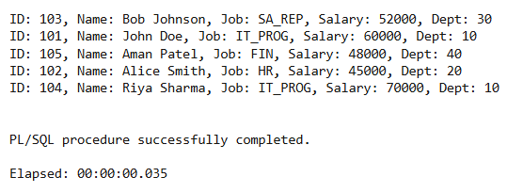

- Write a program in PL/SQL to retrieve the records from the employees table and display them using cursors.
Code:
DECLARE
CURSOR c_emp IS
SELECT * FROM employee;

v_emp employee%ROWTYPE;
BEGIN
OPEN c_emp;

LOOP
FETCH c_emp INTO v_emp;
EXIT WHEN c_emp%NOTFOUND;

DBMS_OUTPUT.PUT_LINE(
v_emp.emp_id || ' - ' ||
v_emp.first_name || ' ' || v_emp.last_name ||
' - Job: ' || v_emp.job_id ||
' - Salary: ' || v_emp.salary ||
' - Dept: ' || v_emp.dept_id
);
END LOOP;

CLOSE c_emp;
END;
/
Output:
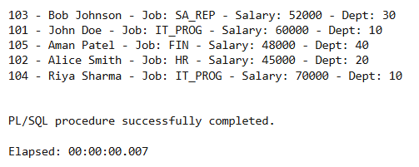

- Write a program in PL/SQL to create an implicit cursor with for loop.
Code:
BEGIN
FOR r IN (SELECT emp_id, first_name, last_name, salary FROM employee)
LOOP
DBMS_OUTPUT.PUT_LINE(
r.emp_id || ' - ' || r.first_name || ' ' ||
r.last_name || ' - Salary: ' || r.salary
);
END LOOP;
END;
/
Output:
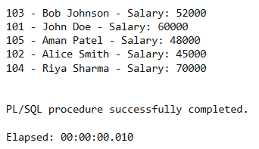

- Write a program in PL/SQL to create an explicit cursor with for loop.
Code:
DECLARE
CURSOR emp_cursor IS
SELECT emp_id, first_name, last_name, job_id
FROM employee;
BEGIN
FOR rec IN emp_cursor LOOP
DBMS_OUTPUT.PUT_LINE(
rec.emp_id || ' - ' || rec.first_name || ' ' ||
rec.last_name || ' - Job: ' || rec.job_id
);
END LOOP;
END;
/
Output:
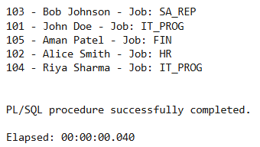

Q2 Considering the tables of Assignment 9 (Question-3), perform the
following tasks:

- Create a trigger to update the remaining quantity of books in the ORDER_DETAILS table, when a new entry is inserted.
Code:
CREATE OR REPLACE TRIGGER trg_update_remaining_qty
AFTER INSERT ON order_details
FOR EACH ROW
BEGIN
UPDATE books
SET qty_available = qty_available - :NEW.qty_ordered
WHERE book_id = :NEW.book_id;
END;
/
Output:
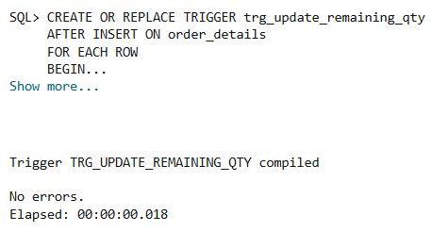

- Create a trigger to find the difference between old no. of quantities of books and new no. of quantities of books.
Code:
CREATE OR REPLACE TRIGGER trg_qty_difference
BEFORE UPDATE ON order_details
FOR EACH ROW
DECLARE
diff NUMBER;
BEGIN
diff := :NEW.qty_ordered - :OLD.qty_ordered;

DBMS_OUTPUT.PUT_LINE('Quantity difference: ' || diff);

UPDATE books
SET qty_available = qty_available - diff
WHERE book_id = :NEW.book_id;
END;
/
Output:
