Database Management Systems: Assignment-2
Name: Suraj Shah
Admission Number: I24AI012

Q1. Create a table Student with these fields:
RollNo Number (6), Name Character (25), Semester Number (3), DOB Date,
AdmissionDate Date, HostelRoom Number (5)
Insert 10 Rows in the above created table.
Display the below details:

- Student table with all columns and rows.
Query:
SELECT * FROM student;
Output:
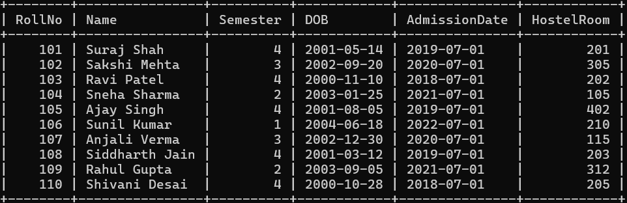

- Student details with columns Roll number and Name only.
Query:
SELECT RollNo, Name FROM student;
Output:
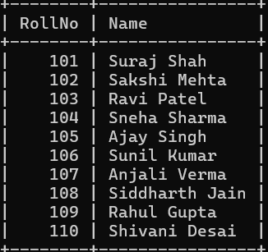
- Student details of all the students who are in 4th semester.
Query:
SELECT * FROM student WHERE Semester=4;
Output:
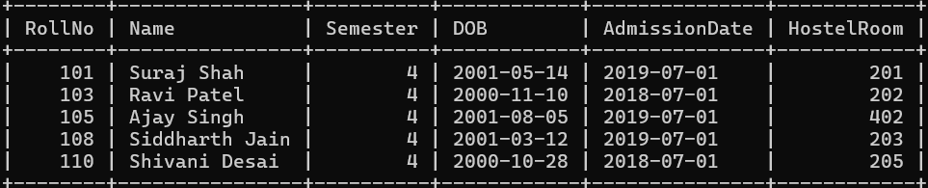

- Student details of all the students whose roll number is between 100 to 200.
Query:
SELECT * FROM student WHERE RollNo BETWEEN 100 AND 200;
Output:


- Student details of all the students whose DOB is greater than 1st jan 2001.
Query:
SELECT * FROM student WHERE DOB > '2001-01-01';
Output:
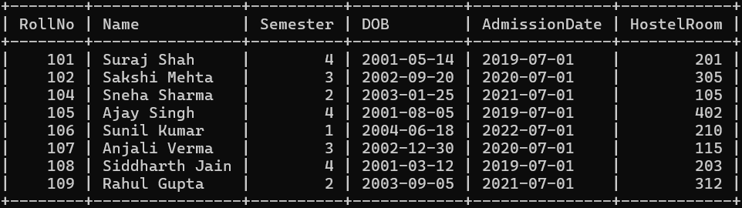

- Student details of a student with enrollment number ‘07’
Query:
SELECT * FROM student WHERE RollNo=107;
Output:
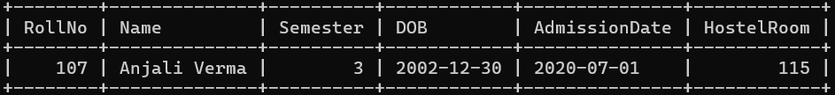

- Students who reside on the second floor in the hostel.
Query:
SELECT * FROM student WHERE HostelRoom LIKE '2%';
Output:
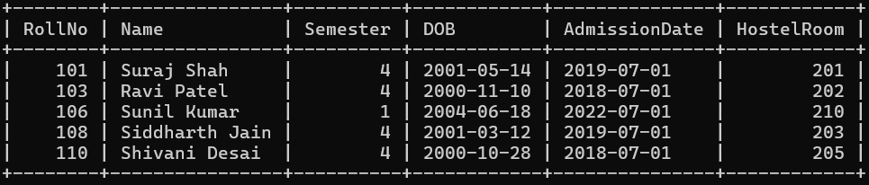

- Students whose name starts with ‘S’
Query:
SELECT * FROM Student WHERE Name LIKE 'S%';
Output:
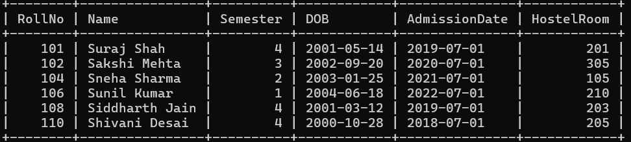

Q2. Create a table Employee with these fields:
EmpID Number (6), Name Character (25), Department Character (30), ManagerID
Number (6), JoiningDate Date, Salary Number (8)
Insert 10 Rows in the above created table.
Display the below details:

- Employee table with all columns and rows.
Query:
SELECT * FROM employee;
Output:
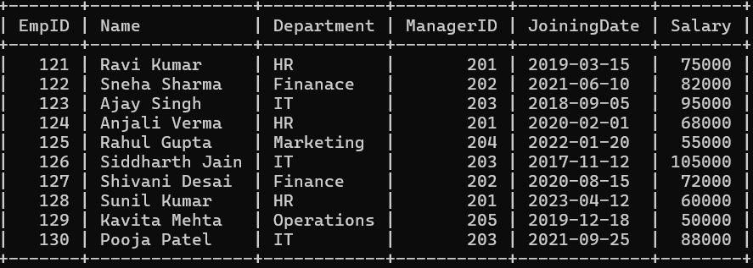

- Employee details with columns Name and Department only.
Query:
SELECT Name, Department FROM employee;
Output:
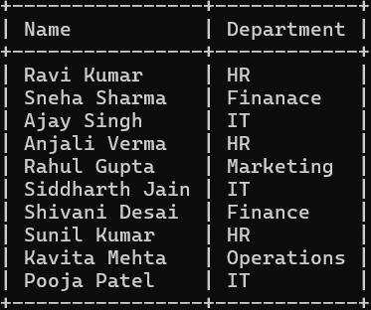

- Employee details of all the Employees who are in HR department.
Query:
SELECT * FROM employee WHERE Department='HR';
Output:
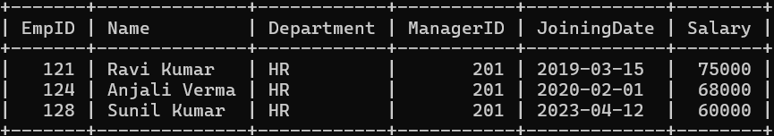

- Employee details of an employee whose EmpID is ‘124’
Query:
SELECT * FROM employee WHERE EmpID=124;
Output:
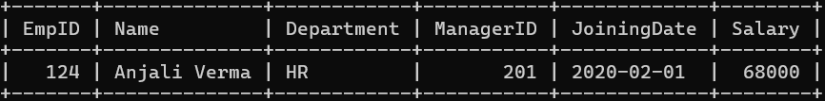

- Employee details of all the Employees whose salary is between 50000 to 100000.
Query:
SELECT * FROM employee WHERE Salary BETWEEN 50000 AND 100000;
Output:
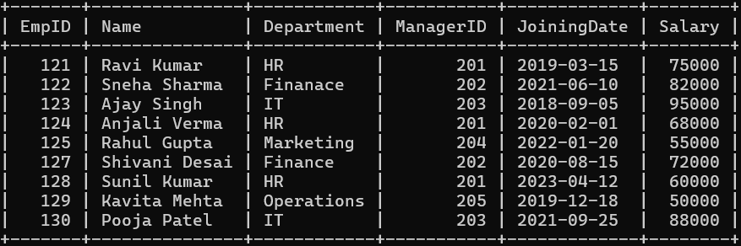

- Employee details of all the Employees whose JoiningDate is greater than 1st jan 2020.
Query:
SELECT * FROM employee WHERE JoiningDate > '2020-01-01';
Output:
