Database Management Systems: Assignment-3
Name: Suraj Shah
Admission Number: I24AI012

Q1. National Hockey League (NHL)
Suppose you are given the following requirements for a simple database for the
National Hockey League (NHL):
● The NHL has many teams,
● Each team has a name, a city, a coach, a captain, and a set of players,
● Each player belongs to only one team,
● Each player has a name, a position (such as left wing or goalie), a skill level,
and a set of injury records,
● A team captain is also a player,
● A game is played between two teams (referred to as host_team and
guest_team) and has a date (such as May 11th, 2017) and a score (such as 4 to
2).
Construct a clean and concise ER diagram. List your assumptions and clearly
indicate the cardinality mappings as well as any role indicators in your ER diagram.
Output:
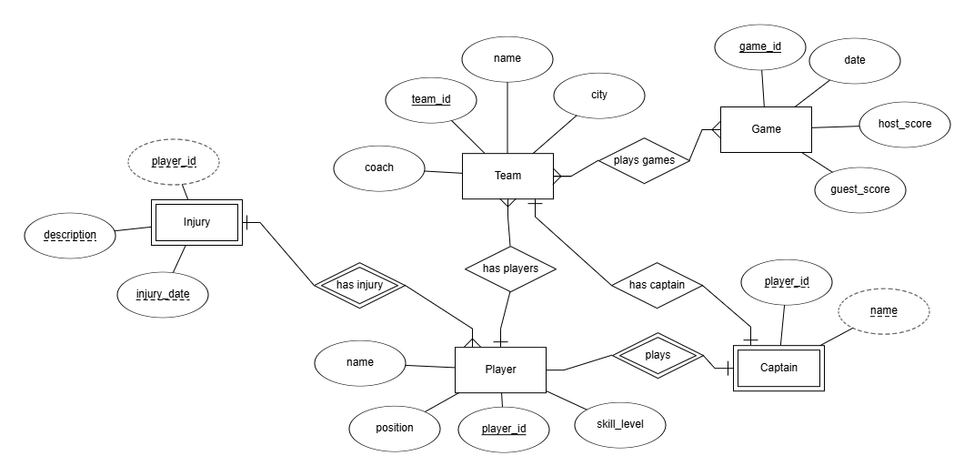

Q2. Book Bank Management System (BBM)
SVNIT has a huge book library. BBM manages the book information like book title,
ISBN number, authors, publisher, year of publication, price, number of copies, etc.
Enrolled students can borrow the book from the library for the whole semester and
can return the book at the end of the last exam day of that semester. If a book is not
returned before the return date, then a penalty will be taken from the student. The
penalty is 1 Rupee for each delay day.
For each academic year the BBM section maintains the book transaction records of
issues and returns to prepare different types of reports.

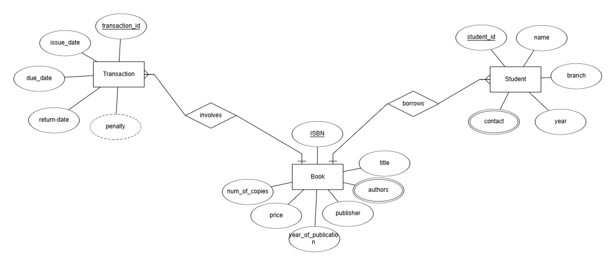
Output:

