Database Management Systems: Assignment-4
Name: Suraj Shah
Admission Number: I24AI012

Q1. A manufacturing company produces products. The following product information is
stored: product name, product ID and quantity on hand. These products are made up
of many components. Each component can be supplied by one or more suppliers.
The following component information is kept: component ID, name, description,
suppliers who supply them, and products in which they are used.
Create an ERD to show how you would track this information.
Show entity names, primary keys, attributes for each entity, relationships between the
entities and cardinality.
Assumptions
1. A supplier can exist without providing components.
2. A component does not have to be associated with a supplier.
3. A component does not have to be associated with a product. Not all
components are used in products.
4. A product cannot exist without components.
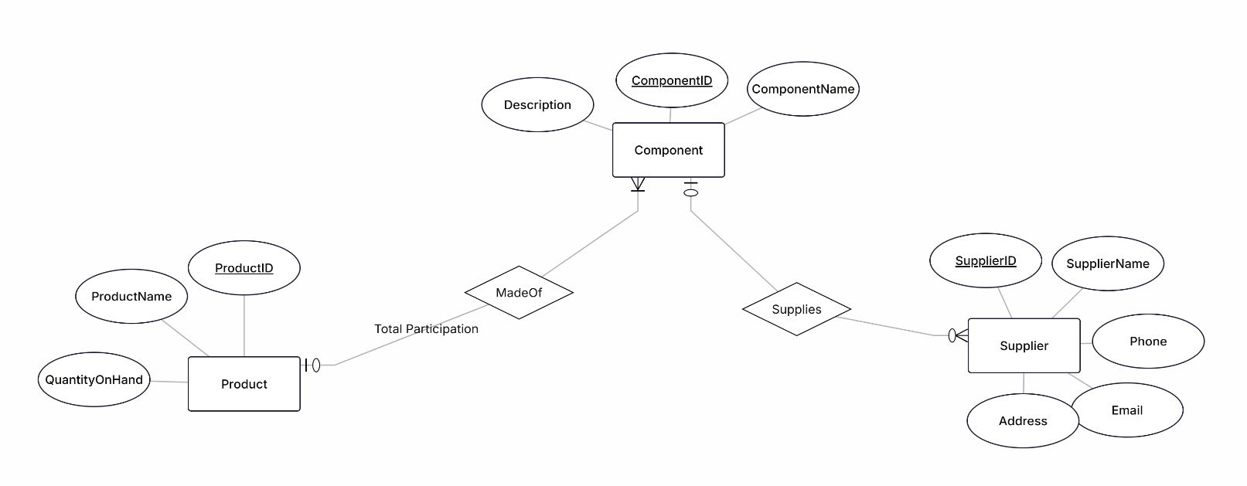
Output:
Q2. Create an ERD for a car dealership. The dealership sells both new and used cars,
and it operates a service facility. Base your design on the following business rules:
1. A salesperson may sell many cars, but each car is sold by only one
salesperson.
2. A customer may buy many cars, but each car is bought by only one customer.
3. A salesperson writes a single invoice for each car he or she sells.
4. A customer gets an invoice for each car he or she buys.
5. A customer may come in just to have his or her car serviced; that is, a
customer need not buy a car to be classified as a customer.
6. When a customer takes one or more cars in for repair or service, one service
ticket is written for each car.
7. The car dealership maintains a service history for each of the cars serviced.
The service records are referenced by the car’s serial number.
8. A car brought in for service can be worked on by many mechanics, and each
mechanic may work on many cars.
9. A car that is serviced may or may not need parts (e.g., adjusting a carburettor
or cleaning a fuel injector nozzle does not require providing new parts).
Output:

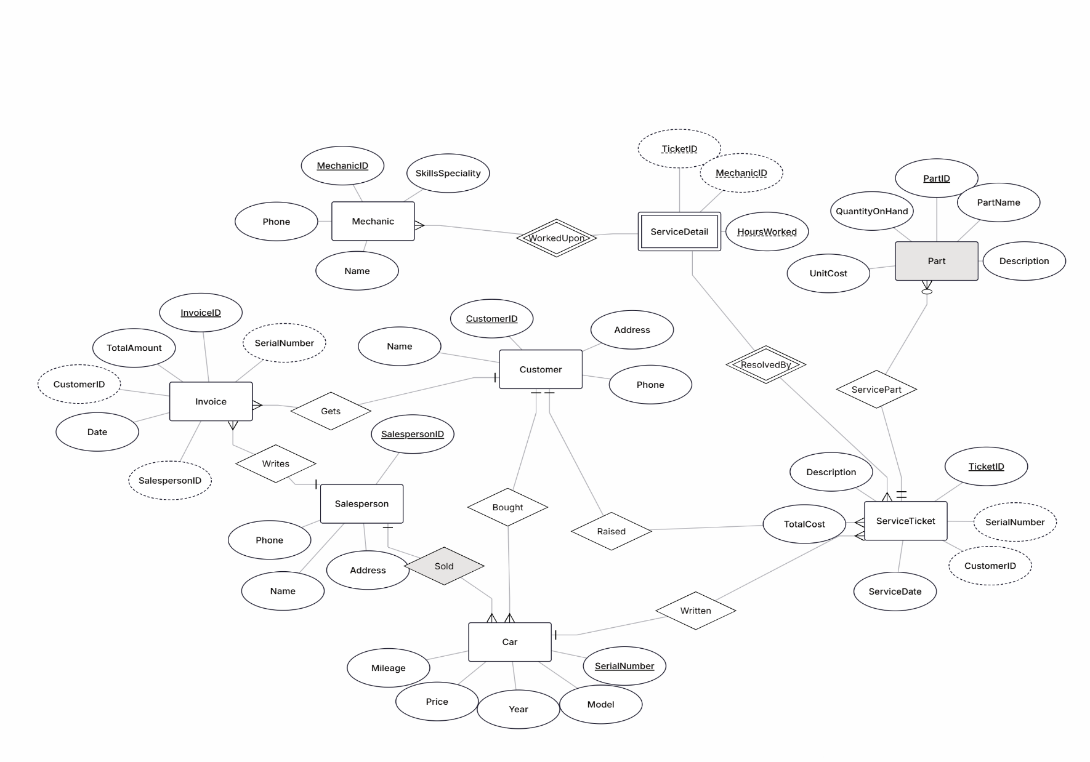

3. Draw an ER diagram of Pharmaceutical. The Prescriptions-R-X chain of
pharmacies has offered to give you a free lifetime supply of medicines if you design
its database. Given the rising cost of health care, you agree. Here is the information
that you gathered.
1. Patients are identified by SSN, and their names, addresses, and also ages.
2. Doctors are identified by an SSN, for each doctor, the name, specialty and years of
experience must be recorded.
3. Each pharmaceutical company is identified by name and has a phone number.
4. For each drug, the trade name and formula must be recorded. Each drug is sold by a
given pharmaceutical company, and the trade name identifies a drug uniquely from
among the products of that company. If a pharmaceutical company is deleted, you
need not keep track of its products any longer.
5. Each pharmacy has a name, address, and phone number.
6. Every patient has a primary physician. Every doctor has at least one patient.
7. Each pharmacy sells several drugs and has a price for each. A drug could be sold at
several pharmacies, and the price could vary from one pharmacy to another.
8. Doctors prescribe drugs for patients. A doctor could prescribe one or more drugs for
several patients, and a patient could obtain prescriptions from several doctors. Each
prescription has a date and a quantity associated with it. You can assume that if a
doctor prescribes the same drug for the same patient more than once, only the last
such prescription needs to be stored.
9. Pharmaceutical company have long-term contracts with pharmacies. A
pharmaceutical company can contract with several pharmaceutical companies. For
each contract, you have to store a start date, and end date, and the text of the contract.
10. Pharmacies appoint a supervisor for each contract. There must always a supervisor
for each contract.
-End of the Spec. Tasks:
1. Draw a ER diagram that captures the above information. Identify and contraints that
are not captured by your ER-diagram.
2. How would your design change if each drug must be sold at a fixed price by all the
pharmacies?
3. How would your design change if the design requirements change as follows: If a
doctor prescribes the same drug for the same patient more than once, several such
prescriptions may have to be stored separately?
Output:
