Database Management Systems: Assignment-5
Name: Suraj Shah
Admission Number: I24AI012

Q1. Use Employee table from Assignment 2.

- Display the list of employees whose name starts with ‘A’.
Query:
SELECT * FROM employee WHERE Name LIKE ‘A%’;
Output:
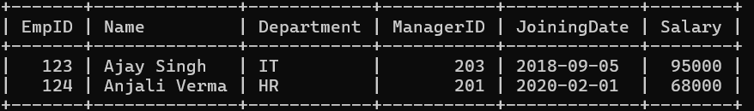

- Add a new column named city and display the list of employees whose city starts with letter ‘m’.
Query:
ALTER TABLE employee ADD City varchar(25);
Output:
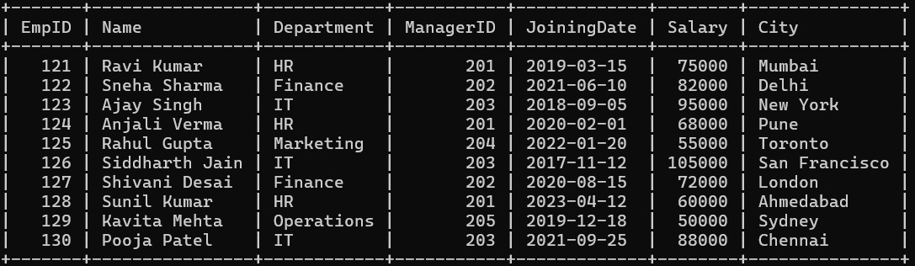
Query:
SELECT * FROM employee WHERE City LIKE 'm%';
Output:
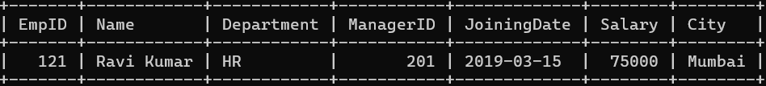

- Display the list of employees whose city ends with word ‘pradesh’.
Query:
SELECT * FROM employee WHERE City LIKE '%pradesh';
Output:

- Display the list of employees who are having exactly five characters in their name.
Query:
SELECT * FROM employee WHERE Name LIKE '_____ %';
Output:
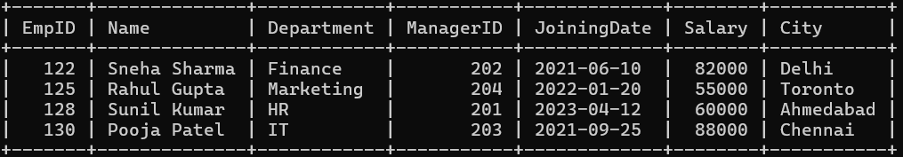

- Display the list of employees whose city is having only five characters.
Query:
SELECT * FROM employee WHERE City LIKE '_____';
Output:
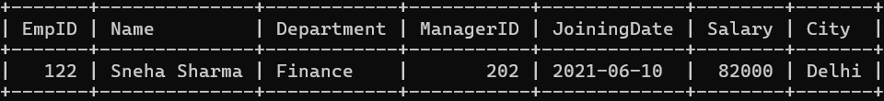

- Find the names of employees whose name includes the substring “man”.
Query:
SELECT * FROM employee WHERE Name LIKE '%man%';
Output:


Q2. Use Student table from Assignment 2.

- Display the list of students whose name starts with ‘N’.
Query:
SELECT * FROM student WHERE Name LIKE 'N%';
Output:

- Add a new column named branch and display the list of employees whose branch starts with letter ‘A’
Query:
ALTER TABLE student ADD Branch varchar(30);
Output:
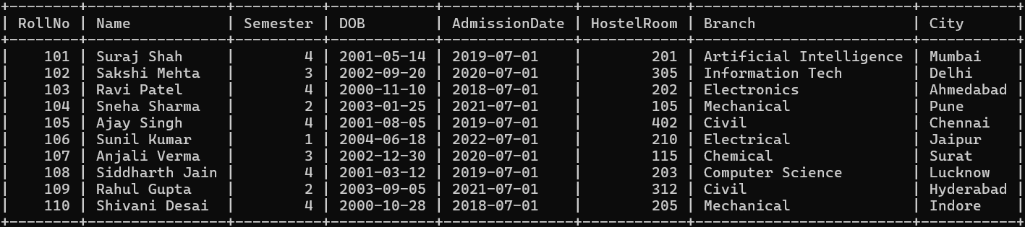
Query:
SELECT * FROM student WHERE Branch LIKE 'A%';
Output:

- Display the list of students who are having exactly five characters in their name.
Query:
SELECT * FROM student WHERE Name LIKE '_____ %';
Output:
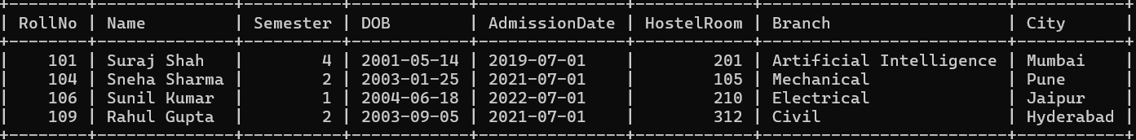

- Add a new column named city and display the list of students whose city is having only ten characters.
Query:
ALTER TABLE student ADD City varchar(25);
SELECT * FROM student where City like '__________';
Output:


- Find the names of students whose name includes the substring “sh”.
Query:
SELECT * FROM student WHERE Name LIKE '%sh%';
Output:
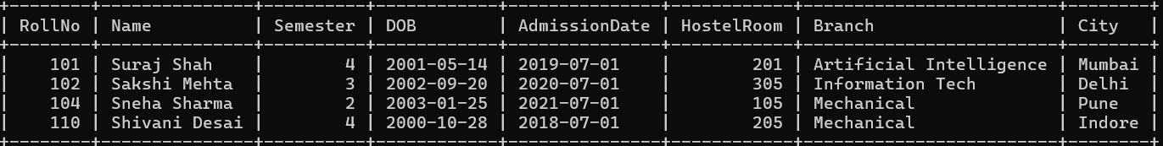

Q3. Create table Customers with this schema: (CustomerID, CustomerName,
ContactName, Address, City, PostalCode, Country)
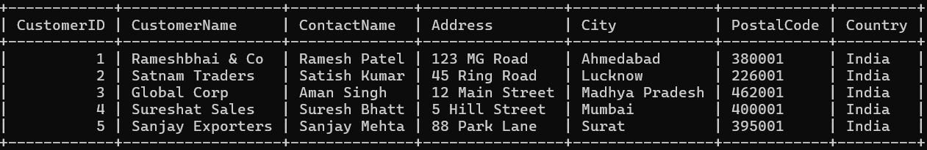

- Return all customers that ends with the pattern 'bhai'.
Query:
SELECT * FROM customers WHERE CustomerName LIKE '%bhai';
Output:

- Return all customers that contains the pattern 'sat'.
Query:
SELECT * FROM customers WHERE CustomerName LIKE '%sat%';
Output:

- Return all customers with a city starting with any character, followed by "pradesh".
Query:
SELECT * FROM customers WHERE City LIKE '%pradesh';
Output:

- Return all customers with a city starting with "S", followed by any four characters, ending with "at".
Query:
SELECT * FROM customers WHERE City LIKE 'S____at';
Output:

- Return all customers from Mumbai.
Query:
SELECT * FROM customers WHERE City='Mumbai';
Output:

