Database Management Systems: Assignment-6
Name: Suraj Shah
Admission Number: I24AI012

Q1. Use the Employee table from Assignment 5. Answer the followings:
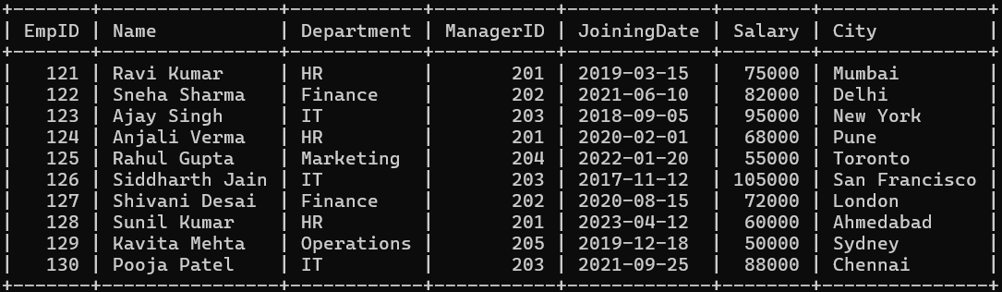

- Display Manager Id of employees whose name starts with ‘A’.
Query:
SELECT ManagerID FROM employee WHERE Name LIKE 'A%';
Output:
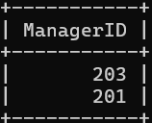

- Display book title and author, language wise.
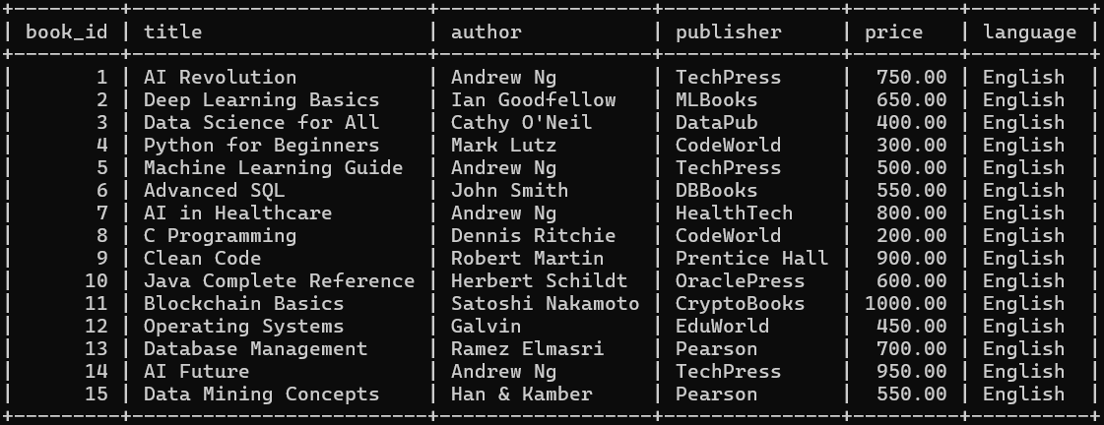

Query:
SELECT language, title, author FROM book ORDER BY language;
Output:


- Display employee count department wise.
Query:
SELECT Department, COUNT(*) AS employee_count FROM employee GROUP BY Department;
Output:
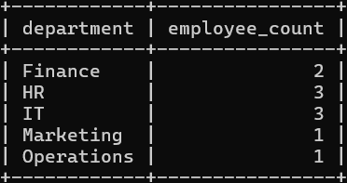

- Display all columns of book library table whose price is more than 500.
Query:
SELECT * FROM book WHERE price>500;
Output:
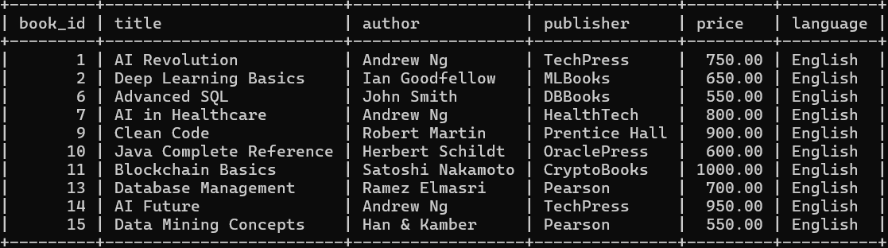

- Display authors with more than 3 books publication.
Query:
SELECT author, COUNT(*) AS book_count FROM book GROUP BY author HAVING COUNT(*)>3;
Output:
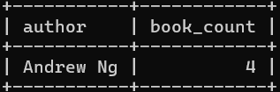

- Display publisher name and book title whose price is greater than 250, author wise.
Query:
SELECT author, publisher, title, price FROM book WHERE price>250 GROUP BY author;
Output:


- Display author and give average price of his/her all books price.
Query:
SELECT author, AVG(price) AS avg_price FROM book GROUP BY author;
Output:
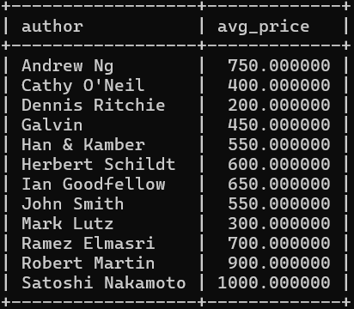

- Display author and book title with highest price.
Query:
SELECT author, title, price FROM book WHERE price = (SELECT MAX(price) FROM book);
Output:


- Display author and book title with least price.
Query:
SELECT author, title, price FROM book WHERE price = (SELECT MIN(price) FROM book);
Output:


- Display author and book title with second highest price.
Query:
SELECT author, title, price FROM book WHERE price = (SELECT MAX(price) FROM book WHERE price < (SELECT MAX(price) FROM book));
Output:
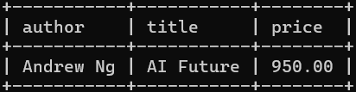

Q2. Use the Student table from Assignment 5. Answer the followings:
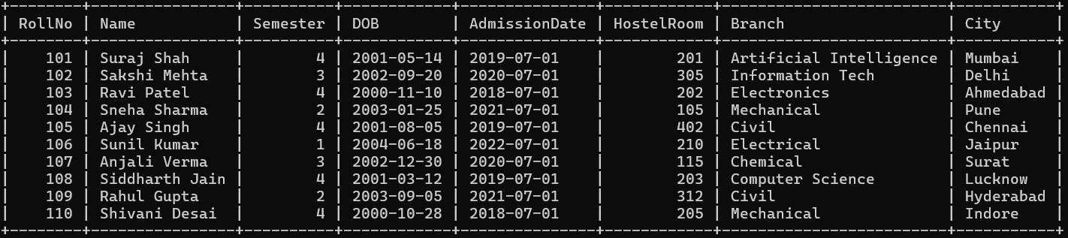
- Display semester of students whose name has the letter ‘a’.
Query:
SELECT Semester FROM student WHERE Name LIKE '%a%';
Output:


- Display count of students semester wise.
Query:
SELECT Semester, COUNT(*) AS StudentCount FROM student GROUP BY Semester;
Output:
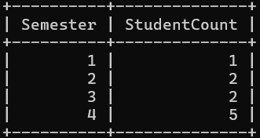

- Display students' names from every department whose roll number is 1.
Query:
SELECT Name, Branch FROM student WHERE RollNo=101;
Output:
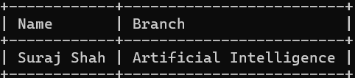

- Display student name and semester of students who are not staying in the hostel.
Query:
SELECT Name, Semester FROM student WHERE HostelRoom IS NULL;
Output:

- Display student count in each semester whose birth month is August.
Query:
SELECT Semester, COUNT(*) AS StudentCount FROM student WHERE MONTH(DOB)=8 GROUP BY Semester;
Output:
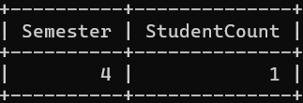

- Display roll number and name of the student who was the first one to get admission in the college.
Query:
SELECT RollNo, Name FROM student WHERE AdmissionDate = (SELECT MIN(AdmissionDate) FROM student);
Output:
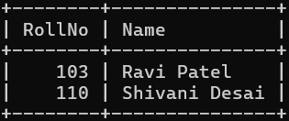

- Display the average count of students. (In any semester)
Query:
SELECT avg(StudentCount) AS AvgStudents FROM (SELECT COUNT(*) AS StudentCount FROM student GROUP BY Semester) AS x;
Output:
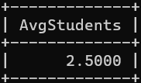

- For every month (Jan-Dec) display the count of students who are having birthdays in that month.
Query:
SELECT MONTH(DOB) AS BirthMonth, COUNT(*) AS StudentCount FROM student GROUP BY MONTH(DOB) ORDER BY BirthMonth;
Output:
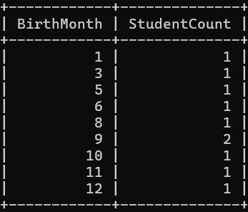

- Display count of students who have taken admission in the last six months.
Query:
SELECT COUNT(*) AS RecentAdmissions FROM student WHERE MONTH(AdmissionDate) BETWEEN 7 AND 12;
Output:


- Display semester with least number of students.
Query:
SELECT Semester FROM student GROUP BY Semester ORDER BY COUNT(*)=1;
Output:
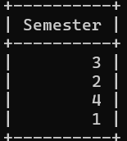

Q3. Create a table named “Hospital management”. Add the columns as per requirements.
Add the records. Answer the followings:
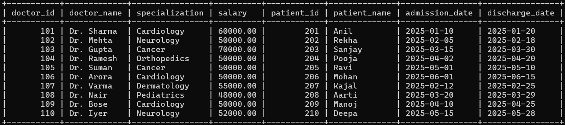

- Display count of doctors as per their specialization.
Query:
SELECT specialization, COUNT(*) AS doctor_count FROM Hospital_Management GROUP BY specialization;
Output:


- Display doctor name from every specialization whose doctor ID is 101.
Query:
SELECT doctor_name, specialization FROM Hospital_Management WHERE doctor_id=101;
Output:
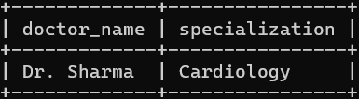

- Display doctor ID and name who are not specialized in cancer.
Query:
SELECT doctor_id, doctor_name FROM Hospital_Management WHERE specialization NOT IN ('Cancer');
Output:
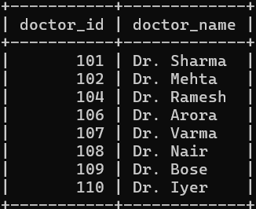

- Display doctors count in each specialization whose salary is 50000.
Query:
SELECT specialization, COUNT(*) AS doctor_count FROM hospital_management WHERE salary=50000 GROUP BY specialization;
Output:
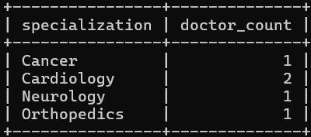

- Display patient ID and patient name who was the first one got admitted in the hospital.
Query:
SELECT patient_id, patient_name FROM Hospital_Management WHERE admission_date = (SELECT MIN(admission_date) FROM Hospital_Management);
Output:
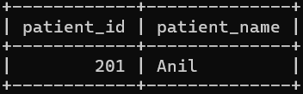

- Display the average count of patients. (In any month)
Query:
SELECT AVG(*) AS avg_patients FROM (SELECT MONTH(admission_date) AS month_no, COUNT(*) AS patient_count FROM Hospital_Management GROUP BY MONTH(admission_date)) AS monthly;
Output:
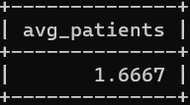

- For every month (Jan-may) display the count of patients who got discharged in that month.
Query:
SELECT MONTH(discharge_date) AS month_no, COUNT(*) AS discharged_patients FROM Hospital_Management WHERE MONTH(discharge_date) BETWEEN 1 AND 5 GROUP BY MONTH(discharge_date);
Output:
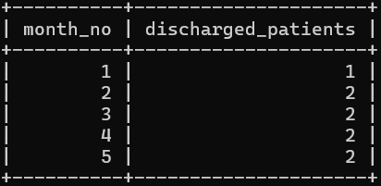

- Display count of patients who got admitted in the last six months.
Query:
SELECT COUNT(*) AS recent_patients FROM Hospital_Management WHERE MONTH(admission_date) BETWEEN 7 AND 12;
Output:
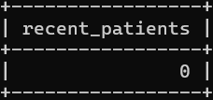

- Display specialization with least number of doctors.
Query:
SELECT specialization FROM Hospital_Management GROUP BY specialization ORDER BY COUNT(*)=1;
Output:


