Database Management Systems: Assignment-7
Name: Suraj Shah
Admission Number: I24AI012

Q1. Consider the following table. Mention the expected super key, candidate key, primary
key, and alternate key. Give syntax for the same.
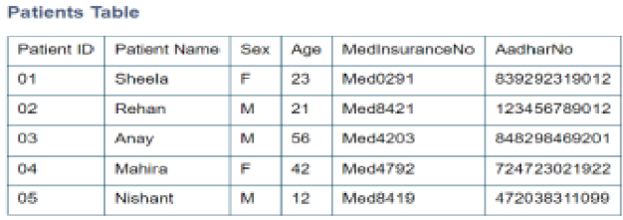
Answer:
- Super Keys: {PatientID}, {MedInsuranceNo}, {AadhaarNo}, {PatientID, PatientName}, ...
- Candidate Keys: {PatientID}, {MedInsuranceNo}, {AadhaarNo}
- Primary Key: {PatientID}
- Alternate Keys: {MedInsuranceNo}, {AadhaarNo}
Query:
CREATE TABLE Patients (PatientID INT PRIMARY KEY, PatientName VARCHAR(50), Sex CHAR(1), Age INT, MedInsuranceNo VARCHAR(20) UNIQUE, AadhaarNo VARCHAR(20) UNIQUE);

Q2. Create an Emp table with the following fields:
(EmpNo, EmpName, Job,Basic, DA, HRA,PF, GrossPay, NetPay)
(Calculate DA as 30% of Basic and HRA as 40% of Basic)

- Mention the expected super key, candidate key, primary key, and alternate key. Give syntax for the same.
Answer:
  - Super Keys: {EmpNo}, {EmpNo, EmpName}, {EmpNo, Job}, …
  - Candidate Keys: {EmpNo}
  - Primary Key: {EmpNo}
  - Alternate Keys: None
Query:
CREATE TABLE Emp (EmpNo INT PRIMARY KEY, EmpName VARCHAR(50), Job VARCHAR(30), Basic DECIMAL(10,2), DA DECIMAL(10,2), HRA DECIMAL(10,2), PF DECIMAL(10,2), GrossPay DECIMAL(10,2), NetPay DECIMAL(10,2));

- Insert Five Records and calculate GrossPay and NetPay.
Query:
INSERT INTO Emp (EmpNo, EmpName, Job, Basic, DA, HRA, PF, GrossPay, NetPay) VALUES
(1, 'Amit', 'Manager', 20000, 0.3*20000, 0.4*20000, 0.1*20000, NULL, NULL),
(2, 'Sneha', 'Clerk', 8000, 0.3*8000, 0.4*8000, 0.1*8000, NULL, NULL),
(3, 'Rohit', 'Analyst', 12000, 0.3*12000, 0.4*12000, 0.1*12000, NULL, NULL),
(4, 'Meena', 'Clerk', 9000, 0.3*9000, 0.4*9000, 0.1*9000, NULL, NULL),
(5, 'Karan', 'Manager', 25000, 0.3*25000, 0.4*25000, 0.1*25000, NULL, NULL);

UPDATE Emp SET GrossPay = Basic + DA + HRA, NetPay = Basic + DA + HRA - PF;
Output:
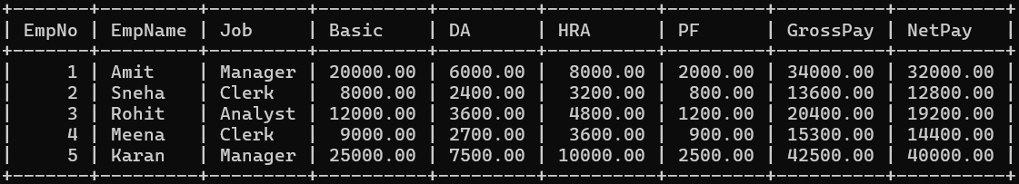

- Display the employees who’s Basic is lowest in each department.
Query:
SELECT e.EmpNo, e.EmpName, e.Job, e.Basic FROM Emp e WHERE Basic = (SELECT MIN(Basic) FROM Emp WHERE Job = e.Job);
Output:
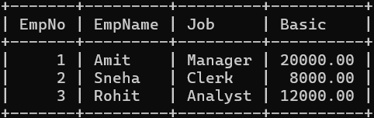

- If NetPay is less than <Rs. 10,000 add Rs. 1200 as special allowances. Display the employees whose GrossPay lies between 10,000 & 20,000.
Query:
UPDATE Emp SET NetPay=NetPay+1200 WHERE NetPay<10000;
Output:
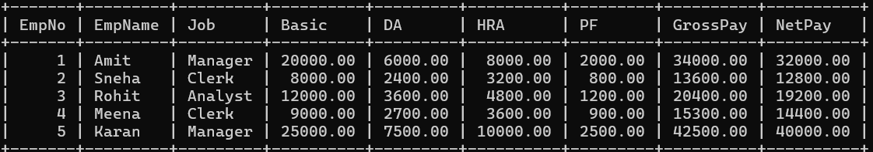

Query:
SELECT * FROM Emp WHERE GrossPay BETWEEN 10000 AND 20000;
Output:
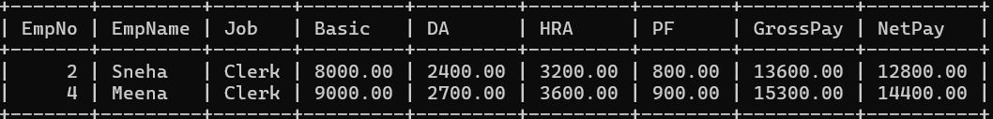

- Display all the employees who earn maximum salary.
Query:
SELECT * FROM Emp WHERE NetPay = (SELECT MAX(NetPay) FROM Emp);
Output:

Q3. Consider the insurance database given below. The primary keys are made bold and
the data types are specified.
PERSON( driver_id:string , name:string , address:string )
CAR( regno:string , model:string , year:int )
ACCIDENT( report_number:int , accd_date:date ,location:string)
OWNS( driver_id:string , regno:string )
ARTICIPATED(driver_id:string,regno:string,report_number:int,damage_amount:int)

- Mention the expected super key, candidate key, primary key, unique key and
alternate key. Give syntax for the same.
Answer:
PERSON:
    - Super Keys: {driver_id}, {driver_id, name}, …
    - Candidate Keys: {driver_id}
    - Primary Key: {driver_id}
    - Unique Key: {driver_id}
    - Alternate Keys: None
    - Query: CREATE TABLE PERSON (driver_id VARCHAR(20) PRIMARY KEY, name VARCHAR(50), address VARCHAR(100));
CAR:
    - Super Keys: {regno}, {regno, model}, …
    - Candidate Keys: {regno}
    - Primary Key: {regno}
    - Unique Key: {regno}
    - Alternate Keys: None
    - Query: CREATE TABLE CAR (regno VARCHAR(20) PRIMARY KEY, model VARCHAR(50), year INT);

ACCIDENT:
    - Super Keys: {report_number}, {report_number, accd_date}, …
    - Candidate Keys: {report_number}
    - Primary Key: {report_number}
    - Unique Key: {report_number}
    - Alternate Keys: None
    - Query: CREATE TABLE ACCIDENT (report_number INT PRIMARY KEY, accd_date DATE, location VARCHAR(100));

OWNS:
    - Super Keys: {driver_id, regno}
    - Candidate Keys: {driver_id, regno}
    - Primary Key: {driver_id, regno}
    - Unique Key: {driver_id, regno}
    - Alternate Keys: None
    - Query: CREATE TABLE OWNS (driver_id VARCHAR(20), regno VARCHAR(20), PRIMARY KEY(driver_id, regno), FOREIGN KEY(driver_id) REFERENCES PERSON(driver_id), FOREIGN KEY(regno) REFERENCES CAR(regno));
ARTICIPATED:
    - Super Keys: {driver_id, regno, report_number}, {driver_id, regno, report_number, damage_amount}
    - Candidate Keys: {driver_id, regno, report_number}
    - Primary Key: {driver_id, regno, report_number}
    - Unique Key: {driver_id, regno, report_number}
    - Alternate Keys: None
    - Query: CREATE TABLE ARTICIPATED (driver_id VARCHAR(20), regno VARCHAR(20), report_number INT, damage_amount INT, PRIMARY KEY(driver_id, regno, report_number), FOREIGN KEY(driver_id, regno) REFERENCES OWNS(driver_id, regno), FOREIGN KEY(report_number) REFERENCES ACCIDENT(report_number));

- Enter at least five tuples for each relation based on a given query.
Query:
INSERT INTO PERSON VALUES
('D001','Amit','Mumbai'),
('D002','Sneha','Delhi'),
('D003','Rohit','Pune'),
('D004','Meena','Chennai'),
('D005','Karan','Kolkata');
Output:
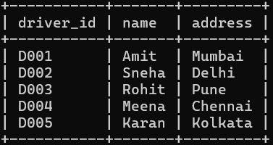

Query:
INSERT INTO CAR VALUES
('MH01AB1234','Swift',2010),
('DL05XY5678','Innova',2008),
('PN12CD3456','Swift',2008),
('TN07EF7890','Fortuner',2009),
('WB09GH1234','Swift',2011);
Output:
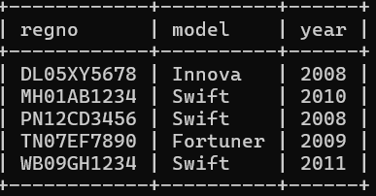

Query:
INSERT INTO ACCIDENT VALUES
(11,'2008-03-15','Mumbai'),
(12,'2008-07-20','Delhi'),
(13,'2009-05-10','Pune'),
(14,'2008-12-01','Chennai'),
(15,'2010-01-25','Kolkata');
Output:
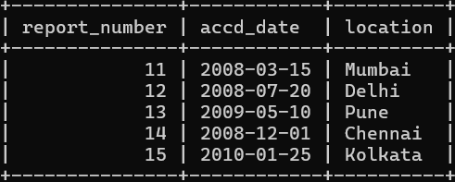

Query:
INSERT INTO OWNS VALUES
('D001','MH01AB1234'),
('D002','DL05XY5678'),
('D003','PN12CD3456'),
('D004','TN07EF7890'),
('D005','WB09GH1234');
Output:
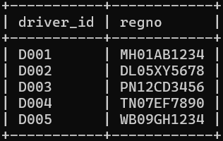

Query:
INSERT INTO ARTICIPATED VALUES
('D001','MH01AB1234',11,15000),
('D002','DL05XY5678',12,20000),
('D003','PN12CD3456',13,18000),
('D004','TN07EF7890',14,22000),
('D005','WB09GH1234',15,25000);
Output:
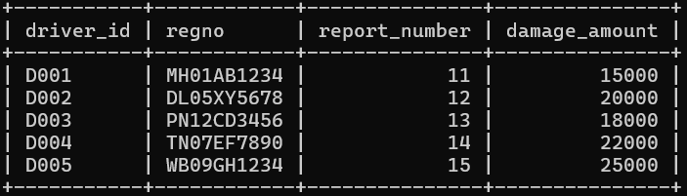

- Demonstrate how you, Update the damage amount for the car with specific regno in the accident with report number 12 to 25000. Find the total number of people who owned cars that were involved in accidents in the year 2008.
Query:
UPDATE ARTICIPATED SET damage_amount=25000 WHERE regno='DL05XY5678' AND report_number=12;
Output:
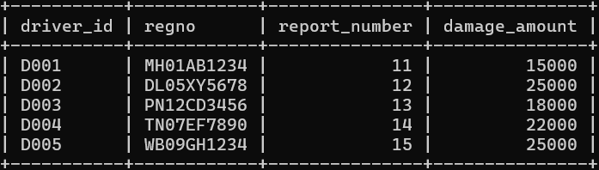

Query:
SELECT COUNT(driver_id) AS total_people FROM ARTICIPATED a join ACCIDENT ac ON a.report_number = ac.report_number WHERE YEAR(ac.accd_date)=2008;
Output:
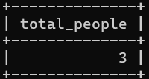

- Find the number of accidents in which cars belonging to a specific model were involved.
Query:
SELECT COUNT(a.report_number) AS accident_count FROM ARTICIPATED a join CAR c ON a.regno = c.regno WHERE c.model='Swift';
Output:
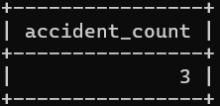

- Create Sales table with the following fields:( Sales No, Salesname, Branch, Salesamount, DOB)

1. Insert five records.
Query:
INSERT INTO Sales VALUES
(1,'Amit','Mumbai',50000,'1985-12-21'),
(2,'Sneha','Delhi',60000,'1987-11-15'),
(3,'Rohit','Mumbai',55000,'1990-12-05'),
(4,'Meena','Delhi',70000,'1988-12-10'),
(5,'Karan','Kolkata',65000,'1992-07-25');
Output:
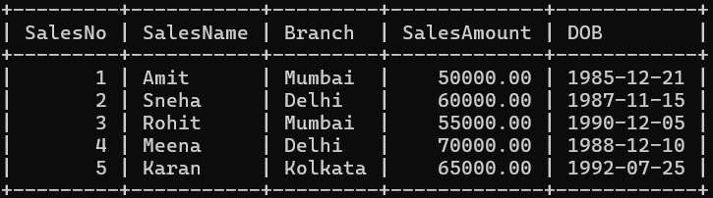

2. Calculate total salesamount in each branch.
Query:
SELECT Branch, SUM(SalesAmount) AS TotalSales FROM Sales GROUP BY Branch;
Output:
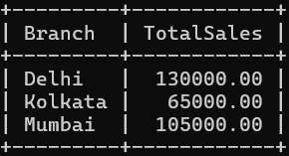

3. Calculate average salesamount in each branch.
Query:
SELECT Branch, AVG(SalesAmount) AS AvgSales FROM Sales GROUP BY Branch;
Output:
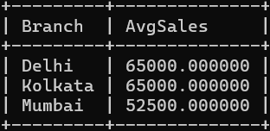

4. Display all the salesmen, DOB who are born in the month of December as day in character format i.e. 21-Dec-09
Query:
SELECT SalesName, DATE_FORMAT(DOB, '%d-%b-%y') AS DOB FROM Sales WHERE MONTH(DOB) = 12;
Output:
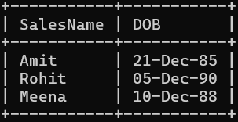

5. Display the name and DOB of salesman in alphabetical order of the month.
Query:
SELECT SalesName, DOB FROM Sales ORDER BY MONTH(DOB);
Output:
