Database Management Systems: Assignment-8
Name: Suraj Shah
Admission Number: I24AI012

Q1. The dataset consists of four tables: author, book, adaptation, and book_review.
Author (id, name, birth_year,death_year)
Book (id, author_id, title,publish_year, publishing house)
Adaptation (book_id, type,title,release_year,rating)
Book_review (book_id, review, author)
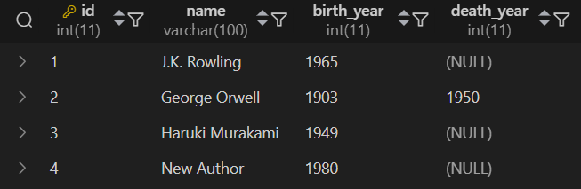

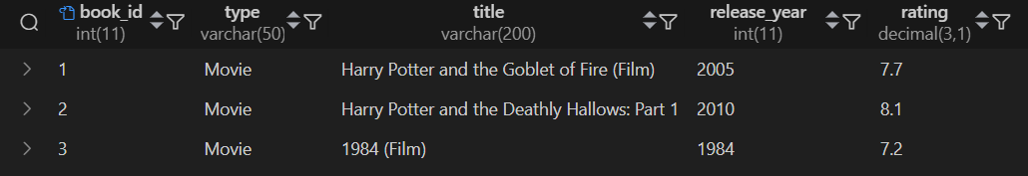

- Show the name of each author together with the title of the book they wrote and the year in which that book was published.
Query:
SELECT a.name AS author_name, b.title AS book_title, b.publish_year FROM Author a JOIN Book b ON a.id = b.author_id
Output:


- Show the name of each author together with the title of the book they wrote and the year in which that book was published. Show only books published after 2005.
Query:
SELECT a.name AS author_name, b.title AS book_title, b.publish_year FROM Author a JOIN Book b ON a.id = b.author_id WHERE b.publish_year > 2005
Output:


- For each book, show its title, adaptation title, adaptation year, and publication year.
Query:
SELECT b.title AS book_title, ad.title AS adaptation_title, ad.release_year AS adaptation_year, b.publish_year FROM Book b JOIN Adaptation ad ON b.id = ad.book_id
Output:


- Show the title of each book together with the title of its adaptation and the date of the release. Show all books, regardless of whether they had adaptations.
Query:
SELECT b.title AS book_title, ad.title AS adaptation_title, ad.release_year FROM Book b LEFT JOIN Adaptation ad ON b.id = ad.book_id;
Output:


- Show all books with their movie adaptations. Select each book's title, the name of its publishing house, the title of its adaptation, and the type of the adaptation. Keep the books with no adaptations in the result.
Query:
SELECT b.title AS book_title, b.publishing_house, ad.title AS adaptation_title, ad.type AS adaptation_type FROM Book b LEFT JOIN Adaptation ad ON b.id = ad.book_id;
Output:


- Join the book_review and book tables using a RIGHT JOIN. Show the title of the book, the corresponding review, and the name of the review's author. Consider all books, even those that weren't reviewed.
Query:
SELECT b.title AS book_title, br.review, br.author AS review_author FROM Book_review br RIGHT JOIN Book b ON br.book_id = b.id;
Output:

- Display the title of each book along with the name of its author. Show all books, even those without an author. Show all authors, even those who haven't published a book yet. Use a FULL JOIN.
Query:
SELECT b.title AS book_title, a.name AS author_name FROM Book b LEFT JOIN Author a ON b.author_id = a.id UNION SELECT b.title AS book_title, a.name AS author_name FROM Book b LEFT JOIN Author a ON b.author_id = a.id;
Output:


Q2. The dataset consists of five tables : Department, Product, Nutrition_data,
Producer,Sales_history
Department (id, name)
Product(id,name,department_id,shelf_id,producer_id,price)
Nutrition_data( product_id, calories, fat, carbohydrate, protein)
Producer(id, name)
Sales_history(date, product_id,amount)
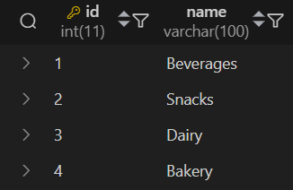
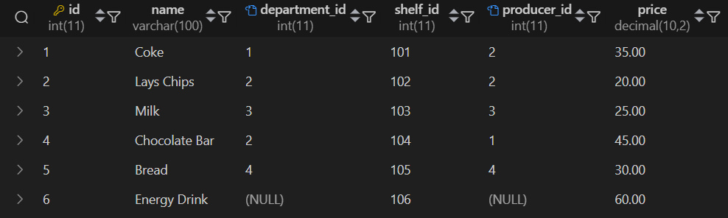
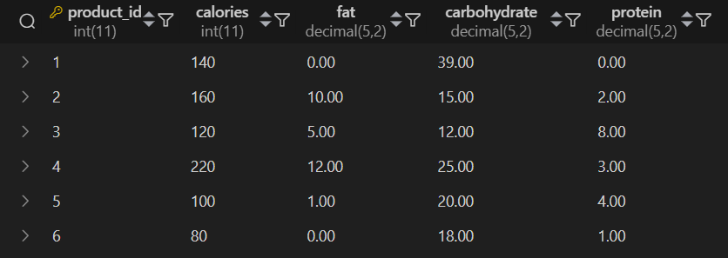
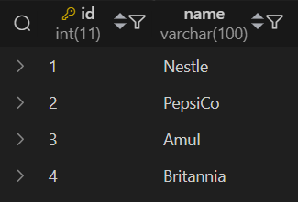
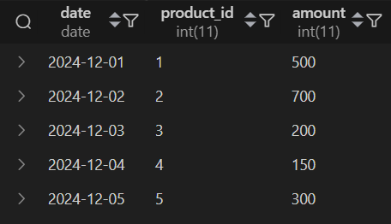

- List all products that have fewer than 150 calories. For each product, show its name (rename the column product) and the name of the department where it can be found (name the column department).
Query:
SELECT p.name AS product, d.name as department FROM Product p JOIN Nutrition_data n ON p.id=n.product_id JOIN Department d ON p.department_id = d.id WHERE n.calories < 150;
Output:
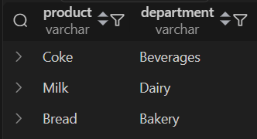

- For each product, show its name, price, producer name, and department name. Alias the columns as product_name, product_price, producer_name, and department_name, respectively. Include all the products, even those without a producer or department. Also, include the producers and departments without a product.
Query:
SELECT p.name AS product_name, p.price AS producer_price, pr.name as producer_name, d.name as department_name FROM Product p LEFT JOIN Producer pr ON p.producer_id = pr.id LEFT JOIN Department d ON p.department_id = d.id UNION SELECT p.name AS product_name, p.price AS producer_price, pr.name as producer_name, d.name as department_name FROM Product p RIGHT JOIN Producer pr ON p.producer_id = pr.id RIGHT JOIN Department d ON p.department_id = d.id
Output:
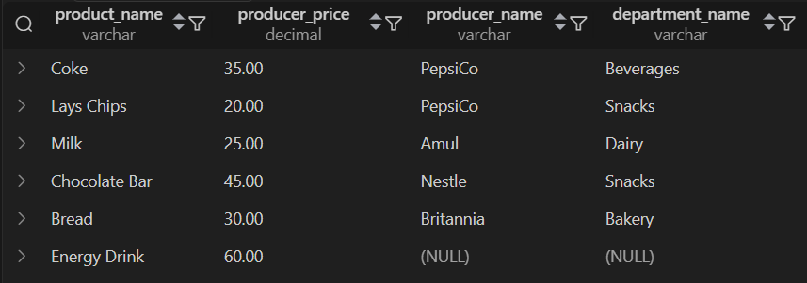

- For each product, display the:
Name of the company that produced it (name the column producer_name).
Name of the department where the product is located (name it department_name).
Product name (name it product_name).
Total number of carbohydrates in the product.
Your query should still consider products with no information about producer_id or department_id.
Query:
SELECT pr.name AS product_name, d.name AS department_name, p.name AS product_name, n.carbohydrate FROM Product p LEFT JOIN Producer pr ON p.producer_id = pr.id LEFT JOIN Department d ON p.department_id = d.id LEFT JOIN Nutrition_data n ON p.id = n.product_id;
Output:
