Database Management Systems: Assignment-9
Name: Suraj Shah
Admission Number: I24AI012

Q 1. Consider the following schema:
Sailors (sid, sname, rating, age)
Boats (bid, bname, color)
Reserves (sid, bid, day(date))
Write subquery statement for the following queries. The bold column names are
indicating primary key.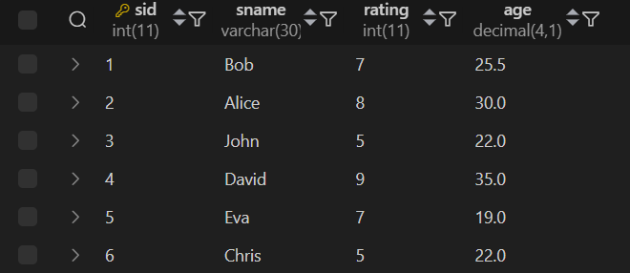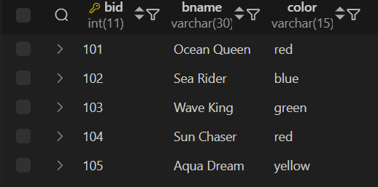
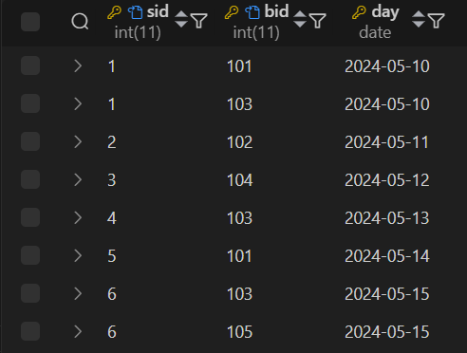

- Find all information of sailors who have reserved boat number 101.
Query:
SELECT * FROM Sailors WHERE sid IN (SELECT sid FROM Reserves WHERE bid=101);
Output:
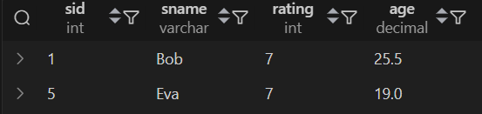

- Find the name of boat reserved by Bob.
Query:
SELECT bname FROM Boats WHERE bid IN (SELECT bid FROM Reserves WHERE sid = (SELECT sid FROM Sailors WHERE sname='Bob'));
Output:


- Find the names of sailors who have reserved a red boat, and list in the order of age.
Query:
SELECT sname FROM Sailors WHERE sid IN (SELECT sid FROM Reserves WHERE bid IN (SELECT bid FROM Boats WHERE color='Red')) ORDER BY age;
Output:
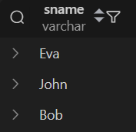

- Find the names of sailors who have reserved at least one boat.
Query:
SELECT sname from Sailors WHERE sid IN (SELECT DISTINCT sid FROM Reserves);
Output:
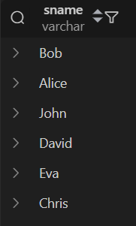

- Find the ids and names of sailors who have reserved two different boats on the same day.
Query:
SELECT sid, sname FROM Sailors WHERE sid IN (SELECT sid from Reserves GROUP BY sid, day HAVING COUNT(DISTINCT bid) > 1);
Output:
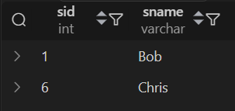

- Find the ids of sailors who have reserved a red boat or a green boat.
Query:
SELECT DISTINCT sid FROM Reserves WHERE bid IN (SELECT bid FROM Boats WHERE color IN ('red', 'green'));
Output:
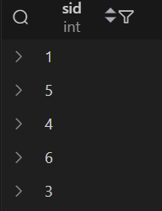

- Find the name and the age of the youngest sailor.
Query:
SELECT sname, age FROM Sailors WHERE age = (SELECT MIN(age) FROM Sailors);
Output:


- Count the number of different sailor names.
Query:
SELECT COUNT(DISTINCT sname) AS total_names from Sailors;
Output:


- Find the average age of sailors for each rating level.
Query:
SELECT rating, AVG(age) AS avg_age FROM Sailors GROUP BY rating;
Output:
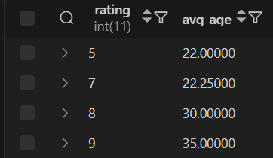

- Find the average age of sailors for each rating level that has at least two sailors.
Query:
SELECT rating, AVG(age) AS avg_age FROM Sailors GROUP BY rating HAVING COUNT(*) >= 2;
Output:
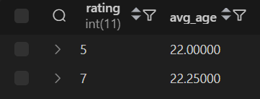

Q 2. Consider the following database for a banking enterprise.
BRANCH ( branch_name:string , branch_city:string , assets:real )
ACCOUNT ( accno:int , branch_name:string , balance:real )
DEPOSITOR ( customer_name:string , accno:int )
CUSTOME ( customer_name:string , customer_street:string , customer_city:string )
LOAN ( loan_number:int , branch_name:string , amount:real )
BORROWER ( customer_name:string , loan_number:int )

- Enter at least five tuples for each relation.
Query:
INSERT INTO BRANCH VALUES
('Main', 'Mumbai', 1000000.00),
('Town', 'Mumbai', 750000.00),
('Park', 'Delhi', 600000.00),
('Central', 'Pune', 500000.00),
('South', 'Chennai', 550000.00);
Output:
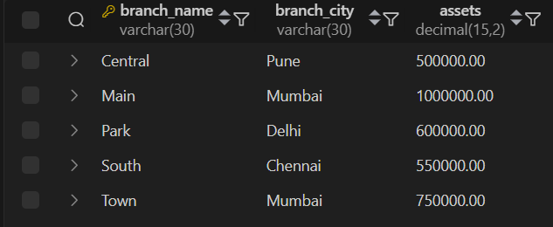

Query:
INSERT INTO ACCOUNT VALUES
(101, 'Main', 50000.00),
(102, 'Main', 30000.00),
(103, 'Town', 25000.00),
(104, 'Park', 45000.00),
(105, 'Central', 60000.00),
(106, 'South', 20000.00),
(107, 'Main', 70000.00),
(108, 'Town', 15000.00);
Output:
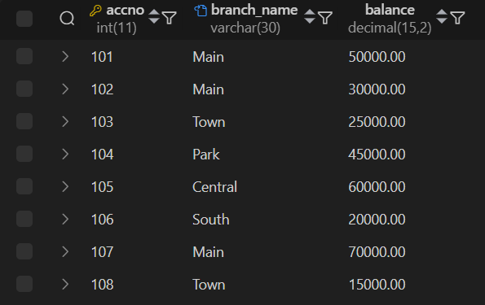

Query:
INSERT INTO CUSTOMER VALUES
('Rahul', 'MG Road', 'Mumbai'),
('Sneha', 'Hill Street', 'Delhi'),
('Amit', 'Park Lane', 'Pune'),
('Priya', 'Marine Drive', 'Mumbai'),
('Ravi', 'Anna Nagar', 'Chennai'),
('Neha', 'Bandra', 'Mumbai');
Output:
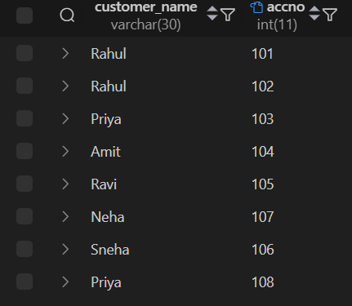
Query:
INSERT INTO DEPOSITOR VALUES
('Rahul', 101),
('Rahul', 102),
('Priya', 103),
('Amit', 104),
('Ravi', 105),
('Neha', 107),
('Sneha', 106),
('Priya', 108);
Output:
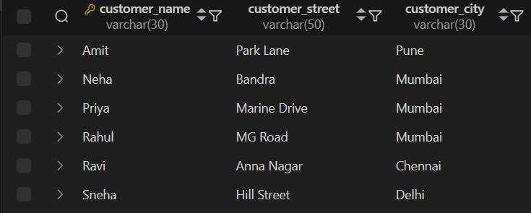
Query:
INSERT INTO LOAN VALUES
(201, 'Main', 100000.00),
(202, 'Town', 50000.00),
(203, 'Park', 120000.00),
(204, 'Central', 80000.00),
(205, 'South', 60000.00);
Output:
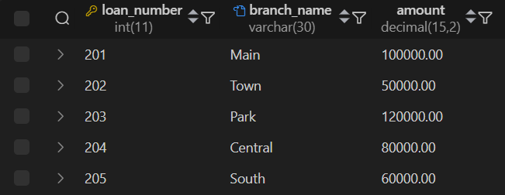
Query:
INSERT INTO BORROWER VALUES
('Rahul', 201),
('Amit', 203),
('Priya', 202),
('Ravi', 205),
('Neha', 204);
Output:
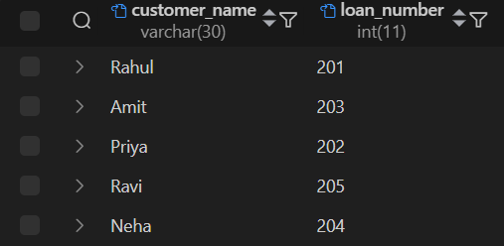

- Find all the customers who have at least two accounts at the main branch.
Query:
SELECT customer_name FROM Depositor WHERE accno IN (SELECT accno FROM Account WHERE branch_name = 'Main') GROUP BY customer_name HAVING COUNT(accno) >= 2;
Output:

- Find all the customers who have an account at all the branches located in a specific city.
Query:
SELECT D.customer_name FROM Depositor D WHERE NOT EXISTS (SELECT B.branch_name FROM Branch B WHERE B.branch_city = 'Mumbai' AND B.branch_name NOT IN (SELECT A.branch_name FROM Account A where A.accno IN (SELECT D2.accno FROM Depositor D2 WHERE D2.customer_name = D.customer_name)));
Output:


- Demonstrate how you delete all account tuples at every branch located in a specific city.
Query:
DELETE FROM Depositor WHERE accno IN (SELECT accno FROM Account WHERE branch_name IN (SELECT branch_name FROM Branch WHERE branch_city = 'Mumbai'));
DELETE FROM Account WHERE branch_name IN (SELECT branch_name FROM Branch WHERE branch_city = 'Mumbai');
Output:


Q 3. The following are maintained by a book dealer.
AUTHOR( author_id:int , name:string , city:string , country:string )
PUBLISHER( publisher_id:int , name:string , city:string , country:string )
CATALOG( book_id:int , title:string , author_id:int , publisher_id:int , category_id:int,
year:int , price:int)
CATEGORY( category_id:int , description:string )
ORDER_DETAILS( order_no:int , book_id:int , quantity:int )

- Create the above tables by properly specifying the primary keys and foreign keys.
Query:
CREATE TABLE AUTHOR (author_id INT PRIMARY KEY, name VARCHAR(50), city VARCHAR(30), country VARCHAR(30));
Output:

Query:
CREATE TABLE PUBLISHER (publisher_id INT PRIMARY KEY, name VARCHAR(50), city VARCHAR(30), country VARCHAR(30));
Output:


Query:
CREATE TABLE CATEGORY (category_id INT PRIMARY KEY, description VARCHAR(50));
Output:

Query:
CREATE TABLE CATALOG (book_id INT PRIMARY KEY, title VARCHAR(100), author_id INT, publisher_id INT, category_id INT, year INT, price DECIMAL(10,2), FOREIGN KEY (author_id) REFERENCES AUTHOR(author_id), FOREIGN KEY (publisher_id) REFERENCES PUBLISHER(publisher_id), FOREIGN KEY (category_id) REFERENCES CATEGORY(category_id));
Output:
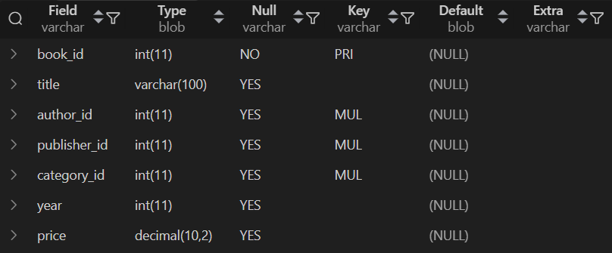
Query:
CREATE TABLE ORDER_DETAILS (order_no INT, book_id INT, quantity INT, PRIMARY KEY (order_no, book_id), FOREIGN KEY (book_id) REFERENCES CATALOG(book_id));
Output:


- Enter at least five tuples for each relation.

Query:
INSERT INTO AUTHOR VALUES
(1, 'Chetan Bhagat', 'Mumbai', 'India'),
(2, 'J.K. Rowling', 'London', 'UK'),
(3, 'George R.R. Martin', 'New Jersey', 'USA'),
(4, 'Ruskin Bond', 'Dehradun', 'India'),
(5, 'Dan Brown', 'New York', 'USA');
Output:
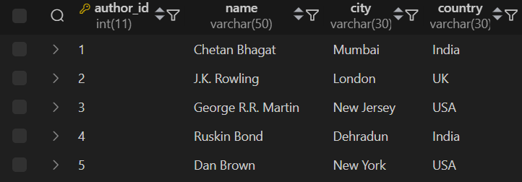
Query:
INSERT INTO PUBLISHER VALUES
(1, 'Penguin Books', 'Delhi', 'India'),
(2, 'Bloomsbury', 'London', 'UK'),
(3, 'HarperCollins', 'New York', 'USA'),
(4, 'Rupa Publications', 'Mumbai', 'India'),
(5, 'Random House', 'Boston', 'USA');
Output:
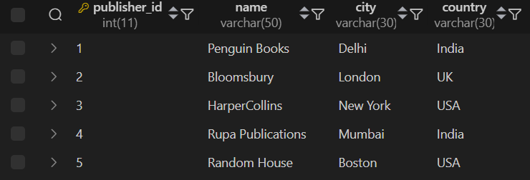

Query:
INSERT INTO CATEGORY VALUES
(1, 'Fiction'),
(2, 'Fantasy'),
(3, 'Mystery'),
(4, 'Thriller'),
(5, 'Romance');
Output:
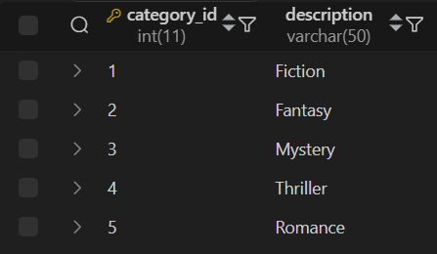
Query:
INSERT INTO CATALOG VALUES
(101, 'Five Point Someone', 1, 4, 1, 2004, 300),
(102, '2 States', 1, 4, 5, 2009, 350),
(103, 'Harry Potter', 2, 2, 2, 2001, 500),
(104, 'Game of Thrones', 3, 3, 2, 2005, 800),
(105, 'Angels and Demons', 5, 5, 4, 2003, 600),
(106, 'Room on the Roof', 4, 1, 1, 1956, 250),
(107, 'Half Girlfriend', 1, 4, 1, 2014, 400),
(108, 'The Da Vinci Code', 5, 5, 3, 2004, 700);
Output:
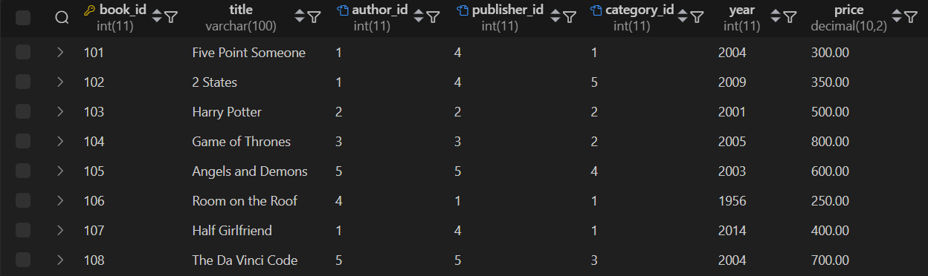

Query:
INSERT INTO ORDER_DETAILS VALUES
(1001, 101, 20),
(1002, 102, 15),
(1003, 103, 30),
(1004, 104, 25),
(1005, 105, 40),
(1006, 107, 10),
(1007, 108, 50);
Output:
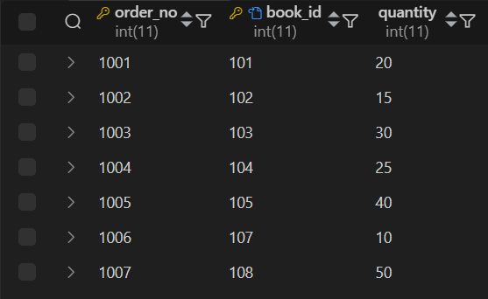

- Give the details of the authors who have 2 or more books in the catalog and the price of the books is greater than the average price of the books in the catalog and the year of publication is after 2000.
Query:
SELECT DISTINCT A.author_id, A.name, A.city, A.country FROM Author A WHERE A.author_id IN (SELECT author_id FROM Catalog WHERE price > (SELECT AVG(price) FROM Catalog) AND year > 2000 GROUP BY author_id HAVING COUNT(book_id) >= 2);
Output:


- Find the author of the book that has maximum sales.
Query:
SELECT A.name, A.city, A.country FROM Author A JOIN Catalog C ON A.author_id = C.author_id JOIN (SELECT book_id FROM Order_details GROUP BY book_id HAVING SUM(quantity) = (SELECT MAX(total_sales) FROM (SELECT SUM(quantity) AS total_sales FROM Order_details GROUP BY book_id) AS t)) AS TopBooks ON c.book_id = TopBooks.book_id;
Output:


- Demonstrate how you increase the price of books published by a specific publisher by 10%.
Query:
UPDATE Catalog SET price = price * 1.1 WHERE publisher_id = (SELECT publisher_id FROM Publisher WHERE name = 'Rupa Publications');
Output:
