Operating Systems: Assignment-1-B
Name: Suraj Shah
Admission Number: I24AI012

Q 1. Write a program to create an empty file named notes.txt inside the Assignment1 directory. Add the text "UNIX is fun!" to the file notes.txt using a single command.
Command:
mkdir -p Assignment1 && echo “UNIX is fun!” > Assignment1/notes.txt
Output:

Q 2. Display the content of notes.txt on the terminal. Count the number of lines, words, and characters in notes.txt.
Command:
wc Assignment1/notes.txt
Output:

Q 3. Create a directory named ProjectWorkspace. Inside ProjectWorkspace, create subdirectories Docs, Code, and Resources. In the Docs directory, create an empty file named README.txt. Move into the Code directory and create an empty file main.py. List all files and directories in ProjectWorkspace to verify the setup.
Command:
mkdir ProjectWorkspace
mkdir ProjectWorkspace/Docs ProjectWorkspace/Code ProjectWorkspace/Resources
touch Docs/README.txt
touch Code/main.py
Output:
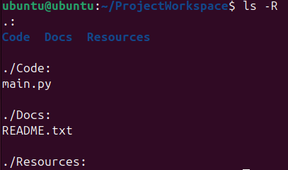

Q 4. In the current directory, create files old_report1.txt, old_report2.txt, and current_report.txt. Move all files starting with "old_" into a directory named OldReports. Verify the moved files by listing the content of OldReports.
Command:
touch old_report1.txt old_report2.txt current_report.txt
mv old_* OldReports/
Output:

Q 5. Write a Shell Script for counting the lines in the text file.
Command:
nano script.sh
#!/bin/bash
if [ $# -eq 0 ]; then
echo "Usage: $0 filename"
exit 1
fi
lines=$(wc -l < "$1")
echo "Number of lines in $1: $lines"

chmod +x script.sh
/script.sh current_report.txt
Output:
