Operating Systems: Assignment-1
Name: Suraj Shah
Admission Number: I24AI012

Q. 1 Practice basic linux commands- ls, cd, pwd, mkdir, rm, rmdir, touch, cp, mv,cat, chmod, kill, top, ssh, etc.

Command: ls
Output:
Command: cd Desktop
Output:
Command: pwd
Output:
Command: mkdir test
Output:
Command: touch file.txt
Output:
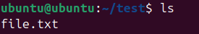
Command: cp file.txt file_new.txt
Output:
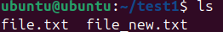
Command: mv file.txt file_new.txt
Output:
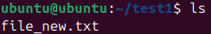
Command: rm file_new.txt
Output:
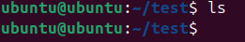
Command: rmdir test
Output:
Command: cat file_new.txt
Output:
Command: chmod +x file_new.txt
Output:
Command:
ps
kill 1234

Command: top
Output:
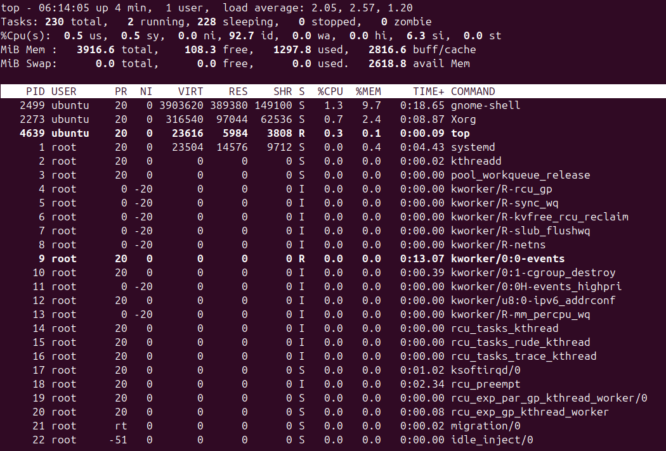
Command: ssh user@192.168.1.10
Output:

Q. 2 Create a folder using mkdir with the name “SVNIT”. Create subfolders inside the SVNIT folder as AI, CSE, MED,ECE

- Create two text files in a AI folder with name file1.txt and file1.txt
Command:
touch file1.txt file2.txt
Output:
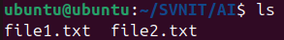

- Copy file1.txt from AI folder to ECE Folder
Command:
cp file1.txt ../ECE/
Output:
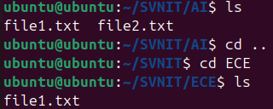

- Move file1.txt from AI folder to MED Folder
Command:
mv file1.txt ../ECE/
Output:
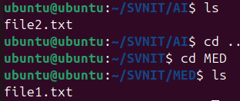

- Change the permissions of file1.txt from ECE folder such that owner can perform read, write and execute where others can perform ONLY read
Command:
chmod 744 ../ECE/file1.txt
Output:

- Delete folder CSE
Command:
rmdir CSE
Output:
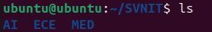

Q.2 Practice Linux commands related to process management

- Start a browser and check the process ID of the browser using Top command
Command:
firefox &
top
Output:
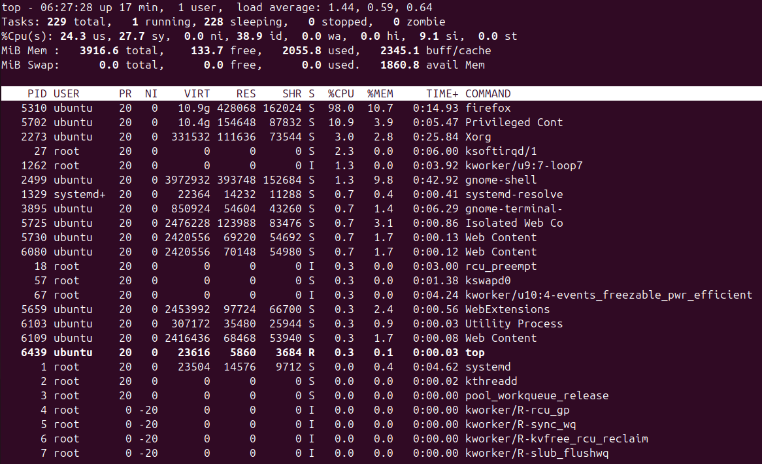

- Kill the browser process using “kill” command
Command:
kill 5310
Output:
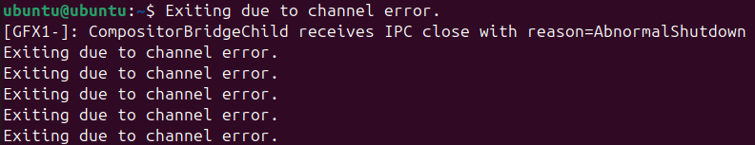

- Change the priority of any user process by using “nice” command
Command:
nice -n 10 sleep 300 &
sudo renice -5 -p 2273
Output:

