Operating Systems: Assignment-10
Name: Suraj Shah
Admission Number: I24AI012

Q 1. To Write a C program to simulate producer-consumer problem using semaphores.
Code:
#include <stdio.h>
#include <stdlib.h>
#include <pthread.h>
#include <semaphore.h>
#include <unistd.h>

#define BUFFER_SIZE 5

int buffer[BUFFER_SIZE];
int in = 0;
int out = 0;

sem_t empty;
sem_t full;
sem_t mutex;

void* producer(void* arg) {
int item;
for(int i = 0; i < 10; i++) {
item = rand() % 100;

sem_wait(&empty);
sem_wait(&mutex);

buffer[in] = item;
printf("Produced: %d\n", item);
in = (in + 1) % BUFFER_SIZE;

sem_post(&mutex);
sem_post(&full);

sleep(1);
}
return NULL;
}

void* consumer(void* arg) {
int item;
for(int i = 0; i < 10; i++) {

sem_wait(&full);
sem_wait(&mutex);

item = buffer[out];
printf("Consumed: %d\n", item);
out = (out + 1) % BUFFER_SIZE;

sem_post(&mutex);
sem_post(&empty);

sleep(2);
}
return NULL;
}

int main() {
pthread_t p_thread, c_thread;

sem_init(&empty, 0, BUFFER_SIZE);
sem_init(&full, 0, 0);
sem_init(&mutex, 0, 1);

pthread_create(&p_thread, NULL, producer, NULL);
pthread_create(&c_thread, NULL, consumer, NULL);

pthread_join(p_thread, NULL);
pthread_join(c_thread, NULL);

sem_destroy(&empty);
sem_destroy(&full);
sem_destroy(&mutex);

return 0;
}
Output:
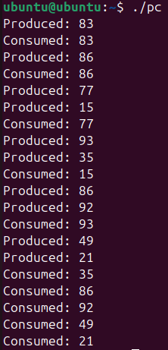

Q 2. Write a C program to simulate the concept of Dining-Philosophers problem.
Code:
#include <stdio.h>
#include <stdlib.h>
#include <pthread.h>
#include <semaphore.h>
#include <unistd.h>

#define N 5

#define THINKING 0
#define HUNGRY 1
#define EATING 2

int state[N];
int phil[N] = {0, 1, 2, 3, 4};

sem_t mutex;
sem_t S[N];

int LEFT(int i) {
return (i + N - 1) % N;
}

int RIGHT(int i) {
return (i + 1) % N;
}

void test(int i) {
if (state[i] == HUNGRY &&
state[LEFT(i)] != EATING &&
state[RIGHT(i)] != EATING) {

state[i] = EATING;
printf("Philosopher %d takes chopsticks %d and %d\n", i, LEFT(i), i);
printf("Philosopher %d is Eating\n", i);

sem_post(&S[i]);
}
}

void take_fork(int i) {

sem_wait(&mutex);

state[i] = HUNGRY;
printf("Philosopher %d is Hungry\n", i);

test(i);

sem_post(&mutex);

sem_wait(&S[i]);
sleep(1);
}

void put_fork(int i) {

sem_wait(&mutex);

state[i] = THINKING;
printf("Philosopher %d putting chopsticks %d and %d down\n", i, LEFT(i), i);
printf("Philosopher %d is Thinking\n", i);

test(LEFT(i));
test(RIGHT(i));

sem_post(&mutex);
}

void* philosopher(void* num) {

int i = *(int*)num;

while (1) {
sleep(1);
take_fork(i);
sleep(2);
put_fork(i);
}
}

int main() {

pthread_t thread_id[N];

sem_init(&mutex, 0, 1);

for (int i = 0; i < N; i++)
sem_init(&S[i], 0, 0);

for (int i = 0; i < N; i++)
pthread_create(&thread_id[i], NULL, philosopher, &phil[i]);

for (int i = 0; i < N; i++)
pthread_join(thread_id[i], NULL);

return 0;
}

Output:
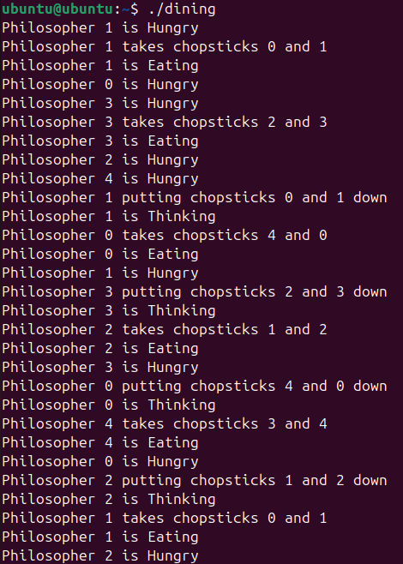

Q 3. Write a C program to simulate the concept of Readers-Writers problem.
Code:
#include <stdio.h>
#include <pthread.h>
#include <semaphore.h>
#include <unistd.h>

sem_t mutex, wrt;
int readcount = 0;
int data = 0;

void* reader(void* arg) {
int id = *(int*)arg;

while(1) {
sem_wait(&mutex);
readcount++;

if(readcount == 1)
sem_wait(&wrt);

sem_post(&mutex);

printf("Reader %d is reading data = %d\n", id, data);
sleep(1);

sem_wait(&mutex);
readcount--;

if(readcount == 0)
sem_post(&wrt);

sem_post(&mutex);

sleep(1);
}
}

void* writer(void* arg) {
int id = *(int*)arg;

while(1) {
sem_wait(&wrt);

data++;
printf("Writer %d is writing data = %d\n", id, data);
sleep(2);

sem_post(&wrt);

sleep(2);
}
}

int main() {
pthread_t r[3], w[2];

sem_init(&mutex, 0, 1);
sem_init(&wrt, 0, 1);

int r_id[3] = {1,2,3};
int w_id[2] = {1,2};

for(int i = 0; i < 3; i++)
pthread_create(&r[i], NULL, reader, &r_id[i]);

for(int i = 0; i < 2; i++)
pthread_create(&w[i], NULL, writer, &w_id[i]);

for(int i = 0; i < 3; i++)
pthread_join(r[i], NULL);

for(int i = 0; i < 2; i++)
pthread_join(w[i], NULL);

return 0;
}

Output:
