Operating Systems: Assignment-13
Name: Suraj Shah
Admission Number: I24AI012

Q 1. Write a program to simulate segmentation using a static segment table and perform address translation.
Code:
#include <stdio.h>

#define MAX_SEGMENTS 10

struct Segment {
int base;
int limit;
};

int main() {
struct Segment segTable[MAX_SEGMENTS];
int n, i;

printf("Enter number of segments: ");
scanf("%d", &n);

printf("Enter base and limit for each segment:\n");
for (i=0; i<n; i++) {
printf("Segment %d:\n", i);
printf("Base: ");
scanf("%d", &segTable[i].base);
printf("Limit: ");
scanf("%d", &segTable[i].limit);
}

int seg_no, offset;

while (1) {
printf("\n Enter segment number (-1 to exit): ");
scanf("%d", &seg_no);

if (seg_no==-1) {
break;
}

printf("Enter offset: ");
scanf("%d", &offset);

if (seg_no>=n || seg_no<0) {
printf("Invalid segment number!\n");
continue;
}

if (offset>=segTable[seg_no].limit) {
printf("Segmentation Fault! Offset exceeds limit.\n");
}
else {
int physical_address=segTable[seg_no].base+offset;
printf("Physical Address=%d\n", physical_address);
}
}
return 0;
}

Output:
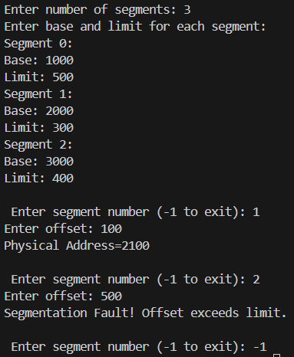

Q 2. Create a simulation that takes a logical address (segment number + offset) and translates it to a physical address using a segment table.
Code:
#include <stdio.h>

struct Segment {
int base;
int limit;
};

int main() {
int n;

printf("Enter number of segments: ");
scanf("%d", &n);

struct Segment segTable[n];

printf("\nEnter base and limit for each segment:\n");
for(int i=0; i<n; i++) {
printf("Segment %d:\n", i);
printf("Base: ");
scanf("%d", &segTable[i].base);
printf("Limit: ");
scanf("%d", &segTable[i].limit);
}

int seg_no, offset;

printf("\nEnter logical address:\n");
printf("Segment number: ");
scanf("%d", &seg_no);

printf("Offset: ");
scanf("%d", &offset);

if(seg_no<0 || seg_no>=n) {
printf("\nInvalid Segment Number!\n");
}
else if(offset>=segTable[seg_no].limit) {
printf("\nSegmentation Fault! Offset exceeds limit.\n");
}
else {
int physical_address=segTable[seg_no].base+offset;
printf("\nPhysical Address=%d\n", physical_address);
}

return 0;
}

Output:
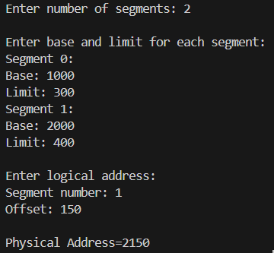

Q 3. Implement a model where each process is divided into segments (code, data, stack), and manage memory allocation and deallocation for each.
Code:
#include <stdio.h>
#include <stdlib.h>

#define MAX_PROCESSES 10

struct Segment {
int base;
int limit;
int allocated;
};

struct Process {
int pid;
struct Segment code;
struct Segment data;
struct Segment stack;
};

struct Process processes[MAX_PROCESSES];
int process_count=0;
int memory_pointer=1000;

void allocate_segment(struct Segment *seg, int size) {
seg->base=memory_pointer;
seg->limit=size;
seg->allocated=1;
memory_pointer+=size;
}

void create_process() {
if (process_count>=MAX_PROCESSES) {
printf("Process limit reached!\n");
return;
}

struct Process p;
p.pid=process_count;

int code_size, data_size, stack_size;

printf("\nEnter sizes for Process %d:\n", p.pid);
printf("Code size: ");
scanf("%d", &code_size);
printf("Data size: ");
scanf("%d", &data_size);
printf("Stack size: ");
scanf("%d", &stack_size);

allocate_segment(&p.code, code_size);
allocate_segment(&p.data, data_size);
allocate_segment(&p.stack, stack_size);

processes[process_count++]=p;

printf("Process %d allocated successfully");
}

void delete_process() {
int pid;
printf("Enter process ID to delete: ");
scanf("%d", &pid);

if (pid<0 || pid>=process_count) {
printf("Invalid PID!\n");
return;
}

processes[pid].code.allocated=0;
processes[pid].data.allocated=0;
processes[pid].stack.allocated=0;

printf("Process %d deallocated!\n", pid);
}

void display() {
printf("\nProcess Table\n");

for(int i=0; i<process_count; i++) {
struct Process p=processes[i];

printf("\nProcess %d:\n", p.pid);

printf("Code -> Base: %d, Limit: %d, %s\n", p.code.base, p.code.limit, p.code.allocated ? "Allocated" : "Free");

printf("Data -> Base: %d, Limit: %d, %s\n", p.data.base, p.data.limit, p.data.allocated ? "Allocated" : "Free");

printf("Stack -> Base: %d, Limit: %d, %s\n", p.stack.base, p.stack.limit, p.stack.allocated ? "Allocated" : "Free");
}
}

int main() {
int choice;

while(1) {
printf("\n1. Create Process\n2. Delete Process\n3. Display\n4. Exit\n");
printf("Enter choice: ");
scanf("%d", &choice);

switch(choice) {
case 1:
create_process();
break;
case 2:
delete_process();
break;
case 3:
display();
break;
case 4:
exit(0);
default:
printf("Invalid choice!\n");
}
}

return 0;
}

Output:
