Operating Systems: Assignment-2
Name: Suraj Shah
Admission Number: I24AI012

Q 1. Write a Shell Script to find factorial of a number.
Code:
#!/bin/bash

echo "Enter a number:"
read n

fact=1

if [ $n -lt 0 ]; then
echo "Factorial is not defined for negative numbers"
exit 1
fi

for (( i=1; i<=n; i++ ))
do
fact=$((fact * i))
done

echo "Factorial of $n is: $fact"

Output:
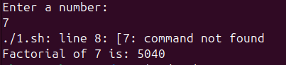

Q 2. Write a shell script for a program to implement an address book with the options
given below:
a) Create an address book.
b) View the address book.
c) Insert a record.
d) Delete a record.
e) Modify a record.
f) Exit.

Code:
#!/bin/bash

BOOK="addressbook.txt"

while true
do
echo "ADDRESS BOOK"
echo "1. Create Address Book"
echo "2. View Address Book"
echo "3. Insert a Record"
echo "4. Delete a Record"
echo "5. Modify a Record"
echo "6. Exit"
echo "Enter your choice:"
read choice

case $choice in

1)
if [ -f $BOOK ]; then
echo "Address book already exists!"
else
touch $BOOK
echo "Address book created successfully."
fi
;;

2)
if [ -s $BOOK ]; then
echo "Address Book Records"
cat $BOOK
else
echo "Address book is empty or does not exist."
fi
;;

3)
echo "Enter Name:"
read name
echo "Enter Phone:"
read phone
echo "Enter Email:"
read email
echo "Enter Address:"
read address

echo "$name | $phone | $email | $address" >> $BOOK
echo "Record inserted successfully."
;;

4)
echo "Enter name to delete record:"
read name
if grep -q "^$name" $BOOK; then
grep -v "^$name" $BOOK > temp.txt
mv temp.txt $BOOK
echo "Record deleted successfully."
else
echo "Record not found."
fi
;;

5)
echo "Enter name to modify record:"
read name
if grep -q "^$name" $BOOK; then
echo "Enter new Phone:"
read phone
echo "Enter new Email:"
read email
echo "Enter new Address:"
read address

sed -i "/^$name/d" $BOOK
echo "$name | $phone | $email | $address" >> $BOOK
echo "Record modified successfully."
else
echo "Record not found."
fi
;;

6)
echo "Exiting Address Book..."
exit 0
;;

*)
echo "Invalid choice. Please try again."
;;
esac
done

Output:
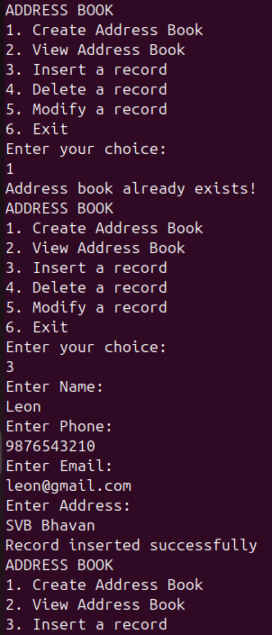
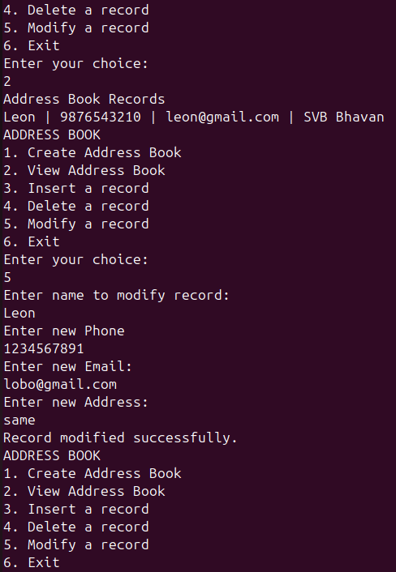
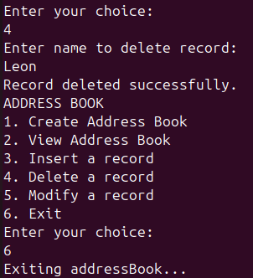

Q 3. Write the shell script that renames all files in the current directory that end in “.jpg” to begin with today’s date in the following format: YYYY-MM-DD. For example, if a picture of cat was in the current directory and today was October 31,2016 it would change name from “mycat.jpg” to “2016–10–31-mycat.jpg”

Code:
#!/bin/bash

date_prefix=$(date +"%Y-%m-%d")

for file in *.jpg
do
[ -e "$file" ] || continue

mv "$file" "$date_prefix-$file"
done

echo "All .jpg files renamed successfully."

Output:
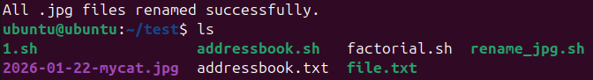

Q 4. Write a shell script for a program with options to calculate the following:
a) Area of a circle
b) Circumference of a circle
c) Area of a rectangle
d) Area of a square

Code:
#!/bin/bash

while true
do
echo "GEOMETRY MENU"
echo "1. Area of a Circle"
echo "2. Circumference of a Circle"
echo "3. Area of a Rectangle"
echo "4. Area of a Square"
echo "5. Exit"
echo "Enter your choice:"
read choice

case $choice in

1)
echo "Enter radius:"
read r
area=$(echo "3.14 * $r * $r" | bc)
echo "Area of Circle = $area"
;;

2)
echo "Enter radius:"
read r
circ=$(echo "2 * 3.14 * $r" | bc)
echo "Circumference of Circle = $circ"
;;

3)
echo "Enter length:"
read l
echo "Enter breadth:"
read b
area=$(echo "$l * $b" | bc)
echo "Area of Rectangle = $area"
;;

4)
echo "Enter side:"
read s
area=$(echo "$s * $s" | bc)
echo "Area of Square = $area"
;;

5)
echo "Exiting program..."
exit 0
;;

*)
echo "Invalid choice! Try again."
;;
esac
done

Output:
