Operating Systems: Assignment-3
Name: Suraj Shah
Admission Number: I24AI012

Q 1. Write a Shell Script to find,

a) Largest of N numbers
Code:
#!/bin/bash

echo "Enter how many numbers:"
read n

largest=0

for ((i=1; i<=n; i++))
do
echo "Enter number $i:"
read num

if [ $i -eq 1 ] || [ $num -gt $largest ]; then
largest=$num
fi
done

echo "Largest number is: $largest"

Output:
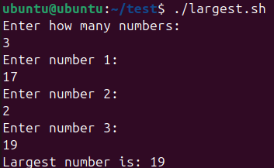

b) Swap two values
Code:
#!/bin/bash

echo "Enter first number:"
read a

echo "Enter second number:"
read b

echo "Before Swap: a=$a, b=$b"

temp=$a
a=$b
b=$temp

echo "After Swap: a=$a, b=$b"

Output:
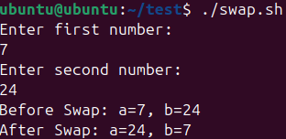

c) Odd or Even

Code:
#!/bin/bash

echo "Enter a number:"
read num

if [ $((num % 2)) -eq 0 ]; then
echo "$num is Even"
else
echo "$num is Odd"
fi

Output:
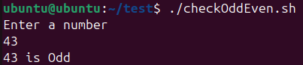
d) Sum of three numbers

Code:
#!/bin/bash

echo "Enter first number:"
read a

echo "Enter second number:"
read b

echo "Enter third number:"
read c

sum=$((a + b + c))

echo "Sum of three numbers = $sum"

Output:
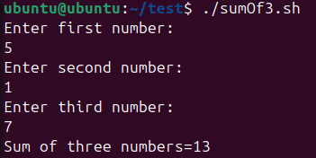

Q 2. Write a shell script to check to see if the file “file_path” exists. If it does exist, display “file_path passwords are enabled.” Next, check to see if you can write to the file. If you can, display “You have permissions to edit “file_path.””If you cannot, display “You do NOT have permissions to edit “file_path”.

Code:
#!/bin/bash

echo "Enter the file path:"
read file_path

if [ -f "$file_path" ]; then
echo "$file_path passwords are enabled."

if [ -w "$file_path" ]; then
echo "You have permissions to edit $file_path."
else
echo "You do NOT have permissions to edit $file_path."
fi

else
echo "$file_path does NOT exist."
fi

Output:
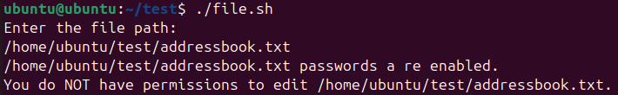

Q 3. Write a shell script that asks the user to type a number of words as input to shell script Store the input words by user into an array. Print how long each word is.
Code:
#!/bin/bash

echo "Enter words (separated by space):"
read -a words

echo "Word lengths:"

for word in "${words[@]}"
do
length=${#word}
echo "$word -> $length characters"
done

Output:
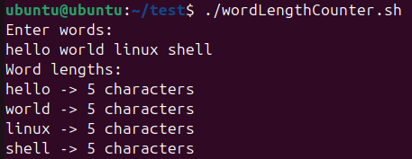

Q 4. Write a shell program to reverse the five-digit integer.
Code:
#!/bin/bash

echo "Enter a five-digit number:"
read num

rev=0

while [ $num -gt 0 ]
do
digit=$((num % 10))
rev=$((rev * 10 + digit))
num=$((num / 10))
done

echo "Reversed number: $rev"

Output:
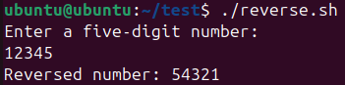

Q 5. Write a shell program to search for a given number from the list of numbers using binary search.
Code:
#!/bin/bash

echo "Enter number of elements:"
read n

echo "Enter $n numbers in sorted order:"
for ((i=0; i<n; i++))
do
read arr[$i]
done

echo "Enter number to search:"
read key

low=0
high=$((n-1))
found=0

while [ $low -le $high ]
do
mid=$(((low + high) / 2))

if [ "${arr[$mid]}" -eq "$key" ]; then
echo "Number found at position $((mid + 1))"
found=1
break
elif [ "${arr[$mid]}" -lt "$key" ]; then
low=$((mid + 1))
else
high=$((mid - 1))
fi
done

if [ $found -eq 0 ]; then
echo "Number not found in the list"
fi

Output:
