Operating Systems: Assignment-4
Name: Suraj Shah
Admission Number: I24AI012

Q 1. Perform Following

- Obtain a listing of processes by using the ps command.
Command:
ps
Output:
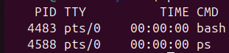

- Use a Linux command which displays a tree of all processes in the system.
Command:
pstree

Output:
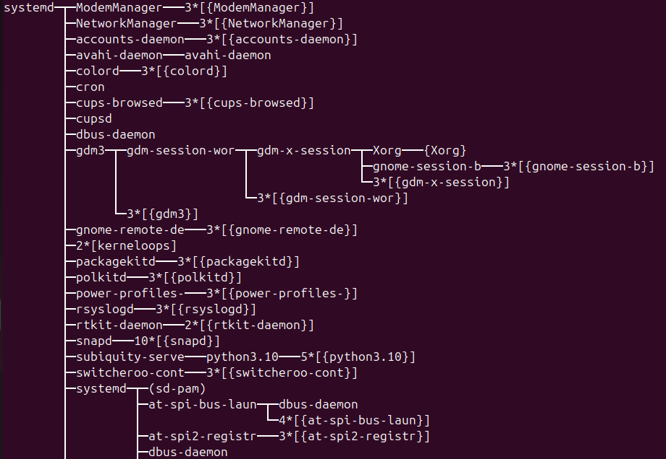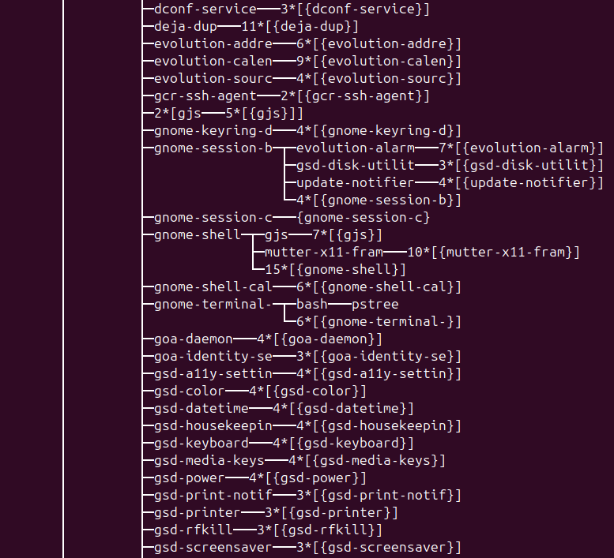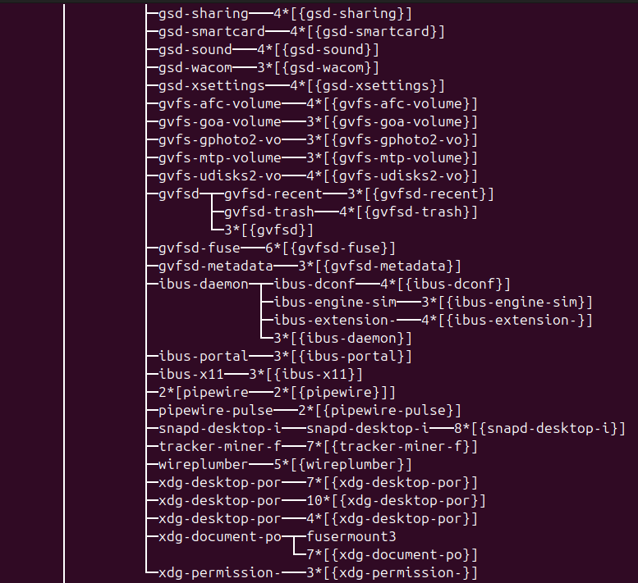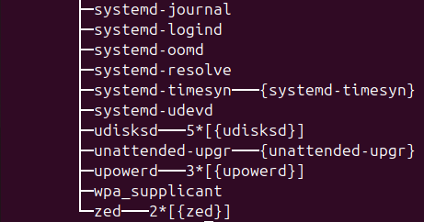

- Use Exec(), Wait() and Exit() system call.
Code:
#include <stdio.h>
#include <unistd.h>
#include <sys/wait.h>
#include <stdlib.h>

int main() {
pid_t pid = fork();

if (pid == 0) {
printf("Child: Executing ls command\n");
execl("/bin/ls", "ls", NULL);
exit(1); // if exec fails
} else {
wait(NULL);
printf("Parent: Child finished execution\n");
exit(0);
}
}

Output:
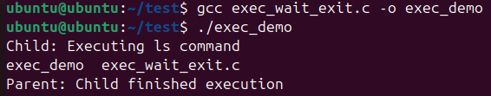

- Start a browser and check the process ID of the browser using Top command
Commands:
firefox &
top
Output:
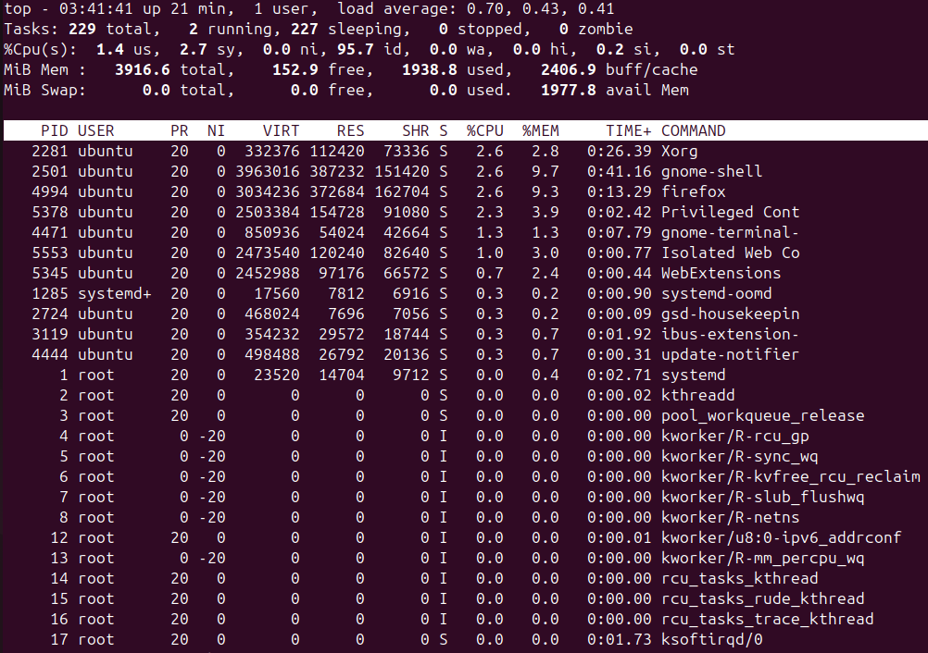

- Kill the browser process using “kill” command
Command:
kill 4994
Output:
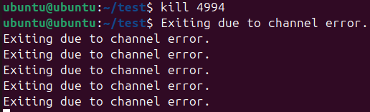

- Change the priority of any user process by using “nice” command
Command:
renice -n 5 -p 10324
Output:
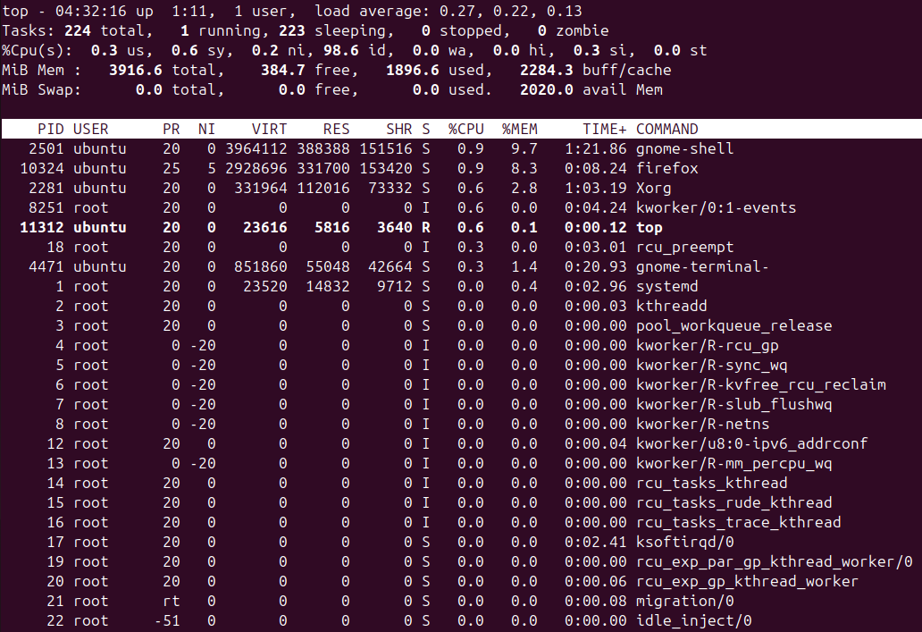

Q 2. Write a C program using the fork() system call that generates this sequence in the child process. The starting number will be provided from the user. For example, if 8 is passed as a parameter on the command line, the child process will output 8, 4, 2, 1. Because the parent and child processes have their own copies of the data, it will be necessary for the child to output the sequence. Parent invoke the wait() call to wait for the child process to complete before exiting the program. Ensure that a positive integer is passed on the command line.

Code:
#include <stdio.h>
#include <stdlib.h>
#include <unistd.h>
#include <sys/wait.h>

int main(int argc, char *argv[]) {

if (argc != 2) {
printf("Usage: %s <positive integer>\n", argv[0]);
return 1;
}

int n = atoi(argv[1]);

if (n <= 0) {
printf("Please enter a positive integer.\n");
return 1;
}

pid_t pid = fork();

if (pid < 0) {
printf("Fork failed!\n");
return 1;
}

else if (pid == 0) {
printf("Child process sequence: ");

while (n > 0) {
printf("%d ", n);
n = n / 2;
}

printf("\n");
exit(0);
}

else {
wait(NULL);
printf("Parent: Child completed.\n");
}

return 0;
}

Output:
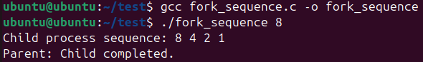

Q 3. Check output and Reason for it.
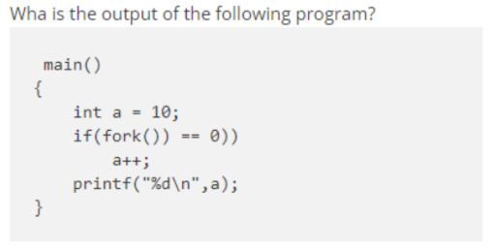
Output:
10
11
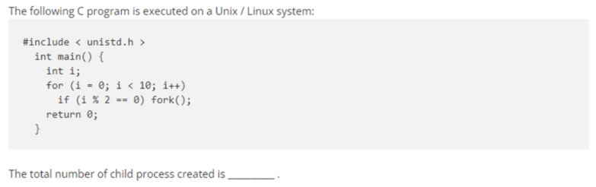
Output:
31

Q4. What happens if parent is killed (status of child), what happens when child is killed, what happens when terminal is killed (). Try these in different sequences - parent, terminal; child terminal; terminal parent etc.
Answer:
Case 1: Parent is killed (child still running)
Parent dies first
Child is still alive
Result:
Child becomes an orphan process
It is adopted by init/systemd (PID 1)
Child continues running normally
Parent PID of child becomes 1
So:
child runs
no crash
OS takes care of it

Case 2: Child is killed
Child dies first
Parent is still alive
Result:
Child becomes a zombie temporarily
Parent must call wait() to collect status
After wait zombie disappears
If parent never calls wait:
zombie stays until parent exits
Zombie = dead process entry still in process table

Case 3: Terminal is killed
When terminal closes:
Linux sends SIGHUP to processes attached to terminal
Default behavior:
both parent and child terminate
Unless program ignores SIGHUP.
So:
terminal closes
both processes die

Different sequences
Parent → Terminal
Kill parent first:
child becomes orphan
Then close terminal:
child gets SIGHUP
child dies
Final: no process running

Child → Terminal
Kill child:
zombie until parent waits
Then close terminal:
parent dies
zombie cleaned automatically
Final: nothing left

Terminal → Parent
Close terminal first:
both parent and child die immediately
No orphan, no zombie

Q 5. Process Variables and System Calls
a) Create a child process using fork() and explore the effects of:
exec()
wait()
yield()
sleep()
Code:
#include <stdio.h>
#include <unistd.h>
#include <sys/wait.h>
#include <sched.h>
#include <stdlib.h>

int main() {
pid_t pid = fork();

if (pid == 0) {
printf("Child: PID = %d\n", getpid());
printf("Child sleeping 2 seconds...\n");
sleep(2);

printf("Child yielding CPU...\n");
sched_yield();

printf("Child executing 'ls' using exec\n");
execl("/bin/ls", "ls", NULL);

printf("Exec failed\n");
exit(1);
}

else {
printf("Parent: PID = %d\n", getpid());
printf("Parent waiting for child...\n");
wait(NULL);
printf("Parent resumes after child finishes\n");
}

return 0;
}

Output:
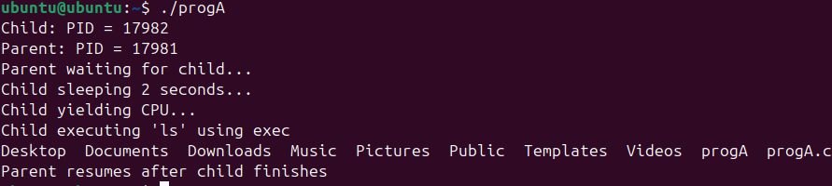

b) Verify whether local, global, and static variables are shared between parent and child processes.
Code:
#include <stdio.h>
#include <unistd.h>

int global = 10;
static int s = 20;

int main() {
int local = 30;

pid_t pid = fork();

if (pid == 0) {
global++;
s++;
local++;

printf("\nChild values:\n");
printf("global = %d\n", global);
printf("static = %d\n", s);
printf("local = %d\n", local);
}

else {
sleep(1);

printf("\nParent values:\n");
printf("global = %d\n", global);
printf("static = %d\n", s);
printf("local = %d\n", local);
}

return 0;
}

Output:
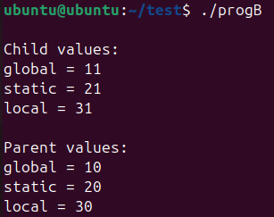

c) Verify the parent of a parent process.
Code:
#include <stdio.h>
#include <unistd.h>

int main() {
printf("Current PID: %d\n", getpid());
printf("Parent PID : %d\n", getppid());

return 0;
}

Output:
