Operating Systems: Assignment-6
Name: Suraj Shah
Admission Number: I24AI012

Q 1. Write a C program to simulate the following preemptive CPU Scheduling algorithms to find turnaround time, waiting time, average turnaround time and average waiting time.
a) FCFS b) SRTF c) Priority Scheduling (Preemptive and Non preemptive) d) SJF
Take required inputs from user such as process id, burst time, arrival time.
Code:
#include <stdio.h>
#include <limits.h>

#define MAX 100

typedef struct {
int pid;
int at; // Arrival Time
int bt; // Burst Time
int ct; // Completion Time
int tat; // Turnaround Time
int wt; // Waiting Time
int priority;
int remaining_bt;
} Process;

void calculateTimes(Process p[], int n) {
float total_tat = 0, total_wt = 0;

printf("\nPID\tAT\tBT\tCT\tTAT\tWT\n");
for(int i = 0; i < n; i++) {
p[i].tat = p[i].ct - p[i].at;
p[i].wt = p[i].tat - p[i].bt;
total_tat += p[i].tat;
total_wt += p[i].wt;

printf("%d\t%d\t%d\t%d\t%d\t%d\n",
p[i].pid, p[i].at, p[i].bt,
p[i].ct, p[i].tat, p[i].wt);
}

printf("\nAverage Turnaround Time = %.2f", total_tat/n);
printf("\nAverage Waiting Time = %.2f\n", total_wt/n);
}

void fcfs(Process p[], int n) {
int time = 0;

for(int i = 0; i < n-1; i++) {
for(int j = 0; j < n-i-1; j++) {
if(p[j].at > p[j+1].at) {
Process temp = p[j];
p[j] = p[j+1];
p[j+1] = temp;
}
}
}

for(int i = 0; i < n; i++) {
if(time < p[i].at)
time = p[i].at;

time += p[i].bt;
p[i].ct = time;
}

calculateTimes(p, n);
}

void sjf(Process p[], int n) {
int completed = 0, time = 0;
int visited[MAX] = {0};

while(completed < n) {
int idx = -1;
int min_bt = INT_MAX;

for(int i = 0; i < n; i++) {
if(p[i].at <= time && !visited[i] && p[i].bt < min_bt) {
min_bt = p[i].bt;
idx = i;
}
}

if(idx != -1) {
time += p[idx].bt;
p[idx].ct = time;
visited[idx] = 1;
completed++;
} else {
time++;
}
}

calculateTimes(p, n);
}

void srtf(Process p[], int n) {
int completed = 0, time = 0;

for(int i = 0; i < n; i++)
p[i].remaining_bt = p[i].bt;

while(completed < n) {
int idx = -1;
int min_bt = INT_MAX;

for(int i = 0; i < n; i++) {
if(p[i].at <= time && p[i].remaining_bt > 0 &&
p[i].remaining_bt < min_bt) {
min_bt = p[i].remaining_bt;
idx = i;
}
}

if(idx != -1) {
p[idx].remaining_bt--;
time++;

if(p[idx].remaining_bt == 0) {
p[idx].ct = time;
completed++;
}
} else {
time++;
}
}

calculateTimes(p, n);
}

void priorityScheduling(Process p[], int n, int preemptive) {
int completed = 0, time = 0;

for(int i = 0; i < n; i++)
p[i].remaining_bt = p[i].bt;

while(completed < n) {
int idx = -1;
int highest = INT_MAX;

for(int i = 0; i < n; i++) {
if(p[i].at <= time && p[i].remaining_bt > 0 &&
p[i].priority < highest) {
highest = p[i].priority;
idx = i;
}
}

if(idx != -1) {
if(preemptive) {
p[idx].remaining_bt--;
time++;

if(p[idx].remaining_bt == 0) {
p[idx].ct = time;
completed++;
}
} else {
time += p[idx].remaining_bt;
p[idx].remaining_bt = 0;
p[idx].ct = time;
completed++;
}
} else {
time++;
}
}

calculateTimes(p, n);
}

int main() {
Process p[MAX], temp[MAX];
int n, choice;

printf("Enter number of processes: ");
scanf("%d", &n);

for(int i = 0; i < n; i++) {
printf("\nProcess %d\n", i+1);
printf("Process ID: ");
scanf("%d", &p[i].pid);
printf("Arrival Time: ");
scanf("%d", &p[i].at);
printf("Burst Time: ");
scanf("%d", &p[i].bt);
printf("Priority (lower number = higher priority): ");
scanf("%d", &p[i].priority);
}

do {
for(int i = 0; i < n; i++)
temp[i] = p[i];

printf("\nCPU Scheduling Algorithms");
printf("\n1. FCFS");
printf("\n2. SJF (Non-Preemptive)");
printf("\n3. SRTF (Preemptive SJF)");
printf("\n4. Priority (Non-Preemptive)");
printf("\n5. Priority (Preemptive)");
printf("\n6. Exit");
printf("\nEnter choice: ");
scanf("%d", &choice);

switch(choice) {
case 1: fcfs(temp, n); break;
case 2: sjf(temp, n); break;
case 3: srtf(temp, n); break;
case 4: priorityScheduling(temp, n, 0); break;
case 5: priorityScheduling(temp, n, 1); break;
case 6: break;
default: printf("Invalid choice!\n");
}

} while(choice != 6);

return 0;
}

Output:
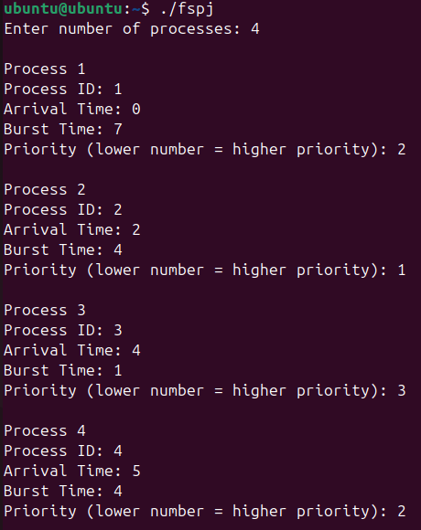
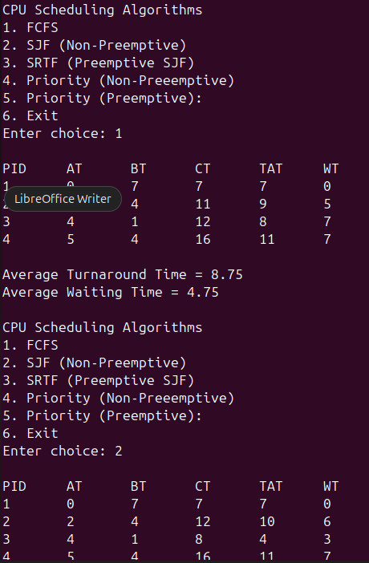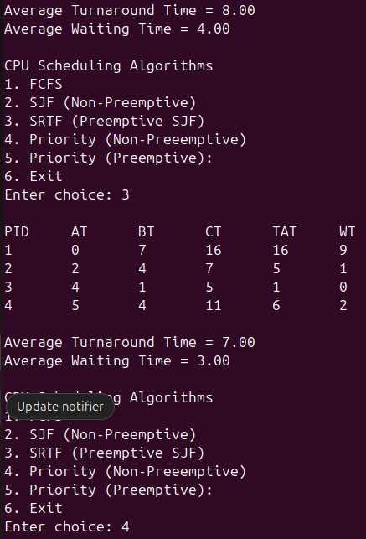
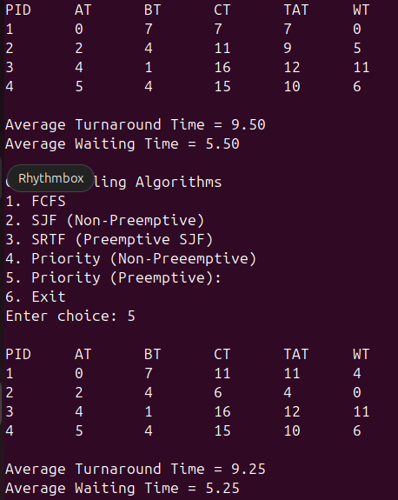

Q 2. Implementation of CPU Scheduling (Pre-emptive Processes): i) Round Robin ii) Longest job
first and iii) Longest Remaining Time First
Code:
#include <stdio.h>
#include <limits.h>

#define MAX 100

typedef struct {
int pid;
int at; // Arrival Time
int bt; // Burst Time
int ct; // Completion Time
int tat; // Turnaround Time
int wt; // Waiting Time
int remaining_bt;
} Process;

void calculate(Process p[], int n) {
float total_tat = 0, total_wt = 0;

printf("\nPID\tAT\tBT\tCT\tTAT\tWT\n");
for(int i = 0; i < n; i++) {
p[i].tat = p[i].ct - p[i].at;
p[i].wt = p[i].tat - p[i].bt;

total_tat += p[i].tat;
total_wt += p[i].wt;

printf("%d\t%d\t%d\t%d\t%d\t%d\n",
p[i].pid, p[i].at, p[i].bt,
p[i].ct, p[i].tat, p[i].wt);
}

printf("\nAverage Turnaround Time = %.2f", total_tat/n);
printf("\nAverage Waiting Time = %.2f\n", total_wt/n);
}

void roundRobin(Process p[], int n, int tq) {
int time = 0, completed = 0;

for(int i = 0; i < n; i++)
p[i].remaining_bt = p[i].bt;

while(completed < n) {
int done = 1;

for(int i = 0; i < n; i++) {
if(p[i].remaining_bt > 0 && p[i].at <= time) {
done = 0;

if(p[i].remaining_bt > tq) {
time += tq;
p[i].remaining_bt -= tq;
} else {
time += p[i].remaining_bt;
p[i].remaining_bt = 0;
p[i].ct = time;
completed++;
}
}
}

if(done)
time++;
}

calculate(p, n);
}

void ljf(Process p[], int n) {
int completed = 0, time = 0;
int visited[MAX] = {0};

while(completed < n) {
int idx = -1;
int max_bt = -1;

for(int i = 0; i < n; i++) {
if(p[i].at <= time && !visited[i] && p[i].bt > max_bt) {
max_bt = p[i].bt;
idx = i;
}
}

if(idx != -1) {
time += p[idx].bt;
p[idx].ct = time;
visited[idx] = 1;
completed++;
} else {
time++;
}
}

calculate(p, n);
}

void lrtf(Process p[], int n) {
int completed = 0, time = 0;

for(int i = 0; i < n; i++)
p[i].remaining_bt = p[i].bt;

while(completed < n) {
int idx = -1;
int max_bt = -1;

for(int i = 0; i < n; i++) {
if(p[i].at <= time && p[i].remaining_bt > 0 &&
p[i].remaining_bt > max_bt) {
max_bt = p[i].remaining_bt;
idx = i;
}
}

if(idx != -1) {
p[idx].remaining_bt--;
time++;

if(p[idx].remaining_bt == 0) {
p[idx].ct = time;
completed++;
}
} else {
time++;
}
}

calculate(p, n);
}

int main() {
Process p[MAX], temp[MAX];
int n, choice, tq;

printf("Enter number of processes: ");
scanf("%d", &n);

for(int i = 0; i < n; i++) {
printf("\nProcess %d\n", i+1);
printf("Process ID: ");
scanf("%d", &p[i].pid);
printf("Arrival Time: ");
scanf("%d", &p[i].at);
printf("Burst Time: ");
scanf("%d", &p[i].bt);
}

do {
for(int i = 0; i < n; i++)
temp[i] = p[i];

printf("\n1. Round Robin");
printf("\n2. Longest Job First (Non-Preemptive)");
printf("\n3. Longest Remaining Time First (Preemptive)");
printf("\n4. Exit");
printf("\nEnter choice: ");
scanf("%d", &choice);

switch(choice) {
case 1:
printf("Enter Time Quantum: ");
scanf("%d", &tq);
roundRobin(temp, n, tq);
break;
case 2:
ljf(temp, n);
break;
case 3:
lrtf(temp, n);
break;
}

} while(choice != 4);

return 0;
}

Output:
