Operating Systems: Assignment-9
Name: Suraj Shah
Admission Number: I24AI012

Q 1. Write a C program to implement Banker’s Algorithm and determine whether the system is in a safe state.
Expected Answer:
Student should write a program that:
• Takes n processes and m resources
• Inputs Allocation, Max, Available
• Computes Need
• Applies Safety Algorithm
• Prints safe sequence or unsafe state

Code:
#include <stdio.h>

int main() {
int n, m, i, j, k;

printf("Enter number of processes: ");
scanf("%d", &n);

printf("Enter number of resources: ");
scanf("%d", &m);

int alloc[n][m], max[n][m], need[n][m];
int avail[m];

printf("\nEnter Allocation Matrix:\n");
for (i=0; i<n; i++) {
for (j=0; j<m; j++) {
scanf("%d", &alloc[i][j]);
}
}

printf("\nEnter Max Matrix:\n");
for (i=0; i<n; i++) {
for (j=0; j<m; j++) {
scanf("%d", &max[i][j]);
}
}

printf("\nEnter Available Resources:\n");
for (i=0; i<m; i++) {
scanf("%d", &avail[i]);
}

for (i=0; i<n; i++) {
for (j=0; j<m; j++) {
need[i][j]=max[i][j]-alloc[i][j];
}
}

int finish[n], safeSeq[n];
int work[m];

for (i=0; i<n; i++) {
finish[i]=0;
}

for (i=0; i<m; i++) {
work[i]=avail[i];
}

int count=0;

while (count<n) {
int found=0;

for (i=0; i<n; i++) {
if (finish[i]==0) {

for (j=0; j<m; j++) {
if (need[i][j]>work[j]) {
break;
}
}

if (j==m) {
for (k=0; k<m; k++) {
work[k]+=alloc[i][k];
}

safeSeq[count++]=i;
finish[i]=1;
found=1;
}
}
}

if (found==0) {
printf("\nSystem is NOT in a safe state.\n");
return 0;
}
}

printf("\nSystem is in a SAFE state.\nSafe sequence: ");
for (i=0; i<n; i++) {
printf("P%d ", safeSeq[i]);
}
printf("\n");

return 0;
}

Output:
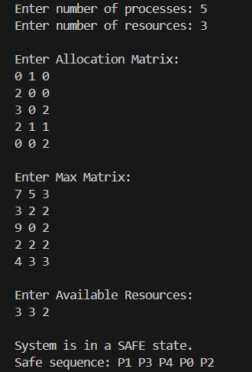

Q 2. Modify the Banker’s Algorithm program to also process a resource request from a process.
Expected Answer:
Program should:
• Take process number and request vector
• Check:
o Request &lt;= Need
o Request &lt;= Available
• Temporarily allocate
• Run safety algorithm
• Grant or deny request

Code:
#include <stdio.h>

int main() {
int n, m, i, j, k;

printf("Enter number of processes: ");
scanf("%d", &n);

printf("Enter number of resources: ");
scanf("%d", &m);

int alloc[n][m], max[n][m], need[n][m];
int avail[m];

printf("\nEnter Allocation Matrix:\n");
for (i=0; i<n; i++) {
for (j=0; j<m; j++) {
scanf("%d", &alloc[i][j]);
}
}

printf("\nEnter Max Matrix:\n");
for (i=0; i<n; i++) {
for (j=0; j<m; j++) {
scanf("%d", &max[i][j]);
}
}

printf("\nEnter Available Resources:\n");
for (i=0; i<m; i++) {
scanf("%d", &avail[i]);
}

for (i=0; i<n; i++) {
for (j=0; j<m; j++) {
need[i][j]=max[i][j]-alloc[i][j];
}
}

int p;
printf("\nEnter process number making request: ");
scanf("%d", &p);

if (p < 0 || p >= n) {
printf("Invalid process number\n");
return 0;
}

int request[m];
printf("Enter request vector:\n");
for (i=0; i<m; i++) {
scanf("%d", &request[i]);
}

for (i=0; i<m; i++) {
if (request[i]>need[p][i]) {
printf("\nError: Request exceeds maximum need.\n");
return 0;
}
}

for (i=0; i<m; i++) {
if (request[i]>avail[i]) {
printf("\nResources not available. Process must wait.\n");
return 0;
}
}

int tempAvail[m], tempAlloc[n][m], tempNeed[n][m];

for (i=0; i<m; i++)
tempAvail[i]=avail[i];

for (i=0; i<n; i++) {
for (j=0; j<m; j++) {
tempAlloc[i][j]=alloc[i][j];
tempNeed[i][j]=need[i][j];
}
}

for (i=0; i<m; i++) {
avail[i]-=request[i];
alloc[p][i]+=request[i];
need[p][i]-=request[i];
}

int finish[n], safeSeq[n];
int work[m];

for (i=0; i<n; i++) {
finish[i]=0;
}

for (i=0; i<m; i++) {
work[i]=avail[i];
}

int count=0;

while (count<n) {
int found=0;

for (i=0; i<n; i++) {
if (finish[i]==0) {

for (j=0; j<m; j++) {
if (need[i][j]>work[j]) {
break;
}
}

if (j==m) {
for (k=0; k<m; k++) {
work[k]+=alloc[i][k];
}

safeSeq[count++]=i;
finish[i]=1;
found=1;
}
}
}

if (found==0) {
for (i=0; i<m; i++)
avail[i]=tempAvail[i];

for (i=0; i<n; i++) {
for (j=0; j<m; j++) {
alloc[i][j]=tempAlloc[i][j];
need[i][j]=tempNeed[i][j];
}
}

printf("\nRequest cannot be granted (UNSAFE state).\n");
return 0;
}
}

printf("\nRequest can be granted.\nSafe sequence: ");
for (i=0; i<n; i++) {
printf("P%d ", safeSeq[i]);
}
printf("\n");

return 0;
}

Output:
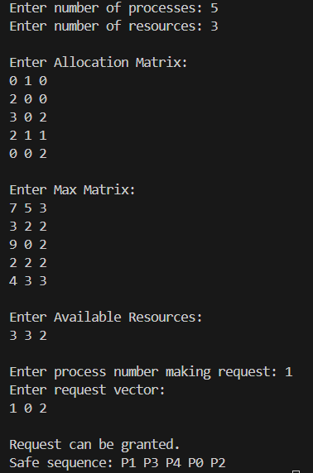
Q 3. Write a program to display all matrices used in Banker’s Algorithm in tabular format.
Expected Answer:
Should print:
• Allocation
• Max
• Need
• Available

Code:
#include <stdio.h>

int main() {
int n, m, i, j, k;

printf("Enter number of processes: ");
scanf("%d", &n);

printf("Enter number of resources: ");
scanf("%d", &m);

int alloc[n][m], max[n][m], need[n][m];
int avail[m];

printf("\nEnter Allocation Matrix:\n");
for (i=0; i<n; i++) {
for (j=0; j<m; j++) {
scanf("%d", &alloc[i][j]);
}
}

printf("\nEnter Max Matrix:\n");
for (i=0; i<n; i++) {
for (j=0; j<m; j++) {
scanf("%d", &max[i][j]);
}
}

printf("\nEnter Available Resources:\n");
for (i=0; i<m; i++) {
scanf("%d", &avail[i]);
}

for (i=0; i<n; i++) {
for (j=0; j<m; j++) {
need[i][j]=max[i][j]-alloc[i][j];
}
}

printf("\n\nPROCESS\tALLOCATION\tMAX\t\tNEED\n");

for (i=0; i<n; i++) {
printf("P%d\t", i);

for (j=0; j<m; j++) {
printf("%d ", alloc[i][j]);
}

printf("\t\t");

for (j=0; j<m; j++) {
printf("%d ", max[i][j]);
}

printf("\t\t");

for (j=0; j<m; j++) {
printf("%d ", need[i][j]);
}

printf("\n");
}

printf("\nAvailable:\n");
for (i=0; i<m; i++) {
printf("%d ", avail[i]);
}

printf("\n");

return 0;
}

Output:
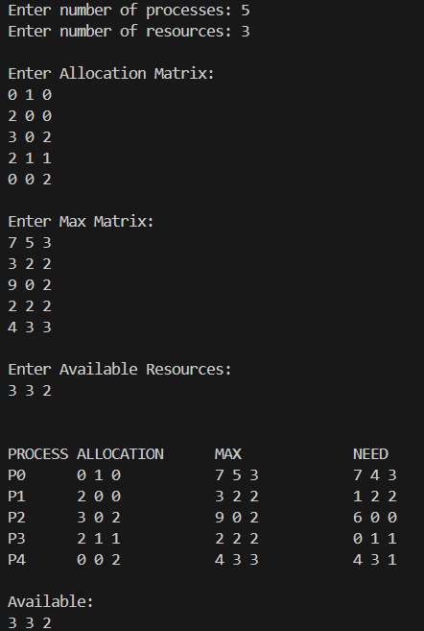

Q 4. Write a menu-driven C program for Banker’s Algorithm with options:
1. Enter data
2. Display Need matrix
3. Check safe state
4. Process resource request
5. Exit

Code:
#include <stdio.h>

#define MAX 10

int n, m;
int alloc[MAX][MAX], max[MAX][MAX], need[MAX][MAX];
int avail[MAX];

void calculateNeed() {
for (int i=0; i<n; i++) {
for (int j=0; j<m; j++) {
need[i][j]=max[i][j]-alloc[i][j];
}
}
}

void enterData() {
printf("Enter number of processes: ");
scanf("%d", &n);

printf("Enter number of resources: ");
scanf("%d", &m);

printf("\nEnter Allocation Matrix:\n");
for (int i=0; i<n; i++) {
for (int j=0; j<m; j++) {
scanf("%d", &alloc[i][j]);
}
}

printf("\nEnter Max Matrix:\n");
for (int i=0; i<n; i++) {
for (int j=0; j<m; j++) {
scanf("%d", &max[i][j]);
}
}

printf("\nEnter Available Resources:\n");
for (int i=0; i<m; i++) {
scanf("%d", &avail[i]);
}

calculateNeed();
}

void displayNeed() {
printf("\nNeed Matrix:\n");
for (int i=0; i<n; i++) {
printf("P%d: ", i);
for(int j=0; j<m; j++) {
printf("%d ", need[i][j]);
}
printf("\n");
}
}

int checkSafe() {
int work[MAX], finish[MAX]={0}, safeSeq[MAX];

for (int i=0; i<m; i++) {
work[i]=avail[i];
}

int count=0;

while (count<n) {
int found=0;

for (int i=0; i<n; i++) {
if (!finish[i]) {
int j;
for (j=0; j<m; j++) {
if(need[i][j]>work[j]) {
break;
}
}

if (j == m) {
for(int k=0; k<m; k++) {
work[k]+=alloc[i][k];
}

safeSeq[count++]=i;
finish[i]=1;
found=1;
}
}
}

if (!found) {
printf("\nSystem is NOT in safe state\n");
return 0;
}
}

printf("\nSystem is in SAFE state\nSafe sequence: ");
for (int i=0; i<n; i++) {
printf("P%d ", safeSeq[i]);
}

printf("\n");
return 1;
}

void requestResources() {
int p, request[MAX];

printf("Enter process number: ");
scanf("%d", &p);

if (p<0 || p>=n) {
printf("Invalid process number\n");
return;
}

printf("Enter request vector:\n");
for(int i=0; i<m; i++) {
scanf("%d", &request[i]);
}

for (int i=0; i<m; i++) {
if (request[i]>need[p][i]) {
printf("Error: exceeds need\n");
return;
}
}

for (int i=0; i<m; i++) {
if (request[i]>avail[i]) {
printf("Resources not available\n");
return;
}
}

int tempAvail[MAX], tempAlloc[MAX][MAX], tempNeed[MAX][MAX];

for (int i=0; i<m; i++) {
tempAvail[i]=avail[i];
}

for (int i=0; i<n; i++) {
for (int j=0; j<m; j++) {
tempAlloc[i][j]=alloc[i][j];
tempNeed[i][j]=need[i][j];
}
}

for (int i=0; i<m; i++) {
avail[i]-=request[i];
alloc[p][i]+=request[i];
need[p][i]-=request[i];
}

if (checkSafe()) {
printf("Request granted\n");
} else {
for (int i=0; i<m; i++) {
avail[i]=tempAvail[i];
}

for (int i=0; i<n; i++) {
for (int j=0; j<m; j++) {
alloc[i][j]=tempAlloc[i][j];
need[i][j]=tempNeed[i][j];
}
}

printf("Request denied (unsafe)\n");
}
}

int main() {
int choice;

while(1) {
printf("\n--- BANKER'S ALGORITHM MENU ---\n");
printf("1. Enter data\n");
printf("2. Display Need matrix\n");
printf("3. Check safe state\n");
printf("4. Process resource request\n");
printf("5. Exit\n");
printf("Enter choice: ");
scanf("%d", &choice);

switch(choice) {
case 1: enterData(); break;
case 2: displayNeed(); break;
case 3: checkSafe(); break;
case 4: requestResources(); break;
case 5: return 0;
default: printf("Invalid choice\n");
}
}
}

Output:
