Learning Activity Operating Systems
Name: Suraj Shah
Admission Number: I24AI012

- Observation: Process Behavior Watch: Open Task Manager, Make observation of processes and their details. Write down all your observations.

In order to analyze how the processes behave in real time, I found opening up my Task Manager on my machine and observing various running process along with their properties.

So, when I opened Task Manager for the first time I saw that there were many more processes running than the applications in which I had manually opened. That made me realize there are tons of background processes running in the operating system which user cannot see directly.

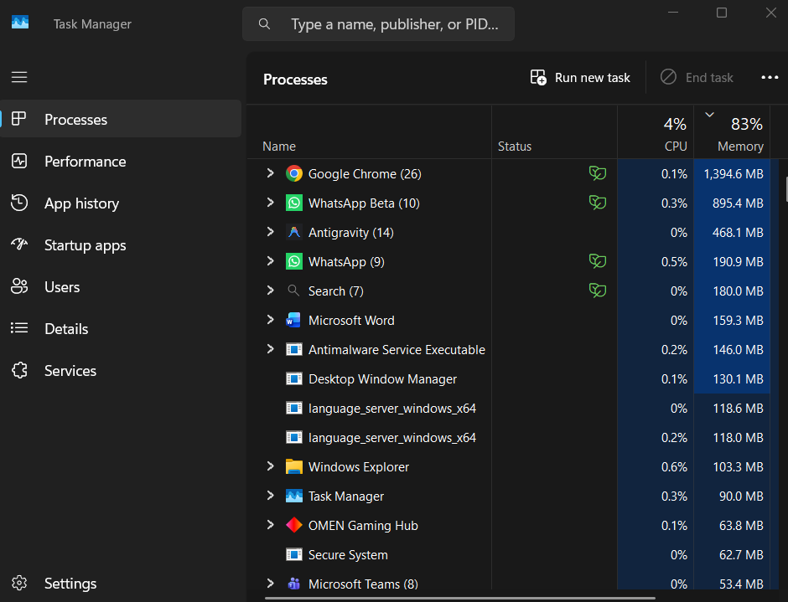

When I clicked the Processes tab, processes were classified based on Apps, Background processes, and Windows processes. Under Apps, applications such as a browser and file explorer showed up along with many unknown processes running in the background.

This contains details like CPU usage, Memory usage, Disk activity & Network usage for each process. And browsing processes (especially with multiple tabs open) used up plenty of CPU/memory.

Now we found one of them interesting, CPU usage was keep changing. On an idle system, some background processes were still consuming small amounts of CPU. This indicates that the operating system is constantly working in the background.

I noticed that the memory usage was also pretty much if not high with just a few applications open. The reason is likely that background services and system processes take up memory for the continuous operation of your system.

Another thing I noticed was that some processes had multiple instances (for example, browser processes). This indicates that modern applications use multiple processes for better performance and stability.

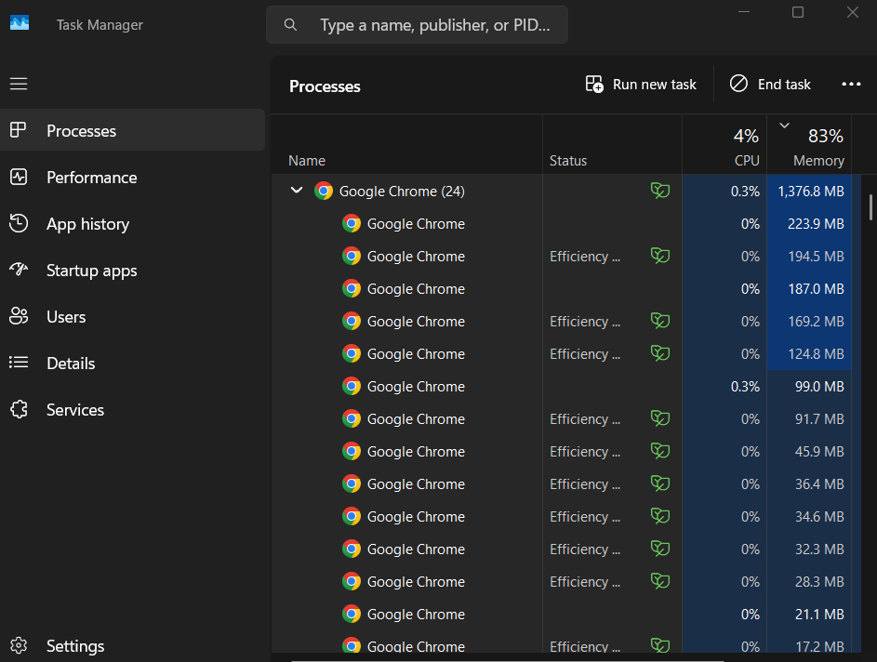

I was able to view more details like Process ID (PID), Status, and Priority when I went to the Details tab. Each Process had its own PID, which makes it easier for the operating system to distinguish between them.

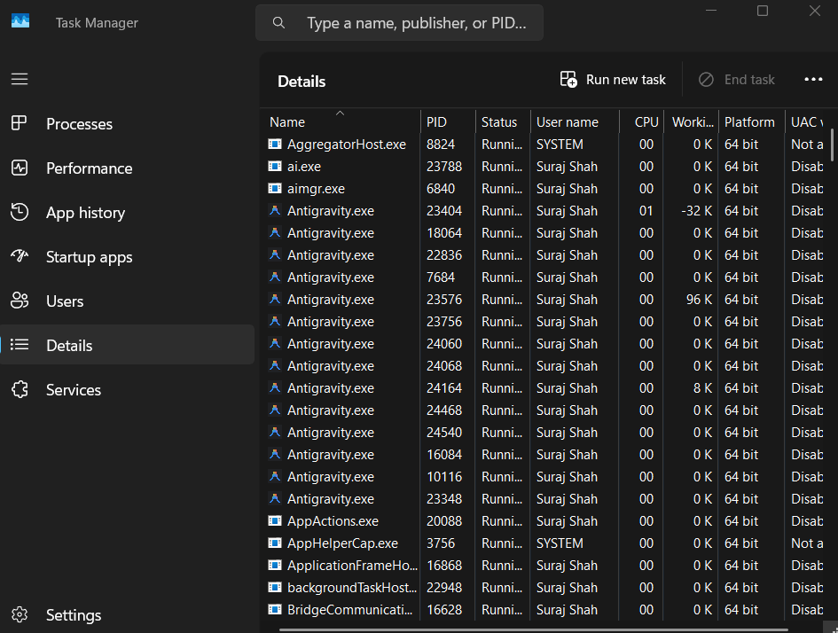

In general, this experiment allowed me to realize that multiple processes run concurrently on any computer at all times, and resource consumption is also variable. Furthermore, I have gained practical insight into how an operating system handles processes in real time.

- Design Your Own Scheduling Algorithm subject to special requirements and specific environment. Check the applicability of scheduling algorithms in applications other than Operating systems.

Objectives
Objectives of this activity include:
• Developing a custom scheduling algorithm considering specific system requirements
• Analyzing its functionality
• Understanding the application of scheduling concepts in areas other than operating systems

Algorithm Suggested
A new scheduling algorithm was proposed by me named 'Adaptive Priority with Aging' (APA). This algorithm uses concepts of priority scheduling with aging to prevent starvation problems.

Workings of the Algorithm
1. A new process is characterized with:
o Initial priority
o Arrival time
o Burst time

2. Process is chosen as per:
o Highest priority
o When priorities are same, then burst time of shorter process gets preference

3. Aging technique:
o If the process is waiting for too long in the queue, then its priority increases
o It prevents starvation of low priority processes

4. Adjustment of priority:
o If the process uses the CPU too much continuously, then priority decreases slightly
o CPU is utilized in a fair manner

Requirement & Working Environment
This type of algorithm would be useful in situations where:
• Fairness and response are important considerations
• Both short & long processes run simultaneously
• Multitasking environment exists

Observations
During designing the above-mentioned algorithm, I observed that:
• Simply relying on priority creates starvation problem
• Using aging solves the problem
• Combining two factors leads to better results than depending upon any one factor
Scheduling in Other Applications
Not only operating systems make use of scheduling techniques. Scheduling is also applicable in other areas:
1. Web Servers
Users' requests can be prioritized depending on their importance.
2. Cloud Computing
Tasks can be assigned to virtual machines depending on resources available at the moment.
3. Banking Systems
Transactions can be prioritized (important transactions, for example).
4. Hospital Management Systems
Patients can be scheduled according to the seriousness of their condition rather than arrival order.
5. Traffic Control Systems
Traffic signals can be adjusted depending on the level of traffic rather than set time intervals.

Problems Encountered
When designing an algorithm, one problem that I encountered was finding a balance between efficiency and fairness. Raising priority too fast could lead to poor system performance, but raising it too slowly could result in starvation.

Conclusion
This assignment allowed me to see that traditional scheduling algorithms are not enough for all situations. Custom algorithms such as APA can provide more opportunities for controlling system performance. Additionally, it allowed me to understand that scheduling is a universal technique that can be applied outside of operating systems.

- Design Operating for Special Users such as Users in Critical Mission or cognitive, visual, or auditory disabilities

Objective
The objective of this assignment is:
• To identify the requirements of special users
• To implement certain features in OS supporting these users
• To enhance the usability, reliability, and accessibility

Design for Critical Mission Users
Special users working in critical mission applications (such as air traffic control or any other medical application) demand reliability and responsive system.
Important aspects in this regard may include:
• Real time processing capability
The system should process instantly without any delay
• Reliability and robustness of system
The system should work properly even in case of failure of certain hardware components
• Reducing user distractions
The interface should not contain unnecessary elements
• Priority task handling mechanism
Priority tasks have to be completed first
• System monitoring and alerts
Alerts should be raised instantly in case of system failure
Thinking along the above lines, I understood that a little delay in such systems would prove very disastrous.

Design for Visually Impaired Users
For visually impaired special users, voice interaction will be very useful.
This would include:
• Speech recognition and screen reader facility for reading the displayed text
• Voice command to navigate through the system
• High contrast theme for partially visually impaired people
• Shortcuts for keyboard operation without mouse usage
I realized during this exercise that even labeling the button with appropriate names plays a vital role here.

Operating System Design for Special User Groups

Operating System Design for Users with Auditory Disabilities
For users having difficulty in relying on sound:
• Visual alarms in place of auditory alarm
• Subtitle and captioned multimedia applications
• Vibrations or visual alarms (on supported systems)
This helps ensure that no important system message is overlooked.

Operating System Design for Users with Cognitive Disabilities
Cognitive disabilities make the users face problems in comprehending complicated system interface designs.
Features used are:
• Minimal and neat user interface
• Step-by-step guidance during the execution of tasks
• Usage of icons and images instead of texts
• Uniformity in design
While working on this part of the assignment, I realized that minimalistic interface benefits even non-disabled users.

Challenges Encountered
The first challenge was to strike a balance between simplicity and functional features. On one hand, simplicity reduces the number of features, whereas complexity would make the special users find it challenging to use.
Secondly, the requirements of different users vary, thus requiring the designer to keep in mind varied requirements.

Conclusion
Designing an operating system for special users involves many factors such as accessibility, reliability, and usability. Real-time processing, assistive technologies, and simplified interfaces are crucial in designing such systems.

- How the threads synchronize with each other for applications.

Objective
The purpose of this exercise is:
• To gain insight into why thread synchronization is needed
• To learn about various techniques employed for synchronization
• To explore how synchronization is used in practical applications

Need for Thread Synchronization
During concurrent execution, multiple threads may attempt to read/write to the same data, which can lead to problems such as:
• Race condition – where the outcome depends on the order of operations
• Inconsistent state of shared variables
• Uncertain behavior
For instance, if two threads try to alter the same variable simultaneously, the end result might be incorrect.

Synchronization Techniques
Several synchronization techniques are commonly utilized:
1. Mutex/Mutual Exclusion Lock
Mutex guarantees that a particular segment of code is executed by only one thread at a time. The other threads have to wait until the lock is released.
2. Semaphore
Semaphore allows for controlling access to a resource by multiple threads simultaneously. It is beneficial when more than one copy of a resource exists.
3. Monitor
Monitor represents an advanced synchronization tool that combines mutex and condition variables.

Working Example
Suppose we have several threads that write into the same file. In such cases, if synchronization is not used, the data can become messed up.
When using a mutex,
• The thread acquires the file first
• The other threads will be waiting until it releases the file
• The thread then writes and releases the file
Thus, using a mutex will make sure that no more than one thread writes into the file at any point in time.

Applications of Thread Synchronization
Thread synchronization is required in several real-life situations:
• Banking system
• Database management systems
• Operating systems
• Web servers
• Multiplayer games

Challenges Faced
In my study about thread synchronization, I found that while synchronization helps to achieve correctness, it also has some drawbacks, such as reduced performance. Moreover, inappropriate use of locks can create problems, such as deadlocks, where the threads wait indefinitely.

Conclusion
Thread synchronization is very important in ensuring correct execution of multi-threaded applications. Methods of synchronization include mutex, semaphores, monitors, etc. This learning activity was quite helpful in realizing the significance of synchronization and its problems.

- Try an Unfamiliar Operating Systems.

Objective
The objective of this activity includes:
• To work on a new operating system
• To understand the features and functionality of the operating system
• To compare this operating system with my usual operating system

Operating System Used
In this assignment, I experimented with the Ubuntu OS (Linux-based). In general, I had been working on the Windows Operating System.

Installation / Setup
Ubuntu was installed on my system by setting up a virtual machine. Installation took some time and it was slightly difficult due to being different from other applications that were usually installed.

Observations
• The interface was completely new from that I was familiar with. Rather than having the start menu, there was the sidebar as well as an application launcher.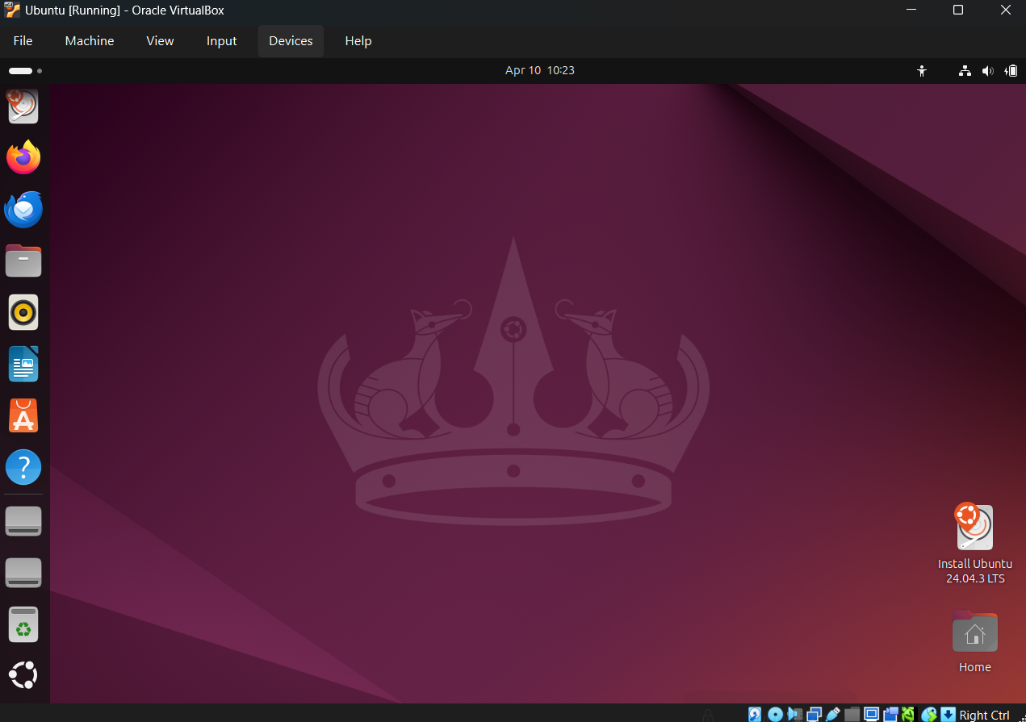

- I noticed that many tasks could be done using the terminal, which was new to me. At first, it felt complicated, but it also seemed powerful.
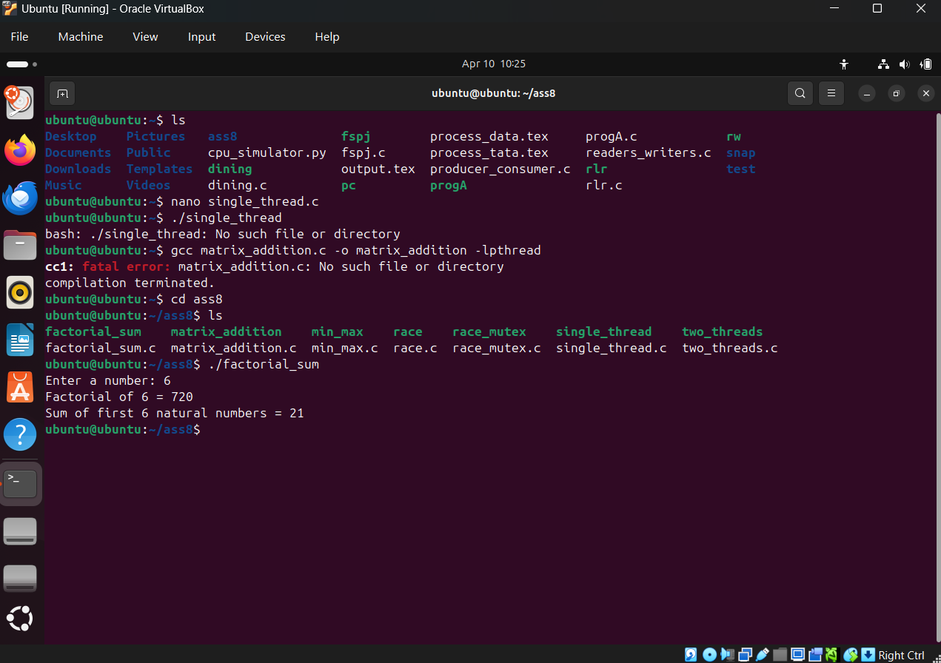

- The system felt lightweight and fast, especially compared to my usual OS.
- Software installation was different. Instead of downloading from websites, I could install applications using commands or a software manager.
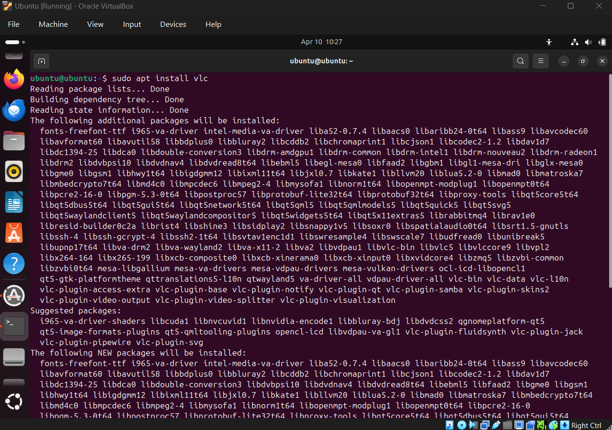

- File structure was also different, with directories like /home, /bin, etc., which I had not seen before.
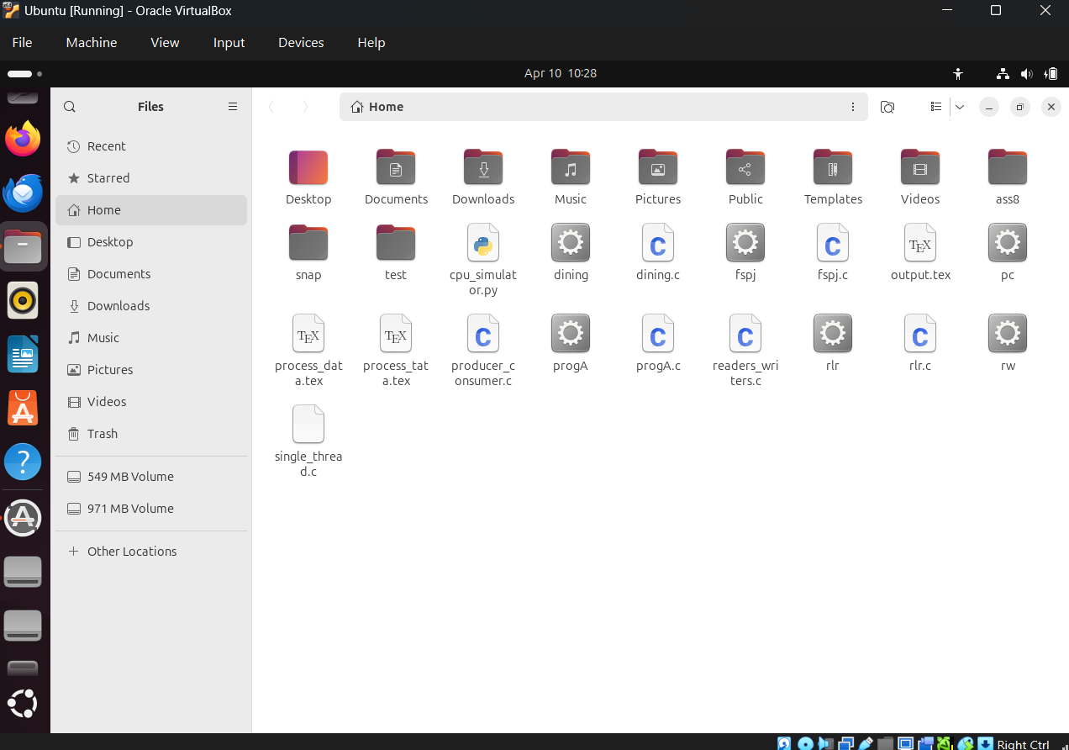

Comparison with Familiar OS
Ubuntu compared with Windows:
• I gained more freedom with Ubuntu
• There was a need for knowledge about the terminal
• More secure than windows and less virus infected
• BUT there was lack of programs I usually work on

Problems Encountered
• In the beginning, I was unable to do things since everything looked new to me
• Terminal commands were hard to memorize
• It took time to find certain settings
Eventually, it got easier to work with it.

Conclusion
I think trying something unfamiliar like a new OS can be good practice. It made me realize that each OS is designed differently depending on what it aims to do.

