**Lab-1**

1. **PROGRAM TO CALCULATE SIMPLE INTEREST.**

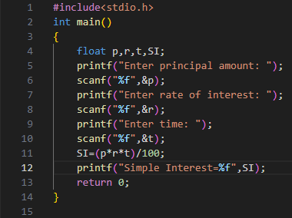

**2. PROGRAM TO READ MARKS OF FIVE SUBJECT OF A STUDENT AND CALCULATE TOTAL**

**AND PERCENTAGE.**

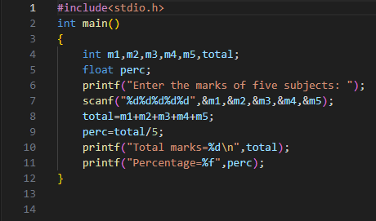

1. **PROGRAM TO CALCULATE GROSS SALARY.**

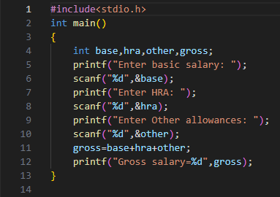

**4. PROGRAM TO CONVERT TEMPERATURE FROM FAHRENHEIT TO CENTIGRADE**

**DEGREES.**

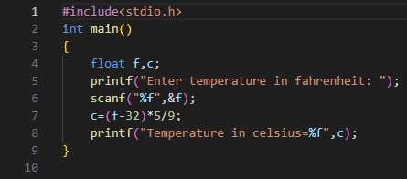

1. **PROGRAM TO SWAP TOW VARIABLES USING THIRD VARIABLE.**

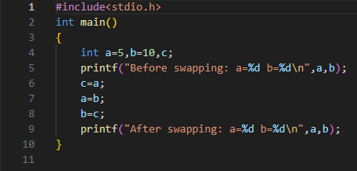

1. **PROGRAM TO SWAP TWO VARIABLES WITHOUT USING THIRD VARIABLE.**

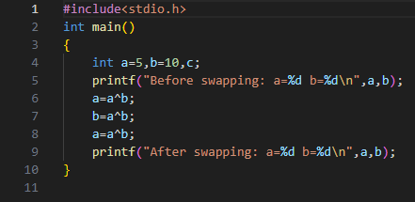

1. **PROGRAM TO CALCULATE AREA OF A TRIANGLE.**

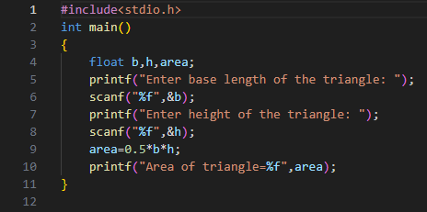

**8. EARTH TAKES A PERIOD OF REVOLUTION OF 31558150 SECONDS .WRITE A C**

**PROGRAM TO CONVERT THIS INTO NUMBER OF DAY,HOURS AND MINUTES**

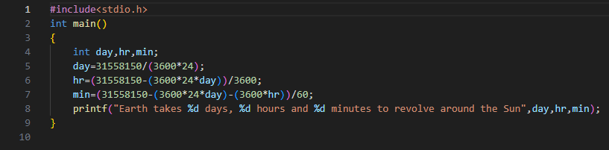

1. **PROGRAM TO READ TIME IN HR,MIN,SEC AND CONVERT IT INTO TOTAL SECOND.**

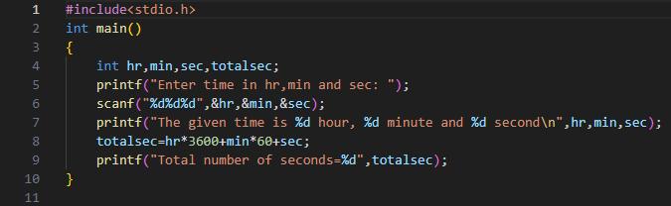

**10. WRITE A C PROGRAM TO CALCULATE THE CUT OFF MARK OF A STUDENT USING THE**

**FORMULA.**

**CM = M/2+P/2+C/2+E**

**WHERE CM = Cut of f mark**

**M = Marks in Mathematics out of 200**

**P = Marks in Physics out of 200**

**C = Marks in Chemistry out of 200**

**E = Marks in entrance examination out of 100**

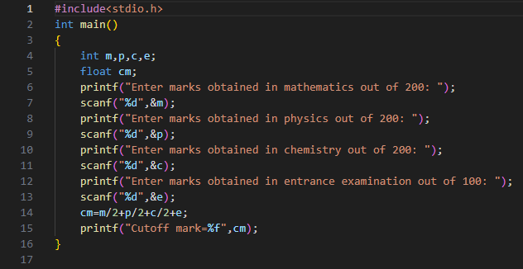

1. **PROGRAM TO READ TOTAL SECOND AND CONVERT IT INTO TIME.**

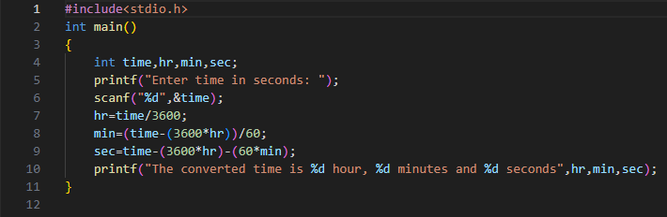

1. **PROGRAM TO PRINT ASCII CODE OF ANY CHARACTER.**

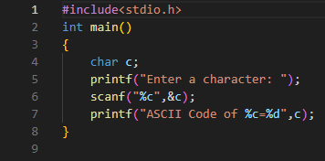

1. **PROGRAM TO CHECK WHETHER A NO. IS EVEN OR ODD.**

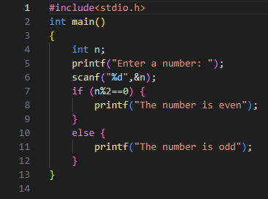

**14. PROGRAM TO CHECK WHETHER A GIVEN CHARACTER IS CAPITAL, LETTER, SMALL**

**CASE LETTER, A DIGIT OR A SPECIAL SYMBOL.**

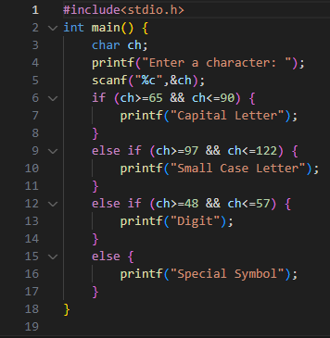

1. **PROGRAM TO READ MARKS OF FIVE SUBJECT AND PRINT DIVISION.**

