ASSIGNMENT NO.—1
Question 1: A die is rolled. What is the probability of getting:
(a) An even number
(b) A number greater than 4
Sol
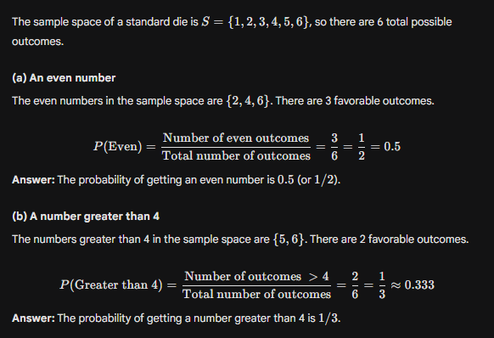

Question 2: In a class of 50 students:
20 like Mathematics (M)
15 like Science (S)
5 like both subjects
What is the probability that a student chosen at random likes Mathematics or Science?

Sol
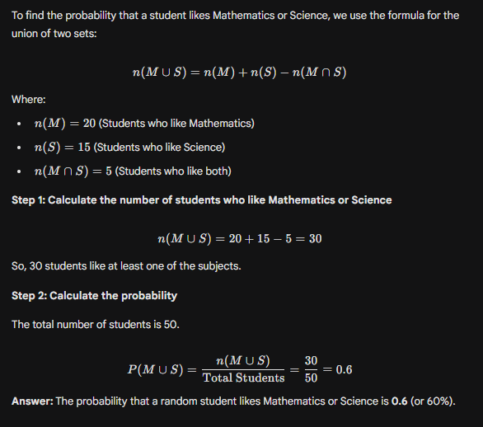

Question 3: A bag has 3 red and 2 blue balls. If one ball is drawn randomly and is red, what is the probability that the next ball is also red (without replacement)?
Sol
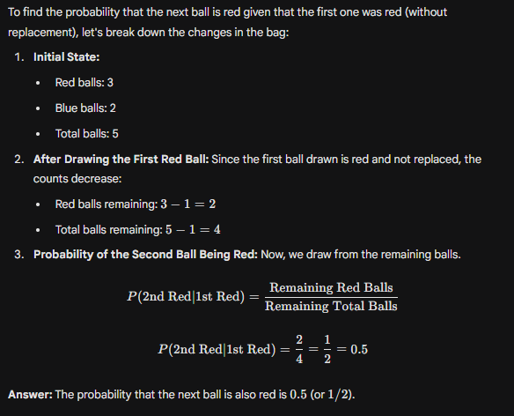
Question 4: The population of a school is divided into 60% boys and 40% girls. If you want equal representation of both genders in the sample, which method should you use: Simple Random Sampling or Stratified Sampling? Why?

Sol
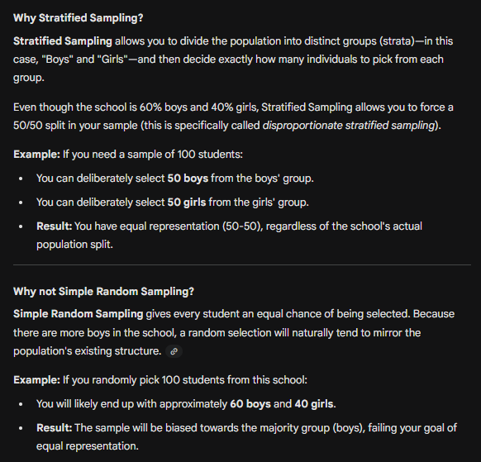

Question 5: The average height of 1000 students = 160 cm. A sample of 100 students shows an average height = 158 cm. Find the sampling error.

Sol
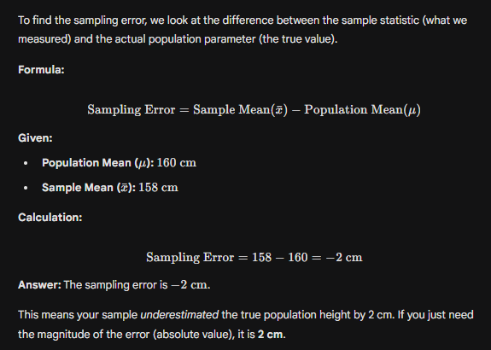

Question 6: The population mean salary is ₹50,000 with σ = ₹5,000. If we take a sample of 100 employees, what is the standard error of the mean (SEM)?

Sol
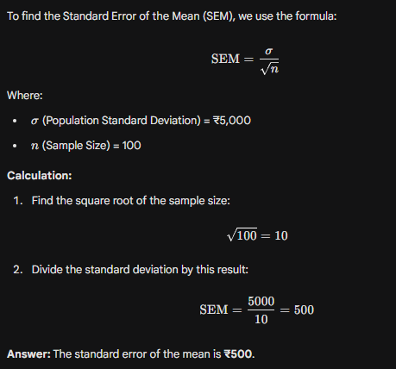
Question 7: In a group of 100 students: 40 like Cricket (C) 30 like Football (F) 10 like both Cricket and Football Find the probability that a student likes at least one sport.
Sol
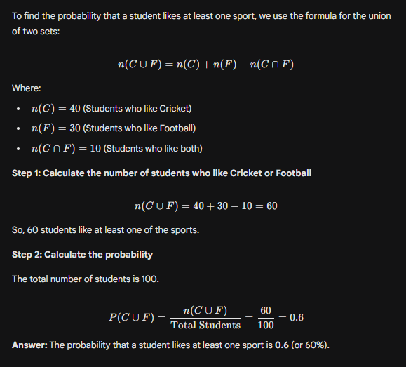

Question 8: From a deck of 52 cards, two cards are drawn without replacement. What is the probability that both are Aces?

Sol
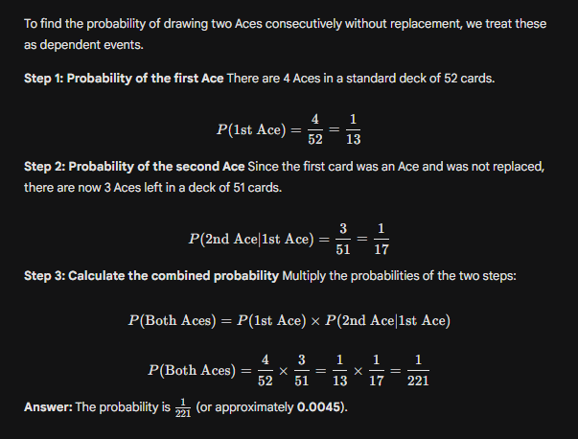

Question 9: A factory produces bulbs with 2% defective rate. If 5 bulbs are chosen at random, what is the probability that all are non-defective?

Sol
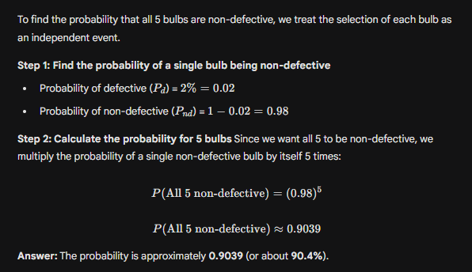
Question 10: Differentiate between discrete and continuous random variables with examples

Sol
Feature | Discrete Random Variable | Continuous Random Variable
Definition | Can only take specific, countable values (often integers). There are "gaps" between values. | Can take any value within a specific range. There are infinitely many possible values.
How it's obtained | By Counting. | By Measuring.
Precision | Exact values (e.g., 1, 2, 3). | Values are often rounded (e.g., 1.5, 1.52, 1.523).

