<!DOCTYPE html>

<html lang="en">

<head>

    <meta charset="UTF-8">

    <meta name="viewport" content="width=device-width, initial-scale=1.0">

    <title>Form Submission Methods</title>

    <style>

        body {

            font-family: Arial, sans-serif;

            text-align: center;

            margin: 20px;

        }

        form {

            margin: 20px auto;

            padding: 20px;

            border: 1px solid #ccc;

            width: 300px;

            border-radius: 5px;

        }

        input {

            display: block;

            width: 100%;

            margin: 10px 0;

            padding: 8px;

        }

        button {

            padding: 10px;

            background: #28a745;

            color: white;

            border: none;

            cursor: pointer;

        }

        button:hover {

            background: #218838;

        }

    </style>

</head>

<body>

    <h2>GET and POST Methods</h2>

    <h3>Submit using GET</h3>

    <form action="action.php" method="GET">

        <label for="name">Name:</label>

        <input type="text" id="name" name="name" required>

        <label for="password">Password:</label>

        <input type="password" id="password" name="password" required>

        <button type="submit">Submit (GET)</button>

    </form>

    <h3>Submit using POST</h3>

    <form action="action.php" method="POST">

        <label for="namePost">Name:</label>

        <input type="text" id="namePost" name="name" required>

        <label for="passwordPost">Password:</label>

        <input type="password" id="passwordPost" name="password" required>

        <button type="submit">Submit (POST)</button>

    </form>

</body>

</html>

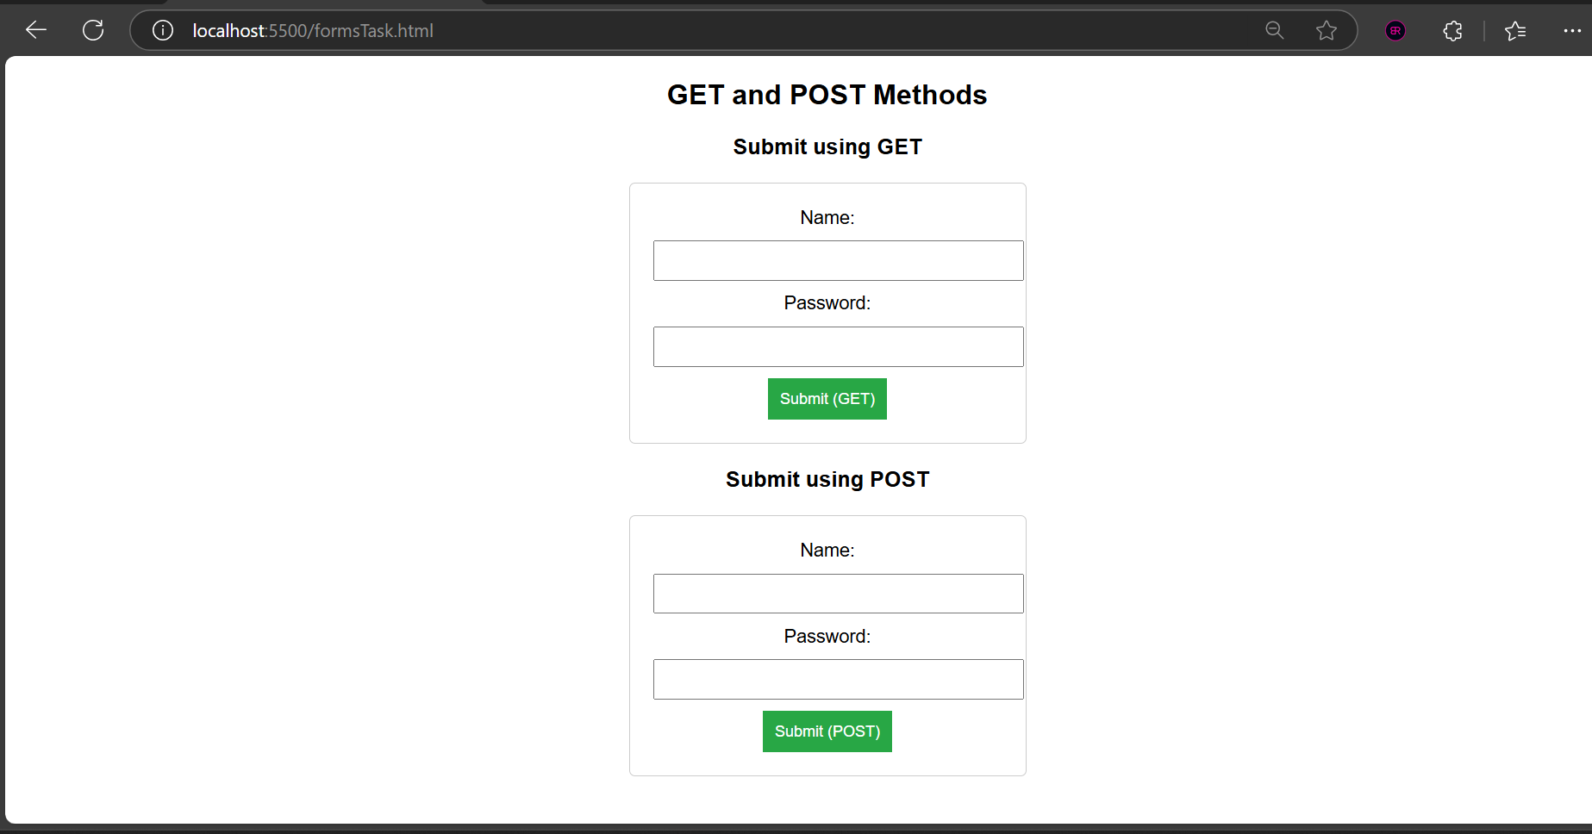

Github link: Git link: https://github.com/Suraj57886/22BD1A052T-FEWD-.git