EBS EXPERIMENT

Lets have an instance for this activity

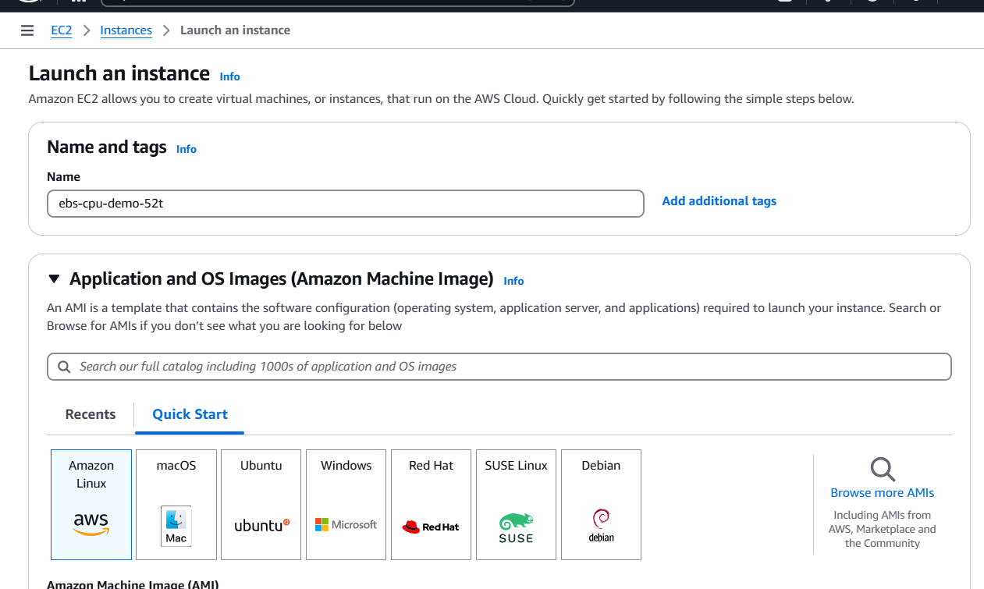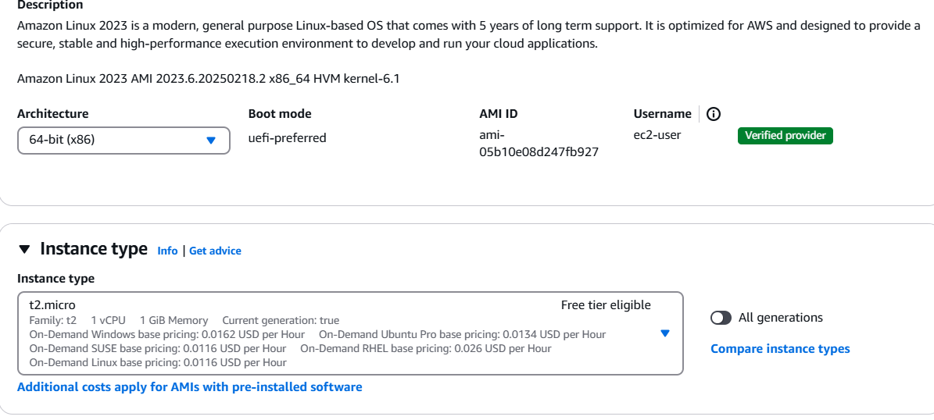

Add an additional volume for this instance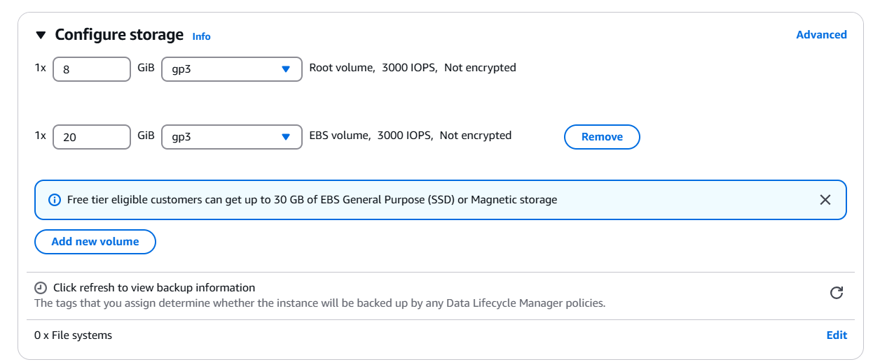

Check for the instance state and ensure it is stopped.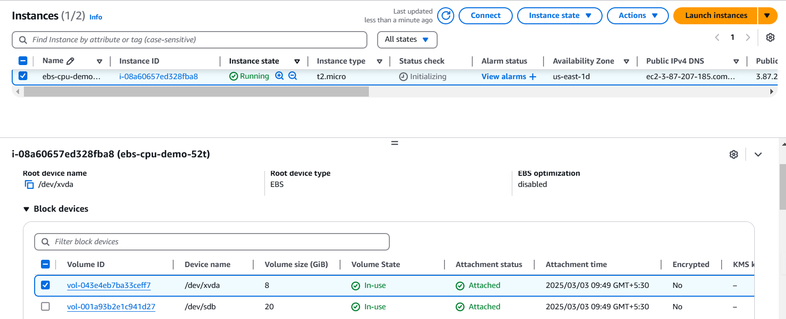

Now try to change instance type 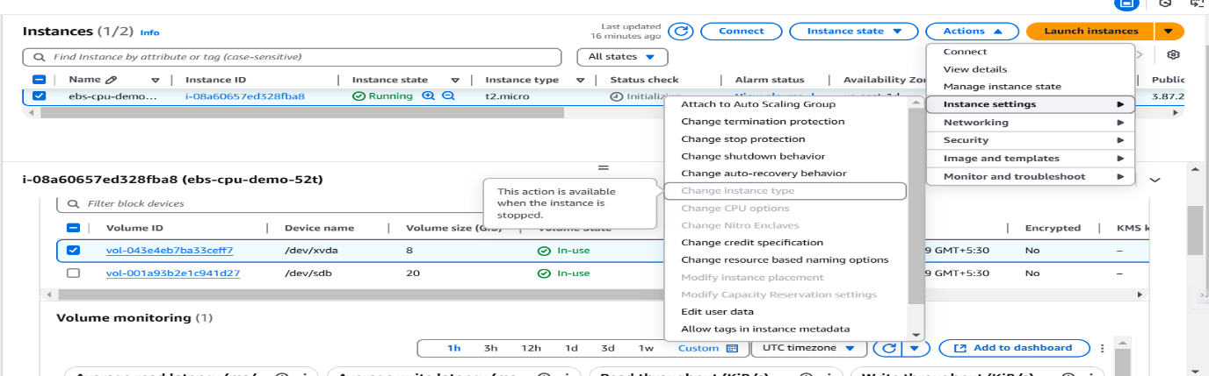

Now change the instance type to t2.medium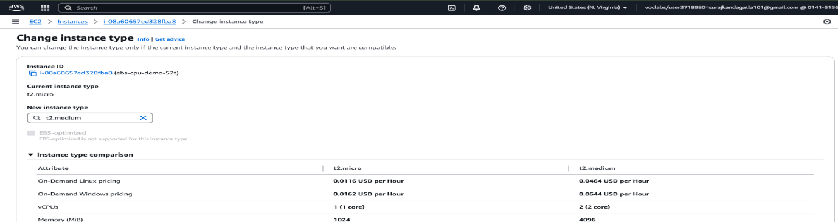

Now that the instance type is changed, we can proceed.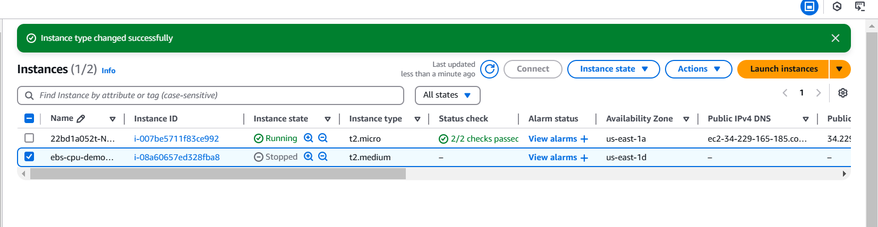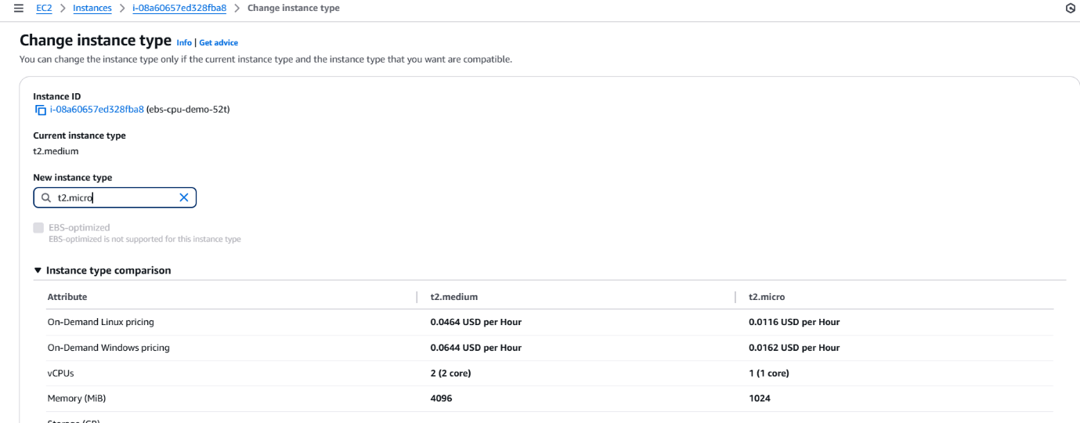

Now connec the instance using any of the method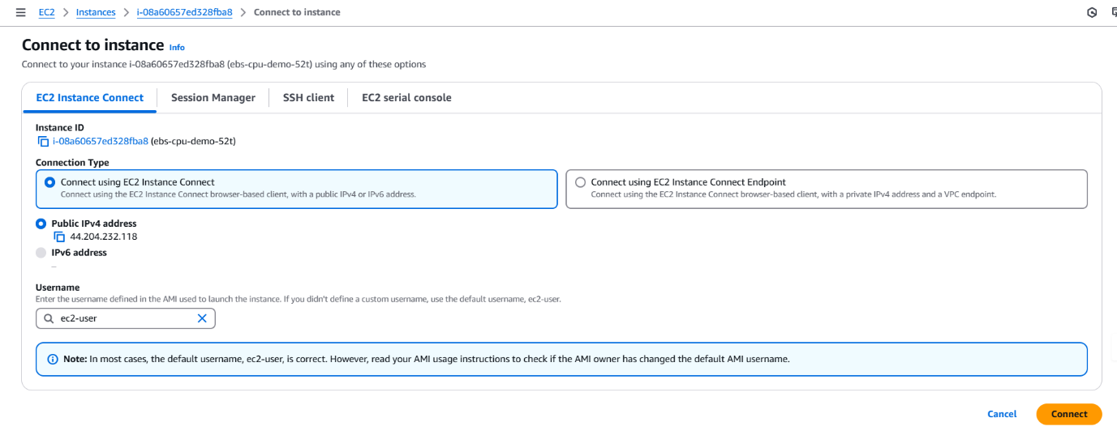

Now we are connected to our instance.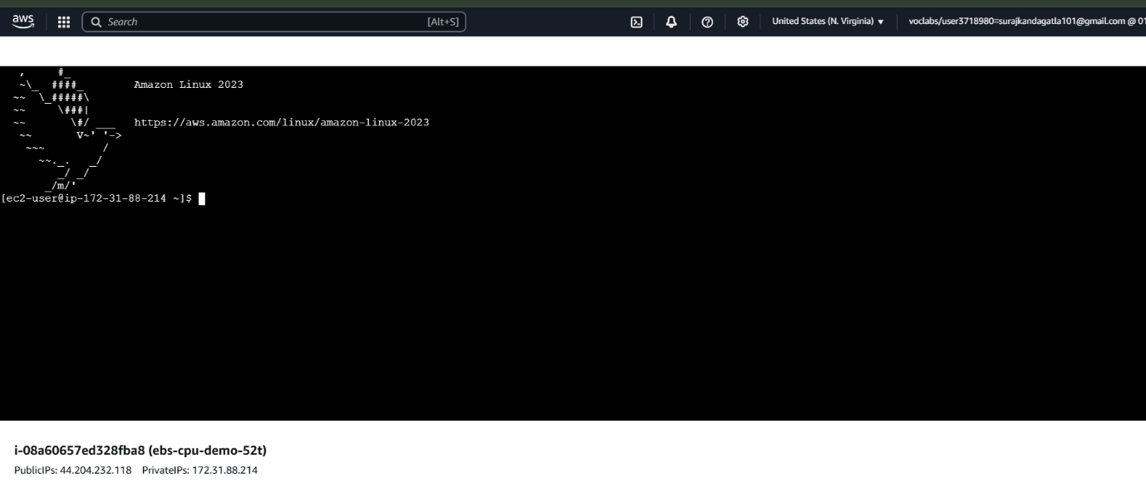

Sudo su, lsblk: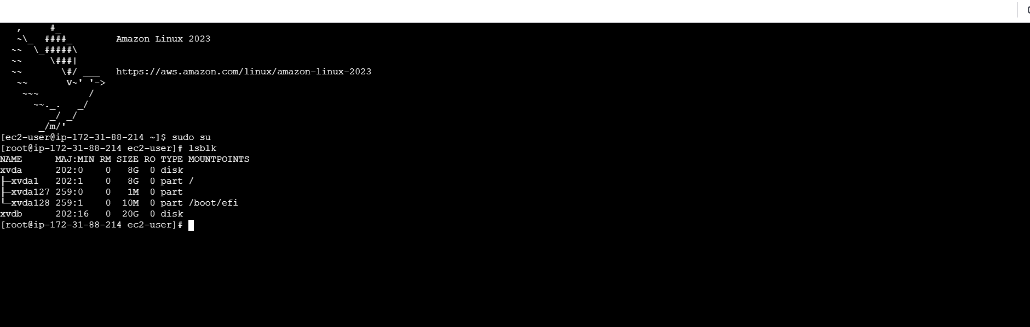

Now create a new volume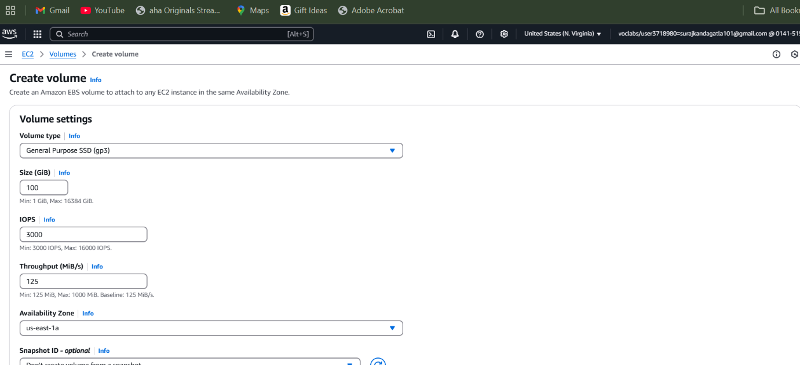

Configure it according to use case.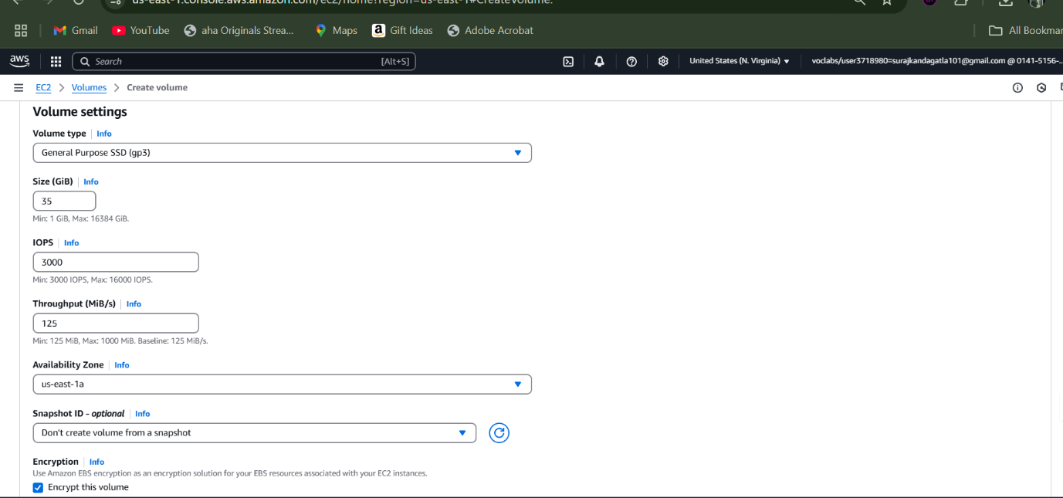

Now upon selecting the created volume, select the option attach volume to attach to an instance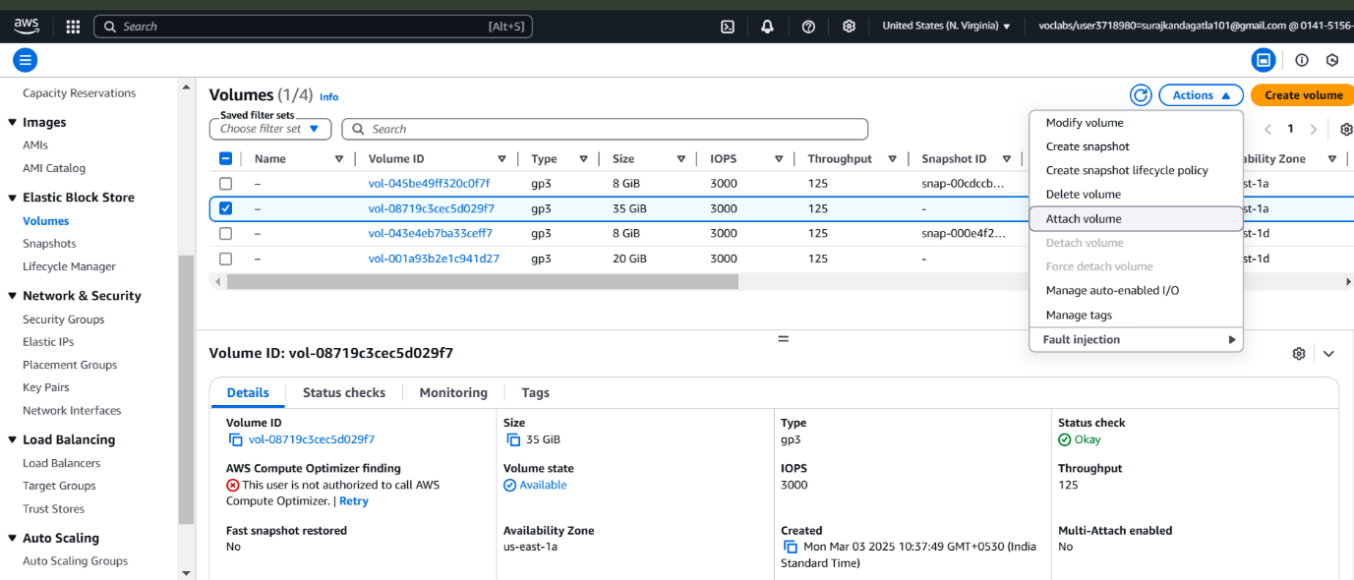

Ensure that both instance and volume are in same availability zones.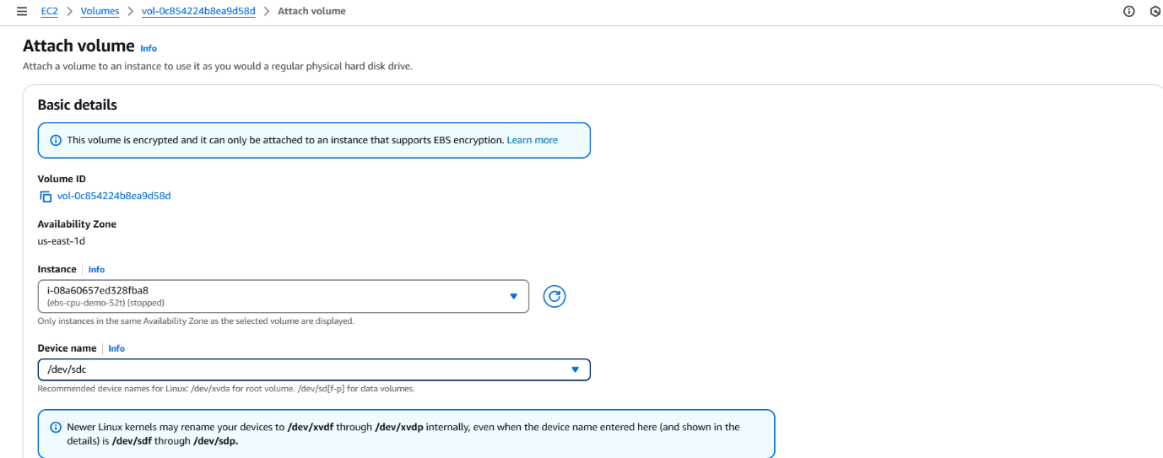

Now we have attached our volume to our instance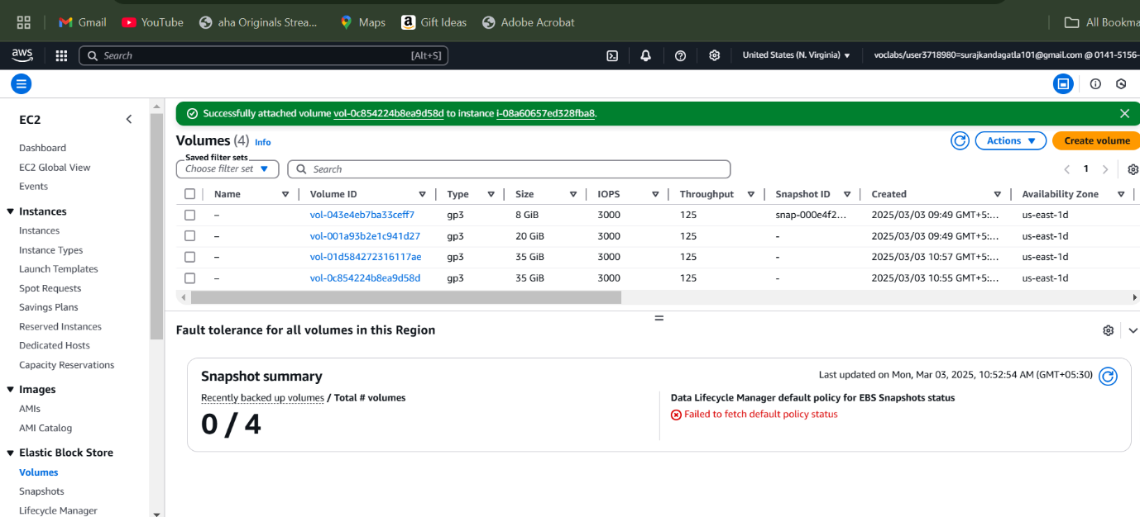

Now we have to ensure this attachment.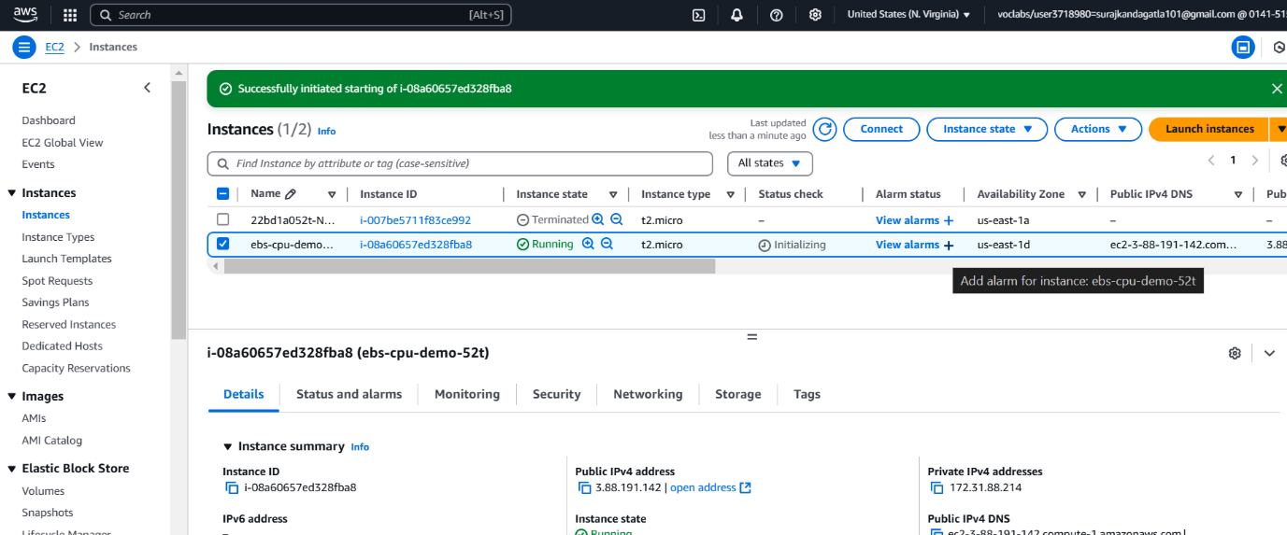

Once you are connected to our instance use “sudo su” and “lsblk” to check for attached volume.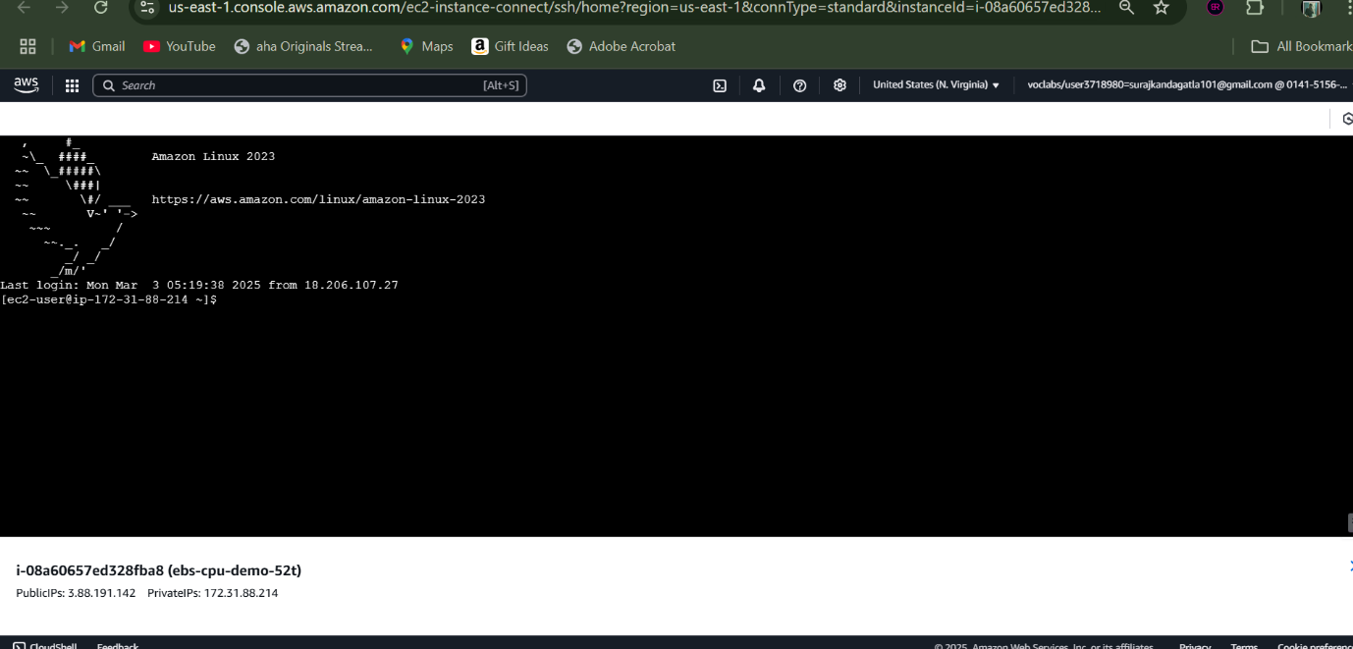

Now we have the volume attached.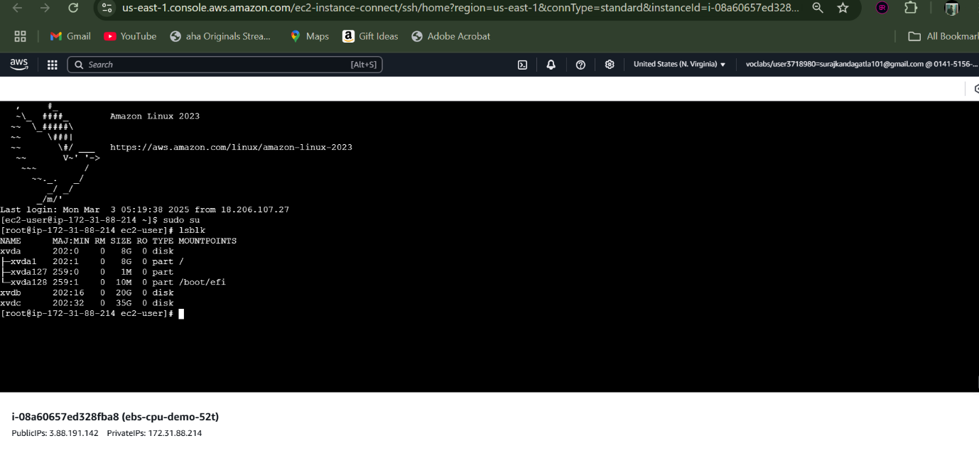

Now use lsblk -fs to view the file system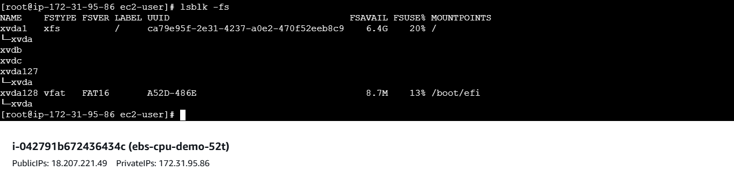

Fdisk -l: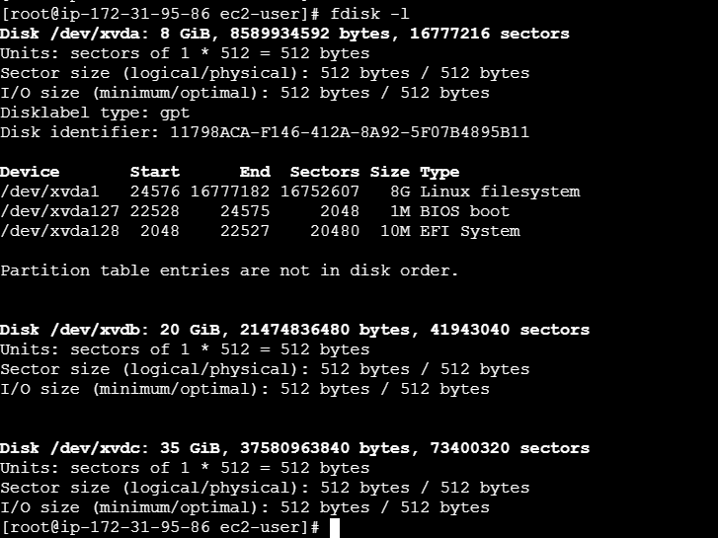

Fdisk /dev/xvdb, use m for menu:  
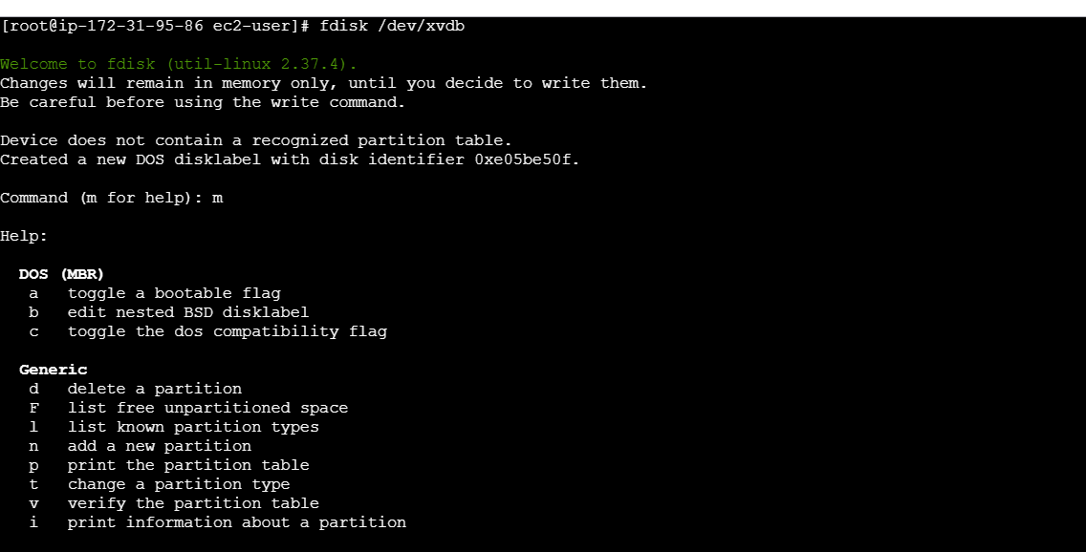

Use p for primary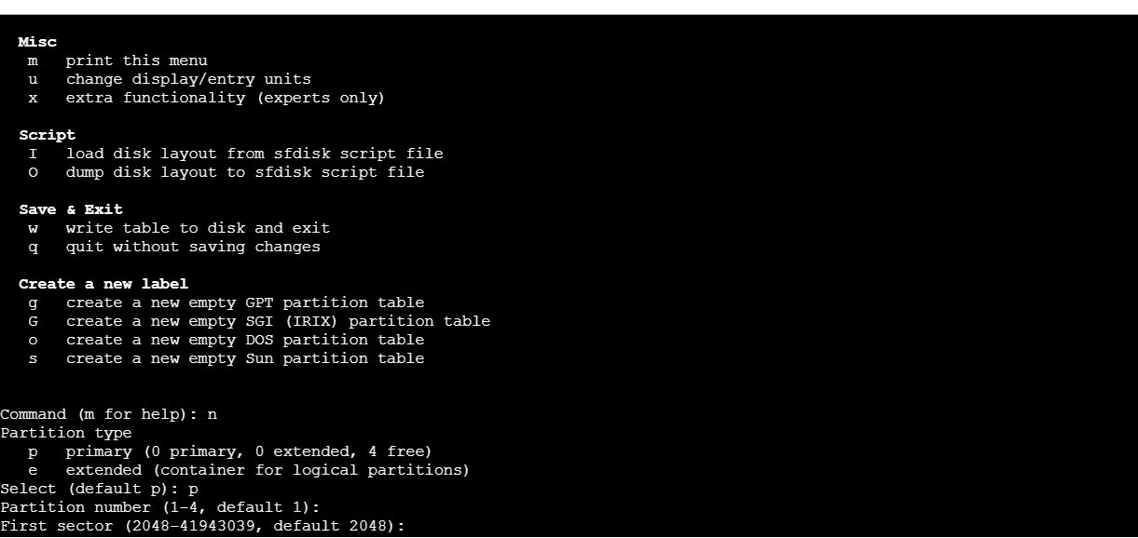

Use w for write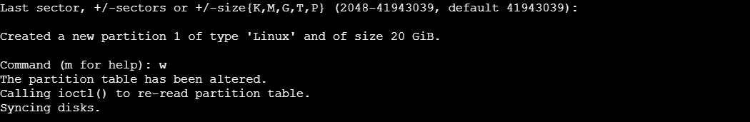

Partprobe, lsblk -fs: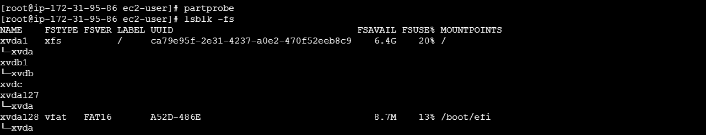

Use mkfs.xfs to make the file system named xvdb1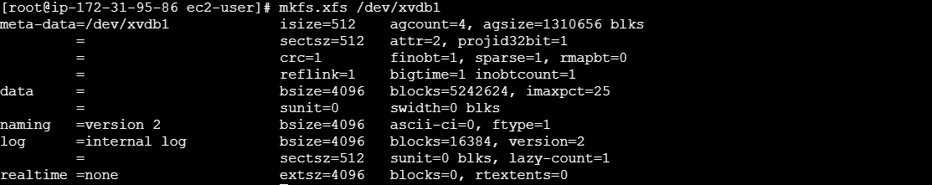

Check for this creation:, now we are mounting a new folder using /mnt/dirname.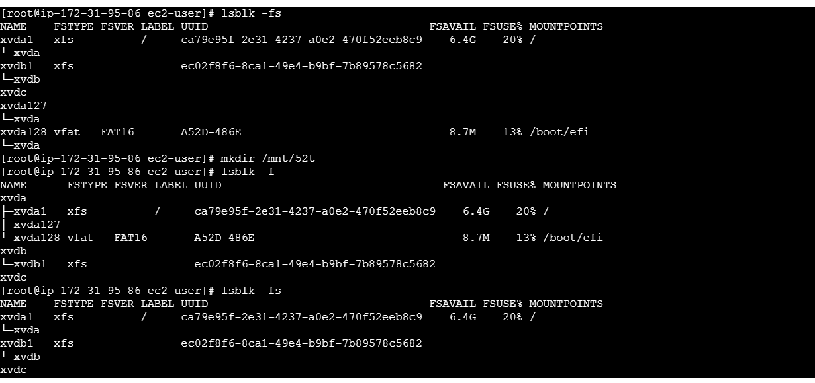

Mounting the directory to our file system. And to check this use lsblk -fs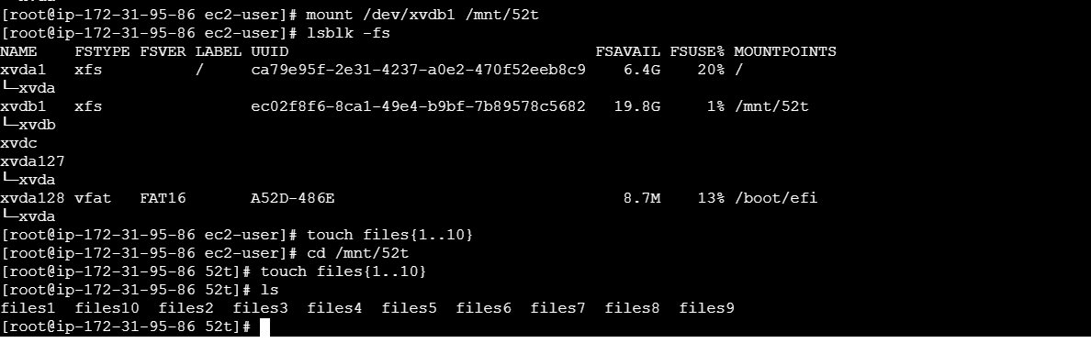

Persistent: